First Iteration Visual Design Document

## Introduction

The purpose of this document is to analyse and describe why and how Joint Venture styled the Chinese Checkers interface for the first iteration version of the application. All visual designs and styles were created after an agreed upon user interface was created for the application. The first iteration visual design process will be the most intensive out of all of the iterations of the project because future iterations will be designed based upon the core specifications described in this document.

# Textures

## Less is More

Trends observed in both mobile and web-based applications in 2013 include: simplicity, minimalism, and less is more ("10 Web Design Trends for 2013", 2012). The Chinese Checkers application was designed with minimalistic and flat textures to ensure that the screen was not overwhelmed while being targeted for smaller devices. From the modern fonts to simplistic images – all have been chosen and designed to be fit with restrictive colour palette to achieve our flat design.

# Colour Swatches

## Primary Palette

rgb(237, 44, 49)

rgb(248, 146, 38)

rgb(248, 232, 22)

rgb(21, 168, 80)

rgb(23, 128, 193)

rgb(134, 1, 175)

## Monochrome Palette

rgb(62, 63, 63)

rgb(124, 125, 127)

rgb(189, 191, 193)

rgb(242, 244, 247)

## Chosen Swatches

Multiple swatches were produced for each palette: Primary and Monochrome. The current palettes chosen are a combination of the most attractive swatches from the original batch. The Primary Palette is used on game tokens such as players and pegs. The rainbow scheme should exist in every activity either in elements of the layout or in a graphic appropriately placed in the activity. The Monochrome Palette is used for the core application colours; from left to right: background, empty peg slot, extra, and text.

## Rejected Swatches

As described above, multiple swatches were rejected to come up with the current palettes. Rejected swatches may be revisited in future iterations, but are not significant enough to this iteration to include in this design document.

# Logo Design

## Name

The name of the application is “Chinese Checkers” and, as such, it is the main text in the logo design for the application. The text is in the font Roboto Condensed (see Assets: Typography section for more information on fonts) and is left aligned.

## Image

Included in the Chinese Checkers branding is a graphic that represents the six potential players in the six primary colours from the Primary Palette. The squares are aligned in decreasing, diagonal order because a North American user would read from left to right and top to bottom. This image will appear in presentations and other documents where the full brand logo is an inappropriate size.

# 

## On a White Background



## On Application Background

# Assets

## Typography

In choosing a font, the team agreed to stay true to a flat and minimalistic style that encompassed the application. The font family Roboto by Android was introduced in Ice Cream Sandwich ("Typography", 2014) and had all of the characteristics of a modern font we required. Roboto comes in two flavours: Normal and Condensed; as well as multiple font styles such as bold, italic and medium. The font in the logo is Roboto Condensed, while the rest of the application is in Roboto Normal.

## Iconography

An icon as defined in this document is a graphical representation of an action, status or application. Initially the choice of icon pack to use was the default Android Action Bar Icon Pack, but, after a team discussion, it was decided to use the Font Awesome, MIT licensed icon pack instead. Attribution to Font Awesome will be given in an About section.

The icons chosen are minimalistic, monochromatic images that can scale smoothly from mdpi to xxhdpi resolutions. The colour of the icons is Light Grayish Blue rgb(242, 244, 247) which is consistent with our chosen colour palette. (See Colour Swatches section for more information on colours.)

## Roboto Normal

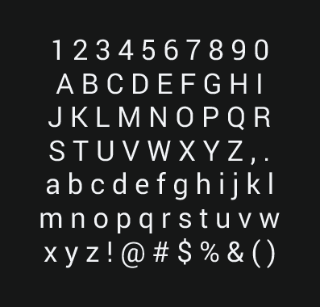

## Android Action Bar Icon Pack



## Font Awesome



# Mock-ups

Main

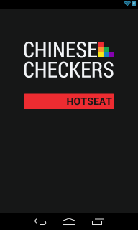

Hot Seat Configuration

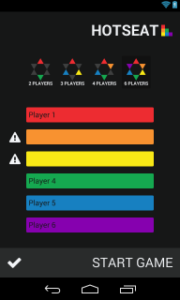

Hot Seat Game

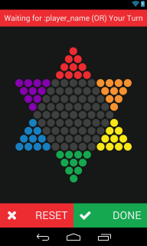

Taking into account the design requirements specified in this document, three mock-up images have been produced that display the layouts of the application for the first iteration as accurately as possible:

* The Main mock-up portrays the first screen that a user will see when the application is launched.
* The Hot Seat Configuration page will be accessed from the Hot Seat button in the Main mock-up.
* After Start Game is pressed in the Hot Seat Configuration mock-up, the user is displayed the game activity which is portrayed in the Hot Seat Game mock-up.

# References

10 Web Design Trends for 2013. (2012, February 27). *Awwwards*. Retrieved January 13, 2014, from http://www.awwwards.com/10-web-design-trends-for-2013.html

Typography. (n.d.). *Android Developers*. Retrieved February 5, 2014, from http://developer.android.com/design/style/typography.html