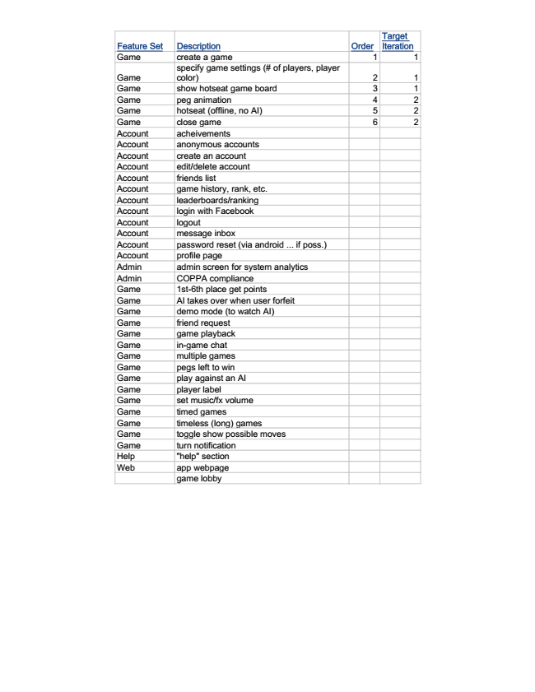

Target Iteration

Feature Set Description Order

Game create a game 1 1

Game

specify game settings (# of players, player color) 2 1 Game show hotseat game board 3 1 Game peg animation 4 2 Game hotseat (offline, no AI) 5 2 Game close game 6 2 Account acheivements Account anonymous accounts Account create an account Account edit/delete account Account friends list Account game history, rank, etc. Account leaderboards/ranking Account login with Facebook Account logout Account message inbox Account password reset (via android ... if poss.) Account profile page Admin admin screen for system analytics Admin COPPA compliance Game 1st-6th place get points Game AI takes over when user forfeit Game demo mode (to watch AI) Game friend request Game game playback Game in-game chat Game multiple games Game pegs left to win Game play against an AI Game player label Game set music/fx volume Game timed games Game timeless (long) games Game toggle show possible moves Game turn notification Help "help" section Web app webpage

game lobby