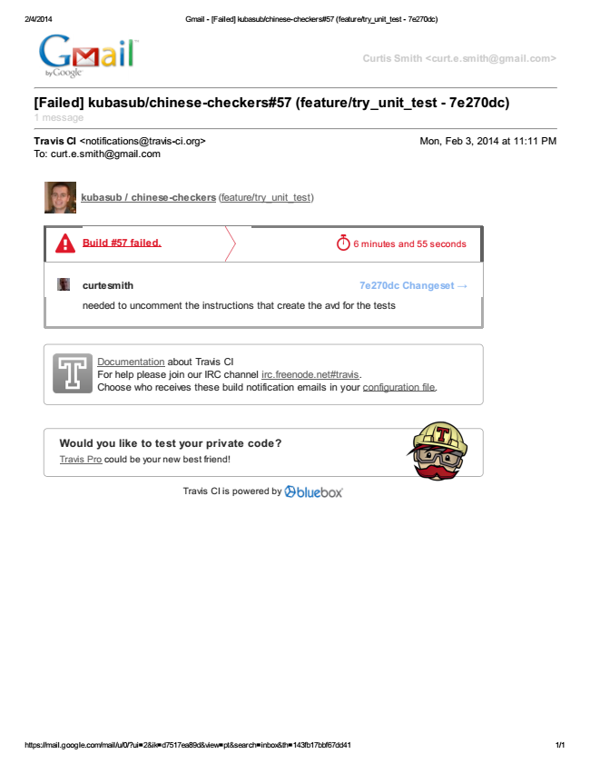

2/4/2014 Gmail - [Failed] kubasub/chinese-checkers#57 (feature/try_unit_test - 7e270dc)

https://mail.google.com/mail/u/0/?ui=2&ik=d7517ea89d&view=pt&search=inbox&th=143fb17bbf67dd41 1/1

Curtis Smith <curt.e.smith@gmail.com>

[Failed] kubasub/chinese-checkers#57 (feature/try_unit_test - 7e270dc) 1 message

Travis CI <notifications@travis-ci.org> Mon, Feb 3, 2014 at 11:11 PM To: curt.e.smith@gmail.com

Documentation about Travis CI For help please join our IRC channel irc.freenode.net#travis. Choose who receives these build notification emails in your configuration file.

Would you like to test your private code? Travis Pro could be your new best friend!

Travis CI is powered by

kubasub / chinese-checkers (feature/try_unit_test)

Build #57 failed.

curtesmith 7e270dc Changeset →

needed to uncomment the instructions that create the avd for the tests

6 minutes and 55 seconds