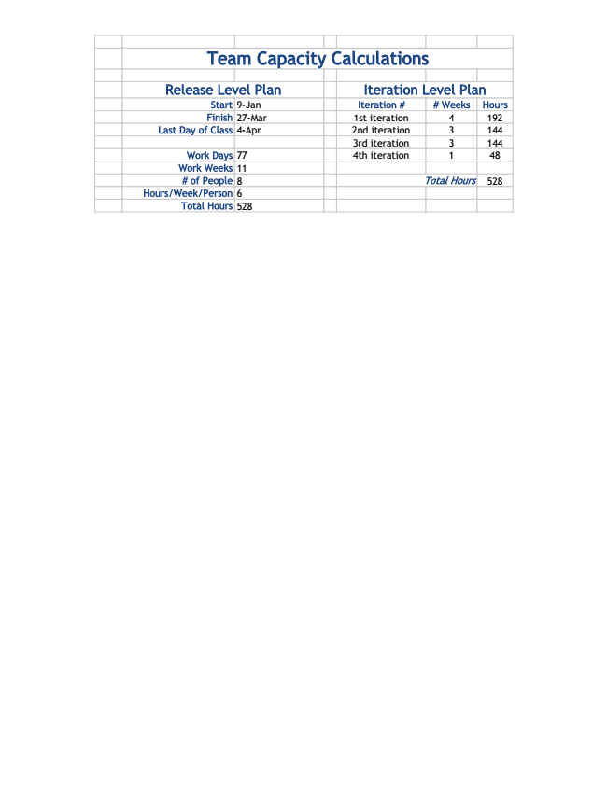

Team Capacity Calculations

Release Level Plan Iteration Level Plan

Start 9-Jan Iteration # # Weeks Hours Finish 27-Mar 1st iteration 4 192 Last Day of Class 4-Apr 2nd iteration 3 144 3rd iteration 3 144 Work Days 77 4th iteration 1 48 Work Weeks 11

# of People 8 Total Hours 528 Hours/Week/Person 6

Total Hours 528