3/15/2018

Kelly, Christopher

40204337

SET08114

Mobile Applications Development

Coursework

Contents

Introduction 2

Critical Evaluation 2

Personal Evaluation 5

References 6

# Introduction

The choice of application for this coursework was to design an android application based off the well-known franchise Uber. The motivation behind this choice was to redesign Ubers layout but to make the application more simplistic and easier to use for both the older generation and younger generation. The scope of the app was to design and implement a working application that allowed two people, for example two friends to request a lift off each other. One person would register and login as a driver, and the other person a passenger. Then to request a lift it was simply a click of a button. After the driver was located a route was added to the google maps API on the screens and both the driver and the passenger had live location tracking to each other. To achieve the motivation behind the app a significant amount of advanced and complex features from the Ubers app were removed and the ability to find a driver involved no more than a simple registration and the click of a button.

# Critical Evaluation

The original Uber app contains a complex registration process that requires a substantial amount of personal details being shared with the company as well as not having the ability to use the app unless you have a payment method added to the account. To simplify this long and tedious process, this app has been designed to only require an email and a password to unlock the ability to call the driver. Ubers app can take a substantially longer time to have a driver confirmed and on route to the passenger’s location as they need to accept the request and have many drivers in the area which could be a potential problem for somebody with a lack of technology skills. As there is a map of all the available drivers present on the customers screen, if they were unfamiliar with newer technology this could prove difficult to interpret and understand and result in them refusing to use the app. This is a crucial factor in the design of my app and making a simple, easy to understand interface that the older or younger generation with a lack of technological experience could easily understand and be more than confident using. My app offers a map with the driver that will be picking the passenger up clearly marked and easy to track without any other distractions or objects that could confuse the passenger.

The use of being able to track a driver in real time allows a more simple and handy experience compared to that of other taxi style apps which only allow a driver to be booked at a certain time. The use of being able to view your drivers location allows a customer to prepare properly and be able to meet the driver on time. With apps that lack this type of interface both customers and drivers can find themselves waiting inconveniently and more importantly unnecessarily as they are unaware of each other’s location. Several similar applications make a customer pay extra based on the quality and price of a car, for example a Mercedes may be classed as ‘luxury’ and force a customer to pay extra. My application does not take any of this into consideration and is therefore more fairly designed.

Many of the other taxi orientated apps offer a similar layout and graphical interface as to that of Ubers and my own and have several features integrated into them that could be used to improve the overall experience users have on my app. An improvement for the future would be the use of choosing a destination, which gives the driver notice of where they need to go before making contact with the passenger. Another feature that could be integrated in the future development is a driver rating system, which allows customers to rate their experience with their driver and therefore allow potential future customers to check their driver’s ratings. This could potentially make them feel more safe and comfortable.

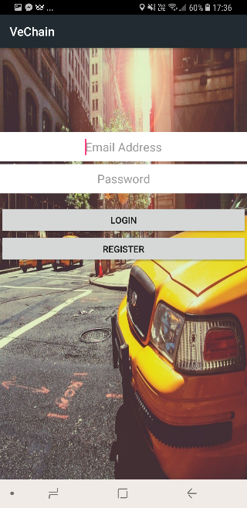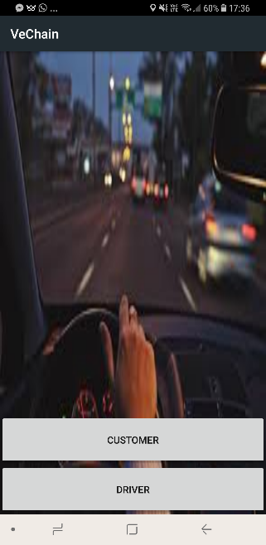Upon opening the app the first decision the user must make is whether they are a Driver or a Customer, they decide this by simply clicking the correct button. They must then either register an account and log in by using a valid email address and password combination, or if they have already, simply log in.

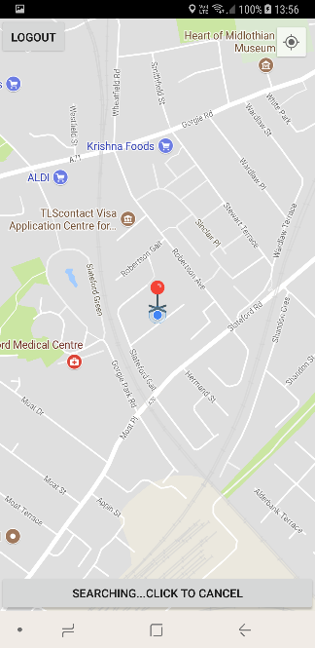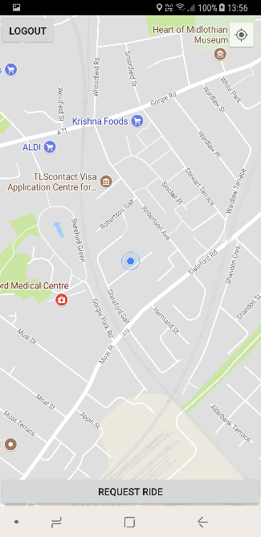

If the user is a customer, they will be presented by this screen which is a map of their surrounding location. To request a driver, they must simply click the request ride button positioned at the bottom of the screen. Upon clicking they will be notified that a driver is being located and another click of the button will cancel the request. A pickup marker is also placed on their location so they know where the driver will be arriving.

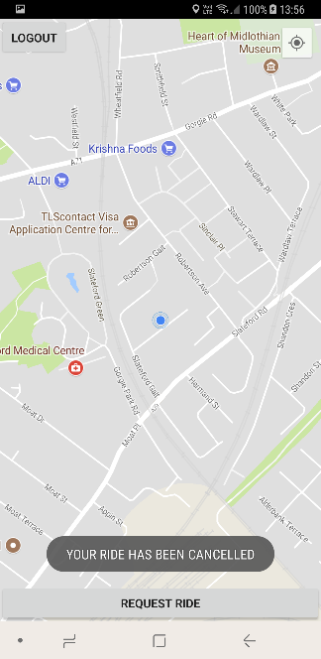This is the screen they will be presented with confirming their ride has been cancelled and ready to re-request if required. If the user wants to then logout they can simply press the logout button located at top left which will take them back to the home screen. This logout button can be pressed at any time and is always clearly located at the top left of the screen.

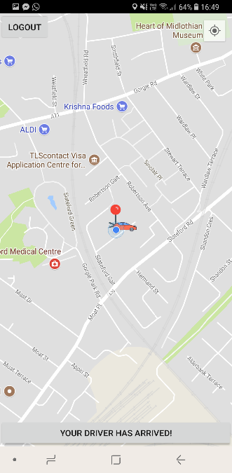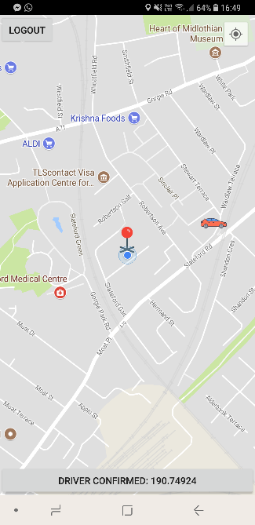Once a driver has been confirmed the user will be notified with the driver clearly located on the map and tracked using live location. The distance the driver is away is displayed in metres and once the distance becomes less than 100m the user will be notified informing them the driver has arrived.

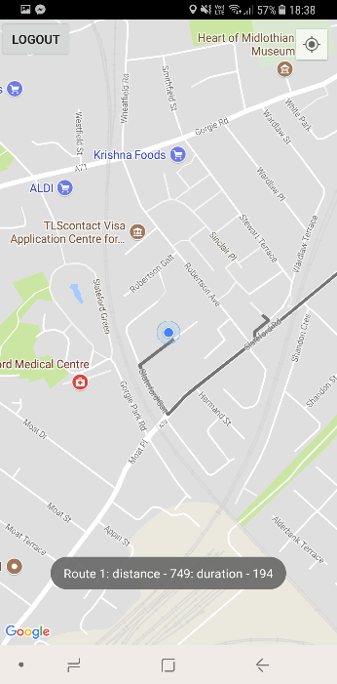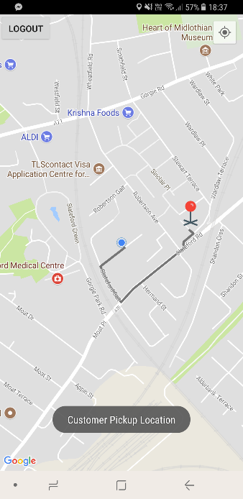

If the user is a Driver then after a customer has requested them and the locations are confirmed, the driver will be made aware of the pickup location. They will also be told the distance In metres and time it will take to arrive.

# Personal Evaluation

Throughout the design and coding of this app a lot of challenges and problems were encountered which needed research and a lot of debugging to be done to resolve. Before the coursework Java was a language I was very unfamiliar with and learning how to implement methods and create classes proved very challenging at the beginning. To ensure I had a sound understanding of this programming language I did a lot of research into learning how to create simple methods and implementing them by using websites which offered simple tutorials such as www.stackoverflow.com and [www.tutorial.com](http://www.tutorial.com). The functionality of the app required the use of firebase which allowed a user database to be created and called to when required. To understand how this worked I used the documentation provided by google as well as watching several YouTube videos of demonstrations to how I could implement firebase for creating a login/registration function. Google offer a range of API’s to use and of which I required a few of these such as google maps. Implementing the map API into my app proved a real challenge which produced the app to crash frequently. The documentation provided by google proved very helpful however more research was needed and again YouTube videos proved very accommodating in locating my coding errors. A first draft of the app lacked any form of visually appealing design and to make it more vibrant I spent a lengthy amount of time looking at backgrounds, button layouts and designs to make the pages stand out. I choose to invest this amount in time in design as I believe it’s a huge factor in what makes a app successful and encourages the users to choose my app over others. During this coursework I grasped a very good understanding of java which I can carry on using in my further studies. The designing and modelling of a app interface was something I had never came across before and I now feel I am confident in the process of achieving this. I also discovered that should a problem arise with my coding or design, I had the composure to track down the source of the problem and evaluate a series of fixes that I could use and then choose the fix that is best. Debugging an android application was something I had never understood before and I have no learned how to work my way through a debugger and use the output to understand how the app code is working and if it is being efficient. To conclude I feel I performed better than I expected and have taken skills from it that I intend to use again in the very near future.

# References

<https://firebase.google.com/docs/android/setup>

<https://github.com/firebase/geofire-java>

<https://www.flaticon.com/search?word=map%20marker>

<https://www.flaticon.com/search?word=car>

<https://github.com/jd-alexander/google-directions-android>

<https://encrypted-tbn0.gstatic.com/images?q=tbn:ANd9GcToobWXMgx7XrPjB-FCPTKGqpE3HmWJ4VK3uOWHGrWNuQUnzcyu>

<http://ded7t1cra1lh5.cloudfront.net/media/212862/98d85cf12296831a40efc1609083a789cc65d073/original/Taxi_%28Medium%29_%281%29.jpg?1478521438>

<https://console.cloud.google.com/home/dashboard>

<https://developer.android.com/training/permissions/requesting.html>

<https://developers.google.com/maps/documentation/android-api/map-with-marker>

<https://developer.android.com/reference/android/widget/Button.html>

<https://firebase.google.com/docs/reference/android/com/google/firebase/database/DatabaseReference>

<https://stackoverflow.com/questions/48962271/app-crashes-after-integrating-glide-gradle>

<https://github.com/bumptech/glide>