**Setup**

This document provides detailed step-by-step instructions to complete setup for the workshop.

**High level steps**

1. Create an S3 bucket that will be used to save movie lens data.
2. Create and IAM policy that provides access to Amazon Personalize APIs.
3. Create an Amazon SageMaker Notebook to explore the movie lens data and use Amazon Personalize APIs to build the movie recommendation model.

**Step-by-Step Instructions**

1. **Create an S3 bucket**
2. Login to the AWS Console and search for S3 service.

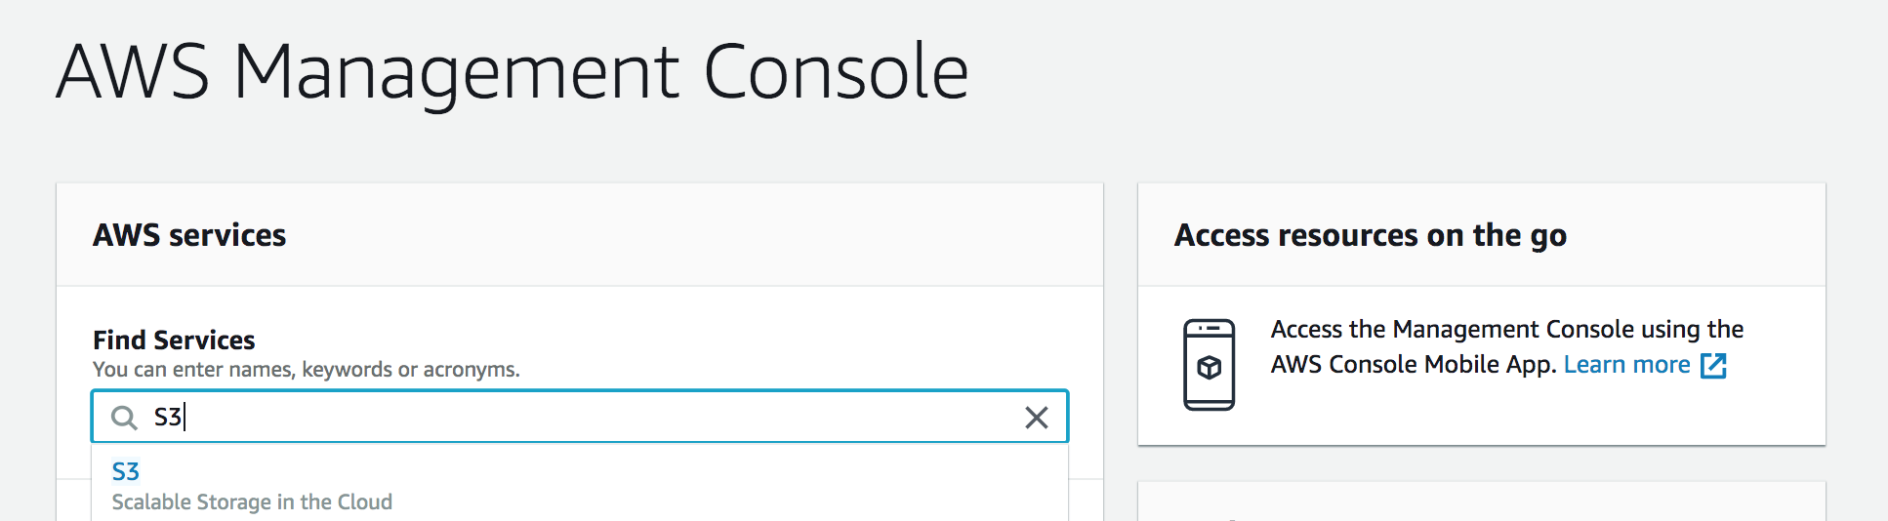

1. In S3 console, click “Create Bucket”

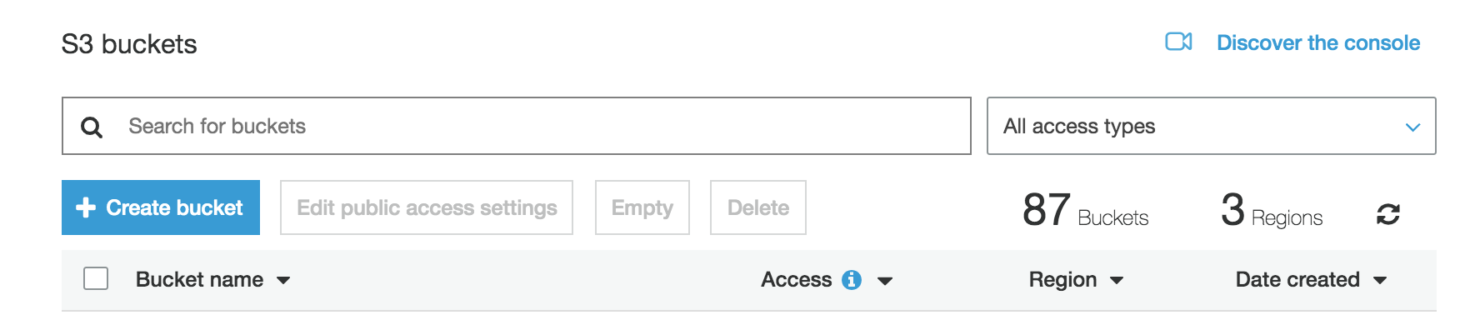

1. In the ‘NameRegion’ screen

Enter unique name for the bucket (for eg., personalize-demo-<firstname>-<lastname>)

Select the region (N.Virginia)

Click Next

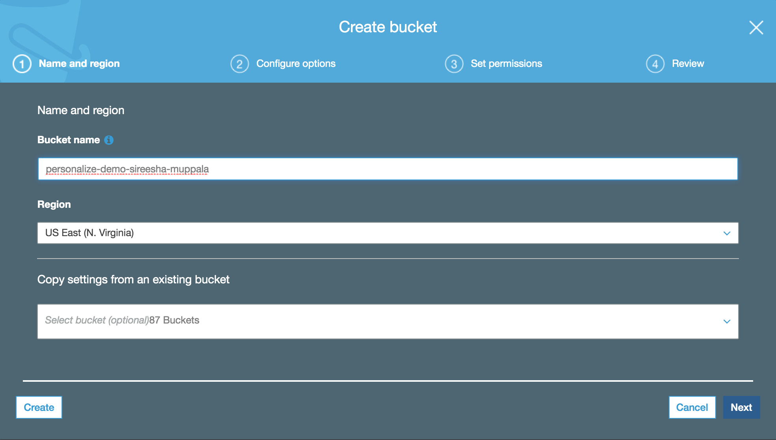

1. In the ‘Configure Options’ screen, leave defaults and click ‘Next’.

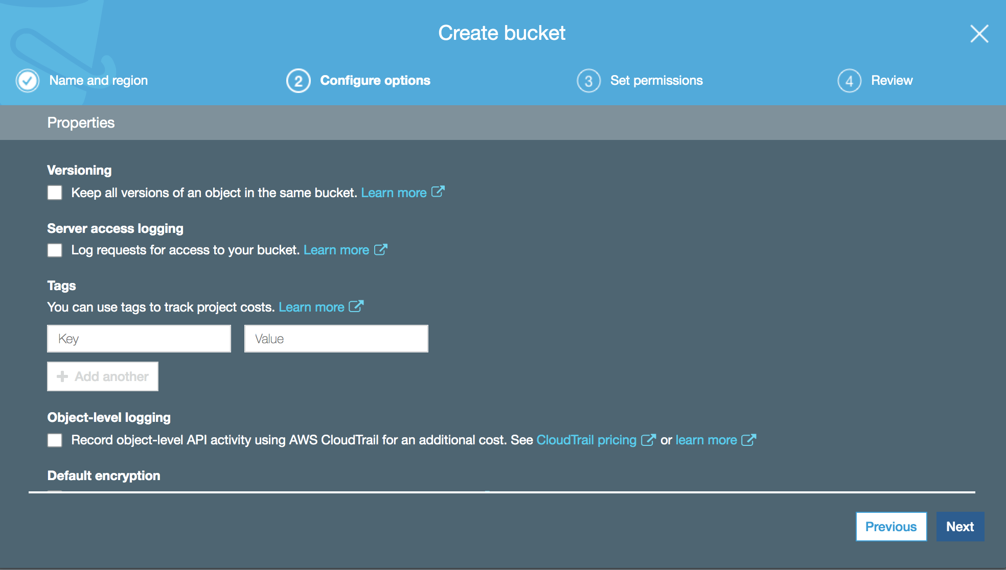

1. In the ‘Set Permissions’ screen, leave defaults to block public access to S3 bucket and click ‘Next’.

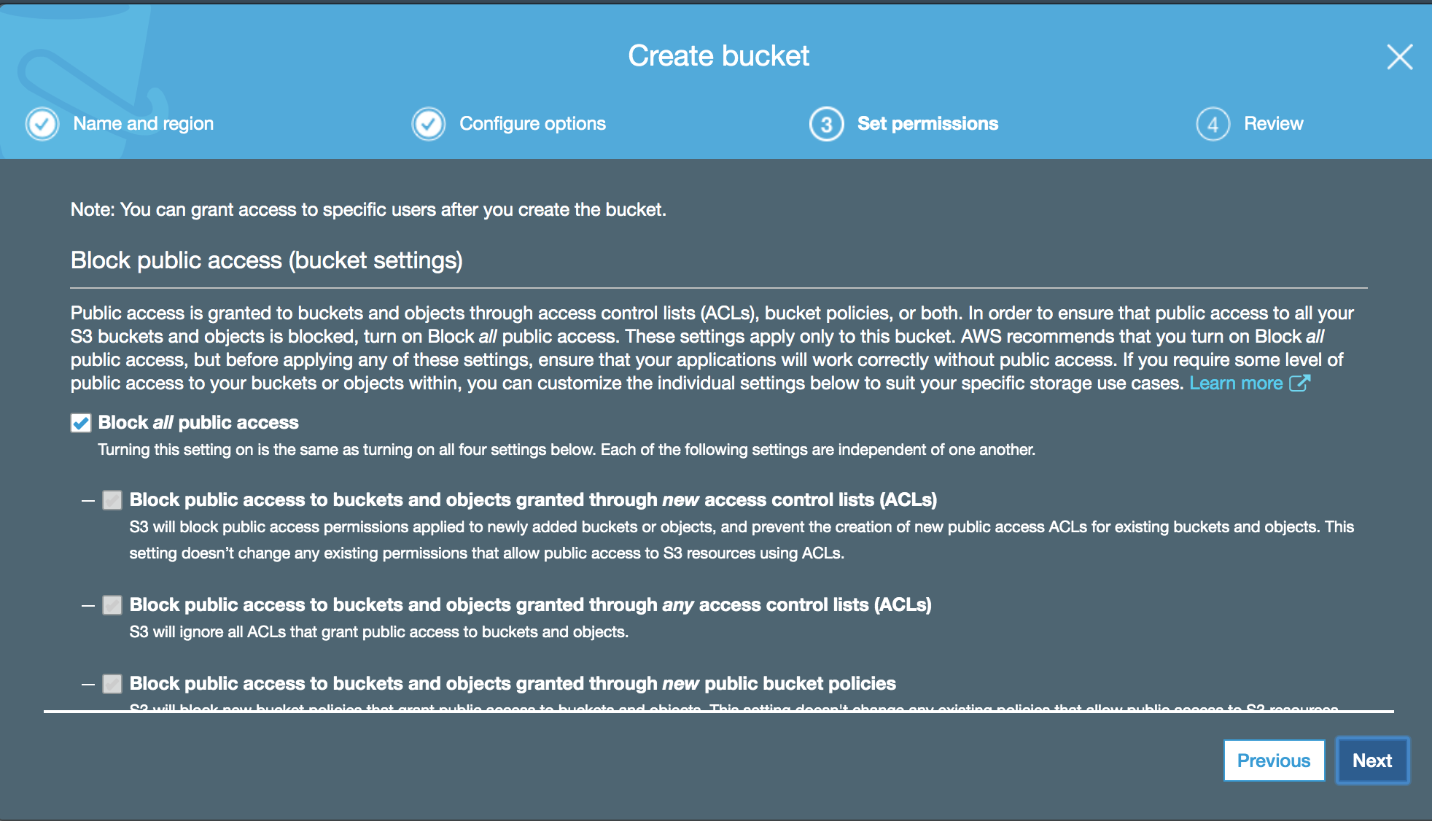

1. In the ‘Review’ screen, review the details and click ‘Next’.

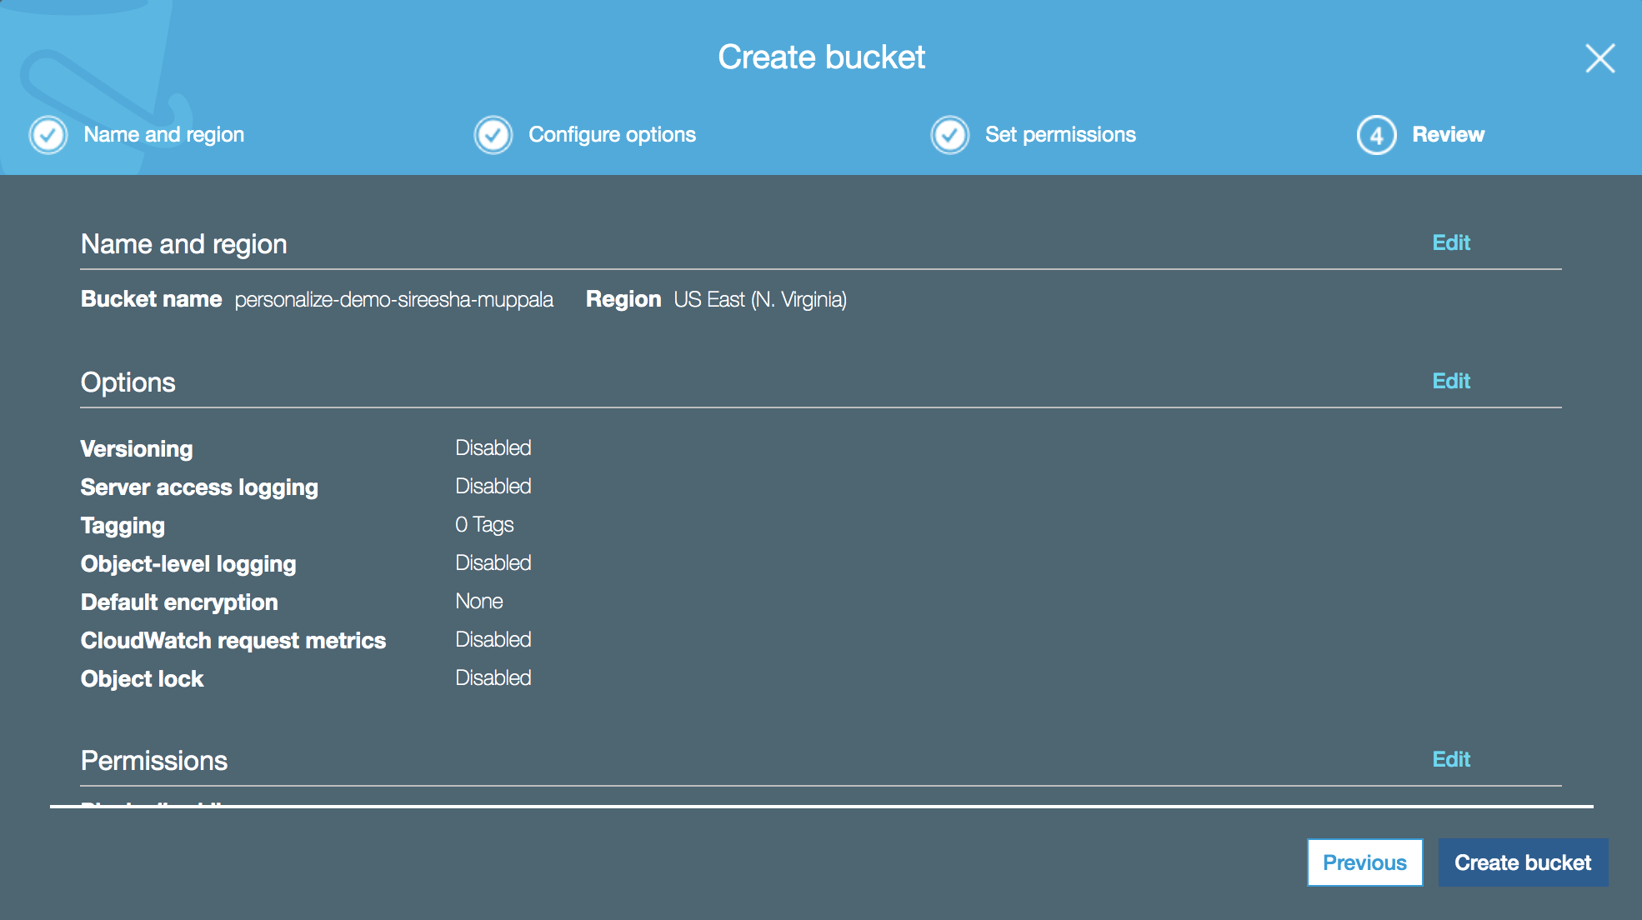

1. Verify that the S3 bucket is created. 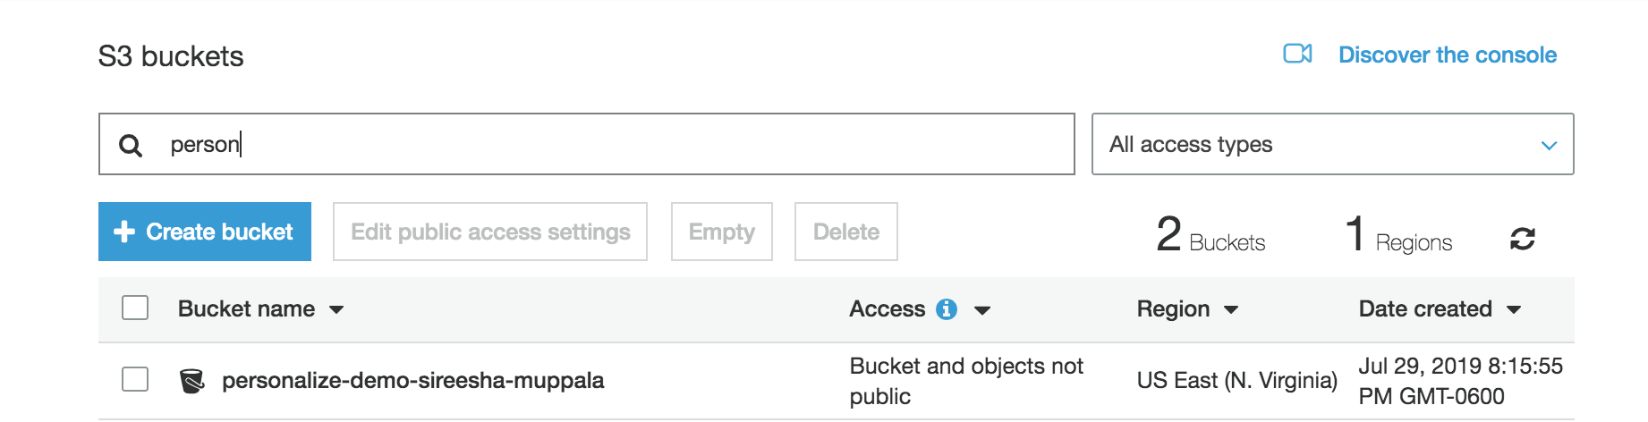
2. **Create an IAM policy that allows access to Amazon Personalize**
3. In AWS Console search for IAM service.

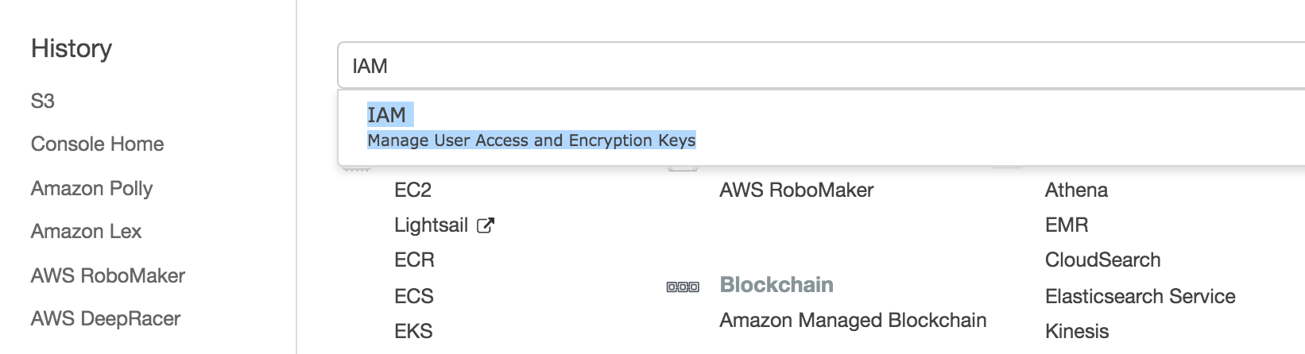

1. Click ‘Policies’ in the navigation bar.

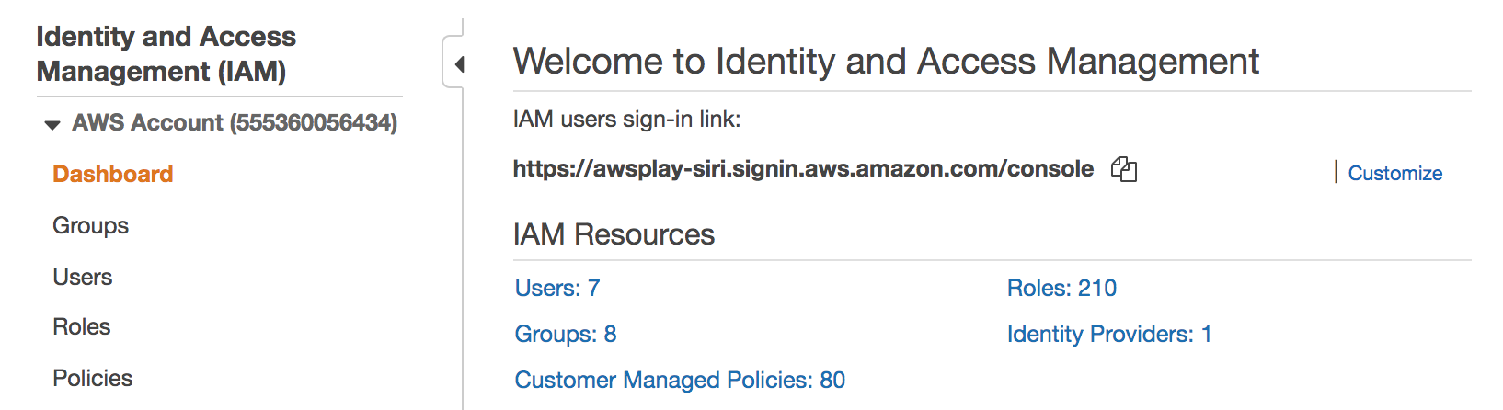

1. Click ‘Create Policy’ and select ‘json’ tab.

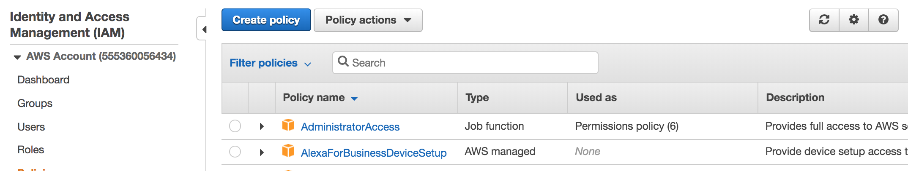

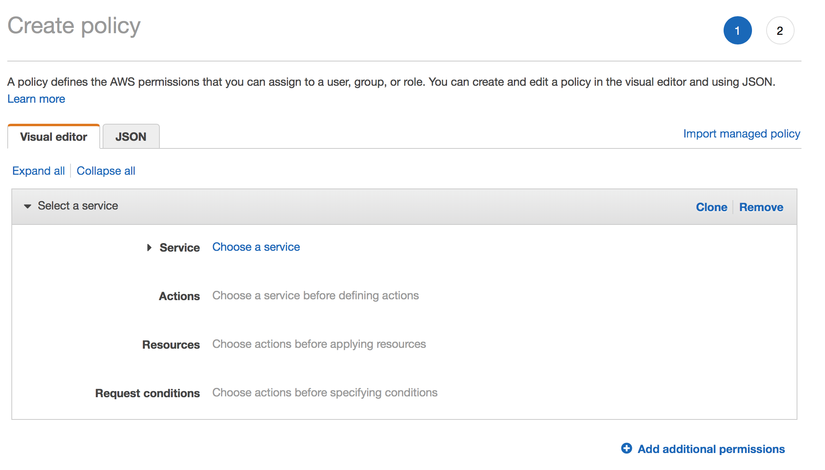

1. In the JSON tab, enter the content from the IAMPolicy.json file (Also included in the repo). Replace the existing content and Click ‘Review policy’

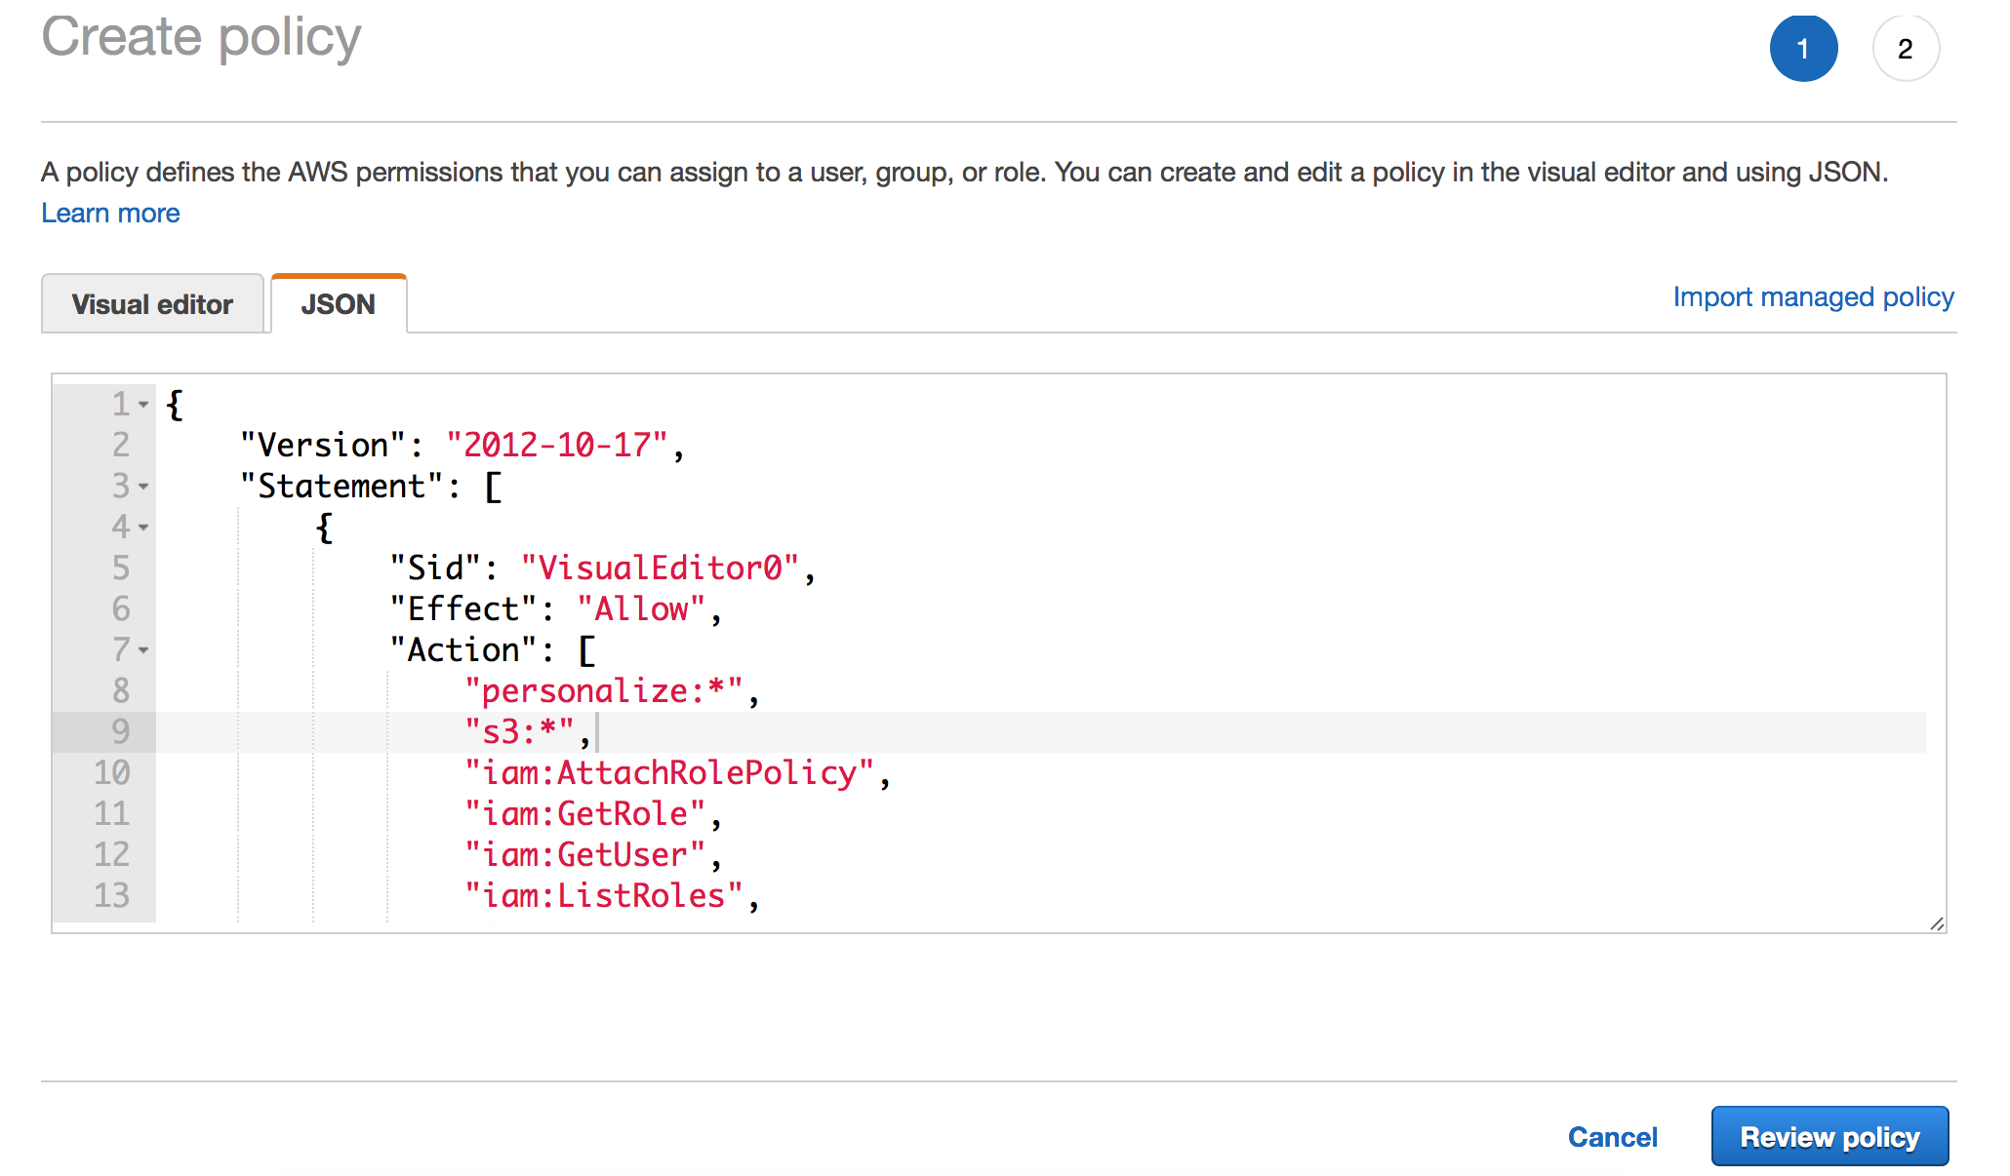

1. In the ‘Review Policy’ screen, enter the name of the policy and click “Create Policy”

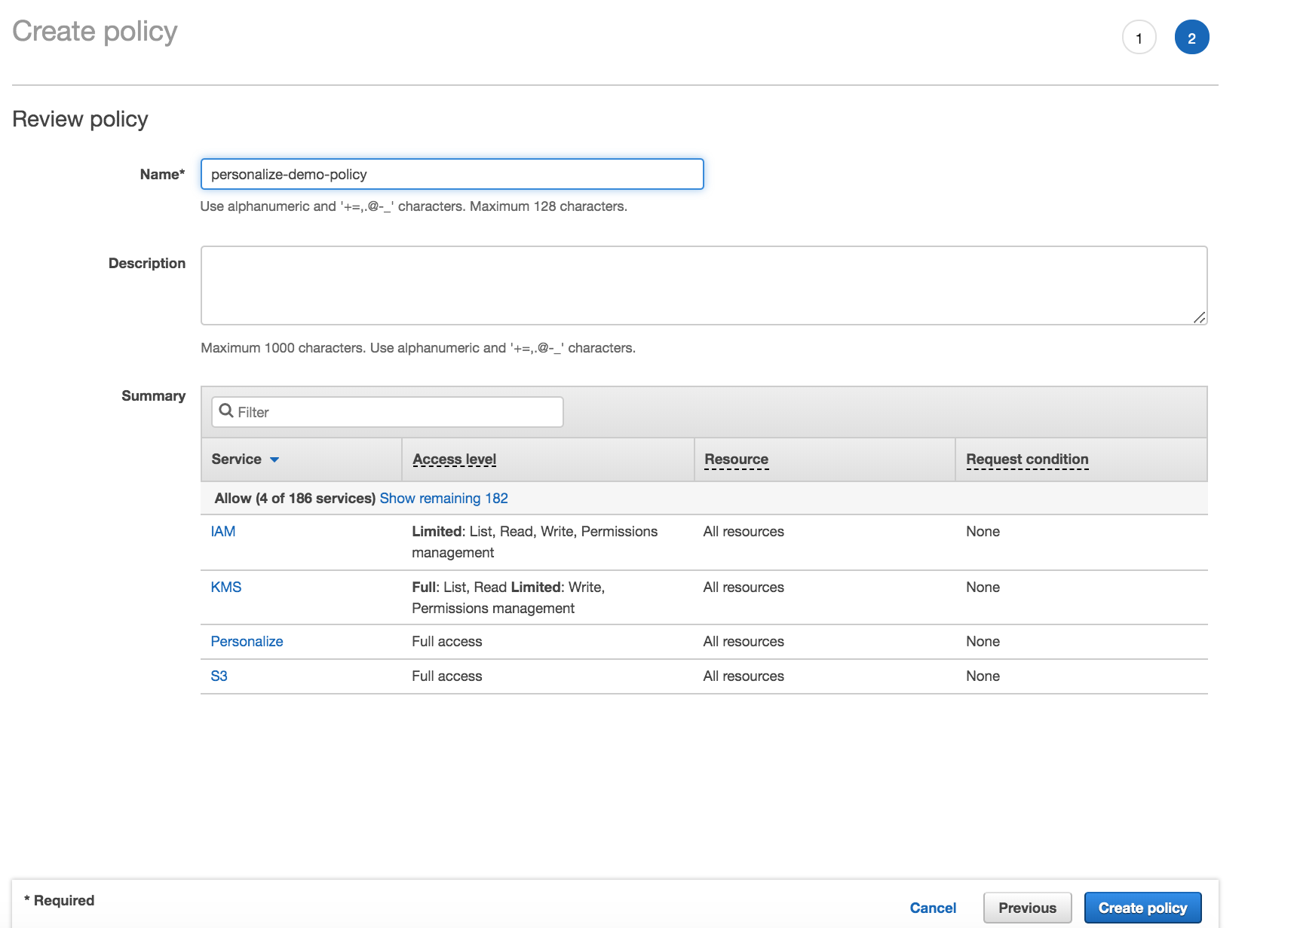

1. Verify that the policy is created.

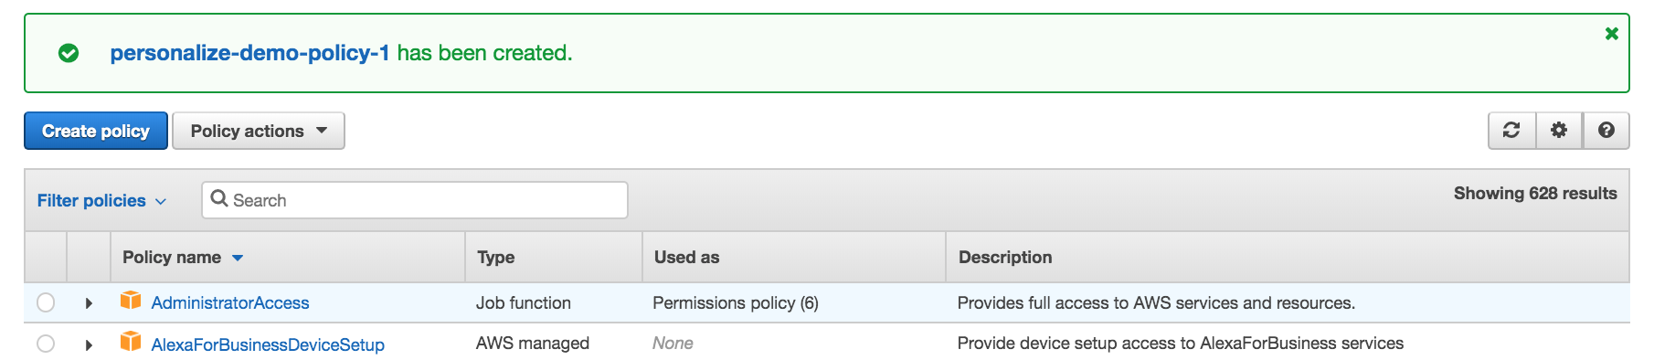

1. **Create a Amazon SageMaker Notebook Instance.**
2. In the AWS Console, search for SageMaker service.

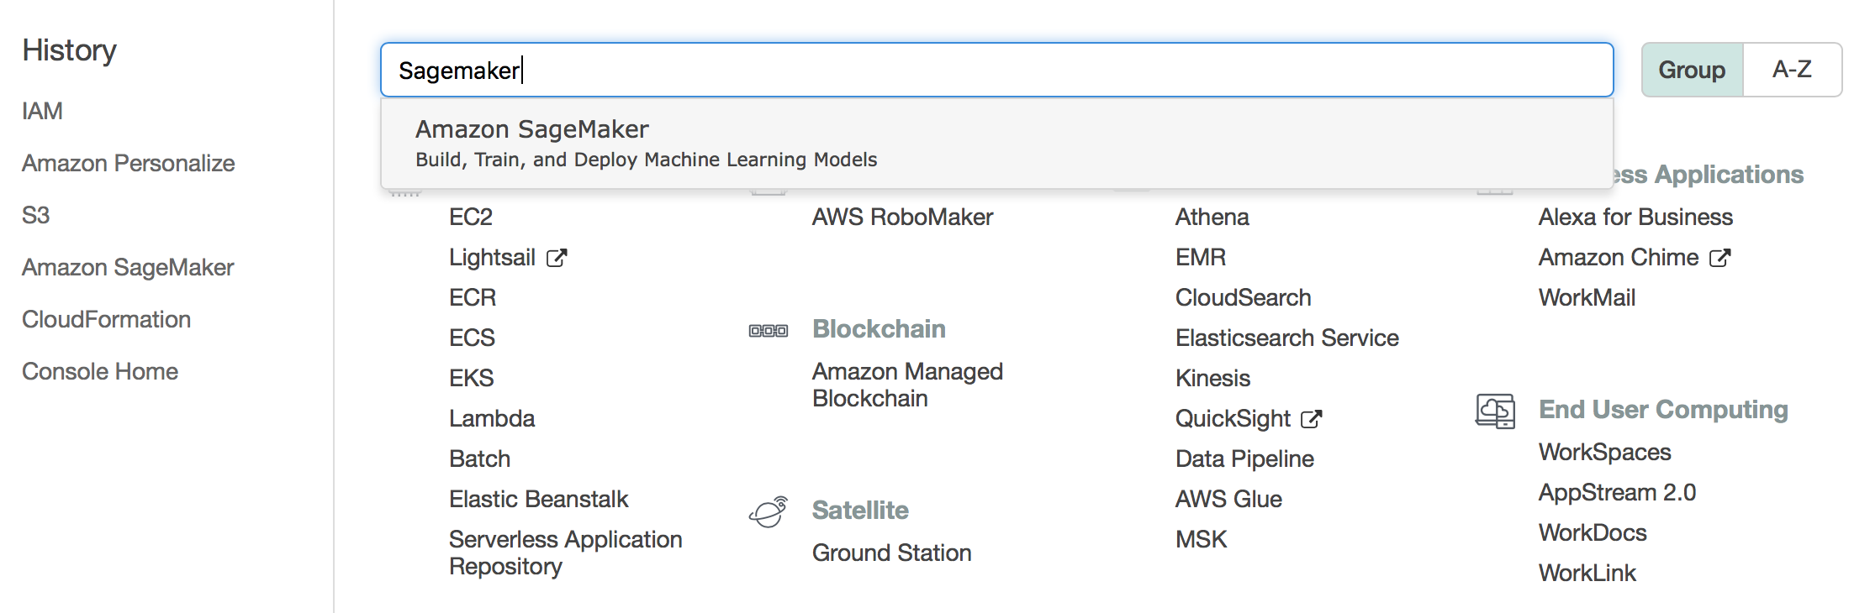

1. In the Amazon SageMaker console, click on the ‘Notebook instances’ from the navigation bar.

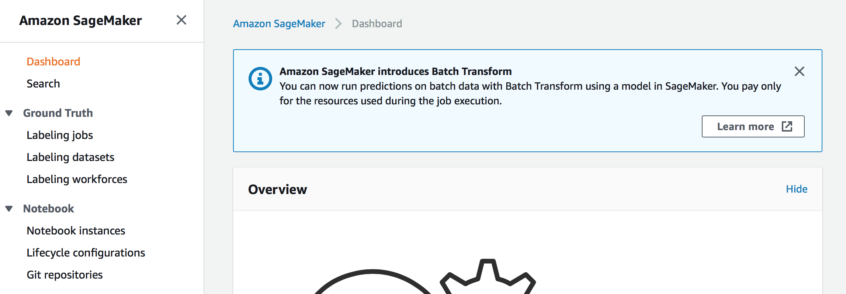

1. Click ‘Create notebook instance’

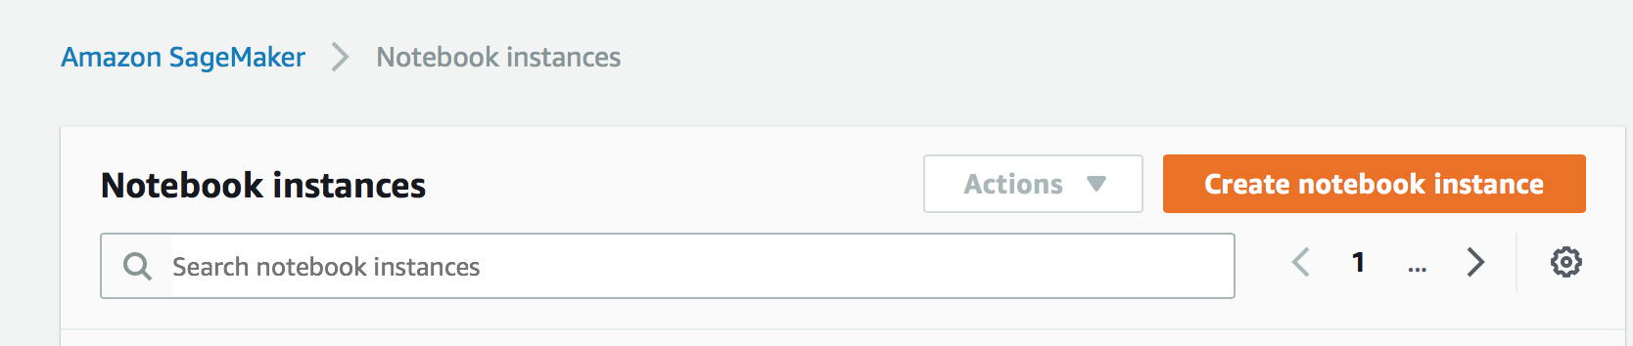

1. In the notebook instance settings

Enter a unique name for the notebook.

Leave the default instance type.

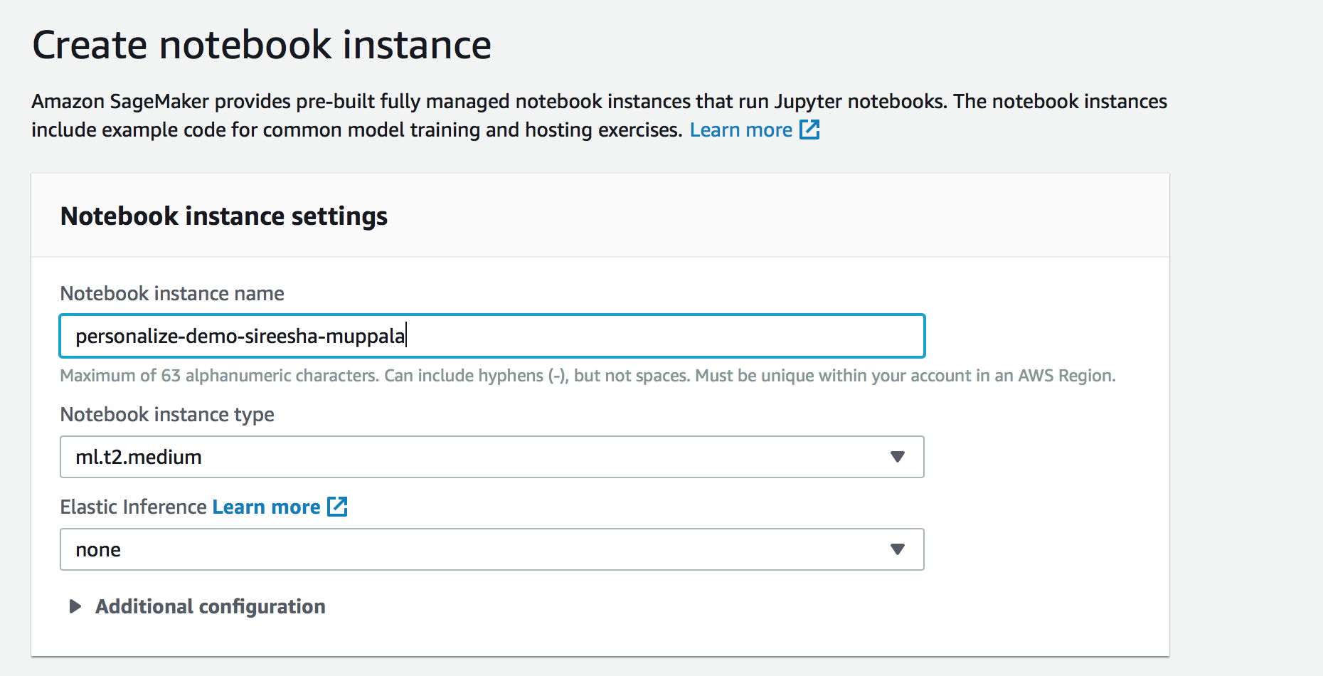

In “Permissions and Encryption” section, for IAM Role, choose “Create a new role” from the dropdown.

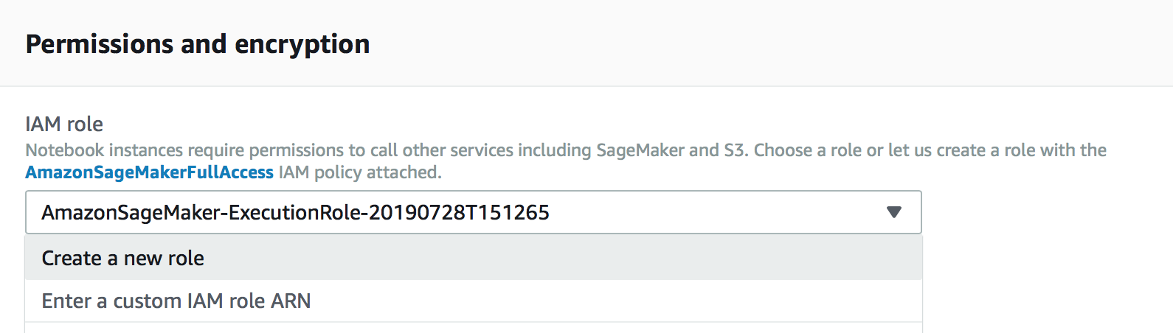

In the “Create an IAM role”, choose ‘Any S3 bucket’ and click ‘Create role’

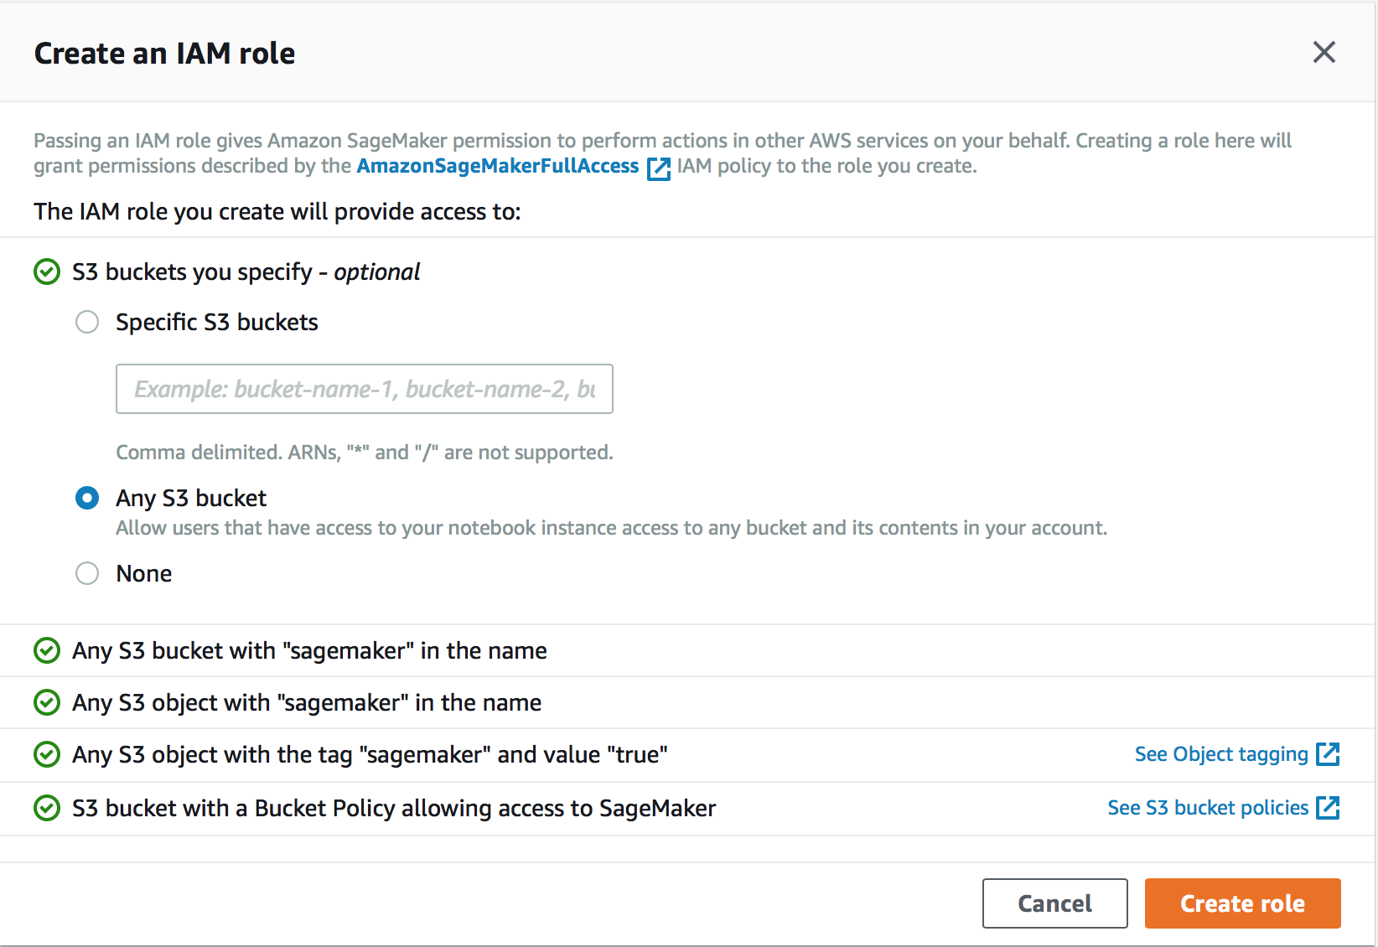

Once the role is created, you will see link to the role. Open the link in a new tab.

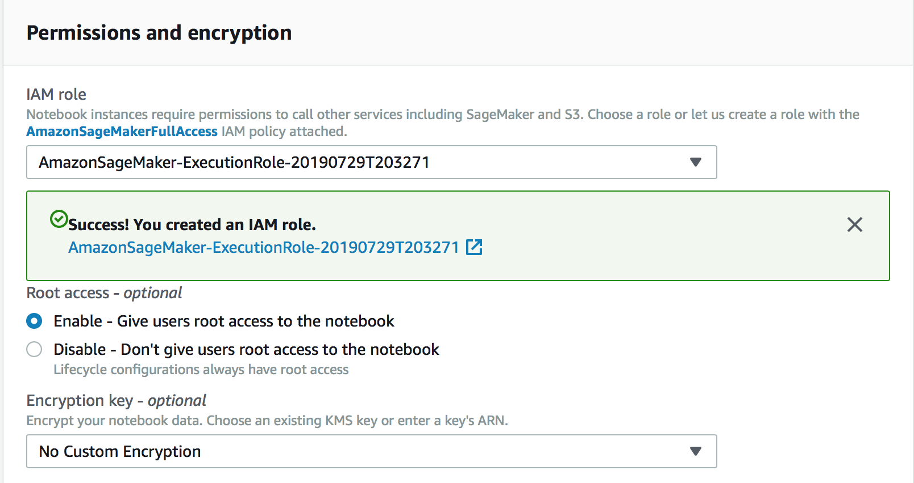

In the “Notebook Instance Settings” screen, click ‘Create notebook instance’.

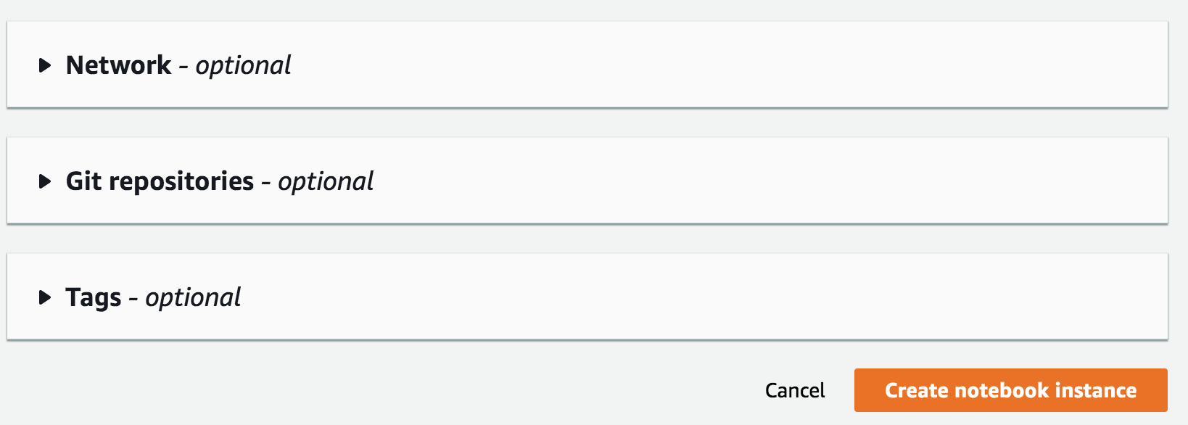

You will see notebook instance creation “In Progress”.

1. While the notebook is being created, attach the IAM policy created in Step 2 to the IAM role created.

Go to the tab with the IAM Role opened, click ‘Attach Policies’

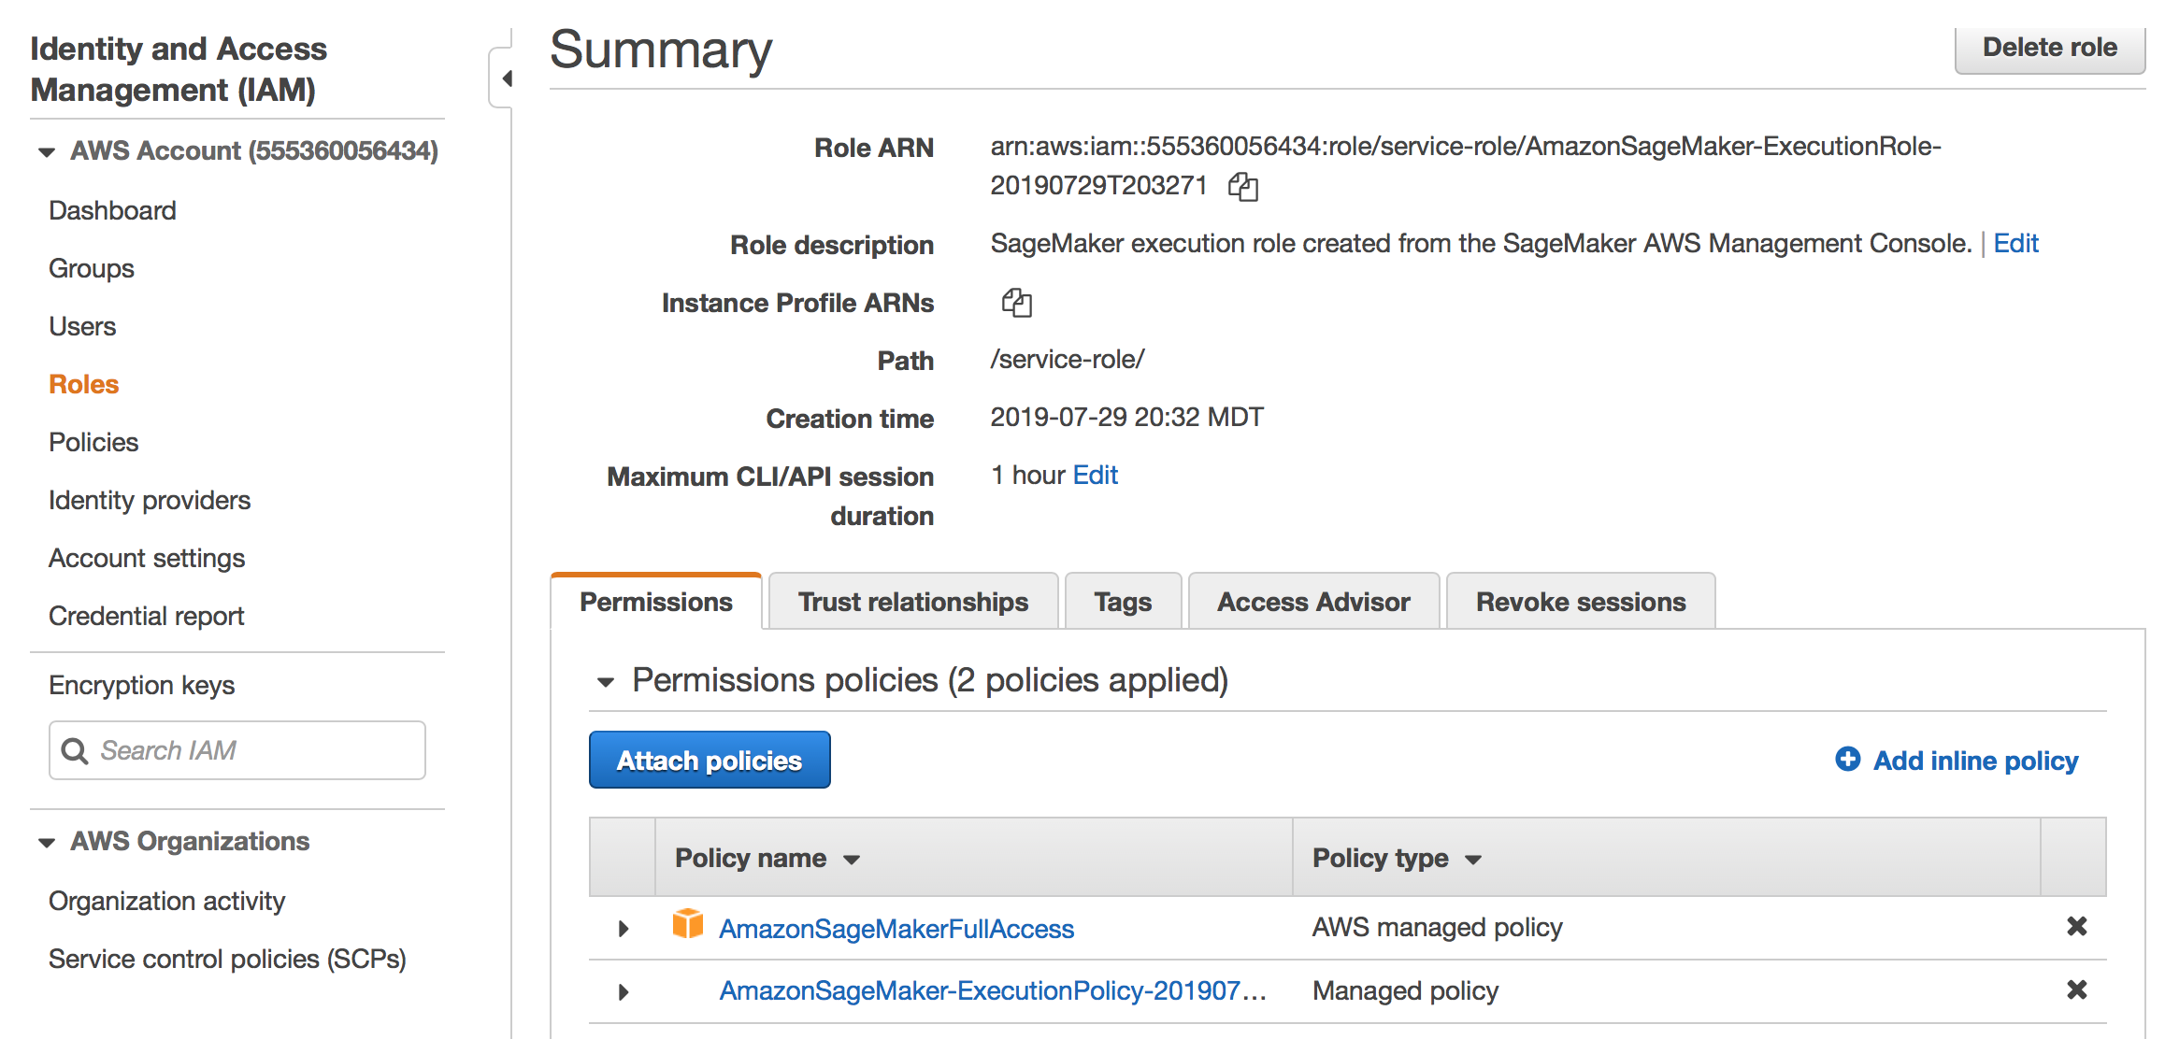

Search for the policy name, select the right policy and click ‘Attach Policy’

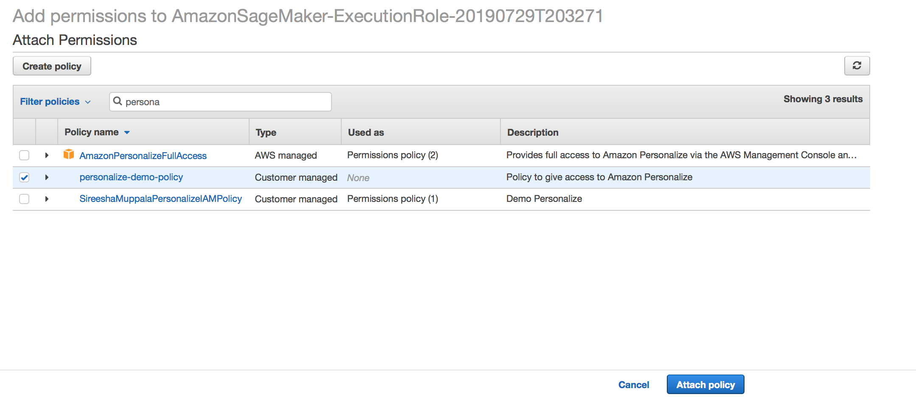

1. Back in the Amazon SageMaker Notebook dashboard, verify that the notebook instance has been created. This process will take 5-10 minutes to complete. Once the status says InService you are ready to continue to the next session.

