# WHITE

## [~~A00 Saragossa opening~~](https://www.365chess.com/eco/A00_Saragossa_opening)

|  |  |
| --- | --- |
| **Move number** | **1** |
| **Half move number** | **1** |
| **Starting FEN Position** | **rnbqkbnr/pppppppp/8/8/8/8/PPPPPPPP/RNBQKBNR w KQkq - 0 1** |
| **Ending FEN Position** | **rnbqkbnr/pppppppp/8/8/8/2P5/PP1PPPPP/RNBQKBNR b KQkq - 0 1** |
| **Chess Piece** | **White Pawn** |
| **Starting Square** | **C2** |
| **Ending Square** | **C3** |

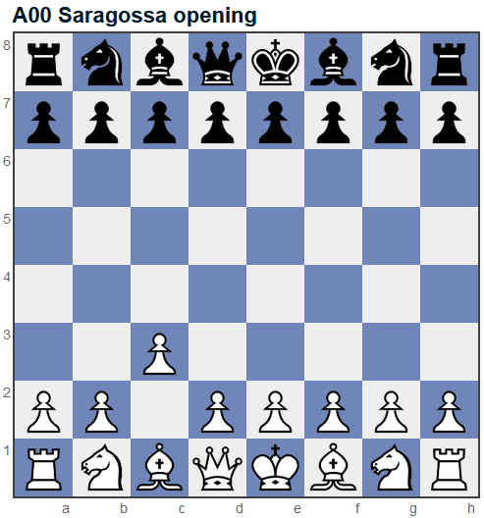

## [A00 Benko's opening](https://www.365chess.com/eco/A00_Benko's_opening)

|  |  |
| --- | --- |
| **Move number** | **1** |
| **Half move number** | **1** |
| **Starting FEN Position** | **rnbqkbnr/pppppppp/8/8/8/8/PPPPPPPP/RNBQKBNR w KQkq - 0 1** |
| **Ending FEN Position** | **rnbqkbnr/pppppppp/8/8/8/6P1/PPPPPP1P/RNBQKBNR b KQkq - 0 1** |
| **Chess Piece** | **White Pawn** |
| **Starting Square** | **G2** |
| **Ending Square** | **G3** |

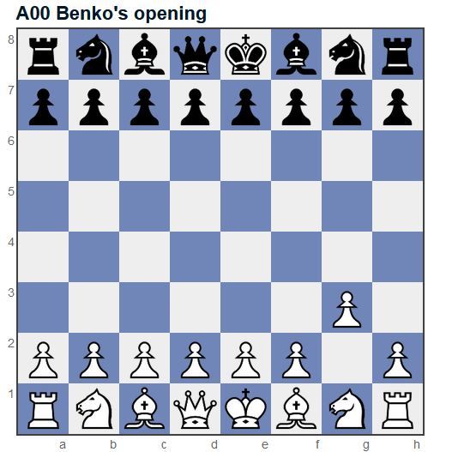

## [A04 Reti opening](https://www.365chess.com/eco/A04_Reti_opening)

|  |  |
| --- | --- |
| **Move number** | **1** |
| **Half move number** | **1** |
| **Starting FEN Position** | **rnbqkbnr/pppppppp/8/8/8/8/PPPPPPPP/RNBQKBNR w KQkq - 0 1** |
| **Ending FEN Position** | **rnbqkbnr/pppppppp/8/8/8/5N2/PPPPPPPP/RNBQKB1R b KQkq - 1 1** |
| **Chess Piece** | **White Knight** |
| **Starting Square** | **G1** |
| **Ending Square** | **F3** |

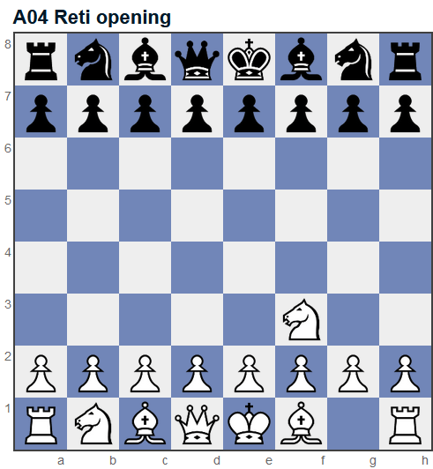

## [A10 English opening](https://www.365chess.com/eco/A10_English_opening)

|  |  |
| --- | --- |
| **Move number** | **1** |
| **Half move number** | **1** |
| **Starting FEN Position** | **rnbqkbnr/pppppppp/8/8/8/8/PPPPPPPP/RNBQKBNR w KQkq - 0 1** |
| **Ending FEN Position** | **rnbqkbnr/pppppppp/8/8/2P5/8/PP1PPPPP/RNBQKBNR b KQkq c3 0 1** |
| **Chess Piece** | **White Pawn** |
| **Starting Square** | **C2** |
| **Ending Square** | **C4** |

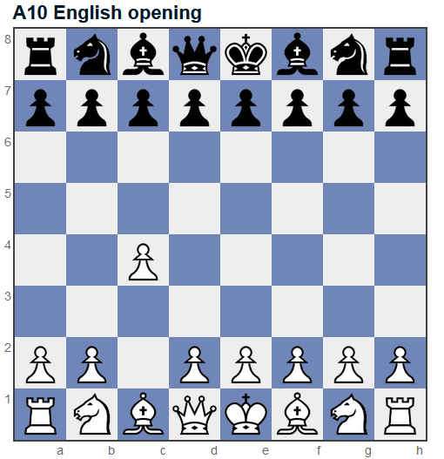

## [A40 Queen's pawn](https://www.365chess.com/eco/A40_Queen's_pawn)

|  |  |
| --- | --- |
| **Move number** | **1** |
| **Half move number** | **1** |
| **Starting FEN Position** | **rnbqkbnr/pppppppp/8/8/8/8/PPPPPPPP/RNBQKBNR w KQkq - 0 1** |
| **Ending FEN Position** | **rnbqkbnr/pppppppp/8/8/3P4/8/PPP1PPPP/RNBQKBNR b KQkq d3 0 1** |
| **Chess Piece** | **White Pawn** |
| **Starting Square** | **D2** |
| **Ending Square** | **D4** |

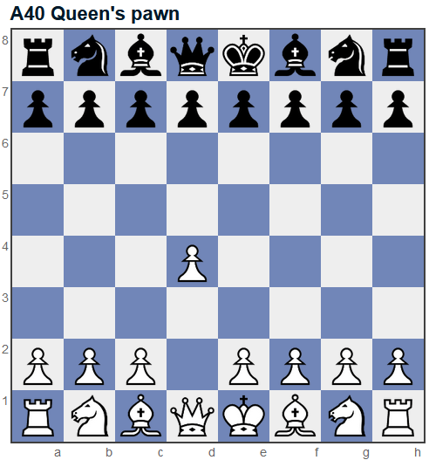

## [B00 King's pawn opening](https://www.365chess.com/eco/B00_King's_pawn_opening)

|  |  |
| --- | --- |
| **Move number** | **1** |
| **Half move number** | **1** |
| **Starting FEN Position** | **rnbqkbnr/pppppppp/8/8/8/8/PPPPPPPP/RNBQKBNR w KQkq - 0 1** |
| **Ending FEN Position** | **rrnbqkbnr/pppppppp/8/8/4P3/8/PPPP1PPP/RNBQKBNR b KQkq e3 0 1** |
| **Chess Piece** | **White Pawn** |
| **Starting Square** | **E2** |
| **Ending Square** | **E4** |

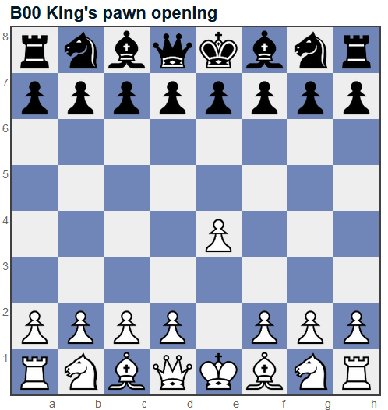

## [B00 King's pawn opening](https://www.365chess.com/eco/B00_King's_pawn_opening)

|  |  |
| --- | --- |
| **Move number** | **2** |
| **Half move number** | **3** |
| **Starting FEN Position** | **rnbqkbnr/ppp1pppp/3p4/8/4P3/8/PPPP1PPP/RNBQKBNR w KQkq - 0 2** |
| **Ending FEN Position** | **rnbqkbnr/ppp1pppp/3p4/8/3PP3/8/PPP2PPP/RNBQKBNR b KQkq d3 0 2** |
| **Chess Piece** | **White Pawn** |
| **Starting Square** | **D2** |
| **Ending Square** | **D4** |

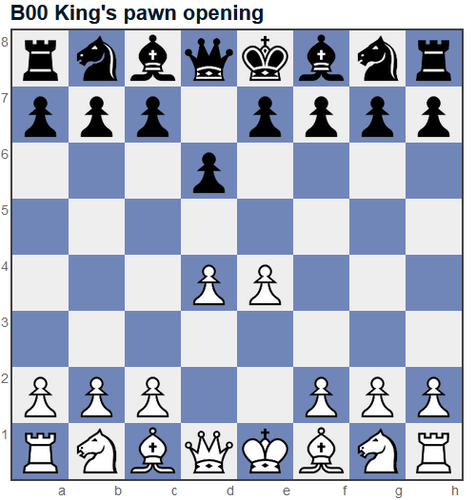

## [B07 Pirc defence](https://www.365chess.com/eco/B07_Pirc_defence)

|  |  |
| --- | --- |
| **Move number** | **3** |
| **Half move number** | **5** |
| **Starting FEN Position** | **rnbqkb1r/ppp1pppp/3p1n2/8/3PP3/8/PPP2PPP/RNBQKBNR w KQkq - 1 3** |
| **Ending FEN Position** | **rnbqkb1r/ppp1pppp/3p1n2/8/3PP3/2N5/PPP2PPP/R1BQKBNR b KQkq - 2 3** |
| **Chess Piece** | **White Knight** |
| **Starting Square** | **B1** |
| **Ending Square** | **C3** |

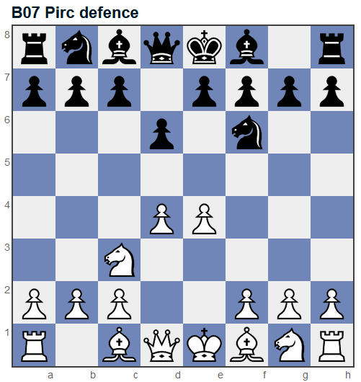

## [C20 King's pawn game](https://www.365chess.com/eco/C20_King's_pawn_game)

|  |  |
| --- | --- |
| **Move number** | **2** |
| **Half move number** | **3** |
| **Starting FEN Position** | **rnbqkbnr/pppp1ppp/8/4p3/4P3/8/PPPP1PPP/RNBQKBNR w KQkq e6 0 2** |
| **Ending FEN Position** | **rnbqkbnr/pppp1ppp/8/4p3/3PP3/8/PPP2PPP/RNBQKBNR b KQkq d3 0 2** |
| **Chess Piece** | **White Pawn** |
| **Starting Square** | **D2** |
| **Ending Square** | **D4** |

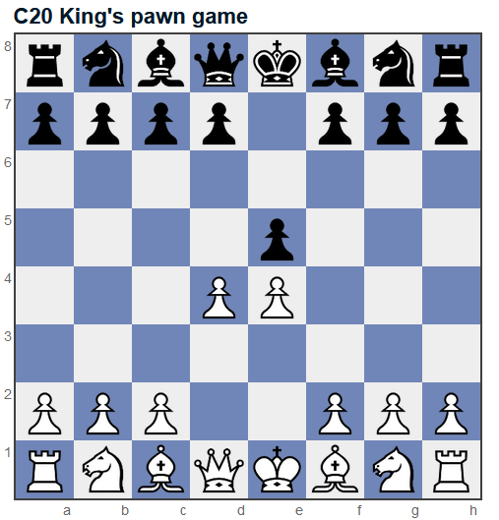

## [C21 Danish gambit](https://www.365chess.com/eco/C21_Danish_gambit)

|  |  |
| --- | --- |
| **Move number** | **3** |
| **Half move number** | **5** |
| **Starting FEN Position** | **rnbqkbnr/pppp1ppp/8/8/3pP3/8/PPP2PPP/RNBQKBNR w KQkq - 0 3** |
| **Ending FEN Position** | **rnbqkbnr/pppp1ppp/8/8/3pP3/2P5/PP3PPP/RNBQKBNR b KQkq - 0 3** |
| **Chess Piece** | **White Pawn** |
| **Starting Square** | **C2** |
| **Ending Square** | **C3** |

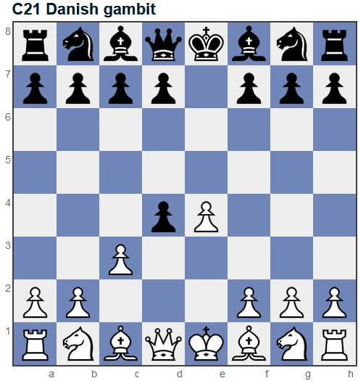

## [C23 Bishop's opening](https://www.365chess.com/eco/C23_Bishop's_opening)

|  |  |
| --- | --- |
| **Move number** | **2** |
| **Half move number** | **3** |
| **Starting FEN Position** | **rnbqkbnr/pppp1ppp/8/4p3/4P3/8/PPPP1PPP/RNBQKBNR w KQkq e6 0 2** |
| **Ending FEN Position** | **rnbqkbnr/pppp1ppp/8/4p3/2B1P3/8/PPPP1PPP/RNBQK1NR b KQkq - 1 2** |
| **Chess Piece** | **White Bishop** |
| **Starting Square** | **F1** |
| **Ending Square** | **C4** |

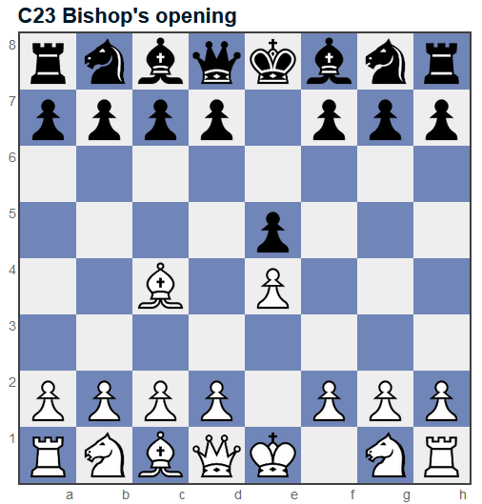

## [C23 Bishop's opening](https://www.365chess.com/eco/C23_Bishop's_opening)

|  |  |
| --- | --- |
| **Move number** | **3** |
| **Half move number** | **5** |
| **Starting FEN Position** | **r1bqkbnr/pppp1ppp/2n5/4p3/2B1P3/8/PPPP1PPP/RNBQK1NR w KQkq - 2 3** |
| **Ending FEN Position** | **r1bqkbnr/pppp1ppp/2n5/4p3/2B1P3/5Q2/PPPP1PPP/RNB1K1NR b KQkq - 3 3** |
| **Chess Piece** | **White Queen** |
| **Starting Square** | **D1** |
| **Ending Square** | **F3** |

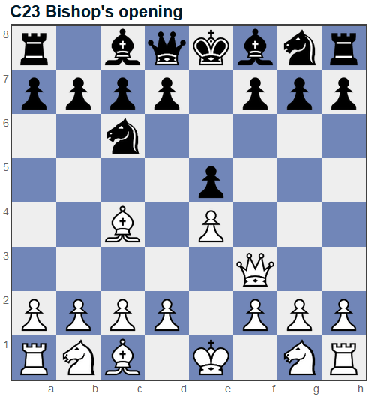

## [C23 Bishop's opening](https://www.365chess.com/eco/C23_Bishop's_opening)

|  |  |
| --- | --- |
| **Move number** | **3** |
| **Half move number** | **5** |
| **Starting FEN Position** | **r1bqkbnr/pppp1ppp/2n5/4p3/2B1P3/8/PPPP1PPP/RNBQK1NR w KQkq - 2 3** |
| **Ending FEN Position** | **r1bqkbnr/pppp1ppp/2n5/4p2Q/2B1P3/8/PPPP1PPP/RNB1K1NR b KQkq - 3 3** |
| **Chess Piece** | **White Queen** |
| **Starting Square** | **D1** |
| **Ending Square** | **H5** |

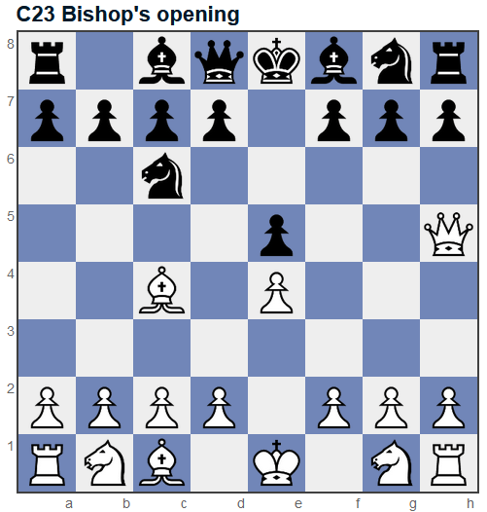

## [C30 King's gambit](https://www.365chess.com/eco/C30_King's_gambit)

|  |  |
| --- | --- |
| **Move number** | **2** |
| **Half move number** | **3** |
| **Starting FEN Position** | **rnbqkbnr/pppp1ppp/8/4p3/4P3/8/PPPP1PPP/RNBQKBNR w KQkq e6 0 2** |
| **Ending FEN Position** | **rnbqkbnr/pppp1ppp/8/4p3/4PP2/8/PPPP2PP/RNBQKBNR b KQkq f3 0 2** |
| **Chess Piece** | **White Pawn** |
| **Starting Square** | **F2** |
| **Ending Square** | **F4** |

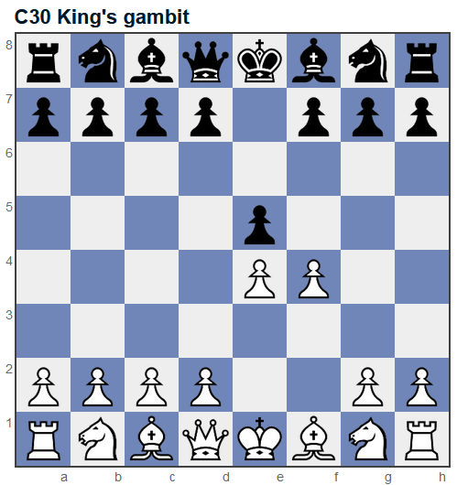

## [C33 King's gambit accepted](https://www.365chess.com/eco/C33_King's_gambit_accepted)

|  |  |
| --- | --- |
| **Move number** | **3** |
| **Half move number** | **5** |
| **Starting FEN Position** | **rnbqkbnr/pppp1ppp/8/8/4Pp2/8/PPPP2PP/RNBQKBNR w KQkq - 0 3** |
| **Ending FEN Position** | **rnbqkbnr/pppp1ppp/8/8/4Pp2/3P4/PPP3PP/RNBQKBNR b KQkq - 0 3** |
| **Chess Piece** | **White Pawn** |
| **Starting Square** | **D2** |
| **Ending Square** | **D3** |

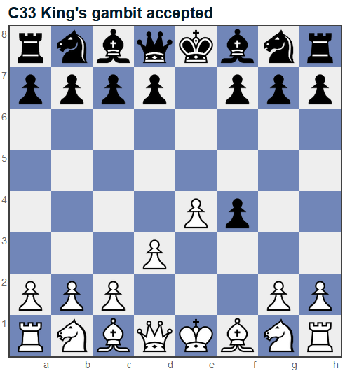

## [C40 King's knight opening](https://www.365chess.com/eco/C40_King's_knight_opening)

|  |  |
| --- | --- |
| **Move number** | **2** |
| **Half move number** | **3** |
| **Starting FEN Position** | **rnbqkbnr/pppp1ppp/8/4p3/4P3/8/PPPP1PPP/RNBQKBNR w KQkq e6 0 2** |
| **Ending FEN Position** | **rnbqkbnr/pppp1ppp/8/4p3/4P3/5N2/PPPP1PPP/RNBQKB1R b KQkq - 1 2** |
| **Chess Piece** | **White Knight** |
| **Starting Square** | **G1** |
| **Ending Square** | **F3** |

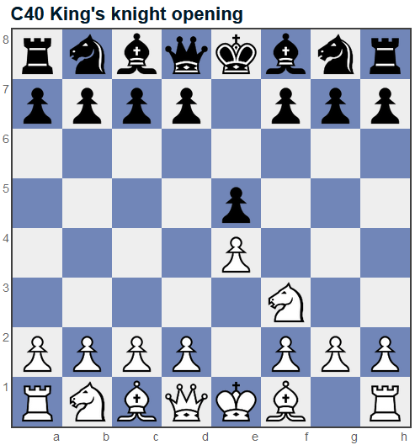

## [C50 Italian Game](https://www.365chess.com/eco/C50_Italian_Game)

|  |  |
| --- | --- |
| **Move number** | **3** |
| **Half move number** | **5** |
| **Starting FEN Position** | **r1bqkbnr/pppp1ppp/2n5/4p3/4P3/5N2/PPPP1PPP/RNBQKB1R w KQkq - 2 3** |
| **Ending FEN Position** | **r1bqkbnr/pppp1ppp/2n5/4p3/2B1P3/5N2/PPPP1PPP/RNBQK2R b KQkq - 3 3** |
| **Chess Piece** | **White Bishop** |
| **Starting Square** | **F1** |
| **Ending Square** | **C4** |

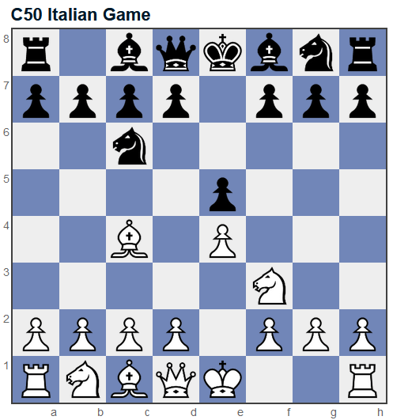

## [C60 Ruy Lopez (Spanish opening)](https://www.365chess.com/eco/C60_Ruy_Lopez_(Spanish_opening))

|  |  |
| --- | --- |
| **Move number** | **3** |
| **Half move number** | **5** |
| **Starting FEN Position** | **r1bqkbnr/pppp1ppp/2n5/4p3/4P3/5N2/PPPP1PPP/RNBQKB1R w KQkq - 2 3** |
| **Ending FEN Position** | **r1bqkbnr/pppp1ppp/2n5/1B2p3/4P3/5N2/PPPP1PPP/RNBQK2R b KQkq - 3 3** |
| **Chess Piece** | **White Bishop** |
| **Starting Square** | **F1** |
| **Ending Square** | **B5** |

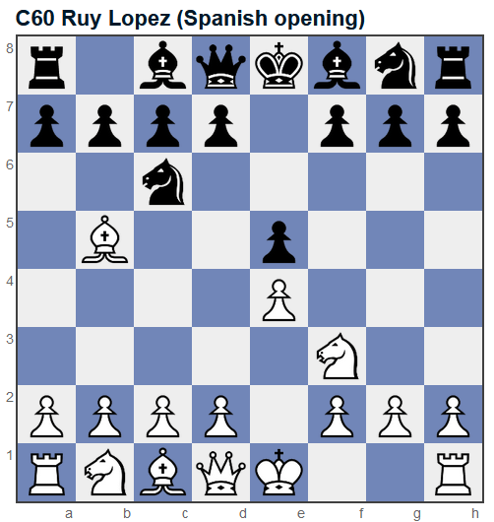

## [D00 Queen's pawn, Mason variation](https://www.365chess.com/eco/D00_Queen's_pawn_Mason_variation)

|  |  |
| --- | --- |
| **Move number** | **2** |
| **Half move number** | **3** |
| **Starting FEN Position** | **rnbqkbnr/ppp1pppp/8/3p4/3P4/8/PPP1PPPP/RNBQKBNR w KQkq d6 0 2** |
| **Ending FEN Position** | **rnbqkbnr/ppp1pppp/8/3p4/3P1B2/8/PPP1PPPP/RN1QKBNR b KQkq - 1 2** |
| **Chess Piece** | **White Bishop** |
| **Starting Square** | **C1** |
| **Ending Square** | **F4** |

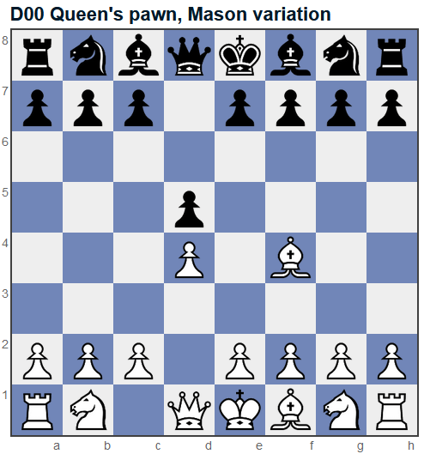

## [D02 London System](https://www.365chess.com/eco/D02_London_System)

|  |  |
| --- | --- |
| **Move number** | **3** |
| **Half move number** | **5** |
| **Starting FEN Position** | **rnbqkb1r/ppp1pppp/5n2/3p4/3P1B2/8/PPP1PPPP/RN1QKBNR w KQkq - 2 3** |
| **Ending FEN Position** | **rnbqkb1r/ppp1pppp/5n2/3p4/3P1B2/5N2/PPP1PPPP/RN1QKB1R b KQkq - 3 3** |
| **Chess Piece** | **White Knight** |
| **Starting Square** | **G1** |
| **Ending Square** | **F3** |

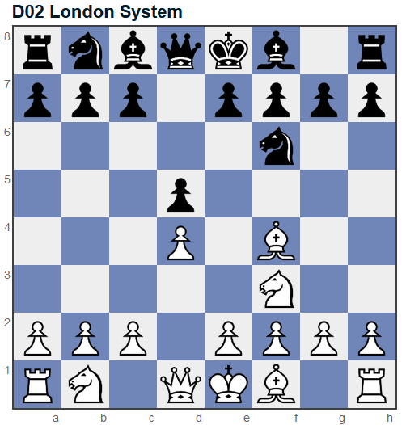

## [D06 Queen's Gambit](https://www.365chess.com/eco/D06_Queen's_Gambit)

|  |  |
| --- | --- |
| **Move number** | **2** |
| **Half move number** | **3** |
| **Starting FEN Position** | **rnbqkbnr/ppp1pppp/8/3p4/3P4/8/PPP1PPPP/RNBQKBNR w KQkq d6 0 2** |
| **Ending FEN Position** | **rnbqkbnr/ppp1pppp/8/3p4/2PP4/8/PP2PPPP/RNBQKBNR b KQkq c3 0 2** |
| **Chess Piece** | **White Pawn** |
| **Starting Square** | **C2** |
| **Ending Square** | **C4** |

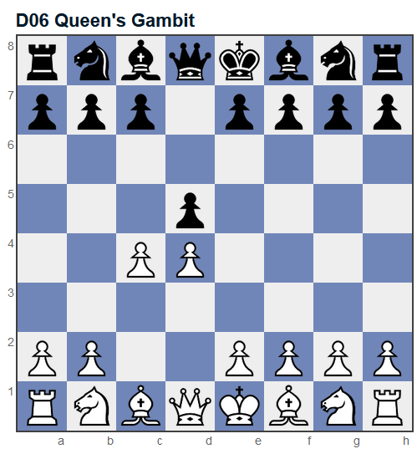

## [D20 Queen's gambit accepted](https://www.365chess.com/eco/D20_Queen's_gambit_accepted)

|  |  |
| --- | --- |
| **Move number** | **3** |
| **Half move number** | **5** |
| **Starting FEN Position** | **rnbqkbnr/ppp1pppp/8/8/2pP4/8/PP2PPPP/RNBQKBNR w KQkq - 0 3** |
| **Ending FEN Position** | **rnbqkbnr/ppp1pppp/8/8/2pP4/4P3/PP3PPP/RNBQKBNR b KQkq - 0 3** |
| **Chess Piece** | **White Pawn** |
| **Starting Square** | **E2** |
| **Ending Square** | **E3** |

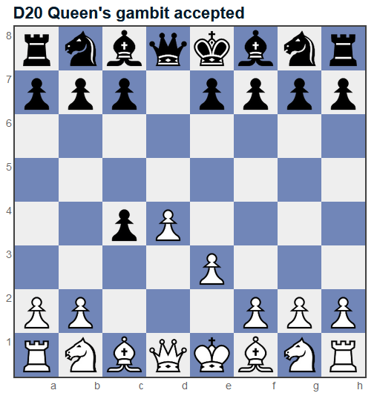

# BLACK

## [A04 Reti opening](https://www.365chess.com/eco/A04_Reti_opening)

|  |  |
| --- | --- |
| **Move number** | **1** |
| **Half move number** | **2** |
| **Starting FEN Position** | **rnbqkbnr/pppppppp/8/8/8/5N2/PPPPPPPP/RNBQKB1R b KQkq - 1 1** |
| **Ending FEN Position** | **rnbqkbnr/pppp1ppp/8/4p3/8/5N2/PPPPPPPP/RNBQKB1R w KQkq e6 0 2** |
| **Chess Piece** | **Black Pawn** |
| **Starting Square** | **E7** |
| **Ending Square** | **E5** |

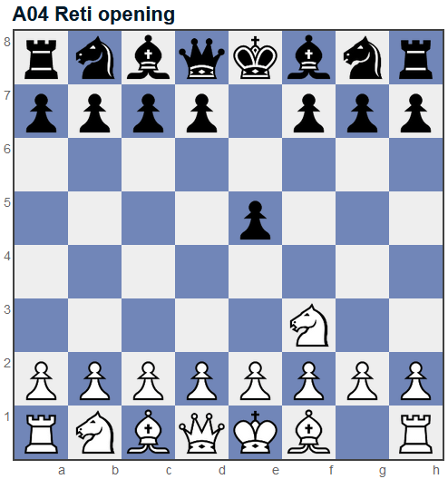

## [A05 Reti opening](https://www.365chess.com/eco/A05_Reti_opening)

|  |  |
| --- | --- |
| **Move number** | **1** |
| **Half move number** | **2** |
| **Starting FEN Position** | **rnbqkbnr/pppppppp/8/8/8/5N2/PPPPPPPP/RNBQKB1R b KQkq - 1 1** |
| **Ending FEN Position** | **rnbqkb1r/pppppppp/5n2/8/8/5N2/PPPPPPPP/RNBQKB1R w KQkq - 2 2** |
| **Chess Piece** | **Black Knight** |
| **Starting Square** | **G8** |
| **Ending Square** | **F6** |

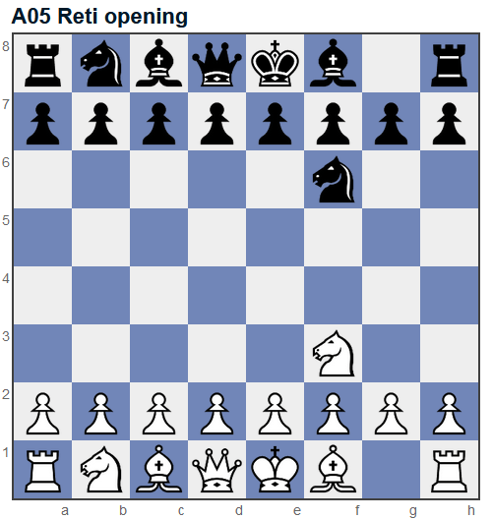

## [A20 English opening](https://www.365chess.com/eco/A20_English_opening)

|  |  |
| --- | --- |
| **Move number** | **1** |
| **Half move number** | **2** |
| **Starting FEN Position** | **rnbqkbnr/pppppppp/8/8/2P5/8/PP1PPPPP/RNBQKBNR b KQkq c3 0 1** |
| **Ending FEN Position** | **rnbqkbnr/pppp1ppp/8/4p3/2P5/8/PP1PPPPP/RNBQKBNR w KQkq e6 0 2** |
| **Chess Piece** | **Black Pawn** |
| **Starting Square** | **E7** |
| **Ending Square** | **E5** |

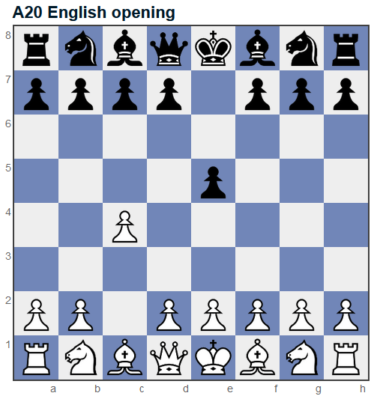

## [A30 English, symmetrical variation](https://www.365chess.com/eco/A30_English_symmetrical_variation)

|  |  |
| --- | --- |
| **Move number** | **1** |
| **Half move number** | **2** |
| **Starting FEN Position** | **rnbqkbnr/pppppppp/8/8/2P5/8/PP1PPPPP/RNBQKBNR b KQkq c3 0 1** |
| **Ending FEN Position** | **rnbqkbnr/pp1ppppp/8/2p5/2P5/8/PP1PPPPP/RNBQKBNR w KQkq c6 0 2** |
| **Chess Piece** | **Black Pawn** |
| **Starting Square** | **C7** |
| **Ending Square** | **C5** |

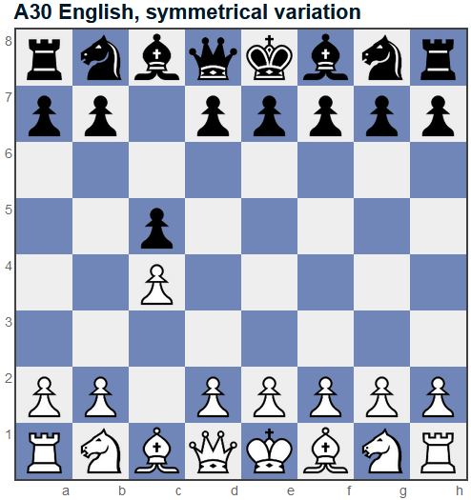

## [A80 Dutch](https://www.365chess.com/eco/A80_Dutch)

|  |  |
| --- | --- |
| **Move number** | **1** |
| **Half move number** | **2** |
| **Starting FEN Position** | **rnbqkbnr/pppppppp/8/8/3P4/8/PPP1PPPP/RNBQKBNR b KQkq d3 0 1** |
| **Ending FEN Position** | **rnbqkbnr/ppppp1pp/8/5p2/3P4/8/PPP1PPPP/RNBQKBNR w KQkq f6 0 2** |
| **Chess Piece** | **Black Pawn** |
| **Starting Square** | **F7** |
| **Ending Square** | **F5** |

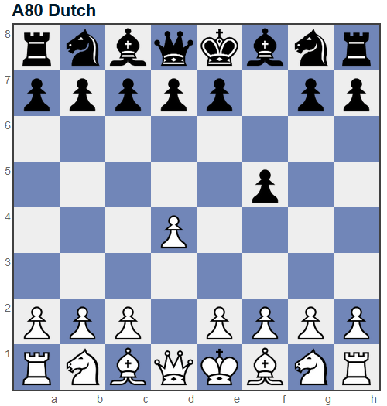

## [B00 King's pawn opening](https://www.365chess.com/eco/B00_King's_pawn_opening)

|  |  |
| --- | --- |
| **Move number** | **1** |
| **Half move number** | **2** |
| **Starting FEN Position** | **rnbqkbnr/pppppppp/8/8/4P3/8/PPPP1PPP/RNBQKBNR b KQkq e3 0 1** |
| **Ending FEN Position** | **rnbqkbnr/ppp1pppp/3p4/8/4P3/8/PPPP1PPP/RNBQKBNR w KQkq - 0 2** |
| **Chess Piece** | **Black Pawn** |
| **Starting Square** | **D7** |
| **Ending Square** | **D6** |

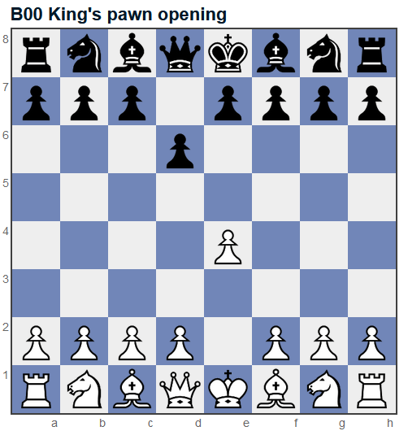

## [B00 King's pawn opening](https://www.365chess.com/eco/B00_King's_pawn_opening)

|  |  |
| --- | --- |
| **Move number** | **2** |
| **Half move number** | **4** |
| **Starting FEN Position** | **rnbqkbnr/ppp1pppp/3p4/8/3PP3/8/PPP2PPP/RNBQKBNR b KQkq d3 0 2** |
| **Ending FEN Position** | **rnbqkb1r/ppp1pppp/3p1n2/8/3PP3/8/PPP2PPP/RNBQKBNR w KQkq - 1 3** |
| **Chess Piece** | **Black Knight** |
| **Starting Square** | **G8** |
| **Ending Square** | **F6** |

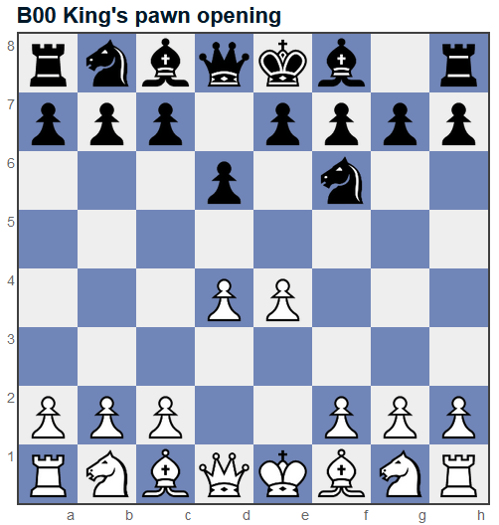

## [B00 KP, Nimzovich defence](https://www.365chess.com/eco/B00_KP_Nimzovich_defence)

|  |  |
| --- | --- |
| **Move number** | **1** |
| **Half move number** | **2** |
| **Starting FEN Position** | **rnbqkbnr/pppppppp/8/8/4P3/8/PPPP1PPP/RNBQKBNR b KQkq e3 0 1** |
| **Ending FEN Position** | **r1bqkbnr/pppppppp/2n5/8/4P3/8/PPPP1PPP/RNBQKBNR w KQkq - 1 2** |
| **Chess Piece** | **Black Knight** |
| **Starting Square** | **B8** |
| **Ending Square** | **C6** |

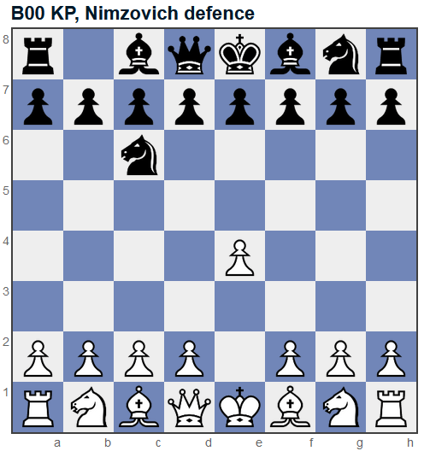

## [B07 Pirc defence](https://www.365chess.com/eco/B07_Pirc_defence)

|  |  |
| --- | --- |
| **Move number** | **3** |
| **Half move number** | **6** |
| **Starting FEN Position** | **rnbqkb1r/ppp1pppp/3p1n2/8/3PP3/2N5/PPP2PPP/R1BQKBNR b KQkq - 2 3** |
| **Ending FEN Position** | **rnbqkb1r/ppp1pp1p/3p1np1/8/3PP3/2N5/PPP2PPP/R1BQKBNR w KQkq - 0 4** |
| **Chess Piece** | **Black Pawn** |
| **Starting Square** | **G7** |
| **Ending Square** | **G6** |

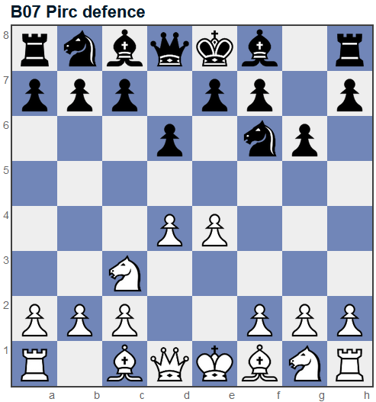

## [B01 Scandinavian (centre counter) defence](https://www.365chess.com/eco/B01_Scandinavian_(centre_counter)_defence)

|  |  |
| --- | --- |
| **Move number** | **1** |
| **Half move number** | **2** |
| **Starting FEN Position** | **rnbqkbnr/pppppppp/8/8/4P3/8/PPPP1PPP/RNBQKBNR b KQkq e3 0 1** |
| **Ending FEN Position** | **rnbqkbnr/pppp1ppp/8/4p3/4P3/8/PPPP1PPP/RNBQKBNR w KQkq e6 0 2** |
| **Chess Piece** | **Black Pawn** |
| **Starting Square** | **E7** |
| **Ending Square** | **E5** |

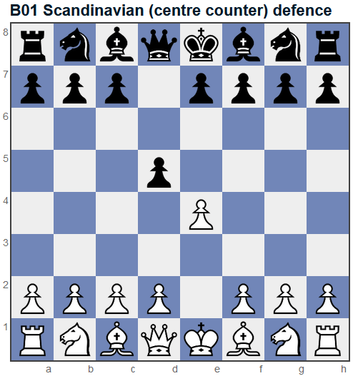

## [B10 Caro-Kann defence](https://www.365chess.com/eco/B10_Caro-Kann_defence)

|  |  |
| --- | --- |
| **Move number** | **1** |
| **Half move number** | **2** |
| **Starting FEN Position** | **rnbqkbnr/pppppppp/8/8/4P3/8/PPPP1PPP/RNBQKBNR b KQkq e3 0 1** |
| **Ending FEN Position** | **rnbqkbnr/pp1ppppp/2p5/8/4P3/8/PPPP1PPP/RNBQKBNR w KQkq - 0 2** |
| **Chess Piece** | **Black Pawn** |
| **Starting Square** | **C7** |
| **Ending Square** | **C6** |

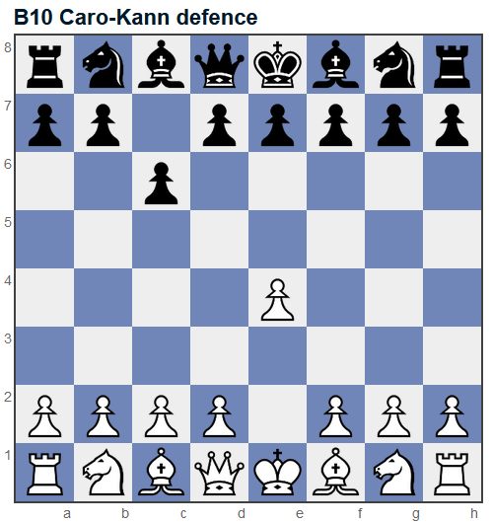

## [B20 Sicilian defence](https://www.365chess.com/eco/B20_Sicilian_defence)

|  |  |
| --- | --- |
| **Move number** | **1** |
| **Half move number** | **2** |
| **Starting FEN Position** | **rnbqkbnr/pppppppp/8/8/4P3/8/PPPP1PPP/RNBQKBNR b KQkq e3 0 1** |
| **Ending FEN Position** | **rnbqkbnr/pp1ppppp/8/2p5/4P3/8/PPPP1PPP/RNBQKBNR w KQkq c6 0 2** |
| **Chess Piece** | **Black Pawn** |
| **Starting Square** | **C7** |
| **Ending Square** | **C5** |

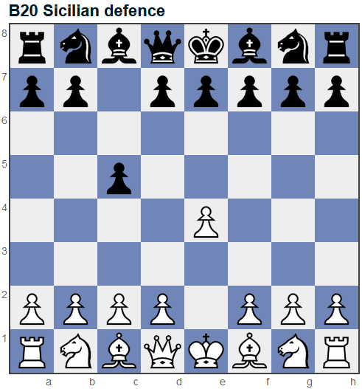

## [C00 French defence](https://www.365chess.com/eco/C00_French_defence)

|  |  |
| --- | --- |
| **Move number** | **1** |
| **Half move number** | **2** |
| **Starting FEN Position** | **rnbqkbnr/pppppppp/8/8/4P3/8/PPPP1PPP/RNBQKBNR b KQkq e3 0 1** |
| **Ending FEN Position** | **rnbqkbnr/pppp1ppp/4p3/8/4P3/8/PPPP1PPP/RNBQKBNR w KQkq - 0 2** |
| **Chess Piece** | **Black Pawn** |
| **Starting Square** | **E7** |
| **Ending Square** | **E6** |

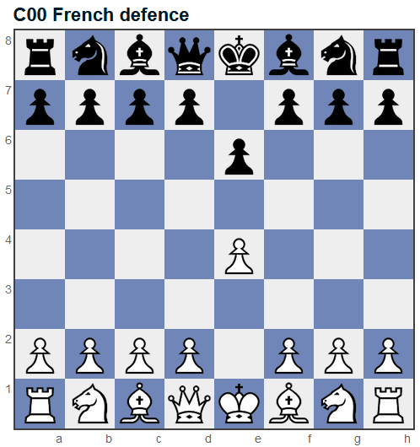

## [C21 Centre game](https://www.365chess.com/eco/C21_Centre_game)

|  |  |
| --- | --- |
| **Move number** | **2** |
| **Half move number** | **4** |
| **Starting FEN Position** | **rnbqkbnr/pppp1ppp/8/4p3/3PP3/8/PPP2PPP/RNBQKBNR b KQkq d3 0 2** |
| **Ending FEN Position** | **rnbqkbnr/pppp1ppp/8/8/3pP3/8/PPP2PPP/RNBQKBNR w KQkq - 0 3** |
| **Chess Piece** | **Black Pawn** |
| **Starting Square** | **E5** |
| **Ending Square** | **D4** |

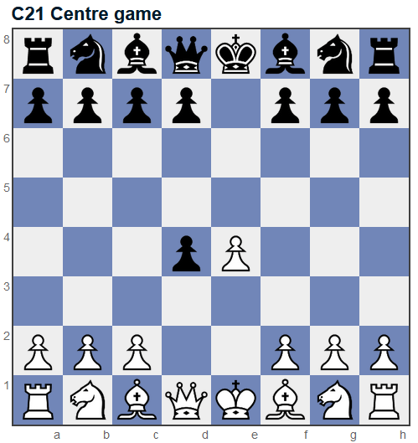

## [C20 King's pawn game](https://www.365chess.com/eco/C20_King's_pawn_game)

|  |  |
| --- | --- |
| **Move number** | **1** |
| **Half move number** | **2** |
| **Starting FEN Position** | **rnbqkbnr/pppppppp/8/8/4P3/8/PPPP1PPP/RNBQKBNR b KQkq e3 0 1** |
| **Ending FEN Position** | **rnbqkbnr/pppp1ppp/8/4p3/4P3/8/PPPP1PPP/RNBQKBNR w KQkq e6 0 2** |
| **Chess Piece** | **Black Pawn** |
| **Starting Square** | **E7** |
| **Ending Square** | **E5** |

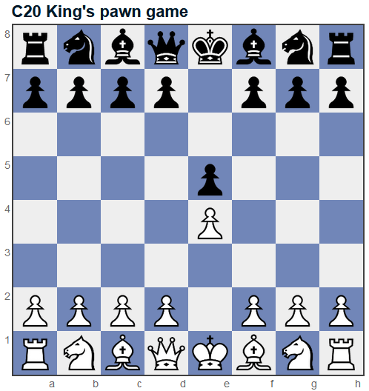

## [C23 Bishop's opening](https://www.365chess.com/eco/C23_Bishop's_opening)

|  |  |
| --- | --- |
| **Move number** | **2** |
| **Half move number** | **4** |
| **Starting FEN Position** | **rnbqkbnr/pppp1ppp/8/4p3/2B1P3/8/PPPP1PPP/RNBQK1NR b KQkq - 1 2** |
| **Ending FEN Position** | **r1bqkbnr/pppp1ppp/2n5/4p3/2B1P3/8/PPPP1PPP/RNBQK1NR w KQkq - 2 3** |
| **Chess Piece** | **Black Knight** |
| **Starting Square** | **B8** |
| **Ending Square** | **C6** |

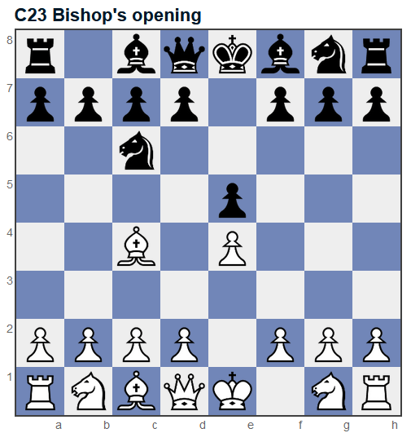

## [C23 Bishop's opening](https://www.365chess.com/eco/C23_Bishop's_opening)

|  |  |
| --- | --- |
| **Move number** | **3** |
| **Half move number** | **6** |
| **Starting FEN Position** | **r1bqkbnr/pppp1ppp/2n5/4p3/2B1P3/5Q2/PPPP1PPP/RNB1K1NR b KQkq - 3 3** |
| **Ending FEN Position** | **r1bqkb1r/pppp1ppp/2n2n2/4p3/2B1P3/5Q2/PPPP1PPP/RNB1K1NR w KQkq - 4 4** |
| **Chess Piece** | **Black Knight** |
| **Starting Square** | **G8** |
| **Ending Square** | **F6** |

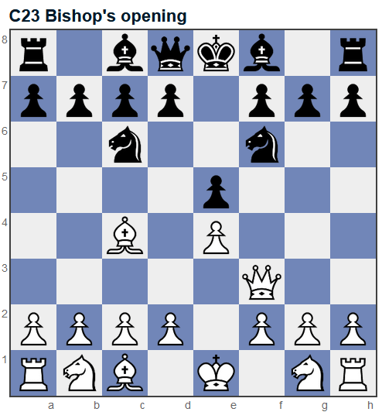

## [C23 Bishop's opening](https://www.365chess.com/eco/C23_Bishop's_opening)

|  |  |
| --- | --- |
| **Move number** | **3** |
| **Half move number** | **6** |
| **Starting FEN Position** | **r1bqkbnr/pppp1ppp/2n5/4p3/2B1P3/5Q2/PPPP1PPP/RNB1K1NR b KQkq - 3 3** |
| **Ending FEN Position** | **r1bqkbnr/pppp2pp/2n2p2/4p3/2B1P3/5Q2/PPPP1PPP/RNB1K1NR w KQkq - 0 4** |
| **Chess Piece** | **Black Pawn** |
| **Starting Square** | **F7** |
| **Ending Square** | **F6** |

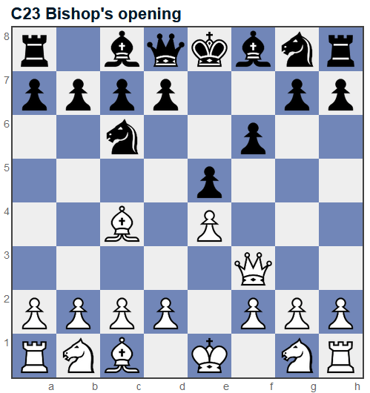

## [C23 Bishop's opening](https://www.365chess.com/eco/C23_Bishop's_opening)

|  |  |
| --- | --- |
| **Move number** | **3** |
| **Half move number** | **6** |
| **Starting FEN Position** | **r1bqkbnr/pppp1ppp/2n5/4p2Q/2B1P3/8/PPPP1PPP/RNB1K1NR b KQkq - 3 3** |
| **Ending FEN Position** | **r1bqkb1r/pppp1ppp/2n2n2/4p2Q/2B1P3/8/PPPP1PPP/RNB1K1NR w KQkq - 4 4** |
| **Chess Piece** | **Black Knight** |
| **Starting Square** | **G8** |
| **Ending Square** | **F6** |

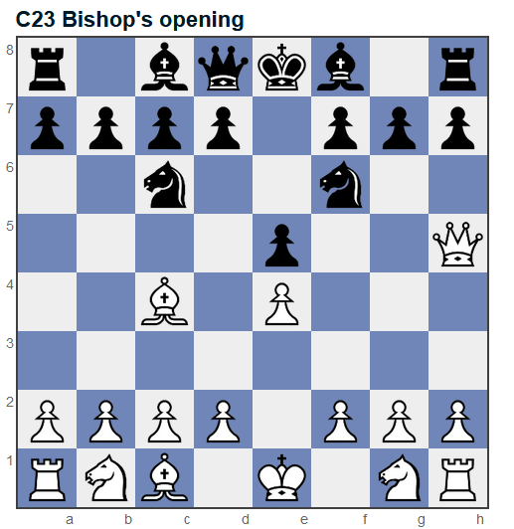

## [C23 Bishop's opening](https://www.365chess.com/eco/C23_Bishop's_opening)

|  |  |
| --- | --- |
| **Move number** | **3** |
| **Half move number** | **6** |
| **Starting FEN Position** | **r1bqkbnr/pppp1ppp/2n5/4p2Q/2B1P3/8/PPPP1PPP/RNB1K1NR b KQkq - 3 3** |
| **Ending FEN Position** | **r1bqkbnr/pppp1p1p/2n3p1/4p2Q/2B1P3/8/PPPP1PPP/RNB1K1NR w KQkq - 0 4** |
| **Chess Piece** | **Black Pawn** |
| **Starting Square** | **G7** |
| **Ending Square** | **G6** |

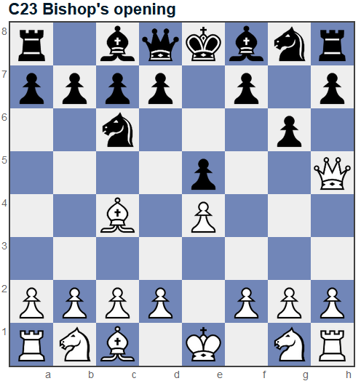

## [C24 Bishop's opening, Berlin defence](https://www.365chess.com/eco/C24_Bishop's_opening_Berlin_defence)

|  |  |
| --- | --- |
| **Move number** | **2** |
| **Half move number** | **4** |
| **Starting FEN Position** | **rnbqkbnr/pppp1ppp/8/4p3/2B1P3/8/PPPP1PPP/RNBQK1NR b KQkq - 1 2** |
| **Ending FEN Position** | **rnbqkb1r/pppp1ppp/5n2/4p3/2B1P3/8/PPPP1PPP/RNBQK1NR w KQkq - 2 3** |
| **Chess Piece** | **Black Knight** |
| **Starting Square** | **G8** |
| **Ending Square** | **F6** |

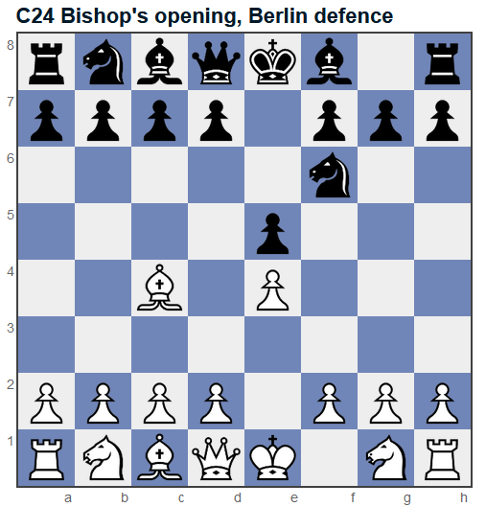

## [C33 King's gambit accepted](https://www.365chess.com/eco/C33_King's_gambit_accepted)

|  |  |
| --- | --- |
| **Move number** | **2** |
| **Half move number** | **4** |
| **Starting FEN Position** | **rnbqkbnr/pppp1ppp/8/4p3/4PP2/8/PPPP2PP/RNBQKBNR b KQkq f3 0 2** |
| **Ending FEN Position** | **rnbqkbnr/pppp1ppp/8/8/4Pp2/8/PPPP2PP/RNBQKBNR w KQkq - 0 3** |
| **Chess Piece** | **Black Pawn** |
| **Starting Square** | **E5** |
| **Ending Square** | **F4** |

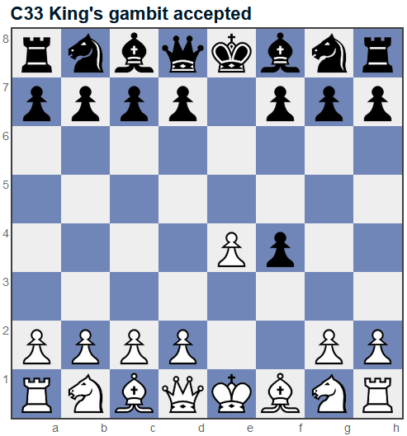

## [C40 Gunderam defence](https://www.365chess.com/eco/C40_Gunderam_defence)

|  |  |
| --- | --- |
| **Move number** | **2** |
| **Half move number** | **4** |
| **Starting FEN Position** | **rnbqkbnr/pppp1ppp/8/4p3/4P3/5N2/PPPP1PPP/RNBQKB1R b KQkq - 1 2** |
| **Ending FEN Position** | **rnb1kbnr/ppppqppp/8/4p3/4P3/5N2/PPPP1PPP/RNBQKB1R w KQkq - 2 3** |
| **Chess Piece** | **Black Queen** |
| **Starting Square** | **D8** |
| **Ending Square** | **E7** |

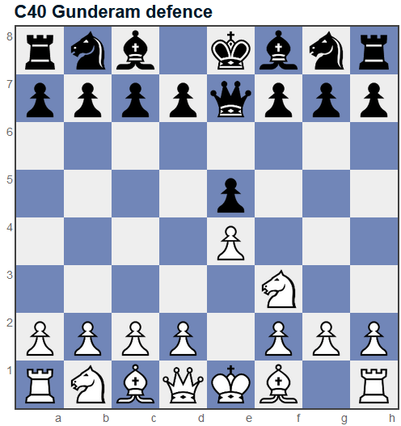

## [C42 Petrov's defence](https://www.365chess.com/eco/C42_Petrov's_defence)

|  |  |
| --- | --- |
| **Move number** | **2** |
| **Half move number** | **4** |
| **Starting FEN Position** | **rnbqkbnr/pppp1ppp/8/4p3/4P3/5N2/PPPP1PPP/RNBQKB1R b KQkq - 1 2** |
| **Ending FEN Position** | **rnbqkb1r/pppp1ppp/5n2/4p3/4P3/5N2/PPPP1PPP/RNBQKB1R w KQkq - 2 3** |
| **Chess Piece** | **Black Knight** |
| **Starting Square** | **G8** |
| **Ending Square** | **F6** |

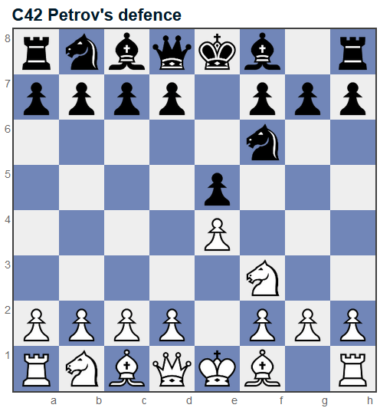

## [C44 King's pawn game](https://www.365chess.com/eco/C44_King's_pawn_game)

|  |  |
| --- | --- |
| **Move number** | **2** |
| **Half move number** | **4** |
| **Starting FEN Position** | **rnbqkbnr/pppp1ppp/8/4p3/4P3/5N2/PPPP1PPP/RNBQKB1R b KQkq - 1 2** |
| **Ending FEN Position** | **r1bqkbnr/pppp1ppp/2n5/4p3/4P3/5N2/PPPP1PPP/RNBQKB1R w KQkq - 2 3** |
| **Chess Piece** | **Black Knight** |
| **Starting Square** | **B8** |
| **Ending Square** | **C6** |

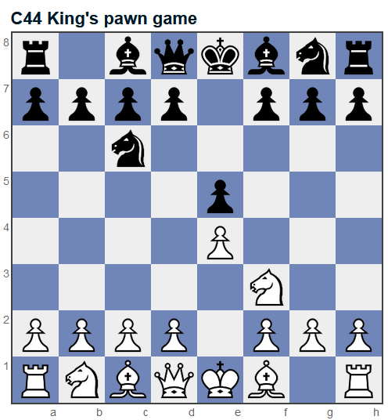

## [C65 Ruy Lopez, Berlin defence](https://www.365chess.com/eco/C65_Ruy_Lopez_Berlin_defence)

|  |  |
| --- | --- |
| **Move number** | **3** |
| **Half move number** | **6** |
| **Starting FEN Position** | **r1bqkbnr/pppp1ppp/2n5/1B2p3/4P3/5N2/PPPP1PPP/RNBQK2R b KQkq - 3 3** |
| **Ending FEN Position** | **r1bqkb1r/pppp1ppp/2n2n2/1B2p3/4P3/5N2/PPPP1PPP/RNBQK2R w KQkq - 4 4** |
| **Chess Piece** | **Black Knight** |
| **Starting Square** | **G8** |
| **Ending Square** | **F6** |

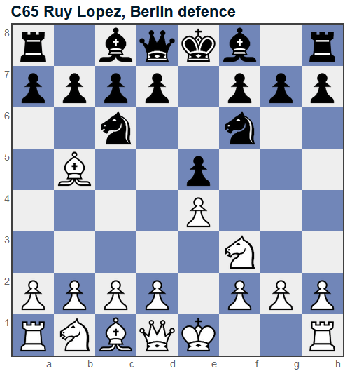

## [D00 Queen's pawn game](https://www.365chess.com/eco/D00_Queen's_pawn_game)

|  |  |
| --- | --- |
| **Move number** | **1** |
| **Half move number** | **2** |
| **Starting FEN Position** | **rnbqkbnr/pppppppp/8/8/3P4/8/PPP1PPPP/RNBQKBNR b KQkq d3 0 1** |
| **Ending FEN Position** | **rnbqkbnr/ppp1pppp/8/3p4/3P4/8/PPP1PPPP/RNBQKBNR w KQkq d6 0 2** |
| **Chess Piece** | **Black Pawn** |
| **Starting Square** | **D7** |
| **Ending Square** | **D5** |

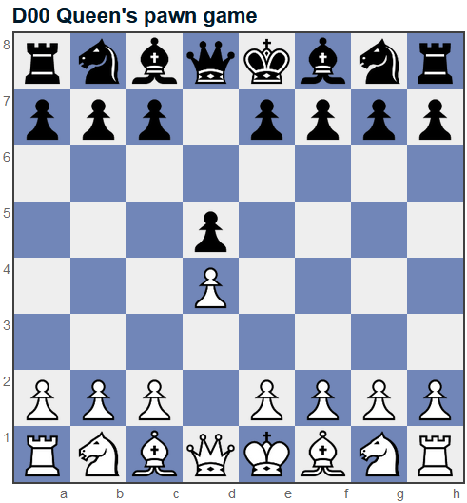

## [D00 Queen's pawn, Mason variation](https://www.365chess.com/eco/D00_Queen's_pawn_Mason_variation)

|  |  |
| --- | --- |
| **Move number** | **2** |
| **Half move number** | **4** |
| **Starting FEN Position** | **rnbqkbnr/ppp1pppp/8/3p4/3P1B2/8/PPP1PPPP/RN1QKBNR b KQkq - 1 2** |
| **Ending FEN Position** | **rnbqkb1r/ppp1pppp/5n2/3p4/3P1B2/8/PPP1PPPP/RN1QKBNR w KQkq - 2 3** |
| **Chess Piece** | **Black Knight** |
| **Starting Square** | **G8** |
| **Ending Square** | **F6** |

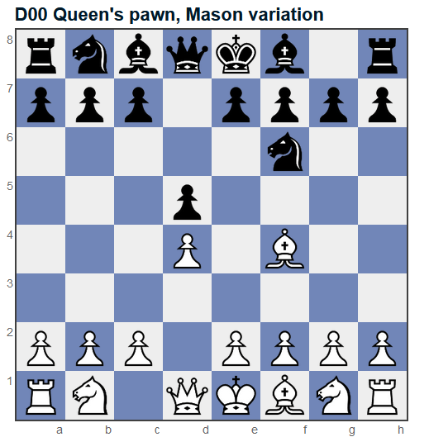

## [D06 Queen's Gambit Declined, Marshall defence](https://www.365chess.com/eco/D06_Queen's_Gambit_Declined_Marshall_defence)

|  |  |
| --- | --- |
| **Move number** | **2** |
| **Half move number** | **4** |
| **Starting FEN Position** | **rnbqkbnr/ppp1pppp/8/3p4/2PP4/8/PP2PPPP/RNBQKBNR b KQkq c3 0 2** |
| **Ending FEN Position** | **rnbqkb1r/ppp1pppp/5n2/3p4/2PP4/8/PP2PPPP/RNBQKBNR w KQkq - 1 3** |
| **Chess Piece** | **Black Knight** |
| **Starting Square** | **G8** |
| **Ending Square** | **F6** |

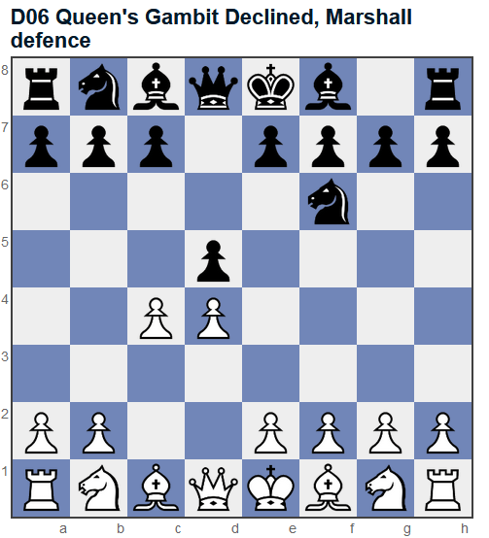

## [D20 Queen's gambit accepted](https://www.365chess.com/eco/D20_Queen's_gambit_accepted)

|  |  |
| --- | --- |
| **Move number** | **2** |
| **Half move number** | **4** |
| **Starting FEN Position** | **rnbqkbnr/ppp1pppp/8/3p4/2PP4/8/PP2PPPP/RNBQKBNR b KQkq c3 0 2** |
| **Ending FEN Position** | **rnbqkbnr/ppp1pppp/8/8/2pP4/8/PP2PPPP/RNBQKBNR w KQkq - 0 3** |
| **Chess Piece** | **Black Pawn** |
| **Starting Square** | **D5** |
| **Ending Square** | **C4** |

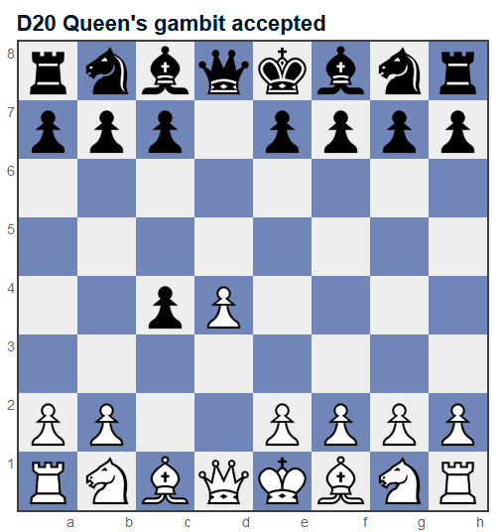

## [D30 Queen's gambit declined](https://www.365chess.com/eco/D30_Queen's_gambit_declined)

|  |  |
| --- | --- |
| **Move number** | **2** |
| **Half move number** | **4** |
| **Starting FEN Position** | **rnbqkbnr/ppp1pppp/8/3p4/2PP4/8/PP2PPPP/RNBQKBNR b KQkq c3 0 2** |
| **Ending FEN Position** | **rnbqkbnr/ppp2ppp/4p3/3p4/2PP4/8/PP2PPPP/RNBQKBNR w KQkq - 0 3** |
| **Chess Piece** | **Black Pawn** |
| **Starting Square** | **E7** |
| **Ending Square** | **E6** |

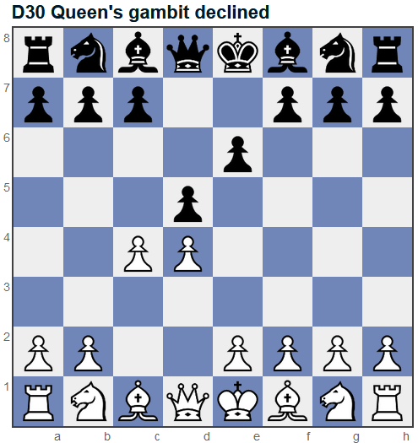

## [D06 Queen's Gambit Declined, Grau (Sahovic) defence](https://www.365chess.com/eco/D06_Queen's_Gambit_Declined_Grau_(Sahovic)_defence)

|  |  |
| --- | --- |
| **Move number** | **2** |
| **Half move number** | **4** |
| **Starting FEN Position** | **rnbqkbnr/ppp1pppp/8/3p4/2PP4/8/PP2PPPP/RNBQKBNR b KQkq c3 0 2** |
| **Ending FEN Position** | **rn1qkbnr/ppp1pppp/8/3p1b2/2PP4/8/PP2PPPP/RNBQKBNR w KQkq - 1 3** |
| **Chess Piece** | **Black Bishop** |
| **Starting Square** | **C8** |
| **Ending Square** | **F5** |

