Truss Project

Final Report

Fall 2020 Engineering Design III

Section B, Group 1

Christopher Kruger, Matthew Tricomi, Christopher Youngclaus

We pledge our honor that we have abided by the Stevens Honor Code.

December 9, 2020

**ABSTRACT**

The Truss Design Project was fundamentally designed to push students to demonstrate their ability as engineering students by requiring groups to create a modeler that would take in information from different iterations of trusses, and output data that proved useful in documenting the design process and understanding the theories at work between each new design. The group picked a simple truss to begin with and built onto each iteration by applying previously known theories including compression vs. tension, simple planar truss theory, load ratios, and geometrical patterns in both real-world and theoretical truss designs. Over the course of several iterations that each introduced small changes to be analyzed, enough information would be provided to the user from the given Truss Designer/Analyzer to determine values such as loads, lengths, and failing members. After plugging said data into a fully-functioning, user-friendly GUI one would be able to easily see the overall weight of each truss as well as stresses, strains, and the associated strength to weight ratios and failure loads. In this report, both the GUI and its associated backend development will be sampled and described from the group’s perspective of their own design process to demonstrate how each set of data translates to each step of the experiment. Conclusive data demonstrates how failing members are determined chiefly by their associated angles and lengths, also that failing members can be strengthened by shortening their lengths, and zero-force members may not necessarily be under tension or compression but may ultimately strengthen the truss and their adjacent members. Performing a real-world experiment through the lens of a simulation allowed the group to refine their skills in Excel, as well as develop better planning and organization skills, and be able to see the big picture before delving into experimentation and analysis.

**Table of Content**

Theory and Introduction……………………………………………………………………….…4

Truss Analyzer and Back End of Modeler………………………………………………………6

Truss GUI………………………………………………………………………………………...8

Iterations…………………………………………………………………………………………10

Reference Table…………………………………………………………………………………16

**Theory and Introduction**

The goal for this final project was to apply what the group learned throughout the semester with both knowledge in Excel as well as knowledge in analyzing trusses. The group learned throughout the semester how to apply formulas, create data sets, graphs, and how to analyze inputs and outputs in Excel through multiple projects building up the final project. Design III in combination with the Mechanics of Solids provides a fundamental understanding of simple planar truss theory. Trigonometry, Pythagorean theorem and Newton’s Third Law in equilibrium are applied directly in the Truss Analyzer. While the user does not physically calculate data with the aforementioned theorems, it is up to the user to validate their data by putting the data in conversation with theory.

Before going into specific equations needed to complete the Truss Modeler, the process in understanding trusses and joints is important to note. Referring to **Figure 1-A**, assume a load is applied at the apex. The first steps are to find equilibrium equations. Summing up forces in the x direction, forces in the y directions, and moments around a point to equal zero lead to the equations . By finding these equations, it helps with finding any unknowns, which may include forces being applied to a member/joint or normal/reactionary forces from a pinned axis. From here, the solver would then find internal forces with standard sign convention indicating either members in tension or compression. Tension members mean the act of each end of the member being conditioned to stretch away from each other while compression members mean the act of each end of the member being pushed together. A similar process is used when finding the internal forces of each member connected to a joint.

The Truss Modeler solves desired outputs from given inputs provided by the Truss Analyzer program.

**Truss Analyzer and Back End of Modeler**

Through the implementation of simple planar truss theory and geometry, the Truss Analyzer runs calculations in the background and provides the user with only relevant information (a reoccurring design decision seen in optimized programs). The Truss Analyzer outputs member lengths, member forces, and names the members arbitrarily with numbers. These data sets are the only inputs that the modeler needs, all calculations are run in the background using known material constants, simple truss-related equations (jpcr and epcr), analysis of outputs, and outside data from real world tests on brass 260. The modeler understands critical length, and chooses between the Johnson’s and Euler’s model for a buckling load. Furthermore, it analyzes whether or not the load is positive or negative and clearly displays if a member is in tension or compression. If the member is in tension, the failing member outputs 385 lbs – this is because tension failing loads are constant and based off of shear (a measurement of change in length/length). For Johnson’s equation a slenderness ratio is calculated which is specific to the member length. It is important to know that the load on the member in the truss analyzer is NOT equal to the failing member load. To calculate the failing member, the modeler uses the loads from the Truss Analyzer and the buckling load. It is from these failing members that we can determine an overall failing load for the truss. The member in compression that fails at the smallest load is the overall failing load because a truss is effectively broken when one member fails. Through member lengths, the modeler calculates volume, density, and truss weight. From truss weight and failing load, the strength to weight is calculated, which is an incredibly important tool for analysis. The strength to weight is effectively an analysis of truss efficiency – the higher the S:W the more efficient the truss is. This metric is important to analyze because one truss design may be able to hold a higher load, but at the cost of weight. Therefore it is possible to have a less efficient truss even if the failing load is greater than other iterations.

Other calculations include information relevant to the real world. Because Epcr and Jpcr are theoretical equations, they are not always accurate for physical models. To combat this inconsistency, the modeler accepts data from an experiment that displays real failing loads at specific member lengths. From this data a trendline can be extrapolated. This trendline can then accept any member length, therefor bridging the gap from Truss Analyzer theory to real world physical trusses.

Additionally, physical trusses must have gussets and joints. In theory joints are infinitely small and infinitely strong. This theory informs the user that bolts must NOT fail. The modeler understands this theory and attempts to estimate a failing load for joints by finding the worst-case scenario (most negative compression force on a member) and multiplying it by a factor of safety. The load that a bolt must take is then used in conjunction with the material property shear strength to determine an effective bolt diameter. This metric is important in the construction of the truss kit by ensuring there is no failure from bolts.

**Truss GUI**

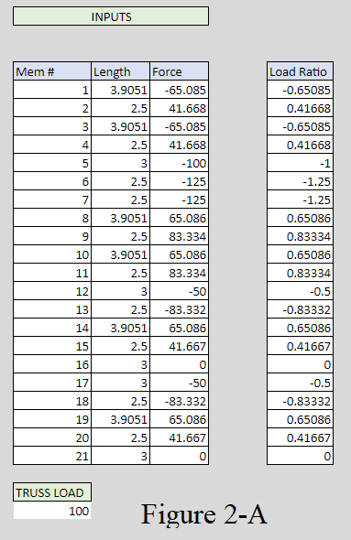The GUI is essentially a simple version of the backend development of our design modeler. Midway through experimentation, the group decided that the current modeler was unorganized and more of a hassle than a help to data analysis. The GUI that was created as a result was directly linked to cells from the initial sheet on Excel, and from there inputs and outputs would go back and forth between the GUI in order to have a proper place to input data and easily visualize the numbers it calculates as a result. **Figure 2-A** shows the input section of the GUI and the user would not actually manually plug-in numbers to each box. The Truss Analyzer provides users with an export option that includes an excel sheet with the data for these columns already printed out, leaving it to be a matter of copy and paste into the GUI. If the inputs are less than the default 21 members, than paste what is needed and drag a gray bar after the last member, all the way to the right then down to cover what is unnecessary. If not enough cells are provided when transferring data from the Truss Analyzer, Excel has a built-in feature that allows a user to select a row of edited cells and drag down as far as needed, creating more cells of the same formatting. For instance, **Figure 2-A** demonstrates 21 members, but should a user need to use 30, one would simply select the bottom row including data for member 21 and drag it down seven cells. This would essentially copy and paste member 21 and automatically set the cells to analyze members 22-30. From there, the backend handles the calculations portion of the GUI. A main reason for hiding these calculations in a second sheet is because of how much the modeler breaks down each equation used to find the product. By breaking all of this down it allows for easier troubleshooting, and the final values that are most significant to the user are displayed cleanly on the right side of the GUI as shown in **Figure 2-B**. The left side of the output section shows the lengths and failure loads for both empirical and theoretical, allowing for easy comparison between the two. The empirical section considers the reduced member length due to the length of the gusset holding the joint in place between members that overlaps the member. The member fail load column signifies the load it would take for a member to fail, and those that are labeled in red are under compression. The lowest absolute value load that is also under compression signifies the likely failing members of the truss. More sections of data are listed to the right (also sorted by theoretical and empirical), and the most important pieces to look at are the ratios at the bottom under ’comparison’ that essentially show the user how efficient or strong the truss is by comparing the theoretical failure load or strength to weight ratio to the empirical version.

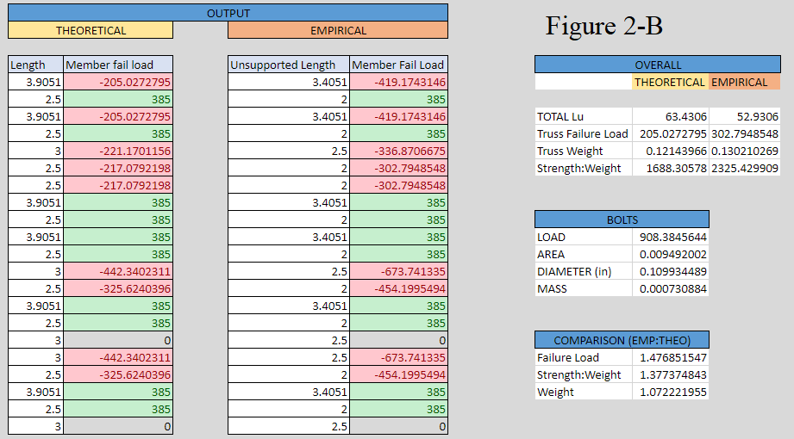

**Iterations**

The group’s first truss design had the intent to prove different theory learned in both Mechanics of Solids as well as Design III. The overall goal was to prove that zero force members (ZFM) can provide stability in a truss by lowering the length of connected members as well as to prove that the change in angles in a truss may help the design for distributing loads. **Figure 3-A** shows the first iteration, starting off with a King Truss. The first iteration had one ZFM and two failing members both in compression at a failing load of 92 lbs. To try and increase the failing load, the group added ZFM to split the failing members which would lower their force load shown in **Figure 3-B**. In this iteration, the truss was turned into a Howe Truss. With this iteration, the strength to weight ratio was increased three times in the empirical truss. The failing load was also increased to 324.5 lbs which is a substantial increase from the 92 lbs. With only the additional weight of two members, this iteration was a complete success compared to the first. **Figure 3-C** shows the third iteration, turning the truss into a scissor truss. With the change in angles on the members in tension, the middle member would turn from a ZFM to a member in tension. The change in angle turned all members into taking a higher load which was unsuccessful. However, the group kept this scissor truss for the new few iterations to see if the group could lower the values again. The strength to weight ratio in the empirical was decreased from a value of 3211 in iteration 2 to a new value of 2696. The failing load was also decreased from a value of 324 lbs to a new value of 260 lbs. **Figure 3-D** shows the fourth iteration with the addition of two ZFM to the original two ZFM. Thinking it would help distribute the load at the apex, the group realized this was useless as the other end was simply connected to a member with no load. This iteration only added weight to the truss with no addition to a strength to weight ratio. The strength to weight ratio was further decreased to a value of 2313 and the failing load stayed the same at 260 lbs. This iteration helped reinforce the idea that ZFM do not act simply to change force distribution, they work to help decrease the load on other members in compression. **Figure 3-E** shows the fifth iteration, having the addition of ZFM to lower the lengths of the two failing compression members. By lowering the length, as explain in previous sections, the load is decreased. The strength to weight ratio in empirical is increased to 2633 from 2313 and the failing load is increased from 260 lbs to 320 lbs. These changes were all beneficial due to the increase of strength in the truss. **Figure 3-F** shows the sixth iteration where the scissor aspect of the truss was removed, bringing the whole truss back parallel to the ground. The parallel tension members on the bottom now replace the middle member with a ZFM and lower the force distribution amongst the whole truss. With this, strength to weight in the empirical truss is improved from 2633 to 3148 with the failing load also increasing from 320 lbs to 400 lbs indicating a full improvement in the truss design. **Figure 3-G** is the seventh and final iteration, marking a complete improvement. All ZFM were removed by removing any parallel members, adding an angle between them. With this change, the strength to weight ratio improved from 3148 to 12033 with an increase in failing load from 400 lbs to 2211 lbs. This change brought a vast improvement in both failing load and strength to weight, with a 2400% increase in failing load compared to the first iteration. These seven iterations proved the use of ZFM and how angles between members can drastically change the load ratio on each member.

The second truss design began as a simple build with the intent of becoming as tall as possible by the final construction while keeping the simple triangular design that the iterations began with. While the main idea was to experiment with truss height and how it affects the strength of the members, the group also looked at the zero force members and what adding or subtracting them from the truss would do to the strength and efficiency of the build as a whole. Looking at **Figure 4-A**, the initial design was a Queen truss, but a rather flat one. The first observation was that the outer members were all equivalent in length and angle from the load, thus they were also equivalent in failure load which was roughly 84 lbs. As a result, **Figure 4-B** demonstrates the addition of two vertical zero force members at the midpoint between the outer members that were previously all equivalent in failure load. The vertical members that were added were attached to a joint already occupied by members, therefore the failing load remained the same and the strength to weight dropped a little bit. While it did not change much, it allowed the group to change the outside of the truss because the initial zero force members that ran from the center of the truss to the midpoint of the outside members becomes a load-bearing member. **Figure 4-C** shows the group beginning to change the height of the truss and only two members are failing now, still at 84 lbs. Also, the middle vertical member became load bearing as well since the change, and out of curiosity the group increased the height to the maximum that the Truss Analyzer allowed, and **Figure 4-D** shows how much longer the topmost members became. Analytically, those two top members on the outside of the truss are the new failing members at about 55 lbs. Unfortunately, the change in height led to a decrease in failure load partially because of the length of those members. The next step was to increase the failing load again, so the group straightened the outer edges, and **Figure 4-E** demonstrates the new shape of the truss. Referring to the outside members, the lower two become the new failing members at about 89 lbs, a major increase from the previous iteration. The back and forth between these two sets of outer members is directly related to the length of the members, seeing how the longer one has always been the first to fail, and also by angle from the applied load. When the truss is straightened, the failure load increases as opposed to angled outside members. **Figure 4-F** shows a big shift in design where the middle of the truss becomes filled with triangles. To boost the failing load once more, zero force members were added to the middle of the triangle and the failure load skyrocketed to roughly 338 lbs. Zero force members do occasionally help with stability and strength of a truss, and while the failure load did increase, the strength to weight ratio between empirical and theoretical decreased from over 2.0 to 1.25. This is mainly because of all the extra weight added onto the truss in the form of zero force members, and since essentially the entire middle of the truss are not load-bearing members the efficiency of the truss plummets. As a last attempt at curiosity, the group makes the bottom of the truss concave and keeps the outer members straight. While the strange shape in **Figure 4-G** may look fun, the efficiency of the truss hits an all-time low for this set of iterations and the failing load decreases to about 127 lbs. While there was obvious improvement in failure load from the first iteration to the last, it came at the cost of the efficiency of the truss. Where more members may have led to higher failure load numbers, the sheer amount of members in the middle of the truss (whether or not they are zero force members) led to a plummet in empirical vs theoretical strength to weight ratio. Another focus of these iterations was tracking the zero force members and by the last iteration there were none left. The shape in **Figure 4-F** shows a lot of flaws in design which led to so many zero force members, but the angles at which the bottom members are changed to force the connecting members to carry some weight, therefore making every member a load-bearing member. Some key takeaways from this portion of the project were that increased truss heights force the members to carry more weight, longer members carry more weight than shorter members at the same angle from the load, and zero force members help with stability at the cost of efficiency.

Truss Design 3 is initially based off of the Pratt Truss design (see **Figure 5-A**)**.** The goal for the first three iterations in this design is to investigate the role of zero force members on truss efficiency and failing member load. From iteration 1 to iteration 2, the zero force members are moved inwards, effectively redistributing the load onto different members. While the member lengths are the same, the process of moving zero force members flips certain members, therefor putting members that were previously in tension, in compression (see **Figure 5-B**)**.** This change increased both the truss failure load and the truss strength to weight. The 3rd iteration moves the zero force member all the way to the middle member **(Figure 5-C).** By having less zero force members, the strength to weight and failing load decreased. It is important to note that for these iterations, the failing member did not change. This is most likely due to the fact that the failing member is based off of angle and load ratio, and while the load ratios did change, the angle did not. There was not enough of an impact on moving these zero force members to change the failing member

Iterations 4 and 5 are focused on changing the number of members in order to investigate what changes in length do to failing members. Furthermore, truss strength to weight is impacted because there is both more material being used in the members and in the physical joints for the truss. **Figure 5-D** showcases adding more member on the outside of the bridge. While adding more members did in fact increase the weight, the reduction of member lengths with consistent truss angles resulted in a greater failing load. **Figure 5-E** applies the same concept but to the entire truss geometry. Unfortunately, this data should be **ignored**. Clearly, this truss is not symmetrical and is the result of a glitch in the Truss Analyzer. It is important to note that the details of the calculations in the Truss Analyzer are **unknown** and mistakes in unorganized modelers can lead to inconsistent data.

Iterations 6 and 7 experiment with truss height. The goal of these iterations is to lower the material whilst keeping the truss angles the same. Iteration 6, is similar to iterations 1,2 and 3, but lowers the height. The truss efficiency does decrease in **Figure 5-F** most likely due to the fact that the member angles change. The failing load also decreases for the same reason. Iteration 7 ( **Figure 5-G)** introduces a convex shape to the bottom of the truss. This is achieved through the adding more members and joints. The addition of members decreases the overall average length of members, and also increases the number of members in tension. Furthermore, ALL buckling loads are modeled through Johnson’s equation.

Overall the 3rd iteration introduces 3 design questions: how do zero force members effect efficiency, how does number of members effect efficiency, and how does height effect members in compression and tension. By analyzing outputs from the modeler the user can clearly answer the above questions.

**REFRENCE TABLE**

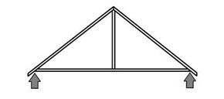FIGURE 1-A

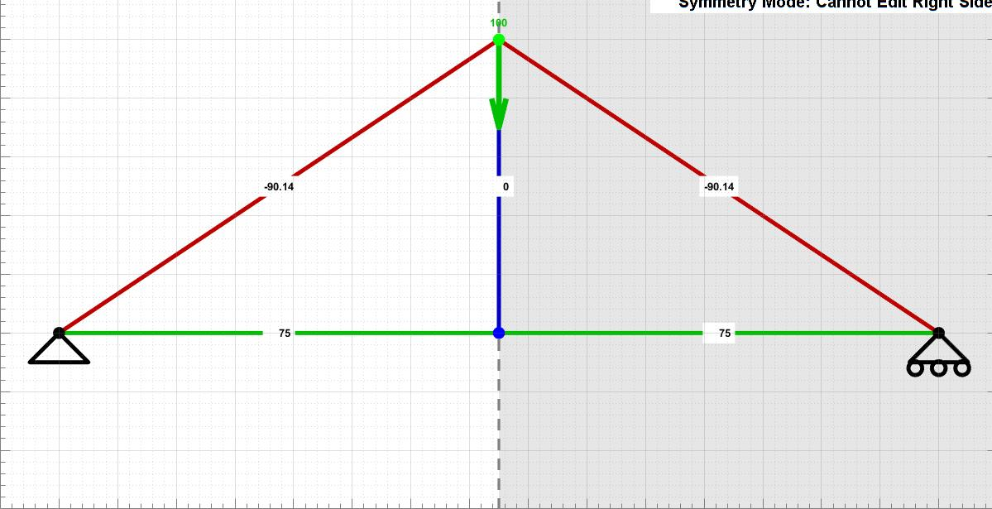Figure 3-A

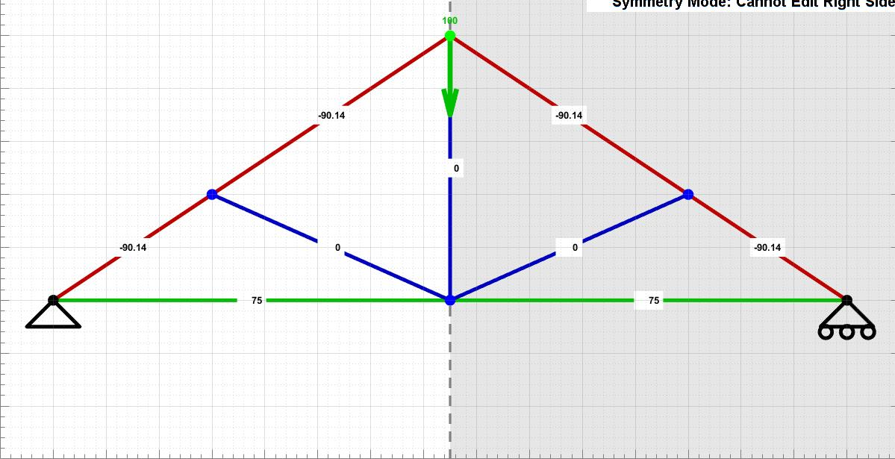Figure 3-B

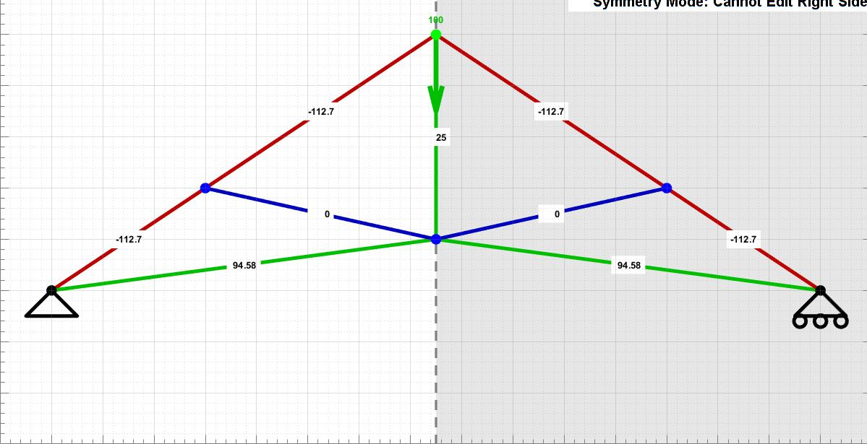Figure 3-C

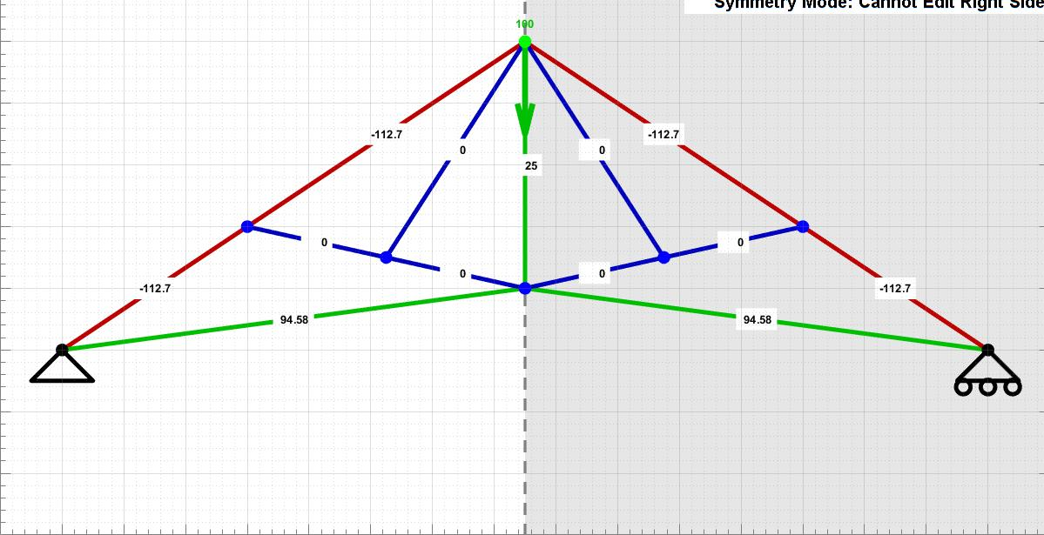Figure 3-D

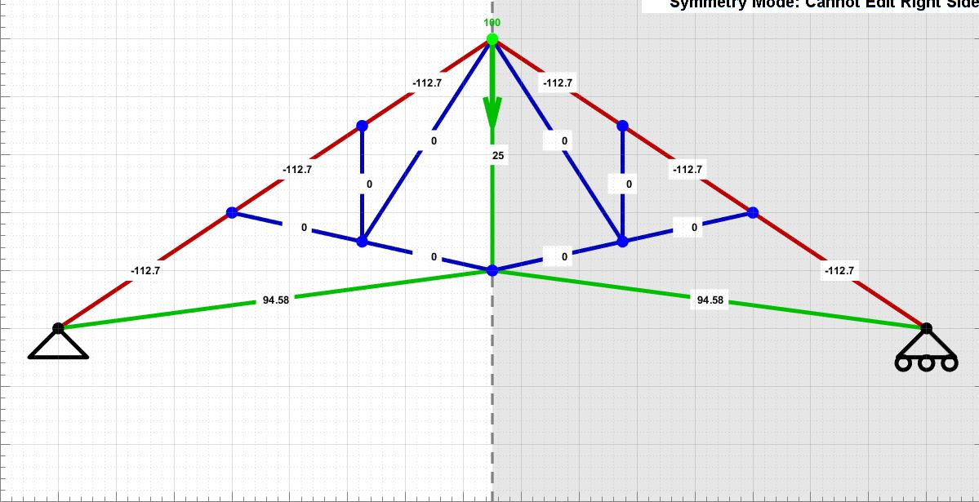 Figure 3-E

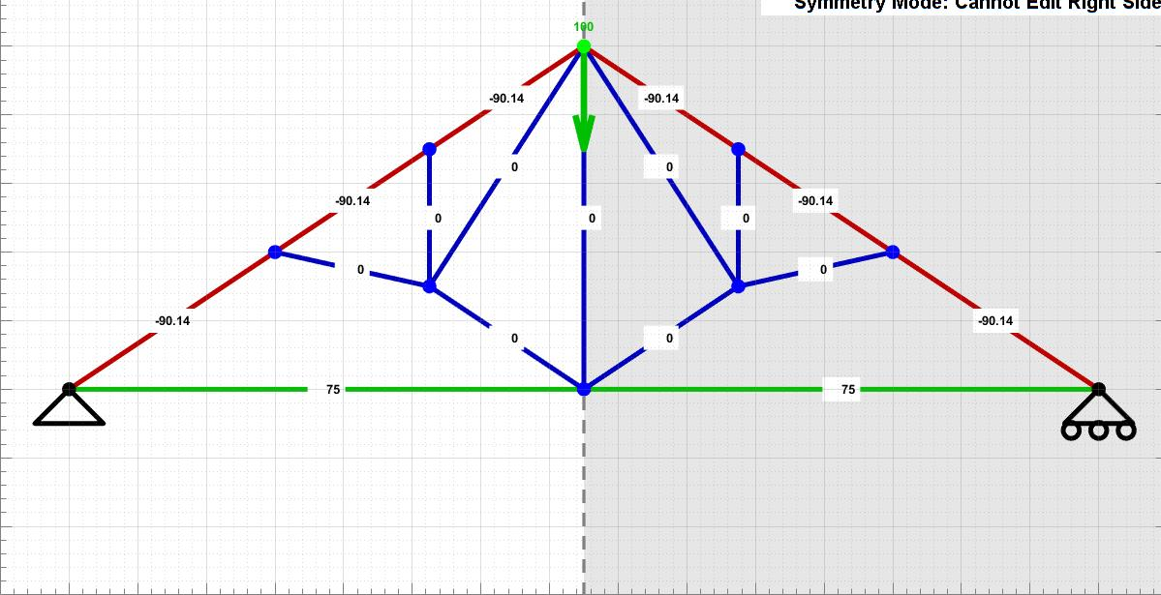 Figure 3-F

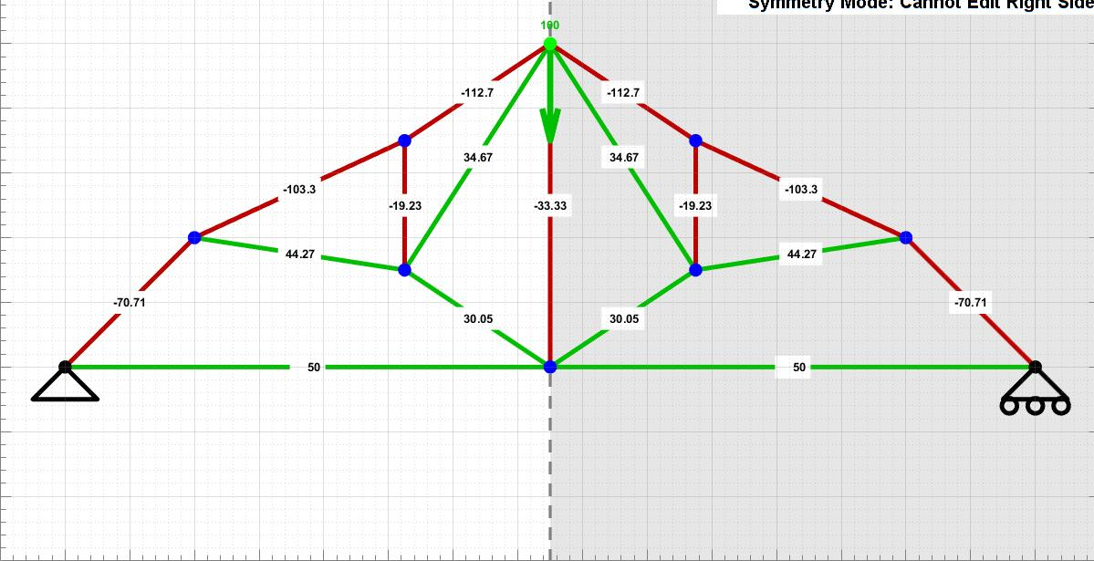 Figure 3-G

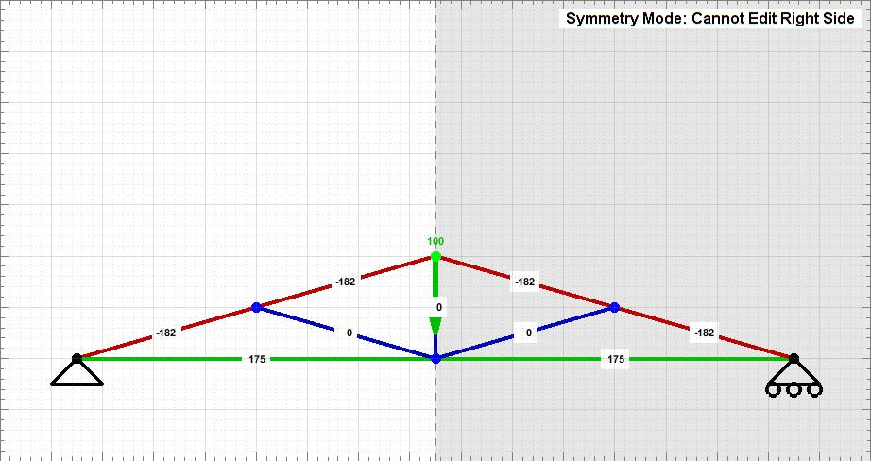Figure 4-A

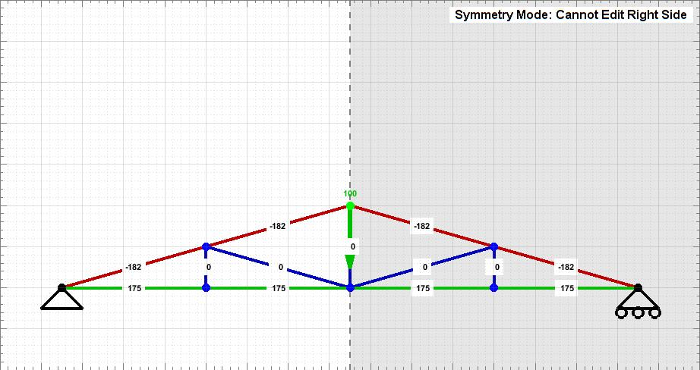 Figure 4-B

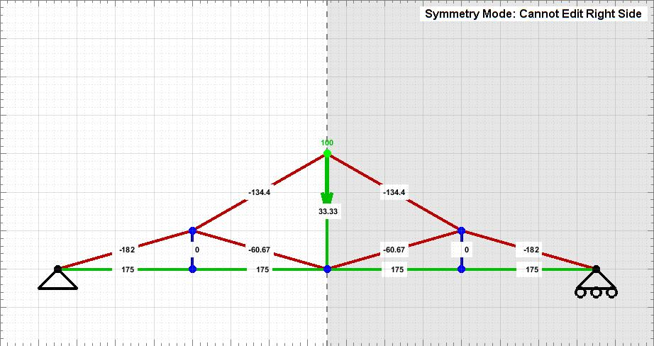 Figure 4-C

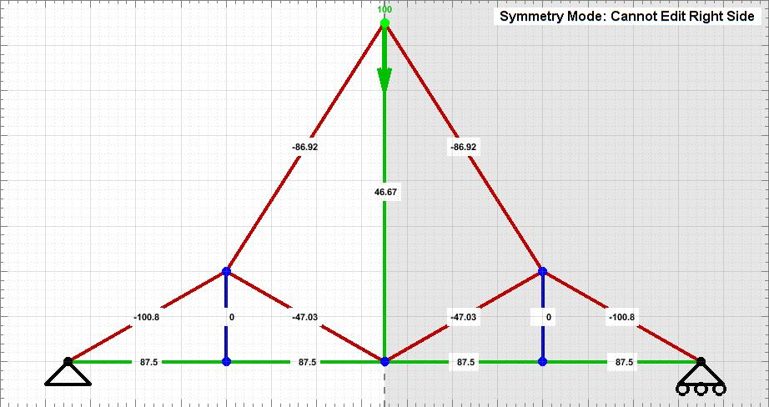 Figure 4-D

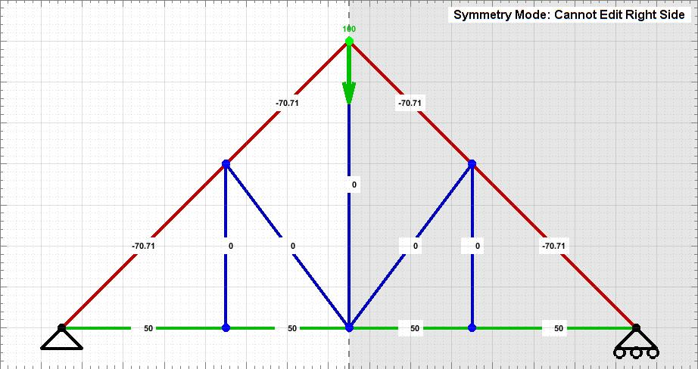 Figure 4-E

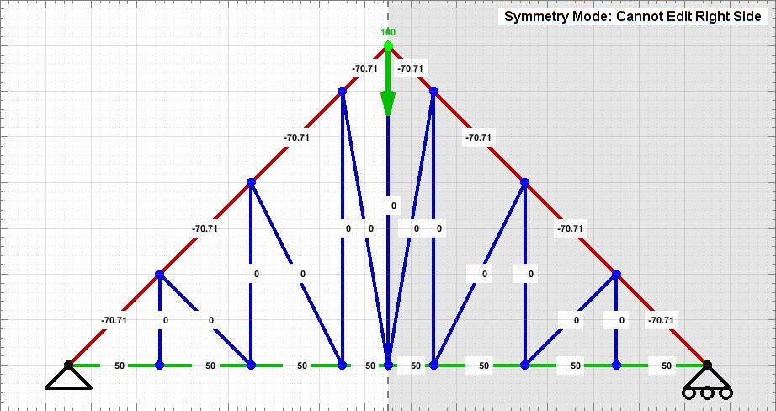 Figure 4-F

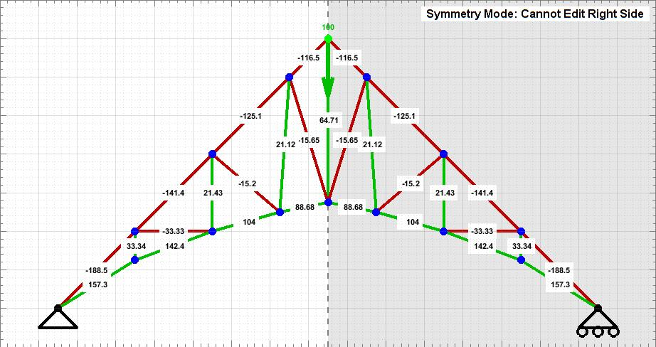 Figure 4-G

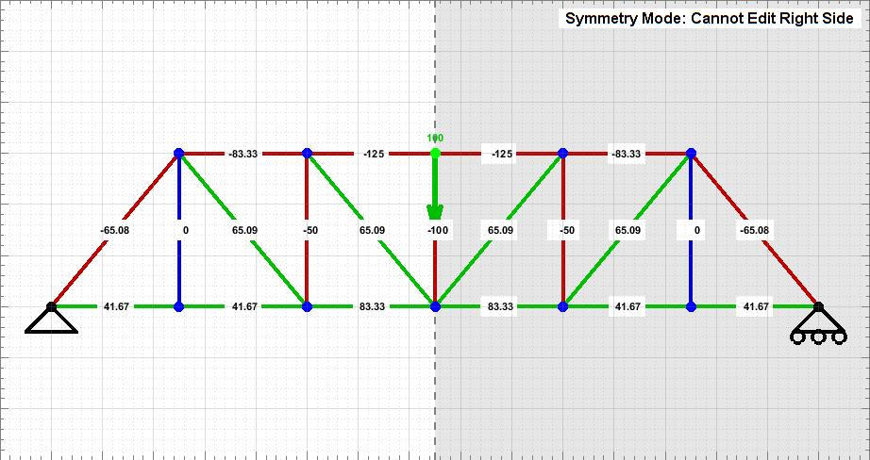 Figure 5-A

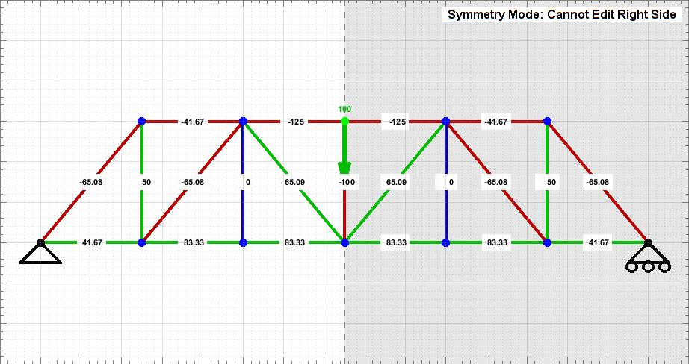 Figure 5-B

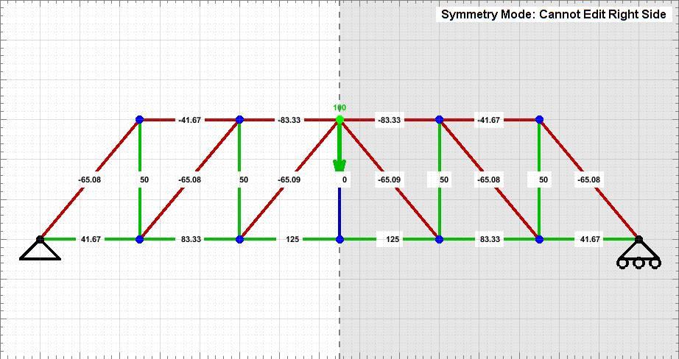 Figure 5-C

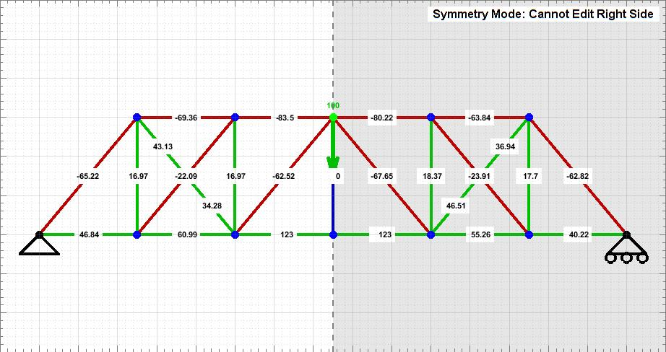 Figure 5-D

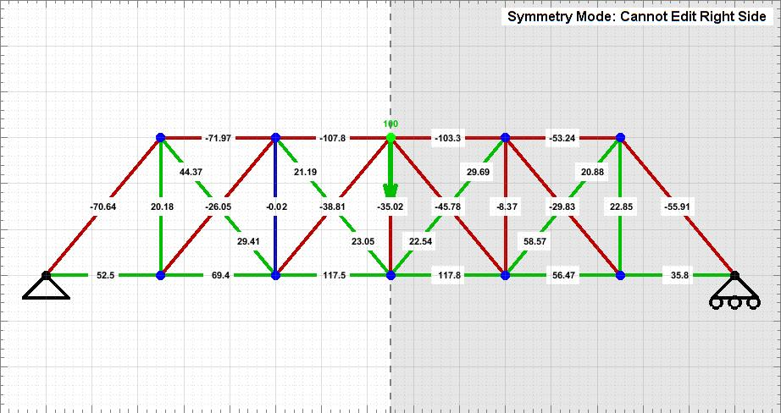 Figure 5-E

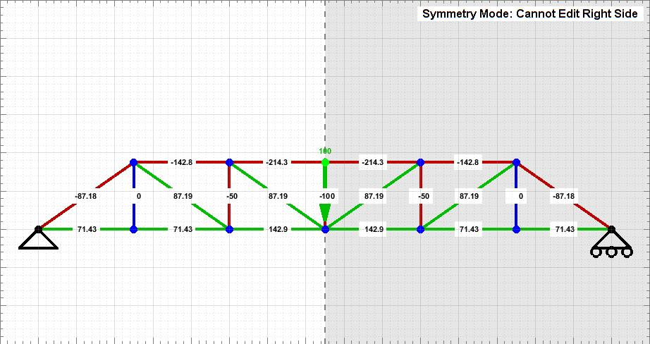 Figure 5-F

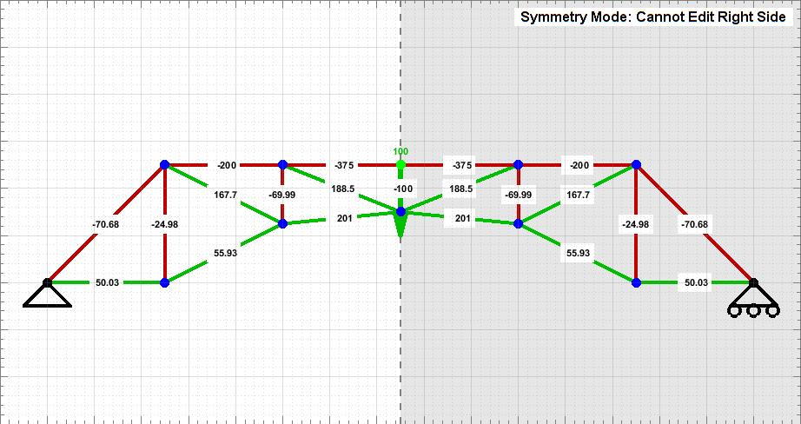 Figure 5-G