The Development Cycle

This document highlights our custom development cycle

Brian Mvukwe

Chris Langeveldt

Elizna Horn

Garryk Walker

Jana Van Niekerk

Contents

Development Cycle 2

Our Revised Development Cycle 3

# Development Cycle

We will iterate through our dev cycle after completion of every phase and feature. We will reflect on what is completed and what still needs to be completed and if any changes in our planning or coding conventions need to be made to accommodate upcoming features.

Our development cycle will follow a similar layout to the iterative Development shown below. However, since we are unable to perform rigorous maintenance post-deployment, a few changes will be made.

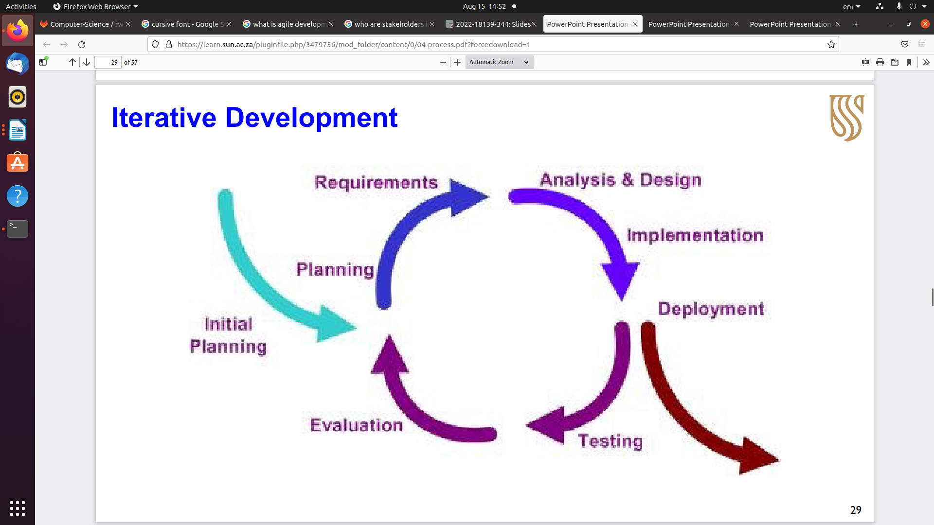

Above the following phases are listed:

1. Initial Planning
2. Planning
3. Requirements
4. Analysis & Design
5. Implementation
6. Deployment
7. Testing
8. Evaluation

# Our Revised Development Cycle

Our Implementation will be the same until we reach deployment. Deployment will be moved to after Evaluation. Our development cycle will be document orientated. The steps are as follows:

# Initial Planning

* + Document name is “Initial Meeting Breakdown”.

# Planning

* + Document name is “Planning”.

# Requirements

* + Document names are
* “Business Requirement Document”
* “Project Requirement Document”

# Analysis & Design

* + Document names are
* “Software Design”
* “User Stories”

# Implementation

* The Implementation will be the presented code.

# Testing

* + The document will provide in depth test cases run on the code and the results of each test. Experiments will also be run to apply strain to the system and provide us with appropriate results.

# Evaluation

* + This document will reiterate the requirements as well as the planning documents to ensure all required areas have been implemented and consider planned, unimplemented features.

# Deployment

* + Our deployment will be the presentations at the end of each sprint. The appropriate documents will be handed over to our clients. A software demonstration will also be presented.

Our iteration frequency will revolve around feature completion and sprint hand-ins. The discussions of each iteration will be documented and tracked throughout the development process.