Covid in Jails- Redcap Data Cleaning

Week of 10-19-2020

2021-02-05

Table of Contents

## Project Enrollments

## `summarise()` ungrouping output (override with `.groups` argument)

|  |  |  |  |
| --- | --- | --- | --- |
| Population | Weekly Enrollments | Follow ups | Total Enrolled |
| incarcerated | 36 | 0 | 451 |
| staff | 22 | 0 | 293 |
| test | 0 | 0 | 7 |

### Enrollment over time

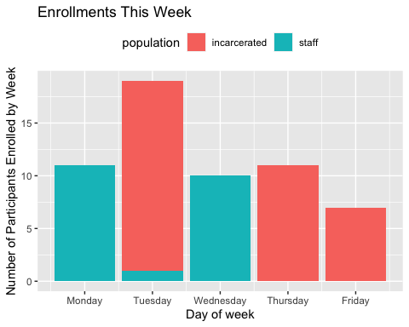

## Warning: Removed 20 rows containing non-finite values (stat_count).

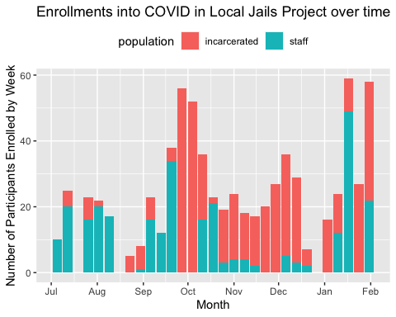

## Accomplishments for the week

* second full week of testing
* With wifi - > no probblems with Redcap

## Challenges

* Running low on premier tests and purple lid tubes

## Quality Control Issues

## `summarise()` ungrouping output (override with `.groups` argument)

|  |  |  |  |
| --- | --- | --- | --- |
| population | Resolved QC Issues | Open QC Issues | QC Issues for Discussion |
| incarcerated | 46 | 0 | 1 |
| staff | 97 | 5 | 1 |

### Types of QC Issues

The QC issues we have are as follows

##### Issues for Discussion Amongst the team

## [1] "This person had tested positive for Covid in June and also recently in September but was asymptomatic and was negative for antibodies"  
## [2] "Repeat record with SMC-S-129, maybe should merge?"

##### Other QC Issues

|  |  |
| --- | --- |
| qc_notes | n |
| Missing consent signature | 2 |
| Need to delete 6 end followups | 1 |
| Repeat record with SMC-S-162, maybe need to merge? | 1 |
| Repeat record with SMC-S-185, should maybe merge? | 1 |
| Repeat Record with SMC-S-25, maybe need to merge? | 1 |