**Robo-Advisors**

1. **Wealthfront**

* US only
* Mobile app available
* Essentially a bank account that automatically splits any incoming cashflow into various subaccounts, which are dedicated to pre-specified purposes by users (Automatic bill paying, savings, investments, etc.)
* users can opt into investing through its **PassivePlus** system, provided it has $500 or above in the account designated for investing
* focuses mainly on **passive investing** through the **modern portfolio theory,** where the system builds a globally diversified portfolio of low-cost index funds for the investor
* **no trading fees or comissions**
* charges 0.25% of the portfolio funds monthly as advisory fee on top of the indexes’ fee of 0.06-0.13% annually
* investors choose their own risk tolerance on the scale of 0.5 to 10 in the system, which dictates what asset classes’ ETFs their money will be invested in as well as the weights
* system execute trades automatically in a way that minimizes taxes
* provides tax loss harvesting for free
* dashboard provides a line graph and a drop down menu to choose between time-weighted or money weighted return number for easier understanding
* diversified portfolio tab shows asset classes that investor is currently invested in and the market values, returns

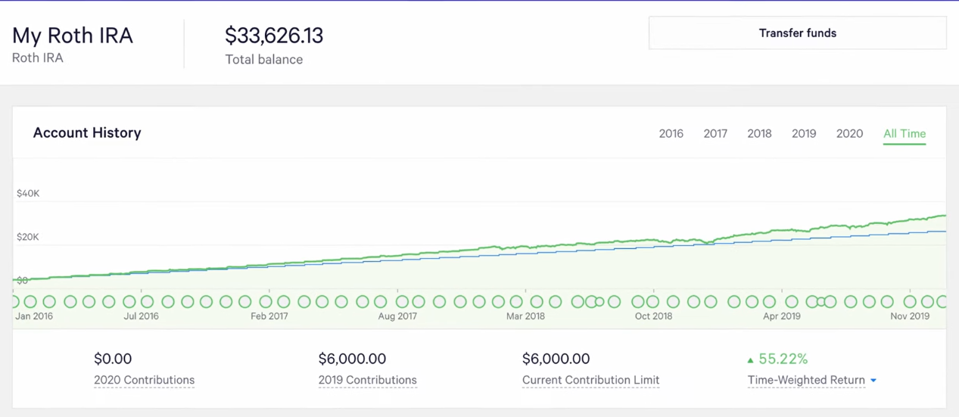

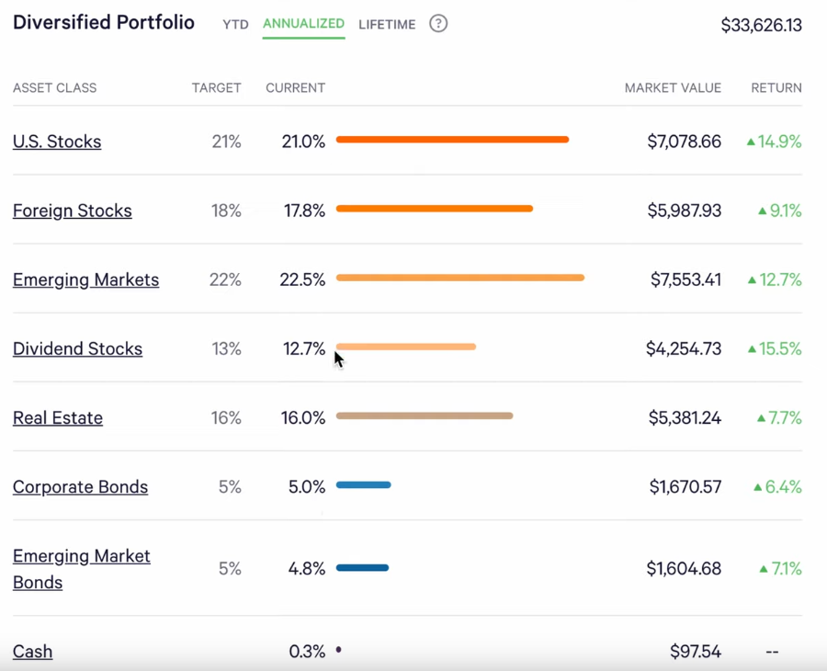

Sources:

https://www.wealthfront.com/

<https://www.wealthfront.com/investing>

https://www.youtube.com/watch?v=0feriJoBmEM

<https://www.youtube.com/watch?v=jzthabbU6nI>

1. **Interactive Advisors**

* Investor fills out a questionnaire to determine risk tolerance levels and needs and a portfolio is customized for him/her
* Allows investor to pick from a range of portfolios that Interactive Advisors have available dedicated to a mandate of the investor’s choosing
* Charges an asset-based management fee (only on money that is invested) between 0.08-1.5% per year, payable monthly
* Also charges **transaction costs** on trades, which are done through its sister company interactive brokers
* portfolios allocate capital to an equity component, a bond component and an inflation-hedging component → main goal is diversification
* The capital allocation to each of these asset classes is dialed up or down depending on the targeted risk level.
* Takes inspiration from modern portfolio theory
* Has the widest variety of securities to choose from out of the top 5 most prominent roboadvisors
* Makes use of fractional shares

Sources:

<https://interactiveadvisors.com/>

<https://interactiveadvisors.com/question-answer-search>

<https://interactiveadvisors.com/learn-more/asset-allocation>

1. **Betterment**

* mobile app available
* $0 minimum investment
* an annual fee of 0.25% per year on investor’s balance on the basic plan and 0.40% on the premium plan, on top of the indexes’ fee of 0.06-0.17% annually
* automatic rebalancing
* provides tax-loss harvesting
* based on modern portfolio theory
* investors can choose their own risk tolerance levels and whether there are specific sectors that they want to avoid investing in
* partnered with goldman sachs for their smart beta strategy portfolio and blackrock on their target income strategy
* investors can manually overweight a specific sector if he/she believes that the sector will outperform
* focuses only on equity ETFs and bond ETFs, **no commodities (unlike interactive advisors)**
* sunburst graph at dashboard to indicate how the investor’s fund is being allocated

Sources:

<https://www.betterment.com/resources/>

<https://www.betterment.com/resources/portfolio-optimization/>

https://www.betterment.com/pricing/