**Call Custom Lambda function from Service Catalog AWS**

**1) Create your lambda function**

- Open <https://console.aws.amazon.com/lambda/>

- Create function

Enter a Function name

Select your Runtime

Select Execution role, basic Lambda permissions should be enough in our case.

- Choose Create function

- Edit your function with your own code

**2) Create a template for your product**

<https://docs.aws.amazon.com/fr_fr/AWSCloudFormation/latest/UserGuide/template-formats.html>

Light exemple :

**AWSTemplateFormatVersion: "2010-09-09"**

**Description: Test Interface**

**Parameters:**

**Hostname:**

**Type: String**

**SecurityGroup:**

**Type: AWS::EC2::SecurityGroup::Id**

**Subnet:**

**Type: AWS::EC2::Subnet::Id**

**VMType:**

**Type: String**

**Default: t2.micro**

**AllowedValues:**

**- t2.micro**

**- m1.small**

**- m1.large**

**ConstraintDescription: "Enter t2.micro, m1.small, or m1.large. Default is t2.micro."**

**DesiredPackage:**

**Type: CommaDelimitedList**

**Default: httpd**

**Resources:**

**MyAWX:**

**Type: Custom::MyAWX**

**Properties:**

**ServiceToken:**

**Fn::Sub: arn:aws:lambda:${AWS::Region}:${AWS::AccountId}:function:LambdaCallRemoteAPIPython**

**Role: !Sub 'arn:aws:iam::${AWS::AccountId}:role/TestRoleServiceCatalog'**

**GlobalVariables:**

**hostname:**

**Ref: Hostname**

**TerraformVariables:**

**subnet:**

**Ref: Subnet**

**vmtype:**

**Ref: VMType**

**AnsibleVariables:**

**desiredpackages:**

**Ref: DesiredPackage**

First part : Parameters, it is the form viewed by the end user.

It could be string field or EC2 field which will get informations

Second part : Resources, it is the call to the Lambda function created previously named “LambdaCallRemoteAPIPython” and send previous collected variables to the lambda function.

**3) Create a portfolio**

Portfolio will contain your products.

- Open <https://console.aws.amazon.com/servicecatalog/>

- Create portfolio

Enter a portfolio name

Enter a description

Enter an owner

- Choose create

**4) Create a product**

Open your portfolio created in the previous step, and then choose Upload new product

- Enter product Details, then choose Next

- Enter support details, then choose Next

- Enter version details,

you can upload your template file directly which result to send it automatically to S3 or before this step you can store your template file on S3 and specify the Amazon S3 template URL.

- Choose create

From now your first product is available. You can now grand user to access the portfolio.

On the portfolio details page, you can go to “Groups, roles, and users” tab, and add groups, roles and/or users as desired.

**Troubleshooting :**

When you launch a product, an ID is generated :



You can check on CloudFormation status and log to have more details about the execution

<https://console.aws.amazon.com/cloudformation/>

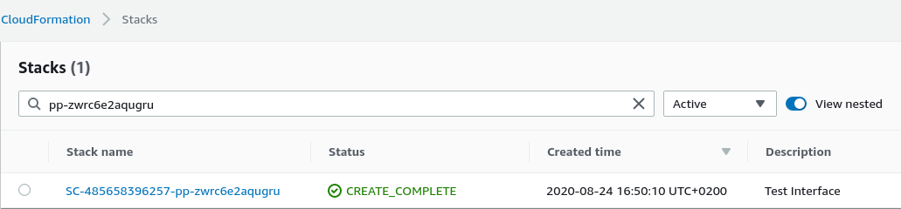

In events tab, we can see differents tasks executed during the product creation

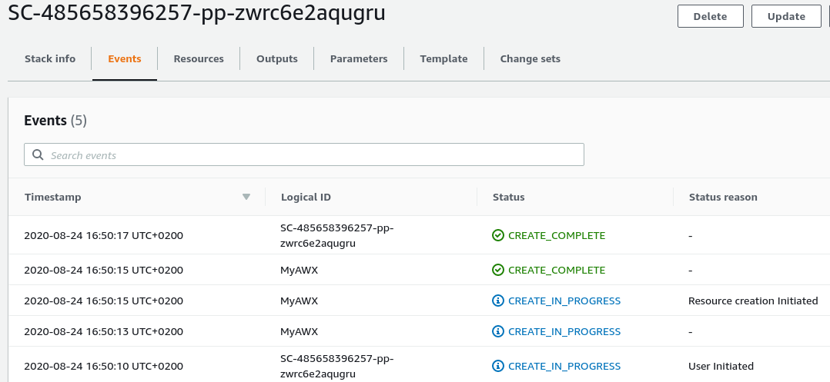

In parameters tabs, we can see parameters set into the user interface

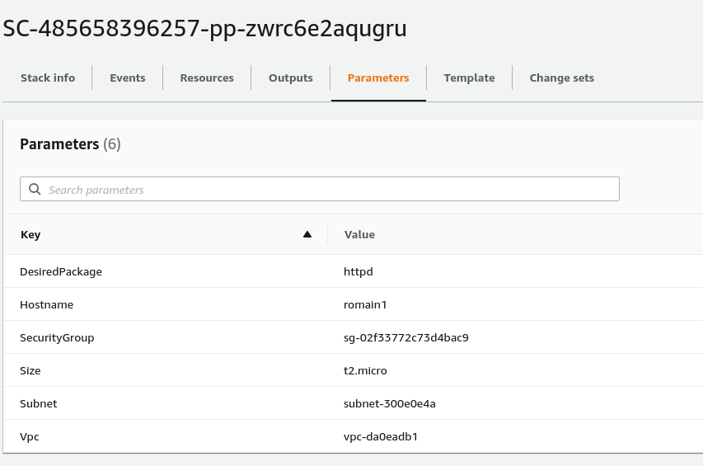

In case of failure during the lambda execution, you can check on CloudWatch to have more logs related to the execution

<https://console.aws.amazon.com/cloudwatch/>

Go to log groups on the left pannel.

Select the desired lambda function, and then you will have log executions in log streams tabs.