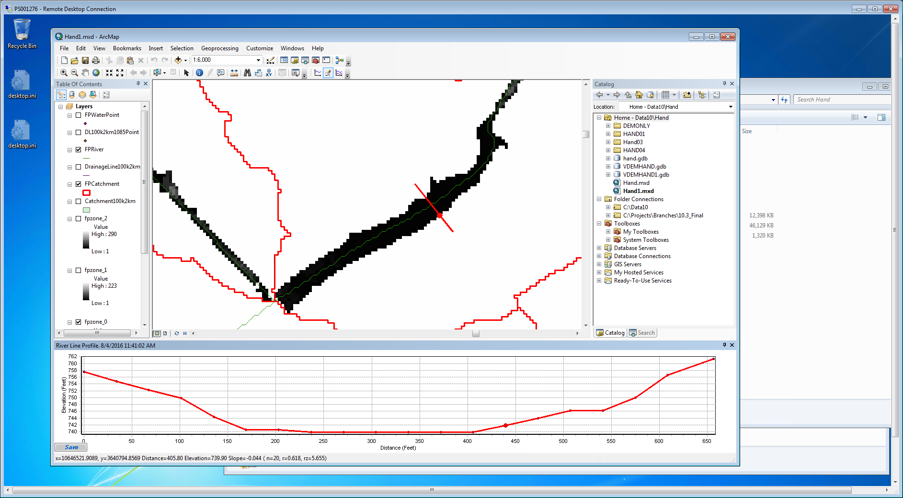

Figure 1. Profile vs Floodplain - dh=2ft

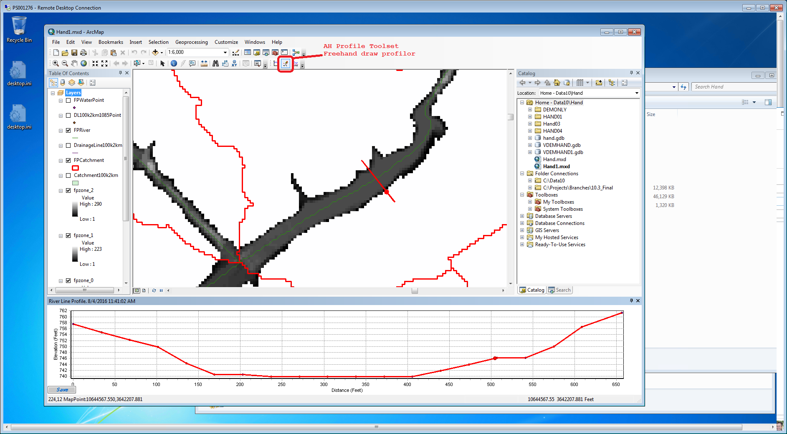

Figure 2. Profile vs Floodplain - dh=6ft

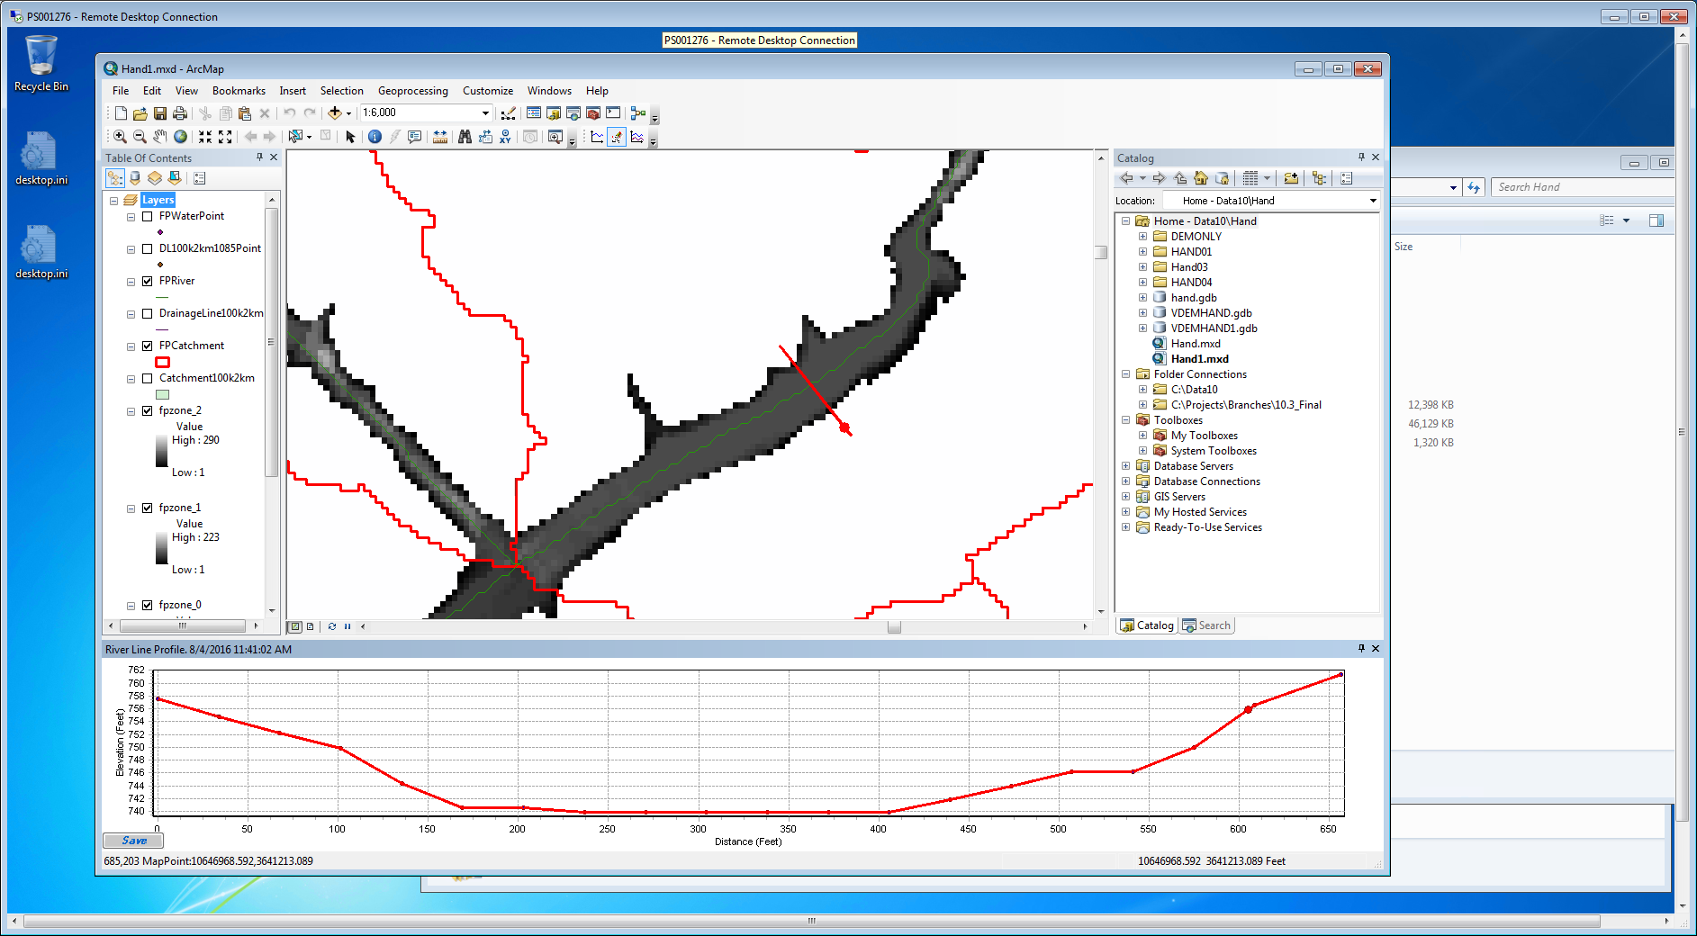

Figure 3. Profile vs Floodplain - dh=16ft

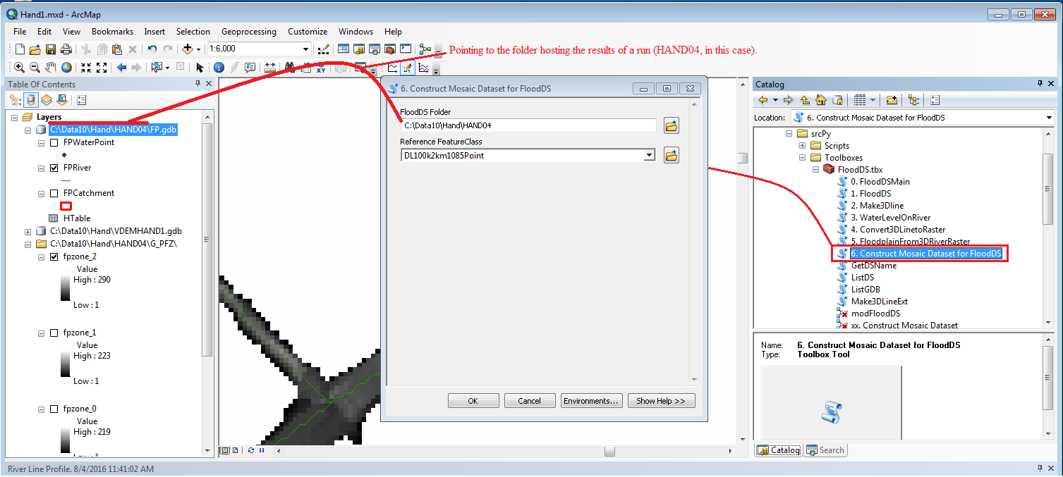

Figure . Construct Mosaic dataset for floodDS

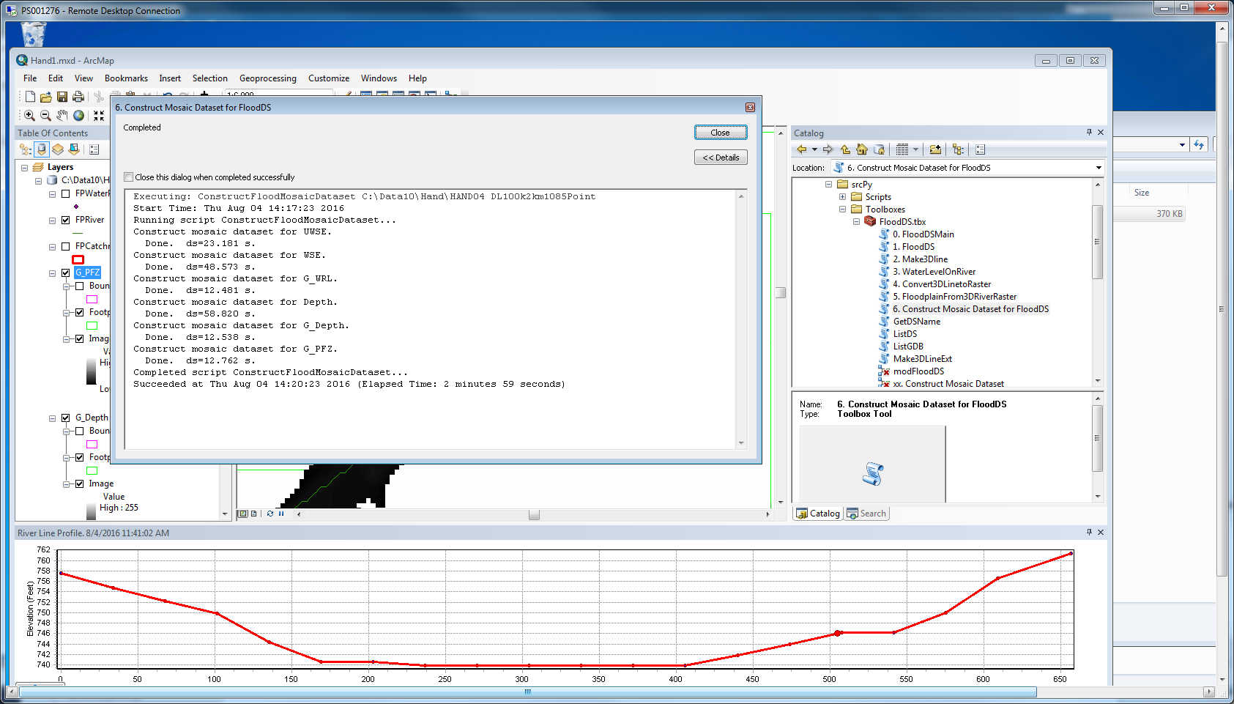

Figure . Construct Mosaic dataset for floodDS – results

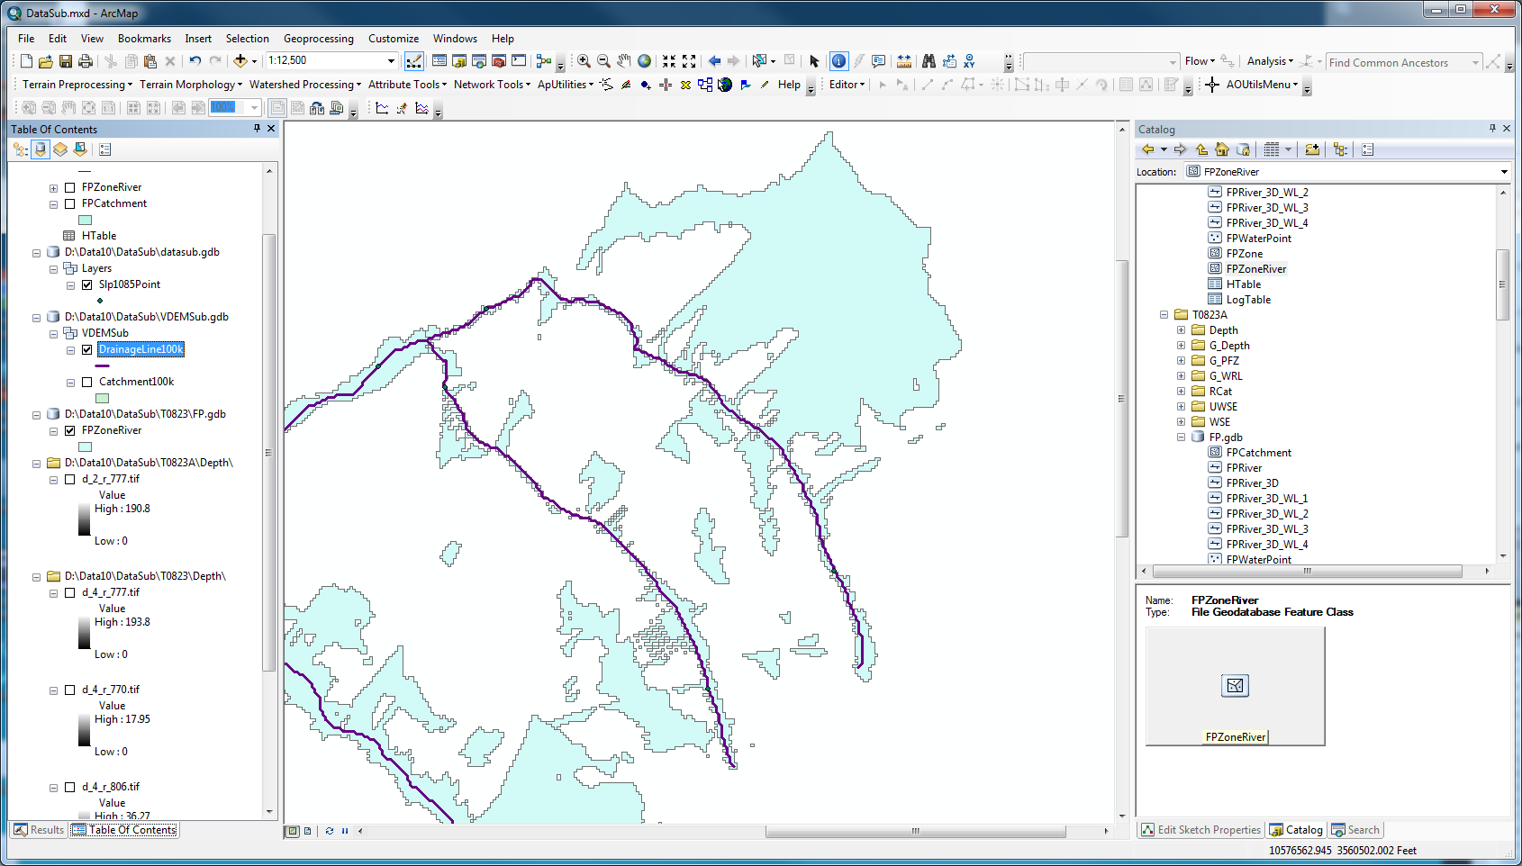

Figure 6. All flooded polygons

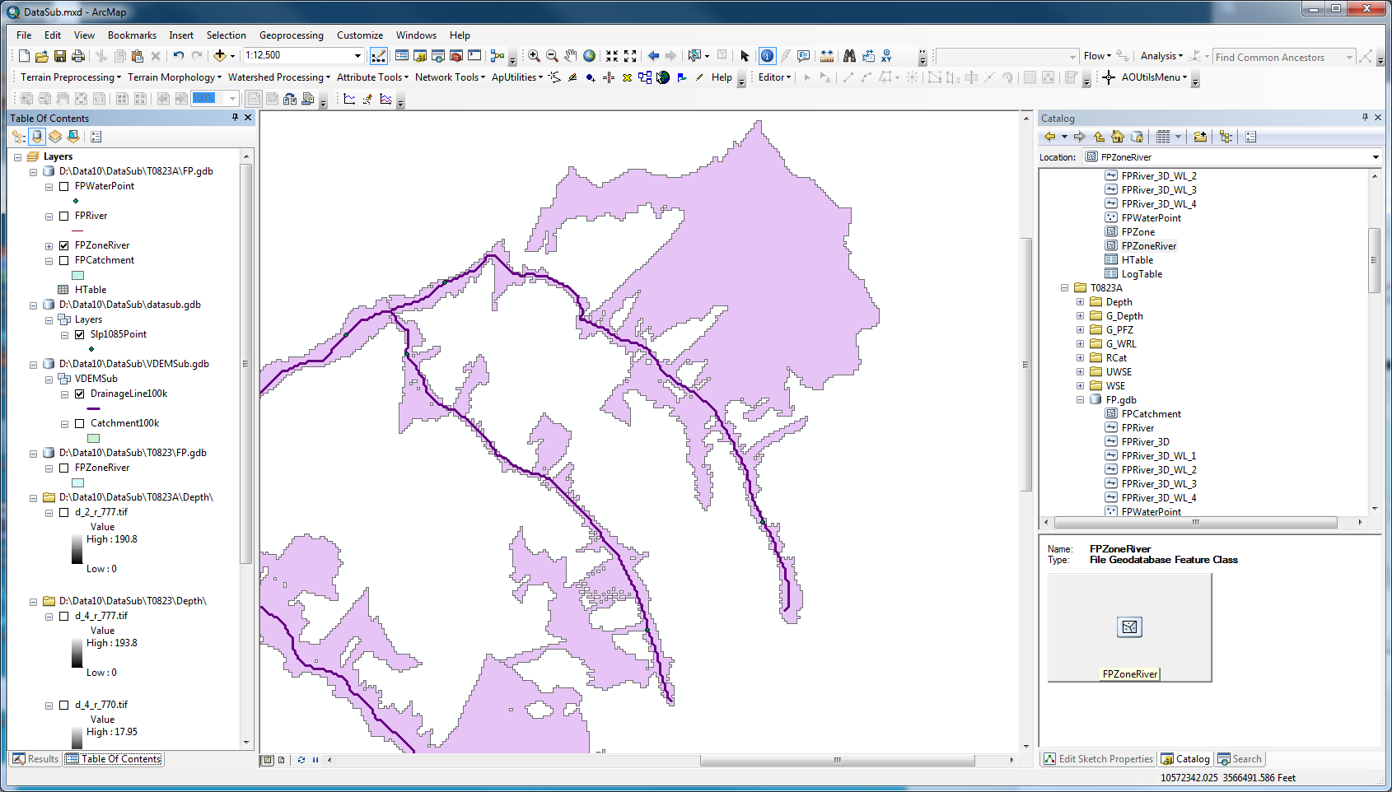

Figure 7. Flooded polygons must connected intersecting the river (connected flooded polygons only)

Multiprocessing

D:\Projects\Branches\10.3_Final\ArcHydroTools\srcPy\AHMain\Scripts\ArcHydro>

python flooddsmainR.py D:\Data10\FloodDS AA3 D:\Data10\FloodDS\floodds.gdb\Layers\DrainageLine D:\Data10\FloodDS\floodds.gdb\Layers\Slp1085Point D:\Data10\FloodDS\floodds.gdb\Layers\Catchment D:\Data10\FloodDS\Layers\fillgrid10 1;4;6;10 None AddDeltaH 2

python mosaicdatasetpolygonupdate.py D:\AHData\FloodDS\FloodDS0829\FP.gdb\Depth_Poly Depth 4

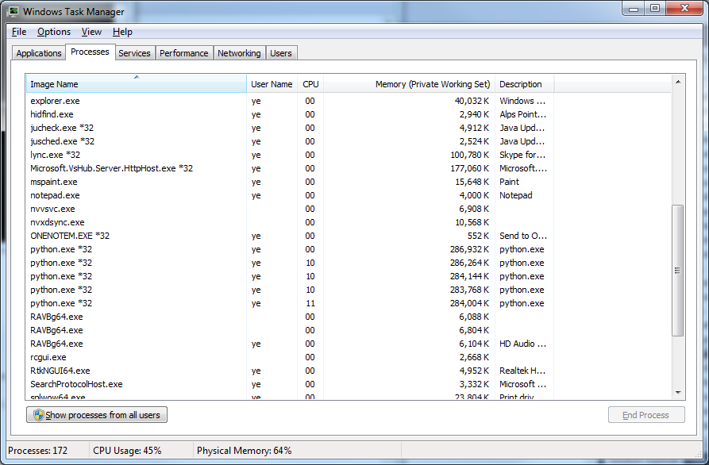

Figure . MultipleProcessing - 4

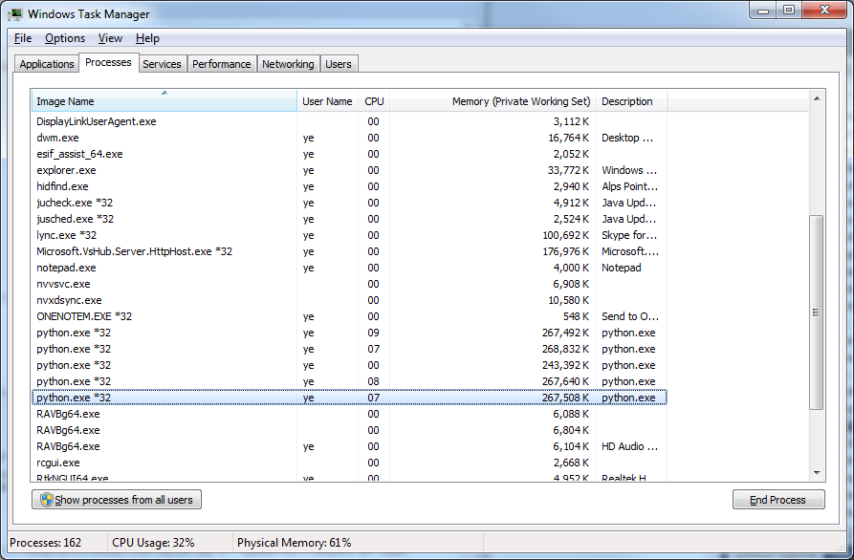

Figure . Multipleprocessing - 4 on updatepolygon.

HAND processing

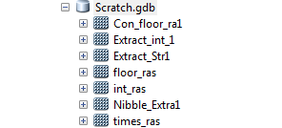

Figure 10. files created under the scratch.gdb when arcpy.env.scratchworkspace = "c:\temp\scratch.gdb" sa.operaionts used are extractbymask, con, int, nibble, times, FloatDivide

Executing: HandBaseCreate filsub 100 Str D:\10Data\Houston\HANDCAT2 Catchment100k

Start Time: Wed Jan 11 09:51:26 2017

Running script HandBaseCreate...

arcpy.Exists(D:\Temp\Scratch.gdb)=True, arcpy.env.scratchFolder=C:\Users\ye\Documents\ArcGIS\scratch, arcpy.Exists(arcpy.env.scratchFolder)=True

Apply multiplier to filsub. dt=0.44 seconds.

Apply int on the multiplied raster filsub. dt=0.17 seconds.

Processing 5 catchments.

Processing 1 of 5 catchments. ddt=11.45 seconds.

Processing 2 of 5 catchments. ddt=8.26 seconds.

Processing 3 of 5 catchments. ddt=8.23 seconds.

Processing 4 of 5 catchments. ddt=11.75 seconds.

Processing 5 of 5 catchments. ddt=8.46 seconds.

Completed processing 5 of 5 catchments. dt=48.14 seconds.

Mosaic 5 catchment LocalMin to form the LocalMin raster. dt=0.73 seconds.

Mosaic 5 catchment Handbase to form the HandBase raster. dt=0.73 seconds.

Saving the Handbase result rasters. dt=50.33 seconds.

Completed script HandBaseCreate...

Succeeded at Wed Jan 11 09:52:17 2017 (Elapsed Time: 50.64 seconds)

memory=200.3k

Executing: HandBaseCreate filsub 100 Str D:\10Data\Houston\HANDCAT2 Catchment100k

Start Time: Wed Jan 11 09:39:30 2017

Running script HandBaseCreate...

arcpy.Exists(C:\Temp\Scratch.gdb)=True, arcpy.env.scratchFolder=C:\Users\ye\Documents\ArcGIS\scratch, arcpy.Exists(arcpy.env.scratchFolder)=True

Apply multiplier to filsub. dt=0.37 seconds.

Apply int on the multiplied raster filsub. dt=0.16 seconds.

Processing 5 catchments.

Processing 1 of 5 catchments. ddt=10.07 seconds.

Processing 2 of 5 catchments. ddt=7.94 seconds.

Processing 3 of 5 catchments. ddt=7.08 seconds.

Processing 4 of 5 catchments. ddt=12.44 seconds.

Processing 5 of 5 catchments. ddt=7.62 seconds.

Completed processing 5 of 5 catchments. dt=45.16 seconds.

Mosaic 5 catchment LocalMin to form the LocalMin raster. dt=0.83 seconds.

Mosaic 5 catchment Handbase to form the HandBase raster. dt=0.75 seconds.

Saving the Handbase result rasters. dt=47.39 seconds.

Completed script HandBaseCreate...

Succeeded at Wed Jan 11 09:40:18 2017 (Elapsed Time: 47.75 seconds)

arcpy.env.scratchGDB

Executing: HandBaseCreate filsub 100 Str D:\10Data\Houston\HANDCAT2 Catchment100k

Start Time: Wed Jan 11 09:35:05 2017

Running script HandBaseCreate...

arcpy.Exists(C:\Users\ye\Documents\ArcGIS\scratch.gdb)=True, arcpy.env.scratchFolder=C:\Users\ye\Documents\ArcGIS\scratch, arcpy.Exists(arcpy.env.scratchFolder)=True

Apply multiplier to filsub. dt=0.43 seconds.

Apply int on the multiplied raster filsub. dt=0.16 seconds.

Processing 5 catchments.

Processing 1 of 5 catchments. ddt=11.23 seconds.

Processing 2 of 5 catchments. ddt=7.73 seconds.

Processing 3 of 5 catchments. ddt=7.52 seconds.

Processing 4 of 5 catchments. ddt=13.61 seconds.

Processing 5 of 5 catchments. ddt=7.78 seconds.

Completed processing 5 of 5 catchments. dt=47.87 seconds.

Mosaic 5 catchment LocalMin to form the LocalMin raster. dt=0.41 seconds.

Mosaic 5 catchment Handbase to form the HandBase raster. dt=0.44 seconds.

Saving the Handbase result rasters. dt=49.32 seconds.

Completed script HandBaseCreate...

Succeeded at Wed Jan 11 09:35:55 2017 (Elapsed Time: 49.87 seconds)

"in_memory"

Executing: HandBaseCreate filsub 100 Str D:\10Data\Houston\HANDCAT2 Catchment100k

Start Time: Wed Jan 11 09:36:55 2017

Running script HandBaseCreate...

arcpy.Exists(in_memory)=True, arcpy.env.scratchFolder=C:\Users\ye\Documents\ArcGIS\scratch, arcpy.Exists(arcpy.env.scratchFolder)=True

Apply multiplier to filsub. dt=0.35 seconds.

Apply int on the multiplied raster filsub. dt=0.16 seconds.

Processing 5 catchments.

Processing 1 of 5 catchments. ddt=3.37 seconds.

Processing 2 of 5 catchments. ddt=2.62 seconds.

Processing 3 of 5 catchments. ddt=2.70 seconds.

Processing 4 of 5 catchments. ddt=3.26 seconds.

Processing 5 of 5 catchments. ddt=2.73 seconds.

Completed processing 5 of 5 catchments. dt=14.69 seconds.

Mosaic 5 catchment LocalMin to form the LocalMin raster. dt=0.54 seconds.

Mosaic 5 catchment Handbase to form the HandBase raster. dt=0.44 seconds.

Saving the Handbase result rasters. dt=16.20 seconds.

Completed script HandBaseCreate...

Succeeded at Wed Jan 11 09:37:11 2017 (Elapsed Time: 16.30 seconds)

Running script HandBaseCreate...

arcpy.Exists(in_memory)=True, arcpy.env.scratchWorkspace=in_memory

arcpy.env.scratchFolder=c:\windows\system32\scratch, arcpy.Exists(arcpy.env.scratchFolder)=True

Apply multiplier to filsub. dt=0.35 seconds.

Apply int on the multiplied raster filsub. dt=0.17 seconds.

Processing 5 catchments.

Processing 1 of 5 catchments. ddt=3.54 seconds.

Processing 2 of 5 catchments. ddt=2.79 seconds.

Processing 3 of 5 catchments. ddt=2.96 seconds.

Processing 4 of 5 catchments. ddt=3.32 seconds.

Processing 5 of 5 catchments. ddt=2.86 seconds.

Completed processing 5 of 5 catchments. dt=15.47 seconds.

Mosaic 5 catchment LocalMin to form the LocalMin raster. dt=0.48 seconds.

Mosaic 5 catchment Handbase to form the HandBase raster. dt=0.40 seconds.

Saving the Handbase result rasters. dt=16.89 seconds.

arcpy.env.workspace=D:\Data10\FloodDS\HANDSUB1\CATPath\CATHandBase

arcpy.env.workspace=C:\Users\ye\Documents\ArcGIS\Default3.gdb

arcpy.env.cellSize=MAXOF

arcpy.env.snapRaster=None

arcpy.env.overwriteOutput=True

arcpy.env.addOutputsToMap=False

Completed script HandBaseCreate...

Succeeded at Wed Jan 11 11:55:47 2017 (Elapsed Time: 17.00 seconds)

Executing: HandBaseCreate filsub 100 Str D:\Data10\DataSub\HANDCAT Catchment100k

Start Time: Wed Jan 11 12:36:12 2017

Running script HandBaseCreate...

arcpy.Exists(in_memory)=True, arcpy.env.scratchWorkspace=in_memory

arcpy.env.scratchFolder=D:\Data10\DataSub\scratch, arcpy.Exists(arcpy.env.scratchFolder)=True

Apply multiplier to filsub. dt=0.34 seconds.

Apply int on the multiplied raster filsub. dt=0.14 seconds.

Processing 5 catchments.

Processing 1 of 5 catchments. ddt=3.70 seconds.

Processing 2 of 5 catchments. ddt=2.68 seconds.

Processing 3 of 5 catchments. ddt=2.88 seconds.

Processing 4 of 5 catchments. ddt=3.27 seconds.

Processing 5 of 5 catchments. ddt=2.82 seconds.

Completed processing 5 of 5 catchments. dt=15.36 seconds.

Mosaic 5 catchment LocalMin to form the LocalMin raster. dt=0.96 seconds.

Mosaic 5 catchment Handbase to form the HandBase raster. dt=0.44 seconds.

Saving the Handbase result rasters. dt=17.30 seconds.

arcpy.env.workspace=D:\Data10\DataSub\HANDCAT\CATPath\CATHandBase

Completed script HandBaseCreate...

Succeeded at Wed Jan 11 12:36:30 2017 (Elapsed Time: 17.65 seconds)

Executing: HandBaseCreate filsub 100 Str D:\Data10\DataSub\HANDCAT Catchment100k

Start Time: Wed Jan 11 12:37:08 2017

Running script HandBaseCreate...

arcpy.Exists(in_memory)=True, arcpy.env.scratchWorkspace=in_memory

arcpy.env.scratchFolder=c:\windows\system32\scratch, arcpy.Exists(arcpy.env.scratchFolder)=True

Apply multiplier to filsub. dt=0.38 seconds.

Apply int on the multiplied raster filsub. dt=0.17 seconds.

Processing 5 catchments.

Processing 1 of 5 catchments. ddt=3.55 seconds.

Processing 2 of 5 catchments. ddt=2.77 seconds.

Processing 3 of 5 catchments. ddt=2.78 seconds.

Processing 4 of 5 catchments. ddt=3.39 seconds.

Processing 5 of 5 catchments. ddt=2.77 seconds.

Completed processing 5 of 5 catchments. dt=15.25 seconds.

Mosaic 5 catchment LocalMin to form the LocalMin raster. dt=0.44 seconds.

Mosaic 5 catchment Handbase to form the HandBase raster. dt=0.45 seconds.

Saving the Handbase result rasters. dt=16.71 seconds.

arcpy.env.workspace=D:\Data10\DataSub\HANDCAT\CATPath\CATHandBase

Completed script HandBaseCreate...

Succeeded at Wed Jan 11 12:37:25 2017 (Elapsed Time: 16.82 seconds)

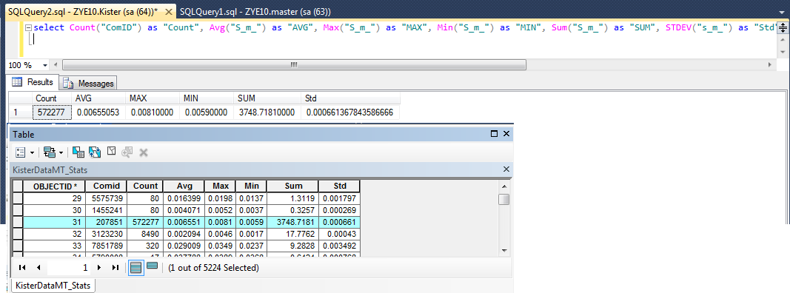

Figure . Stats

select Count("ComID") as "Count", Avg("S_m_") as "AVG", Max("S_m_") as "MAX", Min("S_m_") as "MIN", Sum("S_m_") as "SUM", STDEV("s_m_") as "Std" from dbo.KISTERDATAMT Where COMID = 207851

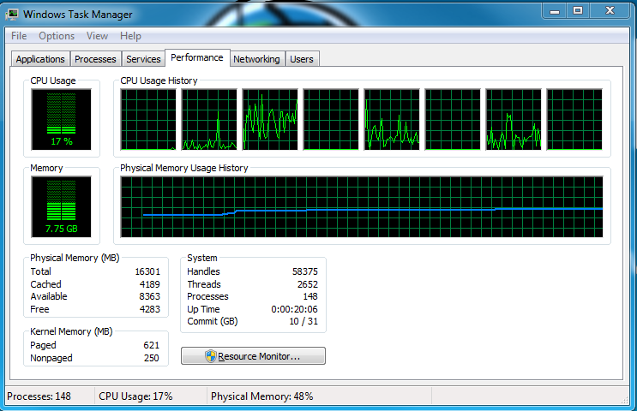

Figure 12. Pandas test 1 - groupby comid, time.

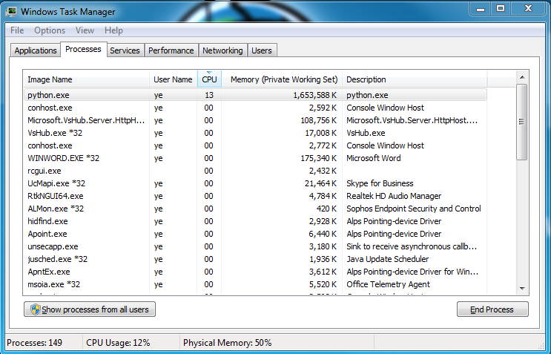

Figure 13. gb = df.groupby(['Comid','ForecastTime']) finished. dt=344.327 s.

# fdgetaddressh.py –

AddressFile: D:\10Data\TXDEM\KisterData\Address05TotPop.csv

KisterFile: C:\10DATA\TXDEM\KisterData\KisterDataMT.csv

OutputFile: C:\10DATA\TXDEM\KisterData\KisterDataMT_AddH.csv

OnIndex: 4 [3=Q,4=H] command line

example:

python fdgetaddressh.py "D:\10Data\TXDEM\KisterData\Address05TotPop.csv" C:\10DATA\TXDEM\KisterData\KisterDataMT.csv

# fdgroupbystats.py (groupby ComID, DistID, RegID, CountyID)

inputs:

C:\10DATA\TXDEM\KisterData\KisterDataMT_AddH.csv

D:\Projects\Branches\10.3_Final\ArcHydroTools\srcPy\AHMain\Scripts\ArcHydro>python fdgroupbystats.py C:\10DATA\TXDEM\KisterData\KisterDataMT

_AddH.csv 4 0 63 C:\10DATA\TXDEM\KisterData\KisterDataMT_AddH_StatsComID.csv

# fdgroupbystatsTS (groupby ComID, DistID, RegID, CountyID and datetime)

inputs

# fdtsvaluemax.py

python fdtsvaluemax.py C:\10DATA\TXDEM\KisterData\KisterDataMT.csv

InputFile: C:\10DATA\TXDEM\KisterData\KisterDataMT.csv

OutputFile: C:\10DATA\TXDEM\KisterData\KisterDataMT_max.csv

Log:

by comid:

python fdgroupbystats.py C:\10DATA\TXDEM\KisterData\KisterDataMT_max_AddH.csv 3 0 63 C:\10DATA\TXDEM\KisterData\KisterDataMT_max_AddH_StatsComID.csv

See results at C:\10DATA\TXDEM\KisterData\KisterDataMT_max_AddH_StatsComID.csv.

Completed processing 27470 stats on 1284 group values. dt=0.070 seconds.

by CountyID:

python fdgroupbystats.py C:\10DATA\TXDEM\KisterData\KisterDataMT_max_AddH.csv 3 4 63 C:\10DATA\TXDEM\KisterData\KisterDataMT_max_AddH_StatsCountyID.csv

Completed processing 27470 stats on 147 group values. dt=0.017 seconds.

Completed, dt=0.067 seconds..

See results at C:\10DATA\TXDEM\KisterData\KisterDataMT_max_AddH_StatsCountyID.csv.

by DistID:

python fdgroupbystats.py C:\10DATA\TXDEM\KisterData\KisterDataMT_max_AddH.csv 3 5 63 C:\10DATA\TXDEM\KisterData\KisterDataMT_max_AddH_StatsDistID.csv

Completed processing 27470 stats on 30 group values. dt=0.010 seconds.

Completed, dt=0.062 seconds..

See results at C:\10DATA\TXDEM\KisterData\KisterDataMT_max_AddH_StatsDistID.csv.

Finished at 2017-03-07 12:23:23

by RegionID:

python fdgroupbystats.py C:\10DATA\TXDEM\KisterData\KisterDataMT_max_AddH.csv 3 6 63 C:\10DATA\TXDEM\KisterData\KisterDataMT_max_AddH_StatsRegID.csv

Completed processing 27470 stats on 6 group values. dt=0.004 seconds.

Completed, dt=0.055 seconds..

See results at C:\10DATA\TXDEM\KisterData\KisterDataMT_max_AddH_StatsRegID.csv.

Finished at 2017-03-07 12:26:42

Download KisterData (MT,ST)->ApplyMax->ApplyAddr->GroupBy (COMID, DistID, CountyID, RegID on population)

Download KisterData (MT,ST)->ApplyAddr->GroupBy(ComID, DistID, CountyID, RegID [StartTime]) (on population)

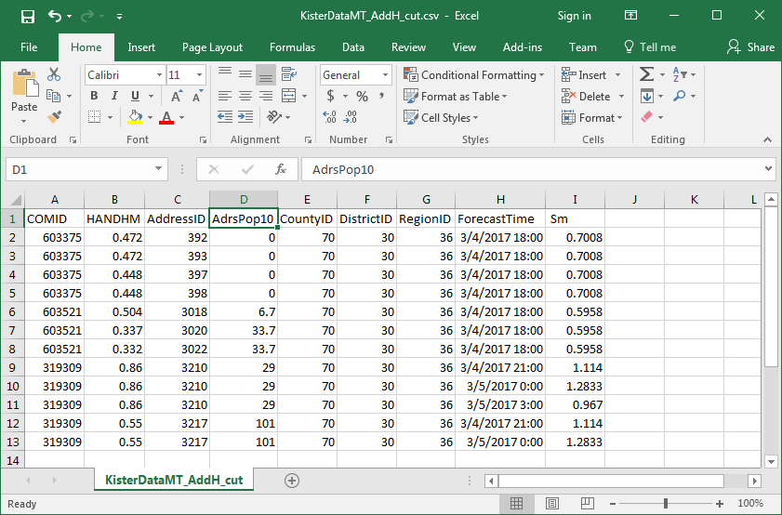

Figure 14. _AddH file structure.

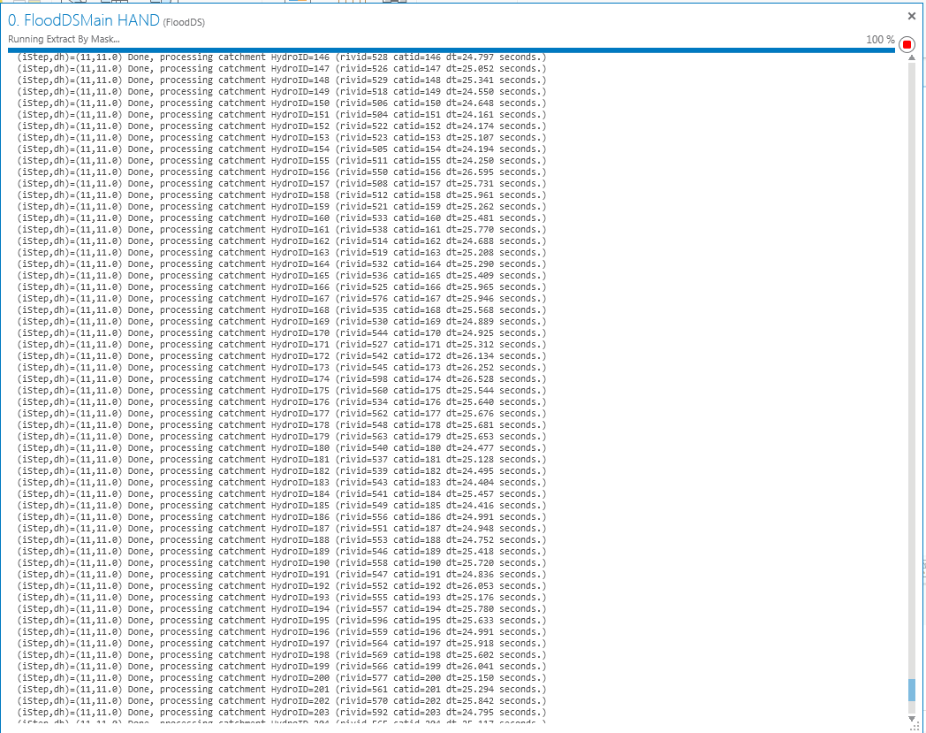

Figure . Delta T

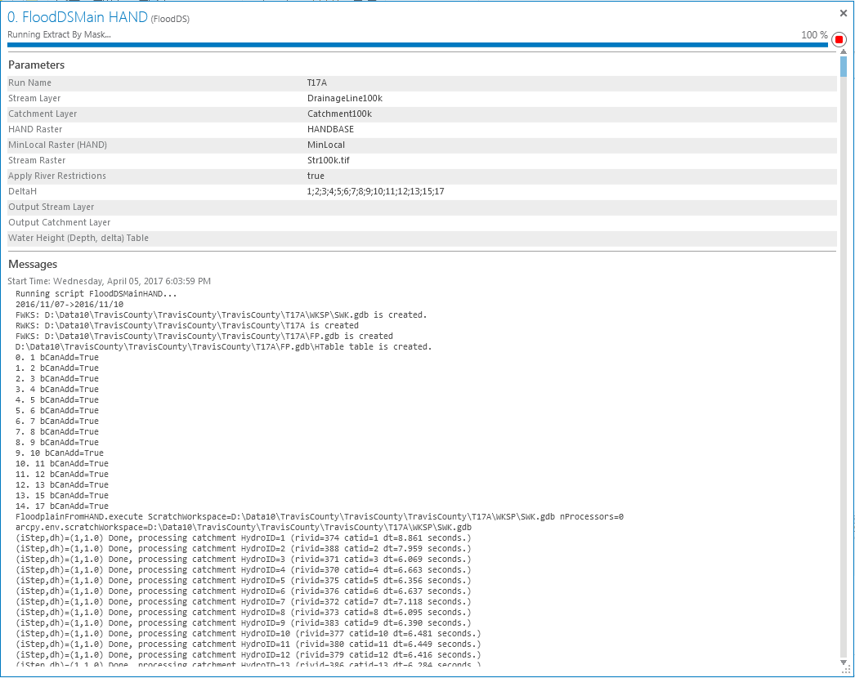

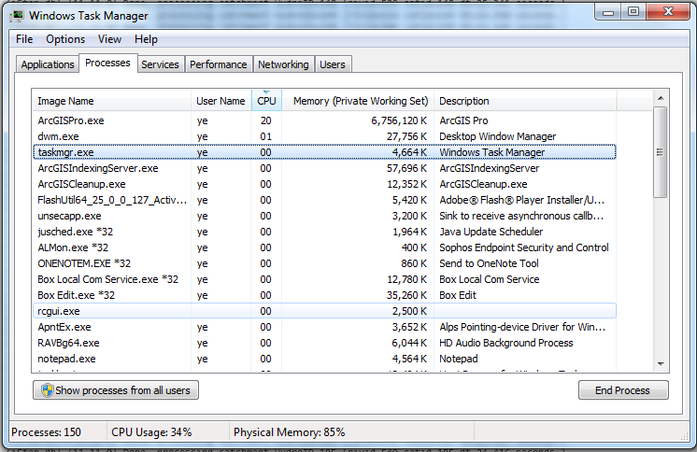

Figure . Memory usage, pro