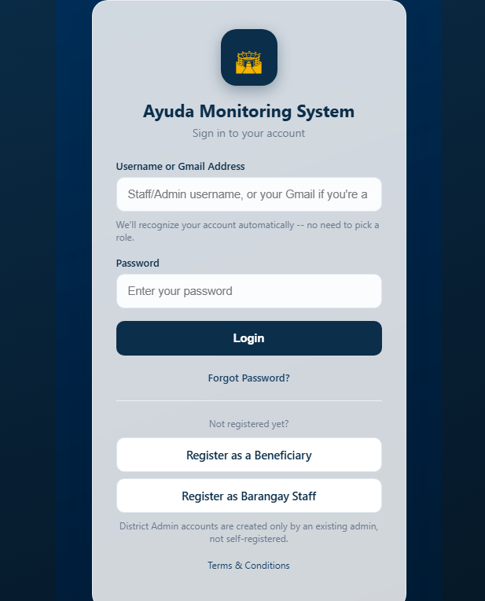

Remove the text of the text in input bar.
Web responsive.
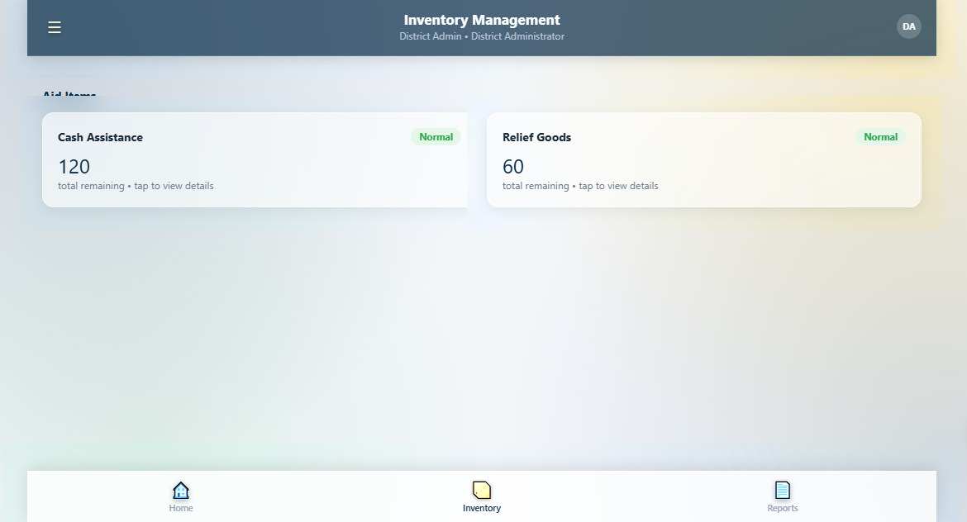
Display Budget , Statistics, Pie chart statistics of the three districts, theres is input for the distribution like Sponsored like location , food packs , and relief goods, pila mabilin sa foodpacks , cash , kung mukuha man ka mo reflect jud na like 50000 sa time na magdistribute na siya dapat mureflect jud na mabawasan siya. Add dummy datas.

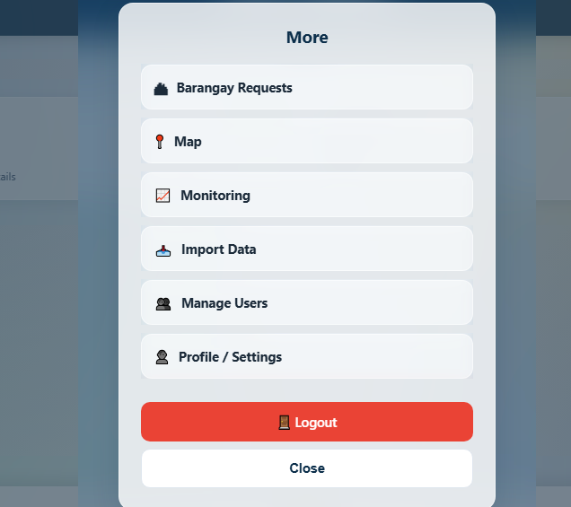

Dira lihokkon ang distribution.

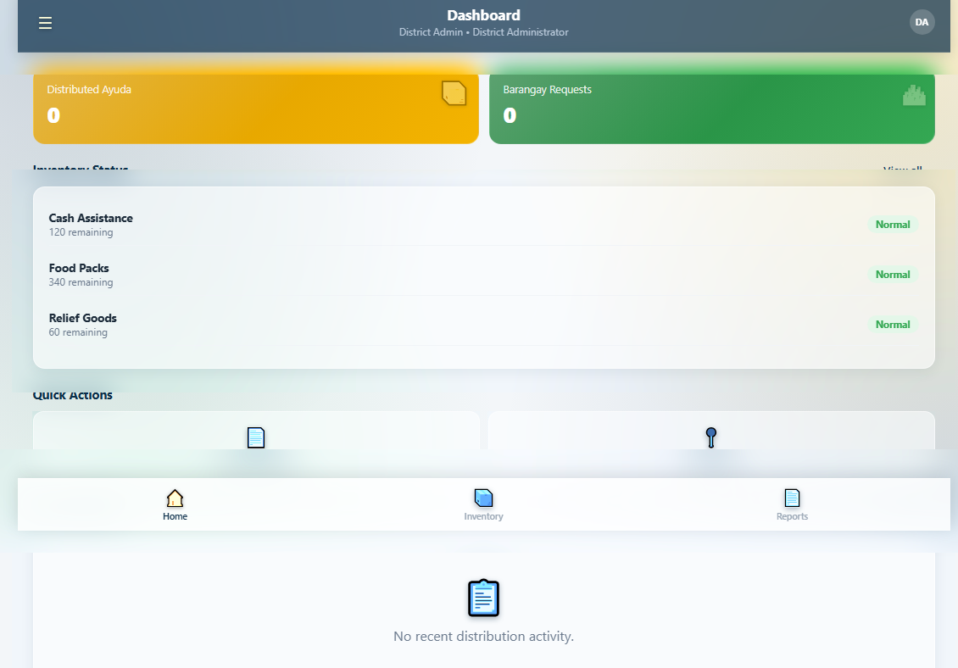

Kung maclick ang distrubte ayuda – makita didtoa ang unsang barangay og district og using klaseng hinabang ilang gi dirstribute money bana, foodpacks , etc.
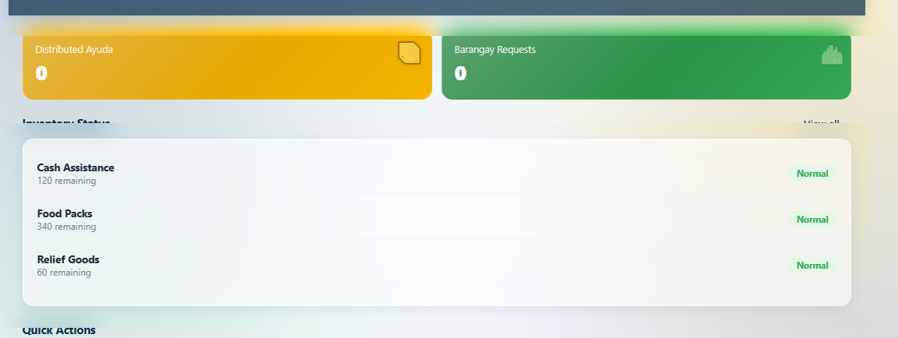

Recent Activities remove inventory Status and remover normal word.
- Add CRUD
- Add approval to the beneficiaries

Add upload excel , csv file to the reports
Proper login – logout.
Categorize per ayuda.
Asking view for admin / brgy / district
- Import data beneficiaries
- Add more dummy data

