Enter membrane content lipids for real membrane

Enter protein IDs

Choose the membrane content Dummy atoms / Real atoms

Choose the membrane geometry sphere/circular

Choose the angle of the arch

Choose the distance between membrane two layers

Choose the Radius of the sphere/circle

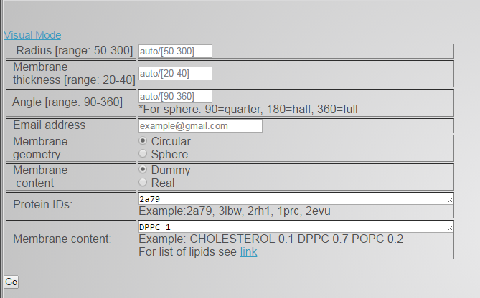

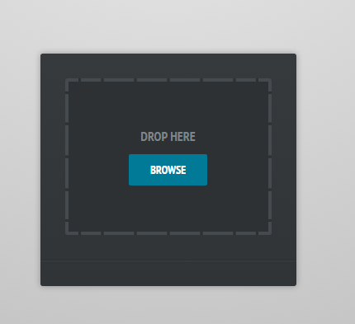

Here you can upload your files