Keeping Good Teachers: Why it Matters and What Leaders Can Do
Educational Leadership, Vol. 60, No. 8 (May 2003), pp. 6-13.

Linda Darling-Hammond

It was overwhelmingly working condition-based things that would make teachers leave…. How teachers are paid was a part of it, but overwhelmingly the things that would destroy the morale of teachers who wanted to leave were the working conditions, … working in facilities, having to pay for supplies, etc.
--A Los Angeles teacher about a high turnover school

“Harris” was a difficult place to work. It was a very big school. The multi- track year-round (schedule) was very hard on teachers. The poor condition of the facilities made it an uncomfortable place to teach. Teachers who had to rove… found that so detrimental to the teaching process and the learning process and the professional growth process that they did not want to continue to have to work in that environment.
-- A California teacher about a high turnover school
I arrived at my first teaching job five years ago, mid year… The first grade classroom in which I found myself had some two dozen ancient and tattered books, an incomplete curriculum, and an incomplete collection of outdated content standards. Such a placement is the norm for a beginning teacher in my district. I was prepared for this placement, and later came to thrive in my profession, because of the preparation I received in my credential program. The concrete things Mills gave me were indispensable to me my first year as they are now: the practice I received developing appropriate curricula; exposure to a wide range of learning theories; training in working with non-English speaking students and children labeled “at risk”… It is the big things, though, that continue to sustain me as a professional and give me the courage to remain and grow: My understanding of the importance of learning from and continually asking questions about my own practice, the value I recognize in cultivating collegial relationships, and the development of a belief in my moral responsibility to my children and to the institution of public education…. I attribute this wholly to the training, education, and support provided to me by Mills.
-- A California teacher from a strong urban teacher education program

What is it that keeps some people in teaching and chases others out? What can be done to increase the holding power of the teaching profession and create a stable, expert teaching force in all kinds of districts? It turns out that the answers to these questions are both predictable and, in some cases, surprising. Most important, it turns out that how schools hire and how they use their resources can make a major difference.

Keeping good teachers should be one of the most important agendas for any school leader. Substantial evidence suggests that, among all school resources, good teachers are the most important determinant of student achievement. Student achievement has been found to be strongly related to teachers’ preparation in both subject matter and teaching methods, as well as to their preparation to work with diverse students (including special needs learners and English language learners). Furthermore, student performance on state tests is significantly higher, both before and after controlling for student poverty, for students whose teachers are fully certified and those who have higher scores on teacher certification tests. Teachers’ experience levels also matters, especially the steep gain in effectiveness that typically occurs after the first few years of teaching. (Although some studies of teachers with exceptionally strong initial teacher preparation have found them to be as effective as veteran teachers.) (For summaries of this research see Darling-Hammond, 2000b and Wilson, Floden, & Ferrini-Mundy, 2001).

Probably the most important thing a school administrator at the school or district level can do to improve student achievement is to attract, retain, and support the continued learning of well-prepared and committed teachers. When teachers have assembled the kind of training and experience that allows them to be successful with students, they constitute a valuable human resource for schools – one that needs to be treasured and supported if schools are to become and remain effective. While recruiting strong teachers is critically important, it is equally important to keep strong teachers, since attrition is a much greater problem in the overall teacher supply picture than is producing enough teachers to fill the nation’s needs. School leaders need to understand the reasons for teacher attrition if they are to develop effective strategies for keeping their best teachers. In this article, I discuss what influences teacher retention and attrition and what school systems can do about it.

Unpacking the dilemmas of teacher supply and demand

It is because of the strong evidence about how teachers matter to student achievement that the “No Child Left Behind” Act requires that all schools be staffed by “highly qualified teachers.” Recruiting such teachers to all schools is a major challenge, especially in cities and poor rural areas. However, as a nation, we produce many more qualified teachers than we hire. It turns out that a major part of the teacher quality challenge rests with keeping the teachers we prepare. The uphill climb to staff our schools with qualified teachers is made that much steeper if teachers leave in large numbers in the face of difficult conditions and few supports. Since the early 1990s, the annual number of exits from teaching has surpassed the number of entrants by an increasingly large amount, putting pressure on the nation’s hiring systems. For example, while U.S. schools hired 230,000 teachers in 1999, 287,000 left in that year (See figure 1.) Less than 20% of this attrition is due to retirement, and especially in hard-to-staff schools, both teacher dissatisfaction with the conditions of work and many teachers’ lack of preparation are critical components of high turnover (Ingersoll, 2001; Henke, et al., 2000).

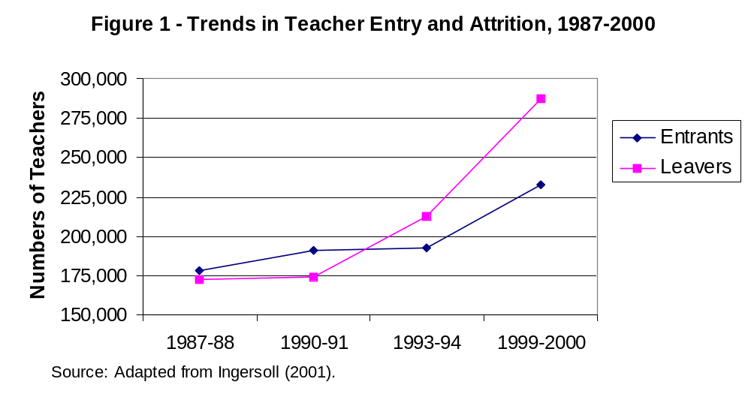

Teaching has long experienced steep attrition in the first few years of teaching, and about one-third of new teachers leave the profession within 5 years. Rates of attrition from individual schools and districts run higher, as they include both “movers,” who leave one school or district for another, and “leavers,” who exit the profession temporarily or permanently. Taken together, movers and leavers particularly affect schools serving poor and minority students. Teacher turnover is 50% higher in high-poverty than in low-poverty schools (Ingersoll, 2001, p. 516), and new teachers in urban districts exit or transfer at higher rates than their suburban counterparts (Hanushek, Kain, & Rivkin, 1999).

There are many reasons for higher attrition from high-poverty schools. Nationally, teachers in schools serving the largest concentrations of low-income students earn, at the top of the scale, salaries one-third less than those in higher income schools (National Center for Education Statistics, 1997), while they also face lower levels of resources, poorer working conditions, and the stresses of working with students and families who have a wide range of needs. Furthermore, more teachers in these schools are underprepared and unsupported, and research also shows that the extent of preparation for teaching have a major effect on whether individuals will stay in the profession.

The costs of early attrition from teaching are enormous. A recent study in Texas, for example, estimated that the state’s annual turnover rate of 15%, which includes a 40% turnover rate for public school teachers in their first three years, costs the state a “conservative” $329 million a year, or at least $8,000 per recruit who leaves in the first few years of teaching (Texas Center for Educational Research, 2000). The study found that only 17% of this attrition was due to retirement. Adding the organizational costs of termination, substitutes, new training, and lost learning sends the estimated national price tag as high as $2.1 billion a year. Instead of using funds for needed school improvements, monies are spent in a manner that produces little long-term payoff for student learning.

Given the strong evidence that teacher effectiveness increases sharply after the first few years of teaching (Kain & Singleton, 1996), this kind of churning in the beginning teaching force wastes money and reduces productivity in education overall, since the system never realizes the eventual payoff from its investment in novices.

In addition, when schools have large concentrations of under-prepared teachers they create a drain on schools’ financial as well as human resources. One recent estimate indicates that in California, for example, more than 20% of schools have more than 20% of their staffs teaching without credentials. These inexperienced, underprepared teachers are assigned almost exclusively to low-income schools serving students of color (Shields et al., 2001). In a startling number of urban schools across the country, a large share of teachers are inexperienced or underqualified or both. Such schools must continually pour money into recruitment efforts and professional support for new teachers, many of them untrained, without reaping dividends from these investments. Other teachers, including the few who could serve as mentors, are stretched thin and feel overburdened by the needs of their colleagues as well as their students. Scarce resources are squandered trying to re-teach the basics each year to teachers who come in with few tools and leave before they become skilled (Carroll, Reichardt, & Guarino, 2000.) As a principal in one such school noted:

(H)aving that many new teachers on the staff at any given time meant that there was less of a knowledge base. It meant that it was harder for families to be connected to the school because -- you know, their child might get a new teacher every year. It meant there was less cohesion on the staff. It meant that every year, we had to recover ground in professional development that had already been covered and try to catch people up to sort of where the school was heading.

Most important, such attrition consigns a large share of children in high turnover schools to a continual parade of relatively ineffective teachers. Unless policies are developed to stem such attrition through better preparation, assignment, working conditions, and mentor support, the goal of ensuring qualified teachers for all students – especially those targeted by No Child Left Behind – cannot be met.

Factors Influencing Teacher Attrition

In all schools, regardless of school wealth, student demographics, or staffing patterns, the most important resource for continuing improvement is the knowledge and skill of the school’s best-prepared and most committed teachers. Four major factors exert strong influences on whether and when teachers leave specific schools or the profession entirely:

- Salaries
- Working conditions
- Preparation
- Mentoring support in the early years of teaching

Among teachers who leave their jobs due to dissatisfaction, salaries and working conditions such as poor administrative support run neck and neck as reasons for leaving. The relative importance of these features varies depending on the conditions of work that teachers experience. For example, poor administrative supports are mentioned more often by teachers leaving low-income schools where working conditions are often more stressful, while salaries are mentioned somewhat more often by teachers leaving more affluent schools.

Salaries. Even if teachers may be more altruistically motivated than some other workers, teaching must compete with other occupations for talented college and university graduates each year. To attract its share of the nation’s college-educated talent and to offer sufficient incentives for professional preparation, the teaching occupation must be competitive in terms of wages and working conditions. From this viewpoint, although overall demand can be met, there is reason for concern, because teacher salaries are relatively low and have been declining in relation to other professional salaries throughout the 1990s. (See figure 2.) Even after adjusting for the shorter work year in teaching, teachers earn 15 -40% less than individuals with college degrees who enter other fields.

Teachers are more likely to quit when they work in districts with lower wages and when their salaries are low relative to alternative wage opportunities, especially for teachers in high demand fields like math and science (Brewer, 1996; Mont and Rees, 1996; Murnane, Singer & Willett, 1989; Murnane and Olsen, 1990; Theobald, 1990; Theobald and Gritz, 1996). Salary differences seem to matter more at the start of the teaching career (Hanushek, Kain and Rivkin, 1999; Gritz and Theobald, 1996). Among experienced teachers, transfers from one school to another appear to be influenced more by “nonpecuniary factors” like working conditions (Loeb & Page, 2000).

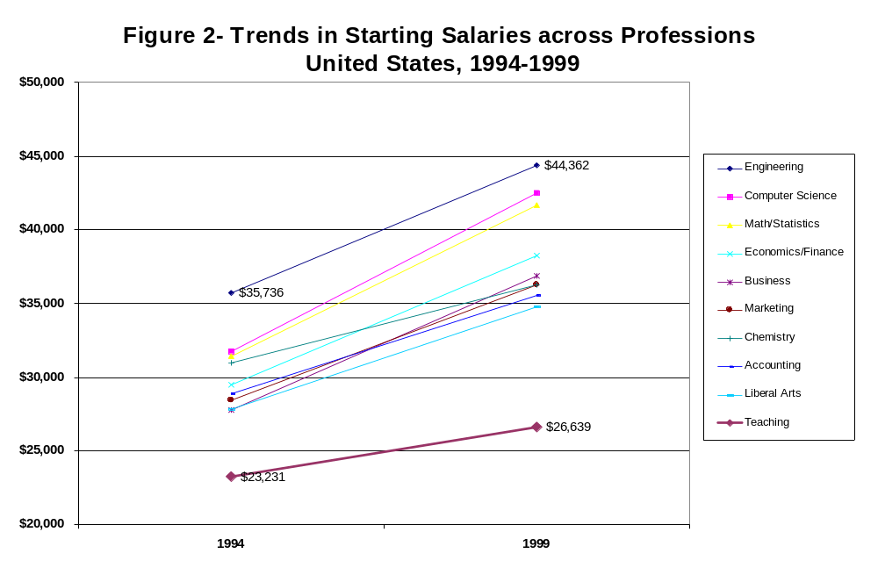

Working Conditions. Surveys of teachers have long shown that working conditions play a major role in decisions to move schools or leave the profession. Teachers’ plans to stay in teaching and their reasons for actually having left are strongly associated with how they feel about administrative support, resources for teaching, and teacher input into decision making (Darling-Hammond, 1997; Ingersoll, 2001, 2002). Further, there are large differences in the support teachers receive in high- versus low-wealth schools. Teachers in more advantaged communities experience easier working conditions, including smaller class sizes and pupil loads and greater influence over school decisions (National Center for Education Statistics, 1997, Table A 4.15). In 1994-95, over one quarter of all school leavers listed dissatisfaction with teaching as a reason for leaving, with those in high-poverty schools more than twice as likely to leave because of dissatisfaction than those in low-poverty schools (Darling-Hammond, 1997).

The high attrition of teachers from schools serving lower-income or lower-achieving students appears to be substantially influenced by the poorer working conditions typically found in schools serving less advantaged students. For example, a survey of California teachers (Harris, 2002) found that teachers in high-minority, low-income schools report significantly worse working conditions – including poorer facilities, less availability of textbooks and supplies, fewer administrative supports, and larger class sizes. Furthermore, teachers surveyed in this study were significantly more likely to say they planned to leave a school soon if the working conditions were poor. An analysis of these California data found that serious turnover problems at the school level are influenced most by working conditions, ranging from large class sizes and facilities problems to multi-track, year-round schedules and faculty ratings of administrative supports (Loeb, Darling-Hammond, & Luczak, forthcoming). Together with salaries, these factors far outweighed the demographic characteristics of students in predicting turnover at the school level. This finding suggests that working conditions should be one target for policies aimed at retaining qualified teachers in high-need schools.

Teacher Preparation and Support. A factor often overlooked in economic analyses is the effects of preparation on teacher retention. A growing body of evidence indicates that attrition is unusually high for those who lack initial preparation. A recent NCES report found that 29% of new teachers who had not had student teaching left within five years, as compared with only 15% of those who had had student teaching as part of a teacher education program (Henke, et al., 2000). This same study found that 49% of uncertified entrants left within five years, as compared to only 14% of certified entrants. In California, the state standards board found that 40% of emergency permit teachers leave the profession within a year, and two-thirds never receive a credential.

Studies have also found that alternate routes into teaching that offer only a few weeks of training before assumption of full teaching responsibilities have very high attrition rates, ranging from 46% over three years for the Massachusetts MINT program (Fowler, 2002) to an average of 80% attrition after two years in the classroom for Teach for America recruits in Houston, Texas (Raymond, Fletcher, & Luque, 2001).

In addition, a growing body of evidence indicates that better prepared teachers stay longer. For example, a longitudinal study of 11 programs found that those who complete redesigned 5-year teacher education programs enter and stay in teaching at much higher rates than 4-year teacher education graduates from the same institutions (Andrew & Schwab, 1995). These programs allow both a major in a disciplinary field, plus intensive training for teaching and long-term student teaching. In addition, both 4- and 5-year teacher education graduates enter and stay at higher rates than teachers hired through alternatives that offer only a few weeks of training before recruits are left on their own in the classroom (Darling-Hammond, 2000a). These differences are so large that, taking into account the costs to states, universities, and school districts for preparation, recruitment, induction, and replacement due to attrition, the actual cost of preparing a career teacher in the more intensive 5-year programs is actually much less than that of preparing a greater number of teachers in short-term programs of only a few weeks in duration, who leave earlier. (See Figure 3, below.)

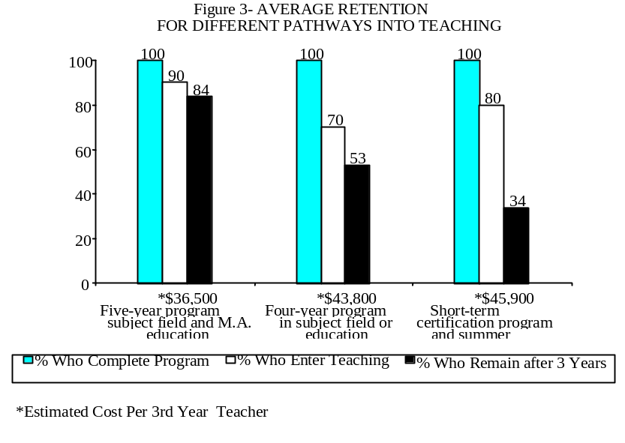

Graduates of extended 5-year programs also report higher levels of satisfaction with their preparation, and receive higher ratings from principals and colleagues.

In 2000, new recruits who had had training in specific aspects of teaching (e.g. selection and use of instructional materials, child psychology, and learning theory), who experienced practice teaching, and who received feedback on their teaching left the profession at rates half as great as those who had no training in these areas (National Commission on Teaching & America’s Future [NCTAF], 2003). Similarly, first-year teachers who feel they are well prepared for teaching are much more likely to plan to stay in teaching than those who feel poorly prepared. On such items as preparation in planning lessons, using a range of instructional methods, and assessing students, two-thirds of those reporting strong preparation intend to stay as compared to only one-third of those reporting weak preparation. (See figure 4.) In these studies and others, graduates of teacher education programs felt significantly better prepared and more efficacious than those entering through alternative routes or with no training (Darling-Hammond, Chung, and Frelow, 2002; NCTAF, 2003).

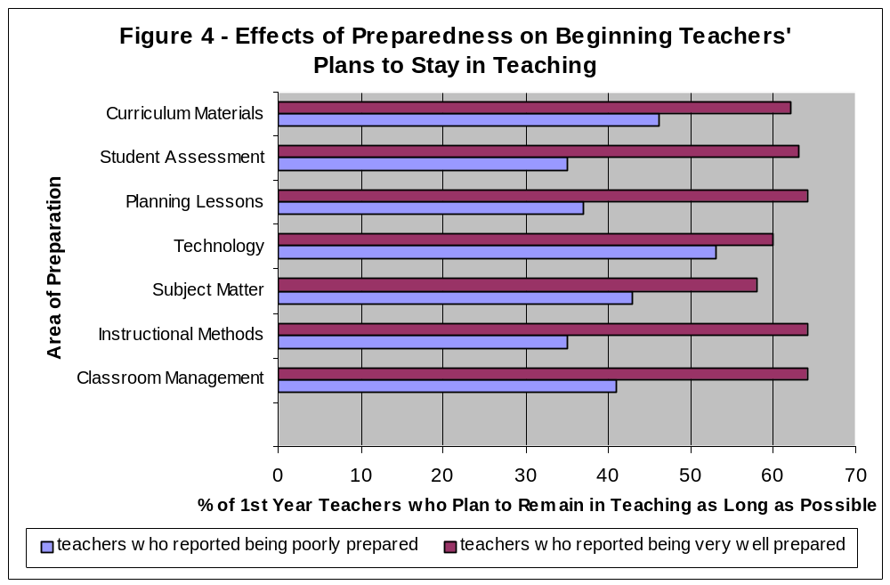

The commitment effects of strong initial preparation are enhanced by equally strong induction and mentoring in the first years of teaching. A number of studies have found that well designed mentoring programs improve retention rates for new teachers along with their attitudes, feelings of efficacy, and their instructional skills.

Districts like Cincinnati, Columbus, and Toledo, Ohio and Rochester, New York, have reduced attrition rates of beginning teachers by more than two-thirds (often from levels exceeding 30% to rates of under 5%) by providing expert mentors with release time to coach beginners in their first year on the job (NCTAF, 1996). These young teachers not only stay in the profession at higher rates but become competent more quickly than those who must learn by trial and error. Each program was established through collective bargaining and is governed by a panel of seven to ten teachers and administrators. The governing panel selects consulting teachers through a rigorous evaluation process that examines teaching skills and mentoring abilities. One reason for the programs’ success is the intensive assistance provided by consulting teachers who are freed up to focus on this job. A full-time consulting teacher might mentor up to 10 teachers in his or her subject matter area. A part-time consulting teacher would take on fewer. This ensures that adequate help and documentation will occur over the course of the year. Mentors meet with one another to share what they are learning about mentoring. The value of the advice offered is increased by the high levels of expertise of the consulting teachers, who are selected for teaching excellence and who generally are matched by subject area and grade level with the teacher being helped. As Carolyn Nellon, Cincinnati’s Director of Human Resources, explained about the sense of responsibility for supporting other teachers’ practice the program has inspired:

I think [there was] a generation of people who didn’t have anyone there to help them when they walked in the door. They went into their room and shut the door. And every year some kids would come through, and however they [taught], that was what was done. The bottom line is, children come first. We are here for the children. We’re professional educators and are here to teach children. That is a driving factor of the Peer Assistance and Evaluation Program.

On the state level, induction programs that are tied to high quality preparation can be doubly effective. In Connecticut, cooperating teachers are trained to use the state portfolio assessment system for beginning teachers that their student teachers will later encounter when they undertake independent classroom teaching. Districts who hire beginning teachers must also provide them with mentors who are also trained in the state teaching standards and portfolio assessment system that were introduced as part of reforms during the 1990s. These reforms also raised salaries and standards for teachers, requiring more preparation in content and pedagogy before entry, and created an assessment of teaching for professional licensure modeled after that of the National Board for Professional Teaching Standards. As two beginning teachers in two different districts noted of this connected system:

The additional benefit of these programs is the new lease on life for many veteran teachers as well. Expert veterans need ongoing challenges to remain stimulated and excited about staying in the profession. Many say that mentoring and coaching other teachers creates an incentive for them to remain in teaching as they gain from both learning from and sharing with other colleagues.

Designing effective mentoring programs is key to reaping these benefits. Although more states are beginning to require induction programs, not all are equally effective. In an assessment of one of the oldest programs, California’s Beginning Teacher Support and Assessment (BTSA) Program, early pilots featuring carefully designed mentoring systems found rates of beginning teacher retention exceeding 90% in the first several years of teaching. However, as the program has scaled up with more uneven implementation across the state, a recent study reported that only 47% of BTSA participants received classroom visits from their support provider at least monthly. Often, districts provided orientation sessions and workshops rather than on-site coaching and mentoring, which is the most powerful component of induction programs (Shields, et al., 2001, p. 101). While the number of state induction programs for beginning teachers has increased from 7 in 1996-97 to 33 in 2002, only 22 states fund these programs (NCTAF, 2003). In order to reap the gains that well-designed programs have realized, state and local induction programs will need to include support for high-quality mentoring.

Conclusion: What School Leaders Can Do

These findings suggest several lessons for educational policy and practice:

- While investments in competitive salaries are important, keeping good teachers – both novices and experienced teachers – is equally a matter of attending to key working conditions that matter to them. In addition to those often considered, like class sizes, teaching loads, and the availability of materials, these include teacher participation in decisionmaking, strong and supportive instructional leadership from principals, and collegial learning opportunities.

- Seeking out and hiring better prepared teachers has many payoffs and savings in the long-run, both in terms of lower attrition and higher levels of competence, which reduce later costs for dealing with unnecessary student failure as well as unnecessary teacher failure.

- When the high costs of attrition are calculated, many of the strategic investments needed to support competent teachers in staying, such as mentoring for beginners and ongoing learning and leadership challenges for veterans, actually pay for themselves in large degree.

As a number of studies have found, there is a magnetic effect when school systems make it clear that they are committed to finding, keeping, and supporting good teachers as a primary focus of school and district management. In urban centers just as in suburban and rural districts, good teachers gravitate to places where they know they will be appreciated; they are sustained by the other good teachers who become their colleagues; and together these teachers become a magnet for still others who are attracted to environments where they can learn from their colleagues and create success for their students. Great school leaders create great school environments for accomplished teaching to flourish and grow.

References

Andrew, M. & Schwab, R.L. (1995). Has reform in teacher education influenced teacher performance? An outcome assessment of graduates of eleven teacher education programs. Action in Teacher Education, 17: 43-53.

Brewer, D.J. (1996). Career paths and quit decisions: Evidence from teaching. Journal
Labor Economics, 14(2) (April), 313-339.

Carroll, S., Reichardt, R. & Guarino, C. (2000). The distribution of teachers among
California’s school districts and schools. Santa Monica, CA: RAND Corporation.

Darling-Hammond, L. (1997). Doing what matters most: Investing in quality teaching. New York: National Commission on Teaching and America's Future.

Darling-Hammond, L. (2000a) Solving the dilemmas of teacher, supply, demand, and quality. New York: National Commission on Teaching and America’s Future.

Darling-Hammond, L. (2000b). Teacher quality and student achievement: A review of state policy evidence. Educational Policy Analysis Archives, 8, (1). http://epaa.asu.edu/epaa/v8n1.

Darling-Hammond, L., Chung, R., & Frelow, F. (2002). Variation in teacher preparation: How well do different pathways prepare teachers to teach? Journal of Teacher Education, 53 (4): 286-302.

Gritz, R. M. & Theobald, N.D. (1996). The effects of school district spending priorities on length of stay in teaching. Journal of Human Resources 31 (3): 477-512.

Hanushek, E.A., Kain, J.F., & Rivkin, S.G. (1999). Do higher salaries buy better teachers? Working Paper 7082. Cambridge, MA: National Bureau of Economic Research.

Harris, P. (2002). Survey of California teachers. Peter Harris Research Group.

Henke, R., Chen, X., & Geis, S. (2000). Progress through the teacher pipeline: 1992-93 college graduates and elementary/secondary school teaching as of 1997. Washington, DC: National Center for Education Statistics, U.S. Department of Education.

Ingersoll, R. M. (2001). Teacher turnover and teacher shortages: An organizational analysis. American Educational Research Journal, 38 (3): 499-534.

Ingersoll, R.M. (2002). Out-of-field teaching, educational inequality, and the organization of schools: An exploratory analysis. Seattle: Center for the Study of Teaching and Policy, University of Washington.

Kain, J.F. & Singleton, K. (1996). Equality of educational opportunity revisited. New England Economic Review (May-June): 87-111.

Loeb, S., Darling-Hammond, L., & Luczak, J. (forthcoming). Teacher turnover: The role of working conditions and salaries in recruiting and retaining teachers. Stanford: Stanford University School of Education.

Loeb, S., & Page, M. (2000). Examining the link between teacher wages and student outcomes: The importance of alternative labor market opportunities and non-pecuniary variation. Review of Economics and Statistics, 82 (3): 393-408.

Mont, D., & Rees, D.I. (1996). The influence of classroom characteristics on high school teacher turnover. Economic Inquiry, 34: 152-167.

Murnane, R.J. and Olsen, R. J. (1990). The effects of salaries and opportunity costs on length of stay in teaching: Evidence from North Carolina. The Journal of Human Resources 25 (1): 106-124.

Murnane, R. J., Singer, J. D., & Willett, J. B. (1989). The influences of salaries and opportunity costs on teachers’ career choices: Evidence from North Carolina. Harvard Educational Review, 59, (3) 325-346.

National Center for Education Statistics (NCES). (1997). America's teachers: Profile of a profession, 1993-94. Washington, DC: U.S. Department of Education.

National Commission on Teaching and America's Future (NCTAF) (2003). No Dream Denied. New York: Author.

National Commission on Teaching and America's Future (NCTAF) (1996). What matters most: Teaching for America's future. New York: Author.

Raymond, M., Fletcher, S., & Luque, J. (2001, Teach for America: An Evaluation of Teacher Differences and Student Outcomes in Houston, Texas. CREDO, The Hoover Institution, Stanford University: www.rochester.edu/credo

Shields, P.M., Humphrey, D.C., Wechsler, M.E., Riel, L.M., Tiffany-Morales, J., Woodworth, K., Youg, V.M. & Price,T. (2001). The status of the teaching profession 2001. Santa Cruz, CA: The Center for the Future of Teaching and Learning.

Texas Center for Educational Research (2000). The Cost of Teacher Turnover. Austin, TX: Texas State Board for Teacher Certification (SBEC).

Theobald, N.D. (1990). An examination of the influences of personal, professional, and school district characteristics on public school teacher retention. Economics of Education Review, 9 (3): 241-250.

Theobald, N.D., & Gritz, R.M. (1996). The effects of school district spending priorities on the exit paths of beginning teachers leaving the district. Economics of Education Review, 15 (1): 11- 22.

Wilson, S., Floden, R., & Ferrini-Mundy (2001). Teacher preparation research: Current knowledge, gaps, and recommendations. University of Washington: Center for the Study of Teaching and Policy.

Ingersoll (2001) extrapolates from cross-sectional data on teacher attrition (from the 1999-2000 Schools and Staffing Surveys) to develop a 5-year attrition rate for beginning teachers of 46%; this figure includes private school teachers who have much higher sources of attrition than public school teachers. He calculates a 5-year attrition rate of about 38% for public school teachers. This approach underestimates survival rates because it does not take into account the return to teaching of individuals who left teaching for a year or two for childrearing or further study and re-entered during the first five years – a proportion that, other estimates suggest, could be about 20% of leavers. With this adjustment, the five-year cumulative attrition rate would be just over 30% for public school teachers. Another estimate, using longitudinal data from the 1993-94 Baccalaureate and Beyond surveys, finds a 4-year attrition rate of about 20% for teachers who entered teaching directly after college (Henke, et al., 2000).
Analyses conducted by Richard Ingersoll show that 13% of beginning teachers who had had any training in child psychology or learning theory, who had observed other classes, or gotten feedback on their own teaching left the profession in 2000-01. The comparable proportions for beginners who had not had training in these areas ranged from 24 to 27 percent. Whereas 12% of beginners who had had practice teaching left teaching, 24% of those who had not had practice teaching left.

