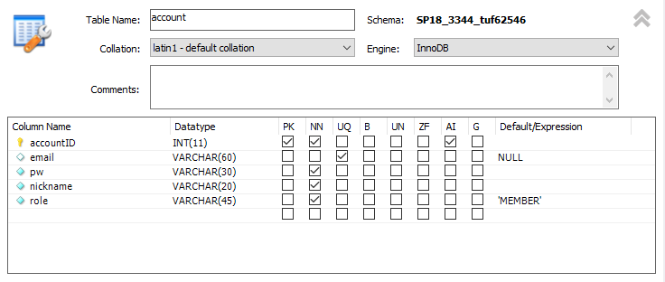

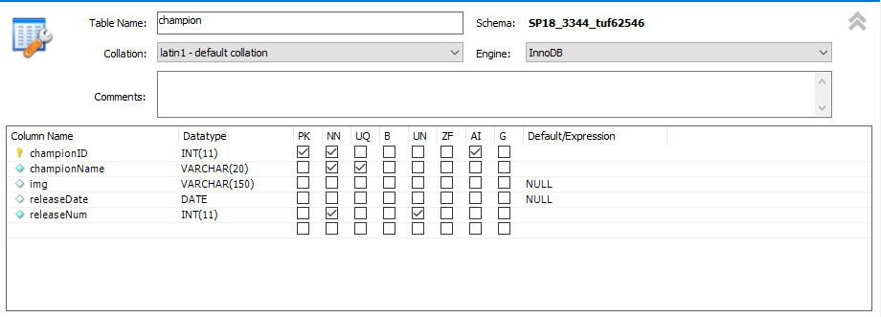

Successful insert into account table:

https://i.gyazo.com/1f6a2bdfd9270cad405c6a64b5d843ba.png

https://i.gyazo.com/41a31ffd49c8c076e23c3a0f0927e151.png

Throwing exception:

https://i.gyazo.com/4af7162dff87e24cb4a12a8bc54b3ba6.png

Updating an account record:

https://i.gyazo.com/dbf3ddb779bc7ad1ab02c9584bcbe261.png

https://i.gyazo.com/6571fe6244db27bddba0d6c9c2ac6689.png

Deleting an account record:

https://i.gyazo.com/5c1b1ea2df5294bb3dccd14ad1962e32.png

https://i.gyazo.com/941c64a528e1c604936509b5d64443cd.png

First select statement:

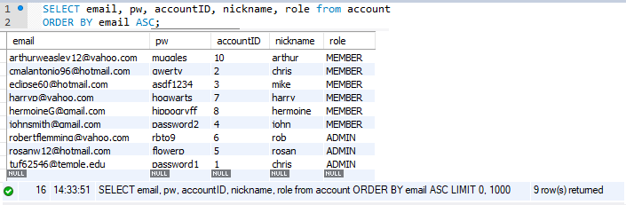

Second select statement:

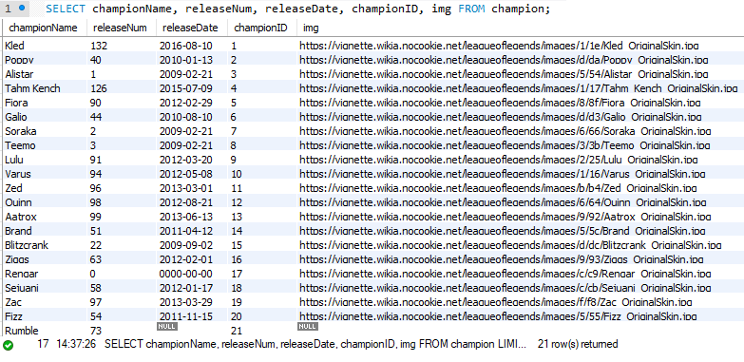

Third select statement:

