Trying to merge from d1 branch to m1 branch. This document with screen shot shows how to resolve the conflicts and merge in myEclipse.

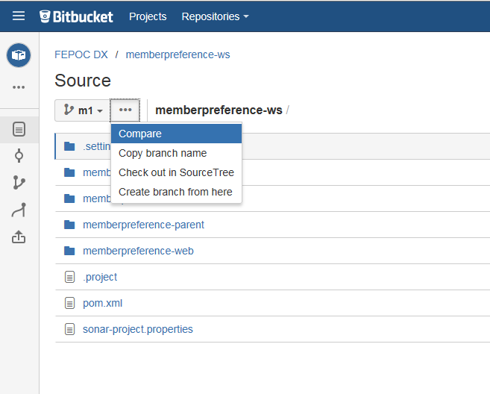

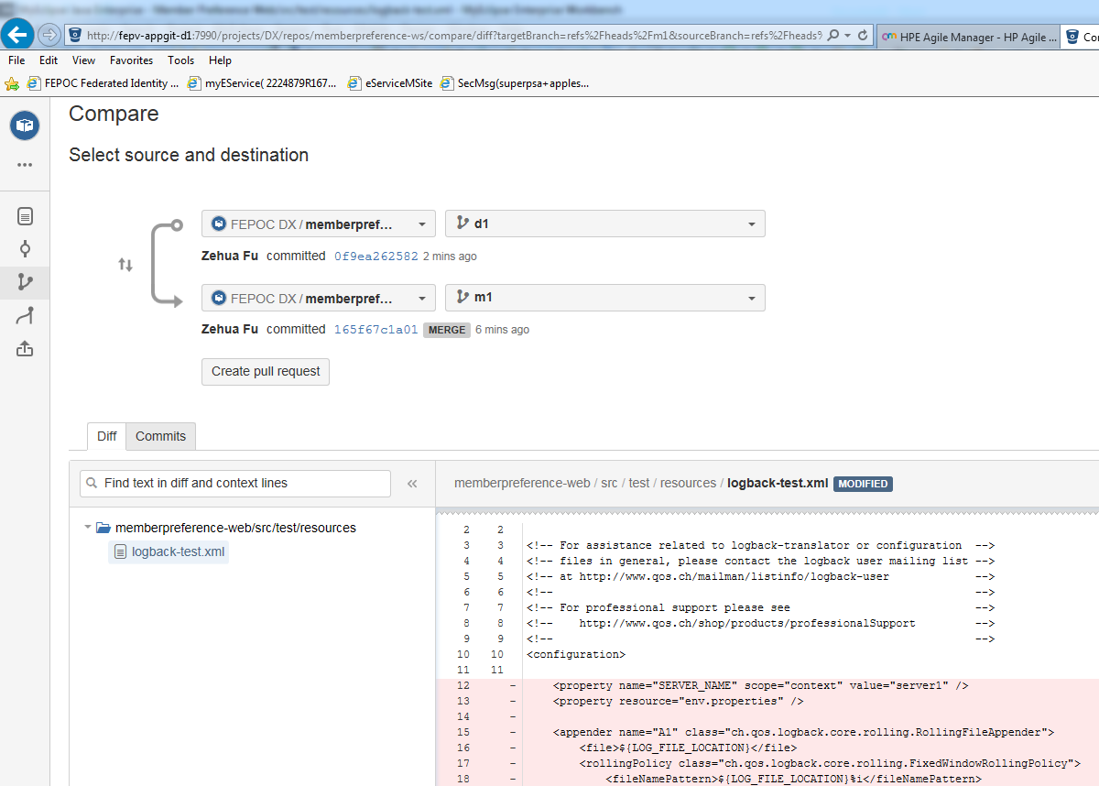

Create a pull request.

After that, click the diff tab, the conflicts will show up with a yellow triangle next to the file name.

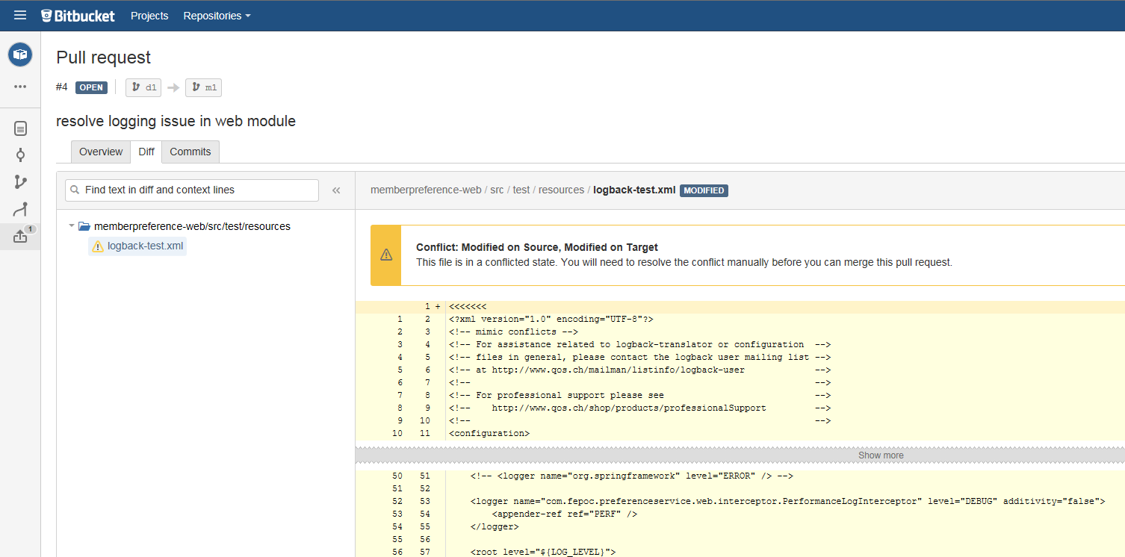

Click decline button on the right upper corner to resolve conflicts from myEclipse.

Go back to myEclipse and switch to the target branch, in this case m1, click Merge.

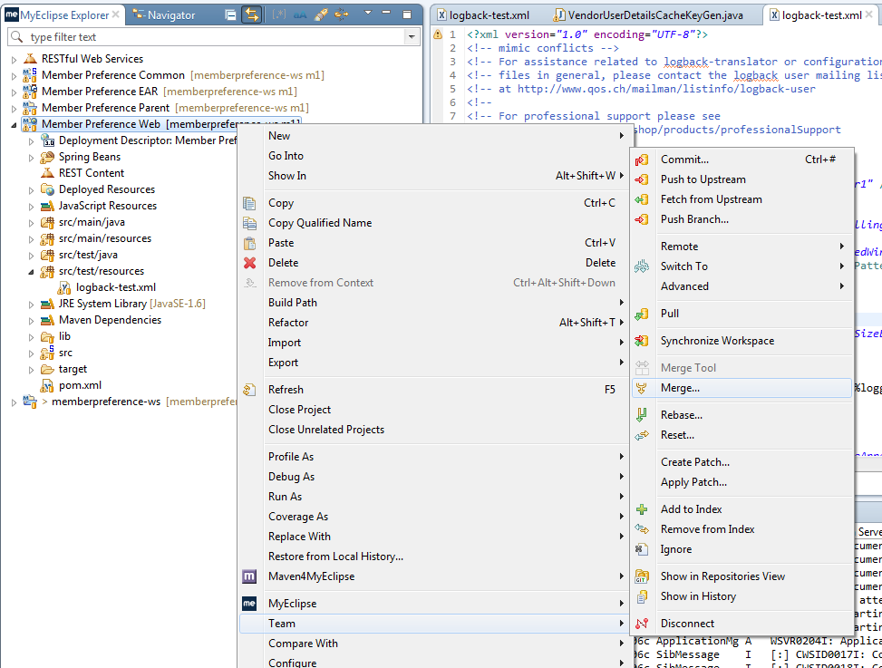

Select the source branch, in this case remote d1. Click Merge button.

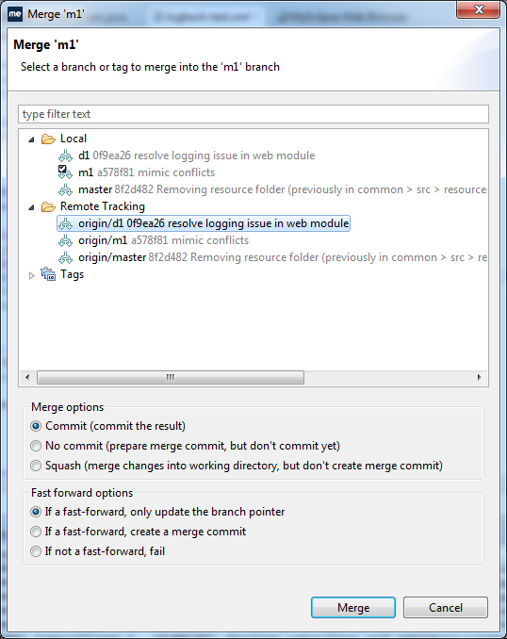

If there is any conflicts, a red conflict mark will show up.

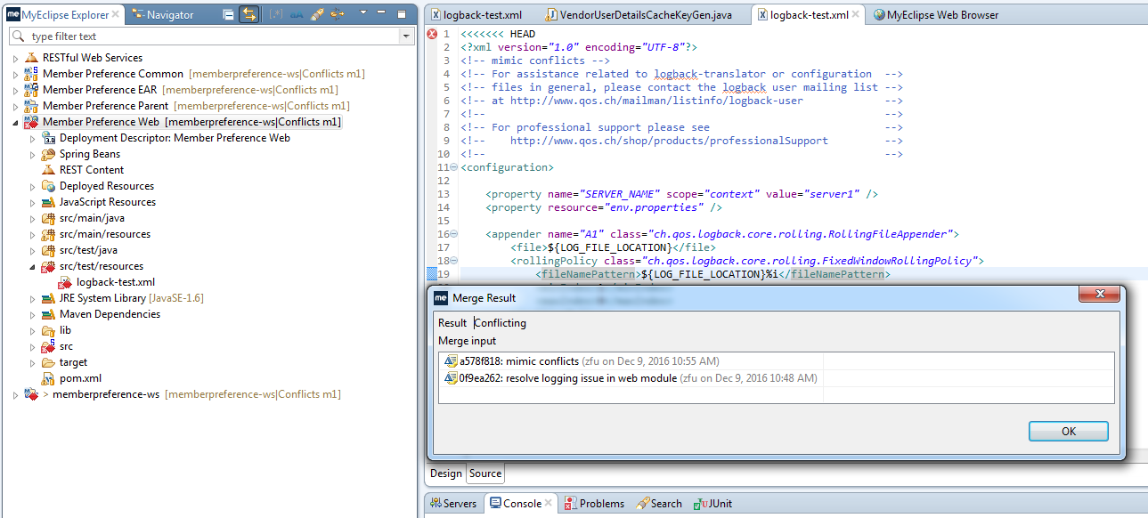

Resolve the conflicts in the file, and synchronize workspace.

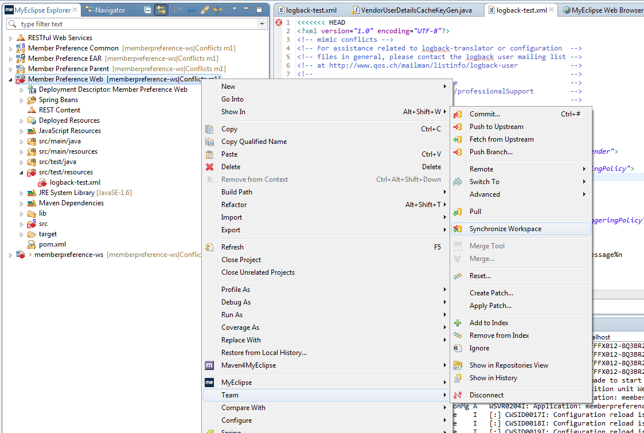

Right click the file, click Mark as Merged.

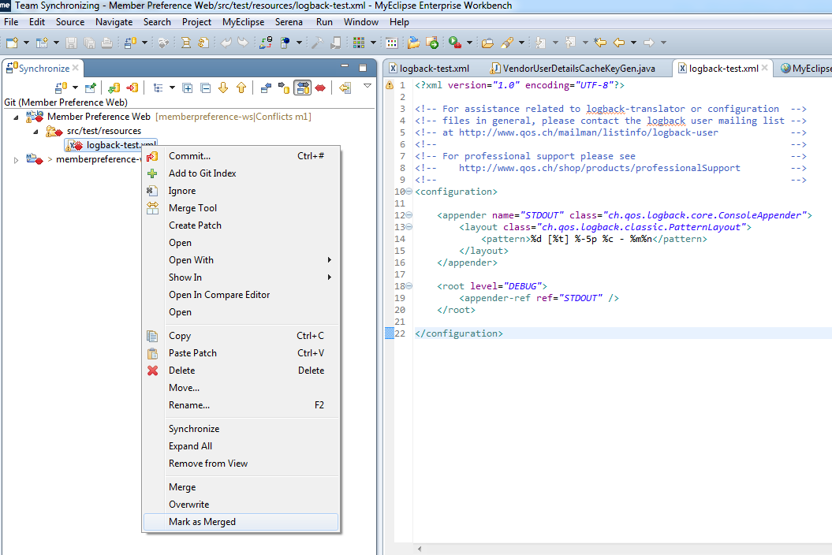

Now the red conflict mark will be gone.

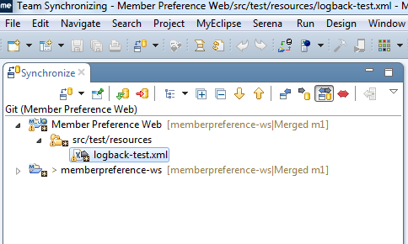

Right click the file again and click “Add to Git Index”

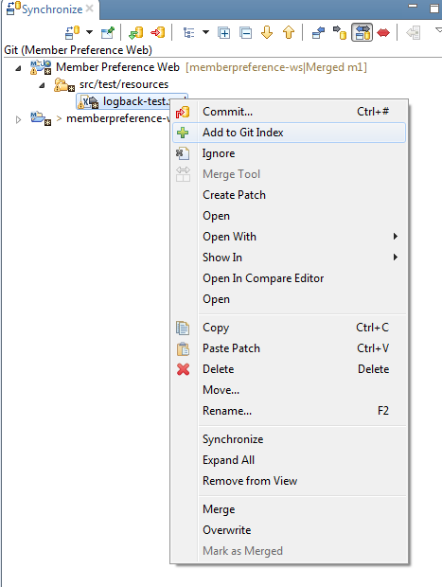

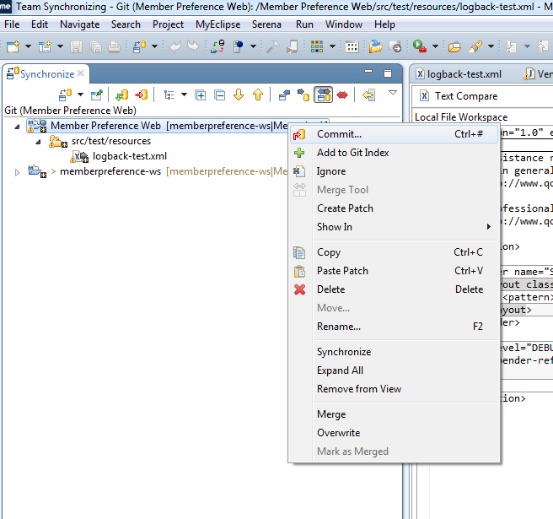

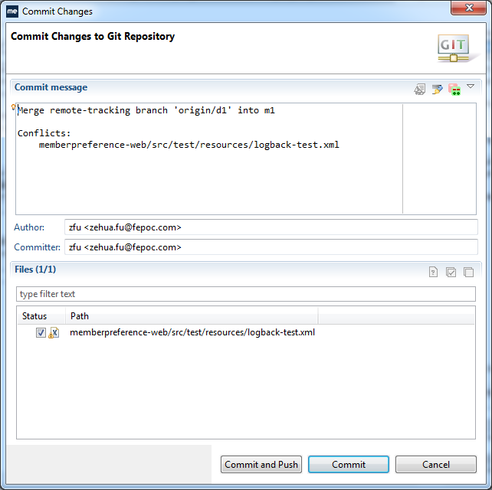

Click button Commit and Push.

