Performing Conceptual Information Integration
By Leveraging Domain Sources
Paul Ramirez, Chris Mattmann

USC
777 S. Citrus Ave. apt. 133, Azusa, CA 91702
5910 Hellman Ave, Los Angeles, CA, 90042
mattmann@usc.edu, pmramire@usc.edu

Abstract
Over the course of this semester we have discussed several levels of information integration. Most of which have focused on how to integrate information structurally and semantically. However, there is another level of information integration which has not been addressed. We believe one can integrate information that is structurally dissimilar. The question becomes how one can discover the way pieces of information conceptually fit together. It is our assertion that by examining domain specific data sources one can learn how information is conceptually related. This would allow html files, images, movies, audio clips, etc. to be related to a particular concept.
Introduction
Information on the internet is integrated inherently by its nature. Content providers are organized around domain names. The websites produced by these content providers are usually based around a central theme or set of concepts. For instance, www.nba.com is base around the central theme of basketball. With thorough examination of content provided by such websites, it is our contention that one could learn the concepts and relations presented by the particular domain or site. These concepts and relations could then be organized graphically into a topographic map like that seen in Figure 1.
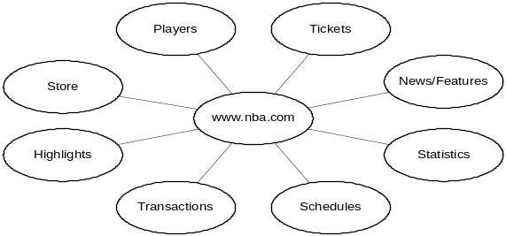

Figure 1.
We believe our approach is quite novel because it looks to examine how certain pieces of information have been integrated by a particular content provider. We feel that this will enable us to correlate information that is more useful to a particular user. Current search engines seem to take a consensus point of view of the information available on the internet. In other words, when you do a search for “java” you get a bunch of results of what “java” is generally understood to be. However, most users have a set of sites they frequent and this weight should be taken into account. Additionally, information seems to gather at particular sources and thus discovering a gold source for a particular concept can be very useful. We aim to uncover these types of sources by allowing the user to give feedback to our search engine and decide which sources are the best.
Project Scope
For our project we will build a conceptual search engine. We will leverage conventional search engines and their ability to restrict queries to particular domains. We will parse the domain sources and mine related concepts by using some of the following techniques.
• Concepts that are physically closer on a particular page are more likely closely related
• Concepts presented in larger text are most likely more important
• The number of times a particular concept appears on a page should increase its relevance.
• Links to other pages can produce a relation to another concept or set of concepts.
• Links to external domains will define relations to external concepts and provide stopping points.
• Navigation on a page which provides links to other concepts.

For our project we will deliver a GUI that displays the results of our conceptual search, a presentation, and a paper. Our preference for presentation days are as follows: April 22, April 29, and April 27.

Copyright © 2002, American Association for Artificial Intelligence (www.aaai.org). All rights reserved.

