Join and Apply: talk track
Prospect to member to product in one application · Navy Federal
One scene per slide in NFCU-Join-and-Apply-Walkthrough.pptx, in this order: the member record, the lead conversion, the case, then the Experience Cloud application from start to finish, then the benefits. About 830 words, roughly 6 minutes spoken.

1. From prospect to member in one application
On screen Navy Federal · Experience Cloud, Service Cloud and Agentforce
Today I want to show you a member relationship that started from nothing. Ethan Carter has never banked with Navy Federal. In one online application he joined, opened his first accounts, and handed the contact center everything it needs to finish the job.
I'll start where your team would see him first, his member record, and then go back and show how he got there.

2. Ethan is a member record, not a web form
On screen Person Account for Ethan Carter
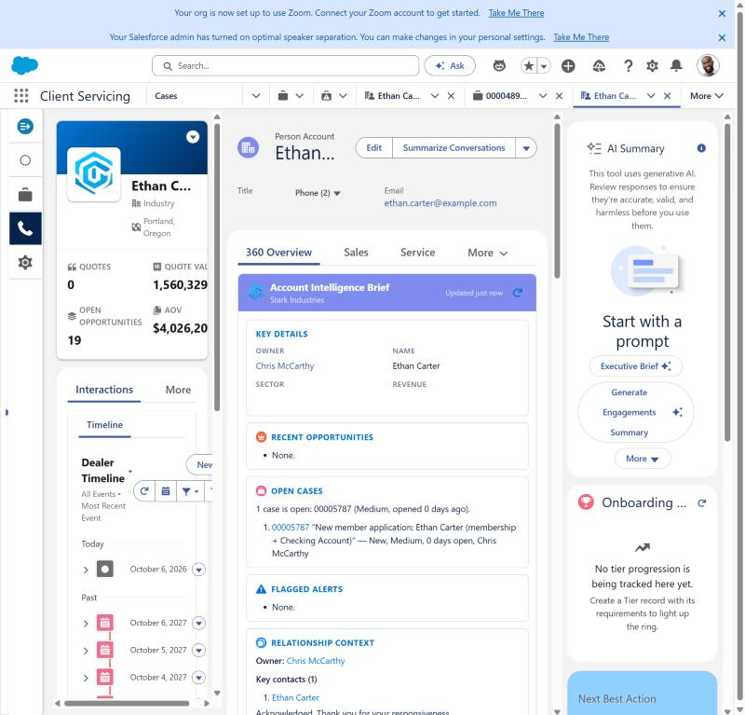 | This is Ethan's Person Account, the single record Navy Federal keeps for him as a member. Nobody keyed this in. It was created the moment he submitted his application online.  Notice the intelligence brief already knows about him: one open case, his new member application. Your rep doesn't have to go looking for what's happening with this person.

3. Prospect to member, automatically
On screen Lead-to-member conversion slide (record IDs and the four records created)
Behind that record is the moment Ethan stopped being a prospect. When he submitted, Salesforce captured him as a Lead, from the website, and immediately converted that Lead into a Person Account and Contact.
That matters for Navy Federal because your prospect data and your member data are the same data. Marketing can see where new members came from, and service sees a real member from the first minute, with no re-keying and no duplicate records.
In the same transaction the system created his membership onboarding record, his product application, the case for your contact center, and attached his documents.

4. The work arrives ready for a member service rep
On screen New member application case in the service console
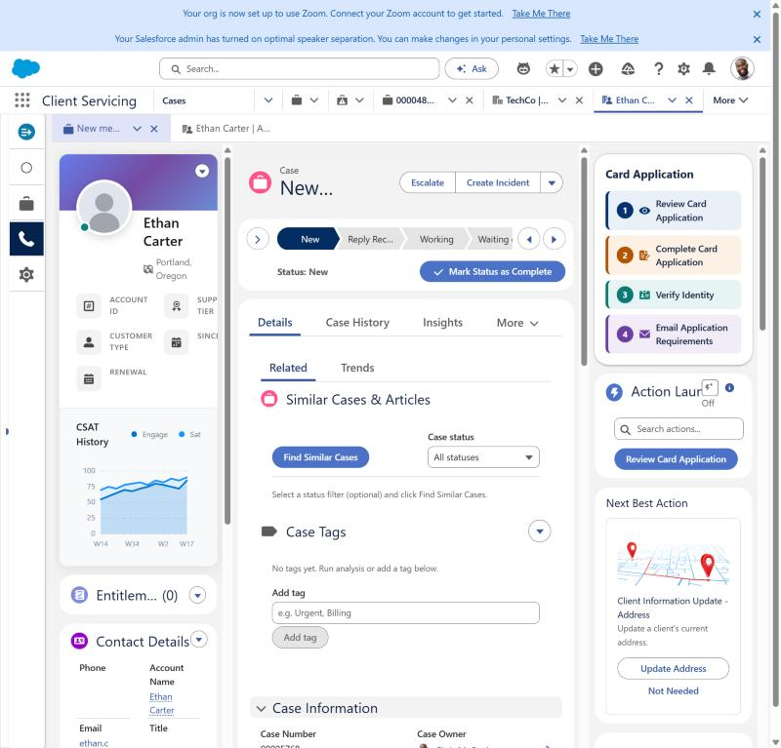 | Here's the case. It's routed like any other case, and it arrives complete: who Ethan is, how he's eligible, what he applied for, and his ID and proof of eligibility already attached.  On the right, the rep's guided actions are numbered one to four: review the application, complete it, verify identity, and email anything that's missing. The Service Rep Assistant is set up with a Navy Federal Member Onboarding topic, so its plan follows the same five steps: confirm eligibility, gather what's needed, submit, verify identity, then activate the account.  So the question for your team becomes, how fast can we verify and open this account, not, who is this person and what did they send us.

5. How Ethan got here
On screen The Experience Cloud application, start to finish
Now let's go back to the beginning and see what Ethan saw on Navy Federal's website.

6. One application to join and apply
On screen Step 1 of 5: Eligibility
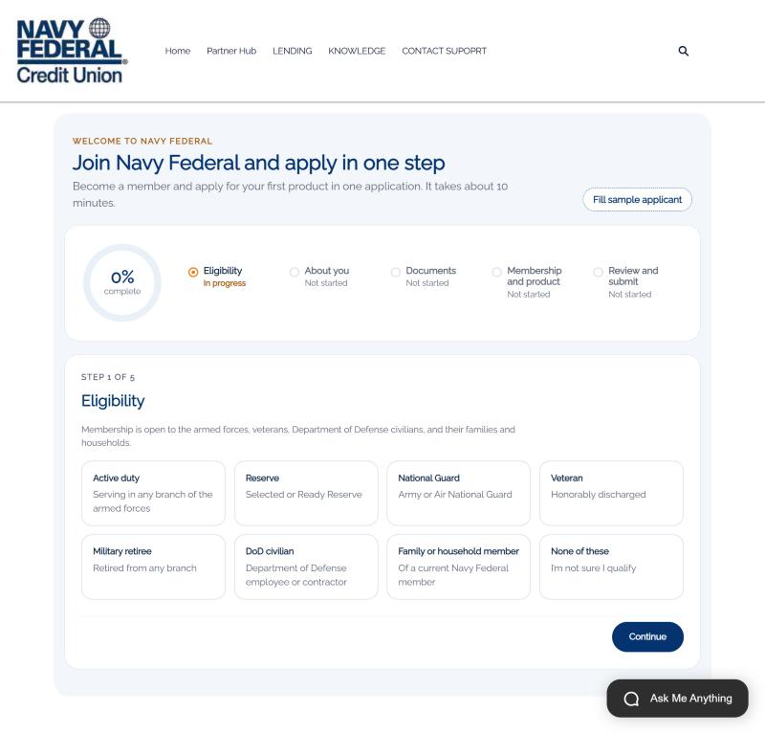 | Ethan lands on one page: join Navy Federal and apply in one step. The progress ring and the five steps tell him exactly how long this will take.  We start with eligibility, because that's the first question a credit union has to answer. He sees every way to qualify, and if he picks none of these, we stop and offer help instead of collecting data we can't use.

7. Household eligibility grows membership
On screen Family or household member of Lauren Bailey
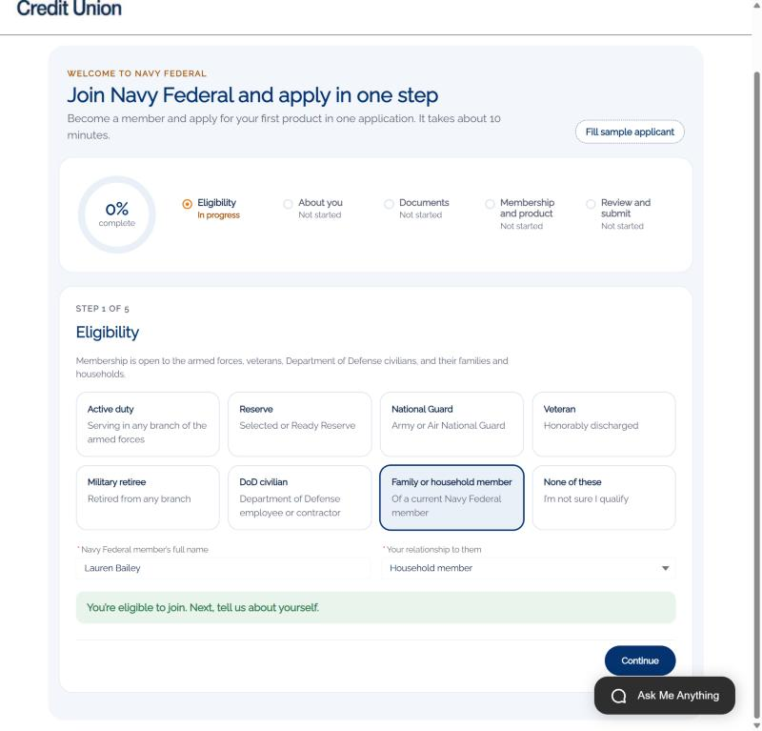 | Ethan isn't military himself. He qualifies as a household member of Lauren Bailey, an existing member and his fiancée. He names her, picks the relationship, and gets an immediate answer: you're eligible to join.  For Navy Federal, this is how existing members bring their households with them.

8. About you, captured once
On screen Step 2 of 5: About you
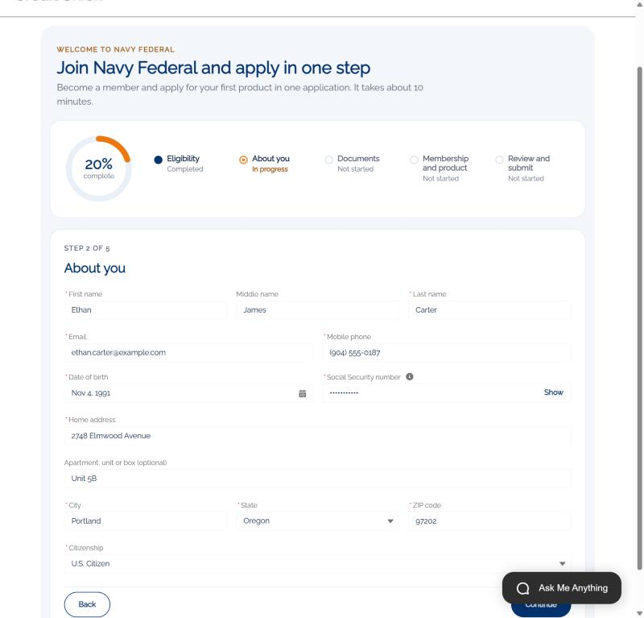 | Next, the basics: name, contact details, date of birth, address and citizenship. His Social Security number is masked as he types and stored encrypted.  He enters this once. The same details become his member record and his product application, so nobody asks him again.

9. Documents up front, not by email later
On screen Step 3 of 5: Documents
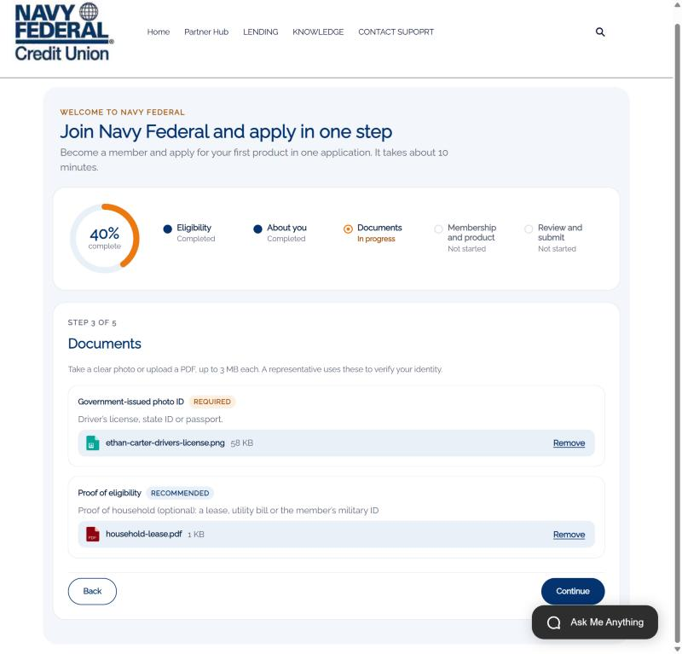 | Then documents. He uploads a photo of his driver's license and proof that he lives in the same household.  Those files go straight onto the case. When your rep opens Verify Identity, the ID and proof are already there, side by side. No email back and forth, no "can you send that again."

10. Membership and a product, together
On screen Step 4 of 5: Membership and product
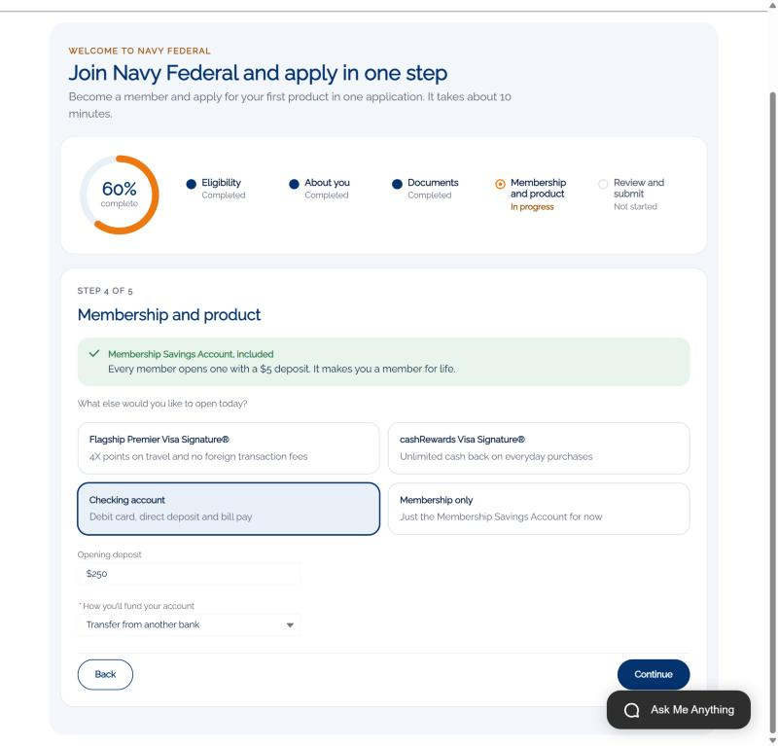 | Here's the heart of it. Every member opens a Membership Savings Account with five dollars, and that's included automatically.  In the same flow, Ethan adds the product he actually came for. He picks checking with a $250 opening deposit, transferred from his current bank. If he'd picked a credit card, we'd ask for income and housing right here.  That's the difference between joining and then applying, and joining by applying.

11. Review, certify, submit
On screen Step 5 of 5: Review and submit
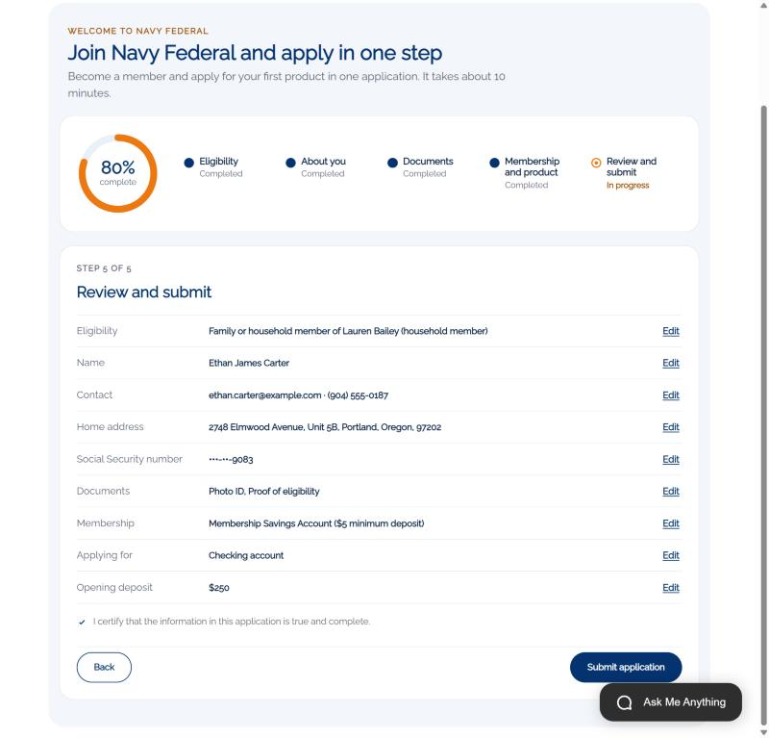 | Before he submits, Ethan sees everything on one screen, can edit any section, and certifies that it's accurate.

12. Welcome to Navy Federal
On screen Case 00005787 · APP-00081 · AF-00033
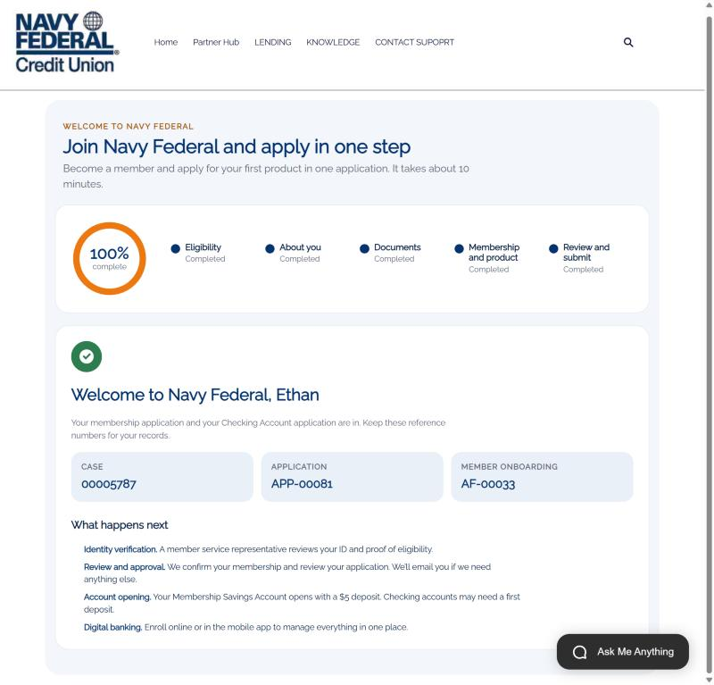 | And he's in. Welcome to Navy Federal, Ethan. He gets his reference numbers and a plain explanation of what happens next: identity verification, review, account opening, then digital banking.  Those numbers are the same case and application we opened at the start. One submission, and the member, the application, the onboarding record, the documents and the case all exist and are linked.

13. What this means for Navy Federal
On screen Benefits slide
So what does this mean for Navy Federal? First, one application instead of two, which means fewer people abandon between joining and applying.
Second, prospects become members automatically, so you have one record per person from the first click. Third, work arrives at the contact center ready, with a guided plan, so reps spend their time verifying and opening accounts, not chasing information.
Fourth, identity verification is faster because the evidence is already there. Fifth, every member becomes a path for their household to join. And it's secure by design: sensitive data is masked and encrypted, and everything is checked on the server.
That's a brand-new relationship, prospect to member to product, in one integrated flow.

