New member journey: talk track
Prospect to funded, primary member · Navy Federal
One scene per slide in NFCU-New-Member-Journey.pptx, in five acts: targeting, join and apply, the banker opens the accounts, the first 30 days, then measure and grow. Targeting is a recommended approach and isn't built in the demo org; identity checks, card activation and the payroll hand-off are simulated. About 1430 words, roughly 10 minutes spoken.

1. A brand-new member, start to finish
On screen Navy Federal · Prospect to funded deposit relationship · Experience Cloud, Service Cloud and Agentforce
Today I want to show you a member relationship that started from nothing. Ethan Carter has never banked with Navy Federal. By the end of this story he's a member with a funded savings and checking account, an active debit card and his paycheck on its way.
We'll follow him through five moments: how we reach him, how he joins and applies, how a banker opens his accounts, his first 30 days, and how Navy Federal measures the whole funnel.

2. Five moments in a new deposit relationship
On screen Journey slide: the five moments
Here's the whole journey on one page. Everything you'll see runs on one platform and one member record, so each step hands off to the next without re-keying.
The first moment, targeting, is the strategy we'd recommend. The four after it are working in the demo org today.

3. Reach the people closest to membership
On screen Act 1 · Targeting
Act one is targeting: who Navy Federal reaches, and where they land.

4. Start with the people closest to membership
On screen Targeting slide: three segments and how a segment becomes a member (concept, not built)
Ethan's story starts before he ever visits the website. The best prospects for Navy Federal are the people already next to a member: spouses, fiancés, adult children and roommates. They're eligible on day one.
With Data Cloud, Navy Federal can build those segments from the household data it already has, then reach them with a personalized email or a member referral that lands on the open account page. To be clear, this targeting piece is our recommended approach, it isn't built in the demo org.
Ethan is exactly that prospect: he's Lauren Bailey's fiancé, and he's been with the same bank since high school.

5. The offer lands on one front door
On screen Open account page · SDO - Consumer site
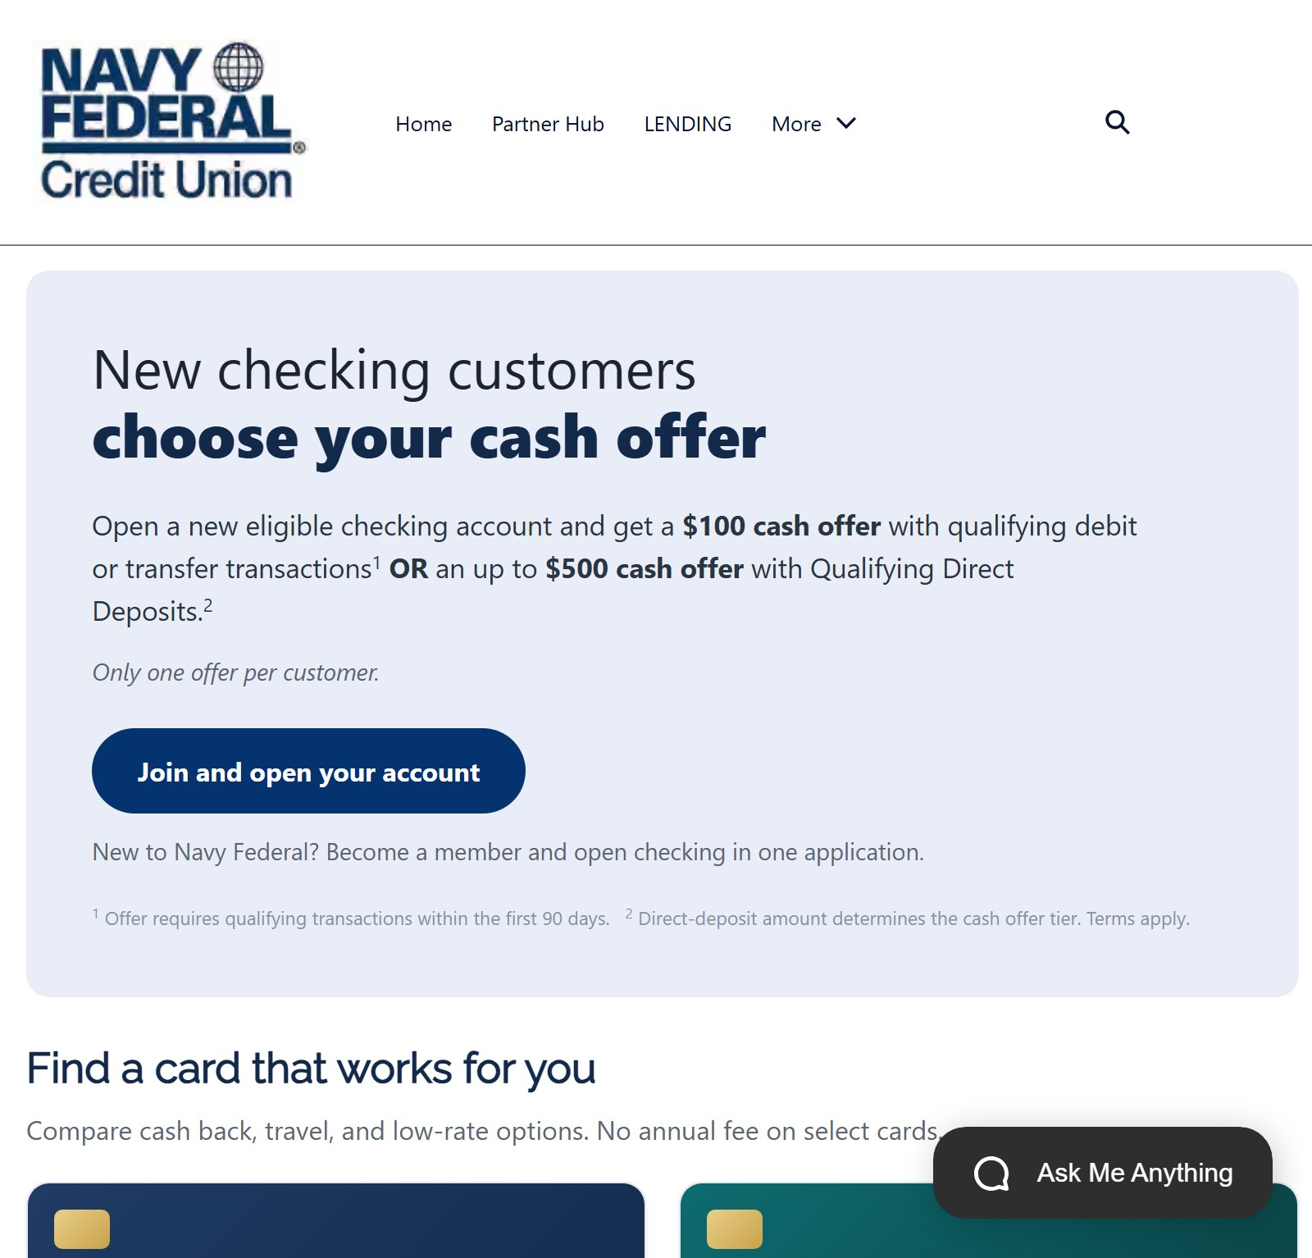 | This is where the campaign lands: the new checking offer. One button, join and open your account, and it goes straight to the application we're about to see.  Because every campaign uses the same front door, Navy Federal can see which segment and which message brought each new member in.

6. Join and apply in one application
On screen Act 2 · Experience Cloud
Act two: Ethan joins Navy Federal and applies for checking in a single application.

7. One application to join and apply
On screen Step 1 of 5: Eligibility
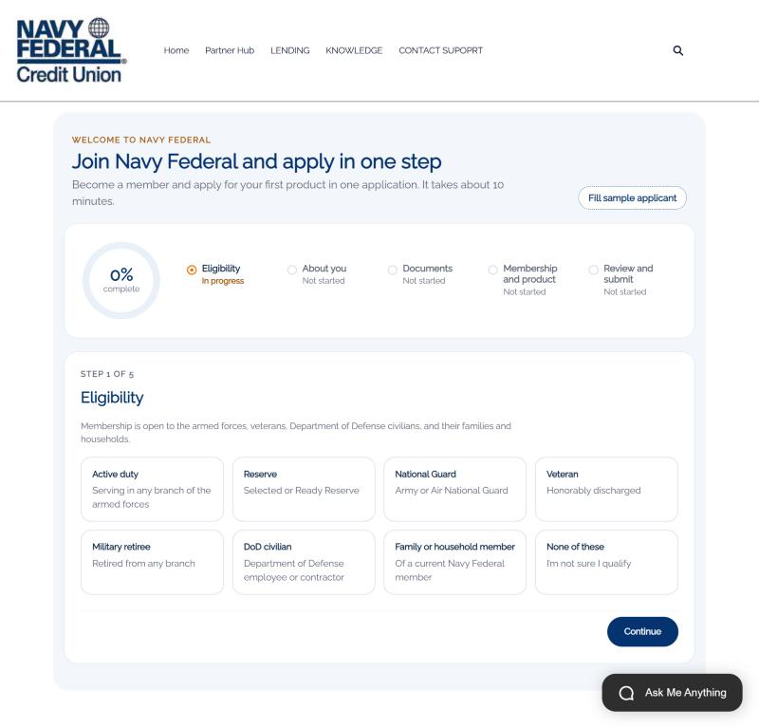 | Ethan lands on one page: join Navy Federal and apply in one step. The progress ring and the five steps tell him exactly how long this will take.  We start with eligibility, because that's the first question a credit union has to answer. He sees every way to qualify, and if he picks none of these, we stop and offer help instead of collecting data we can't use.

8. Household eligibility grows membership
On screen Family or household member of Lauren Bailey
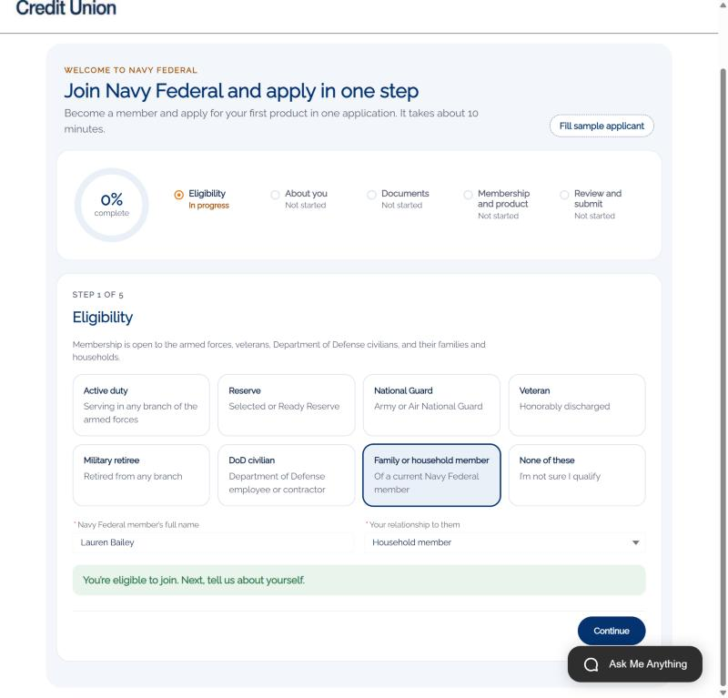 | Ethan isn't military himself. He qualifies as a household member of Lauren Bailey, an existing member and his fiancée. He names her, picks the relationship, and gets an immediate answer: you're eligible to join.  That's the targeting segment paying off. Existing members bring their households with them.

9. About you, captured once
On screen Step 2 of 5: About you
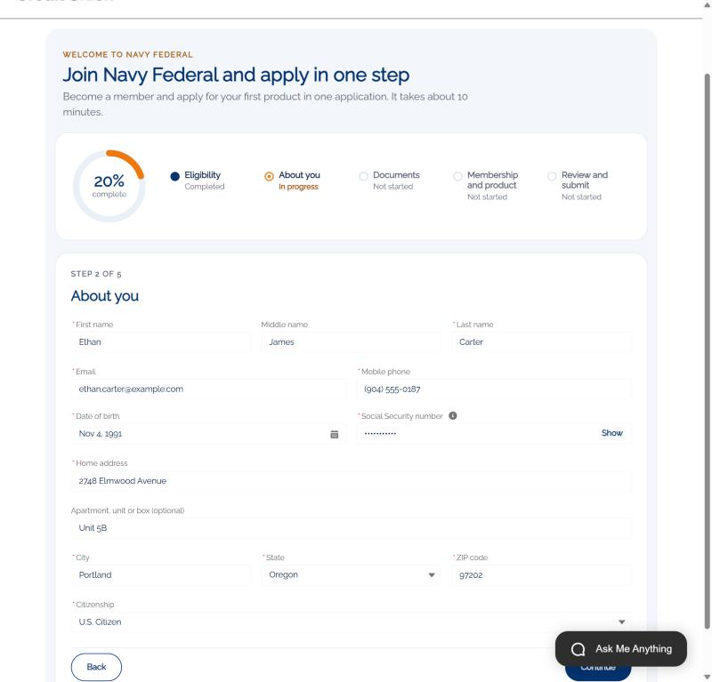 | Next, the basics: name, contact details, date of birth, address and citizenship. His Social Security number is masked as he types and stored encrypted.  He enters this once. The same details become his member record and his account application, so nobody asks him again.

10. Documents up front, not by email later
On screen Step 3 of 5: Documents
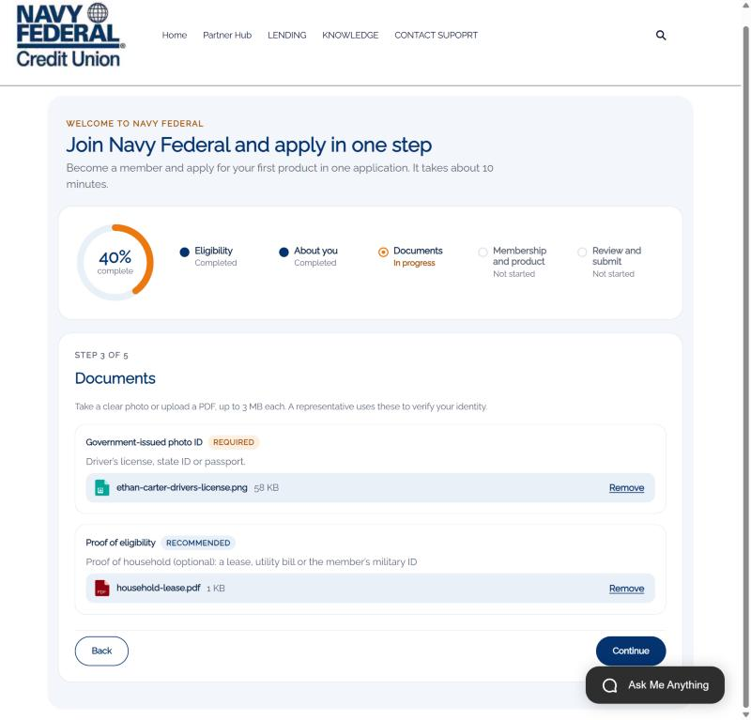 | Then documents. He uploads a photo of his driver's license and proof that he lives in the same household.  Those files go straight onto the case. When the banker opens his accounts, the ID is already there. No email back and forth, no "can you send that again."

11. Membership and checking, together
On screen Step 4 of 5: Membership and product
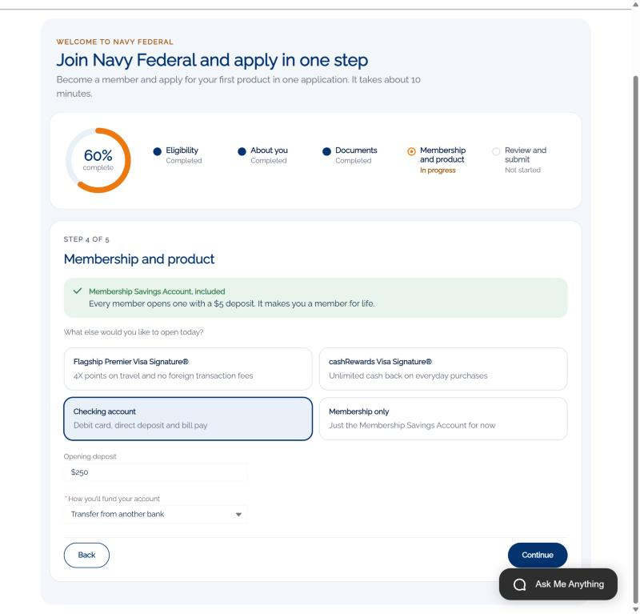 | Here's the heart of it. Every member opens a Membership Savings Account with five dollars, and that's included automatically.  In the same flow, Ethan adds the product he came for: checking, with a $250 opening deposit transferred from his current bank, and a debit card.  That's the difference between joining and then applying, and joining by applying.

12. Review, certify, submit
On screen Step 5 of 5: Review and submit
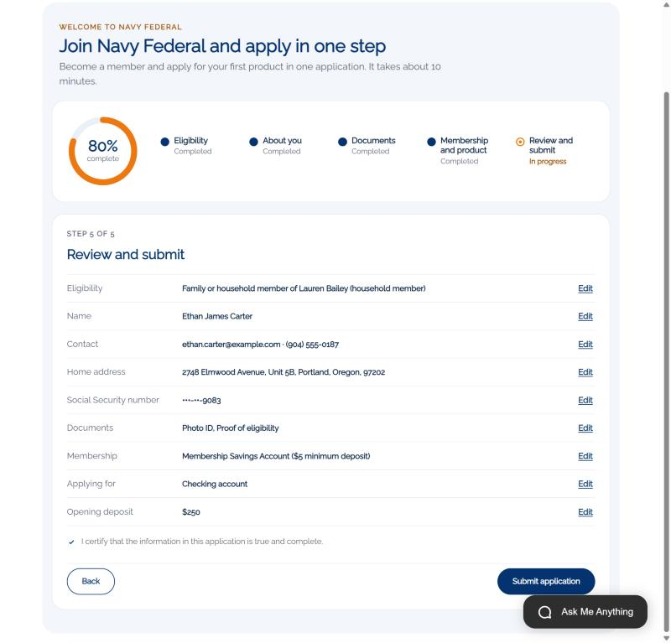 | Before he submits, Ethan sees everything on one screen, can edit any section, and certifies that it's accurate.

13. Welcome to Navy Federal
On screen Case 00005787 · APP-00081 · AF-00033
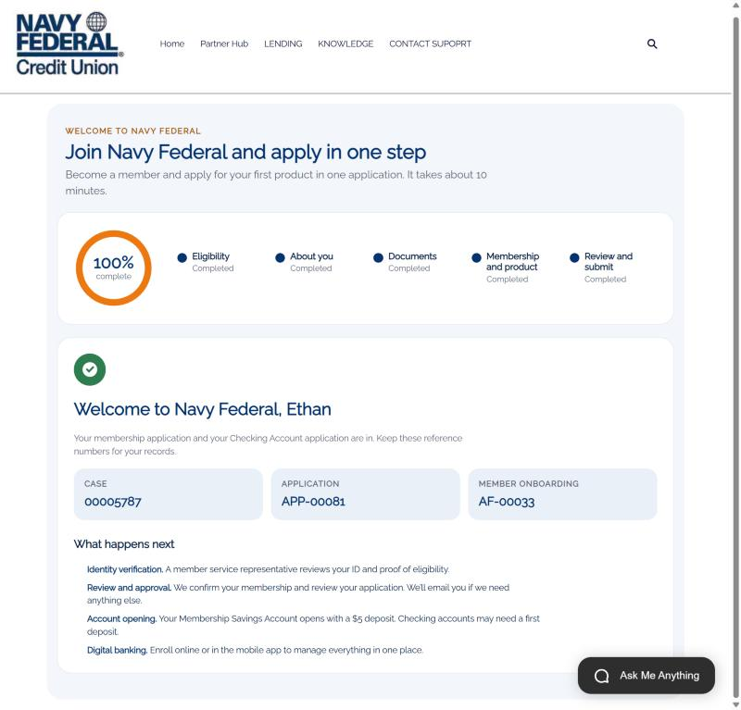 | And he's in. He gets his reference numbers, a plain explanation of what happens next, and a private link to his first 30 days checklist. The same link arrives in his welcome email; in the demo every welcome email goes to the shared demo inbox, so you can open it live.

14. Prospect to member, automatically
On screen Lead-to-member conversion slide (record IDs and the four records created)
Behind that one click, Salesforce captured Ethan as a Lead from the website and immediately converted him into a Person Account. Navy Federal's prospect data and member data are the same data.
In the same transaction the system created his deposit application for savings and checking, his onboarding record, the case for the contact center, and attached his documents.

15. The work arrives ready for a banker
On screen New member application case in the service console
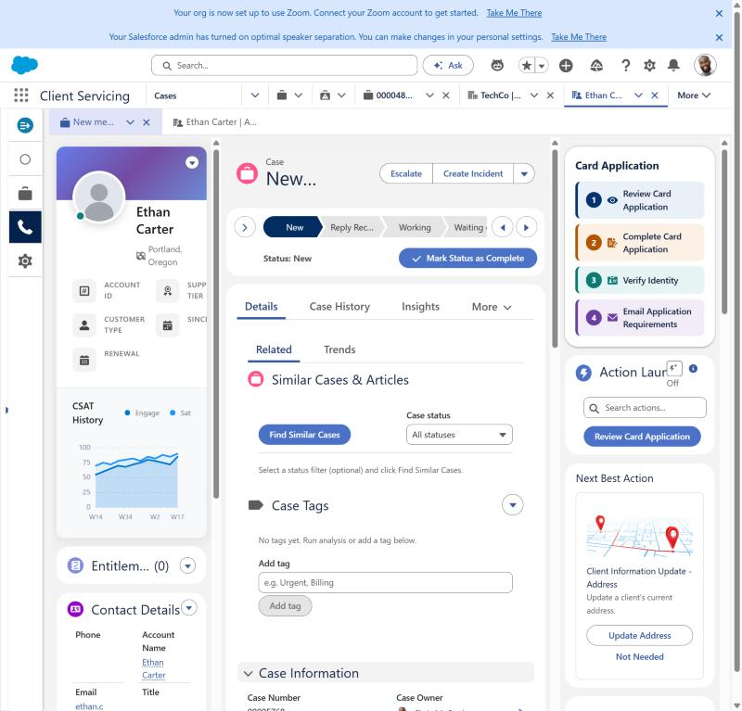 | Here's the case your banker receives. It's routed like any other case, and it arrives complete: who Ethan is, how he's eligible, what he applied for, and his documents.  The Service Rep Assistant is set up with a Navy Federal Member Onboarding topic, so its plan follows the same steps: confirm eligibility, gather what's needed, verify identity, then open the accounts.

16. The banker opens the accounts
On screen Act 3 · Service Cloud
Act three moves to the banker, who verifies Ethan and opens his accounts in one conversation.

17. The banker confirms the products
On screen Open Deposit Accounts · Step 1 of 3: Products
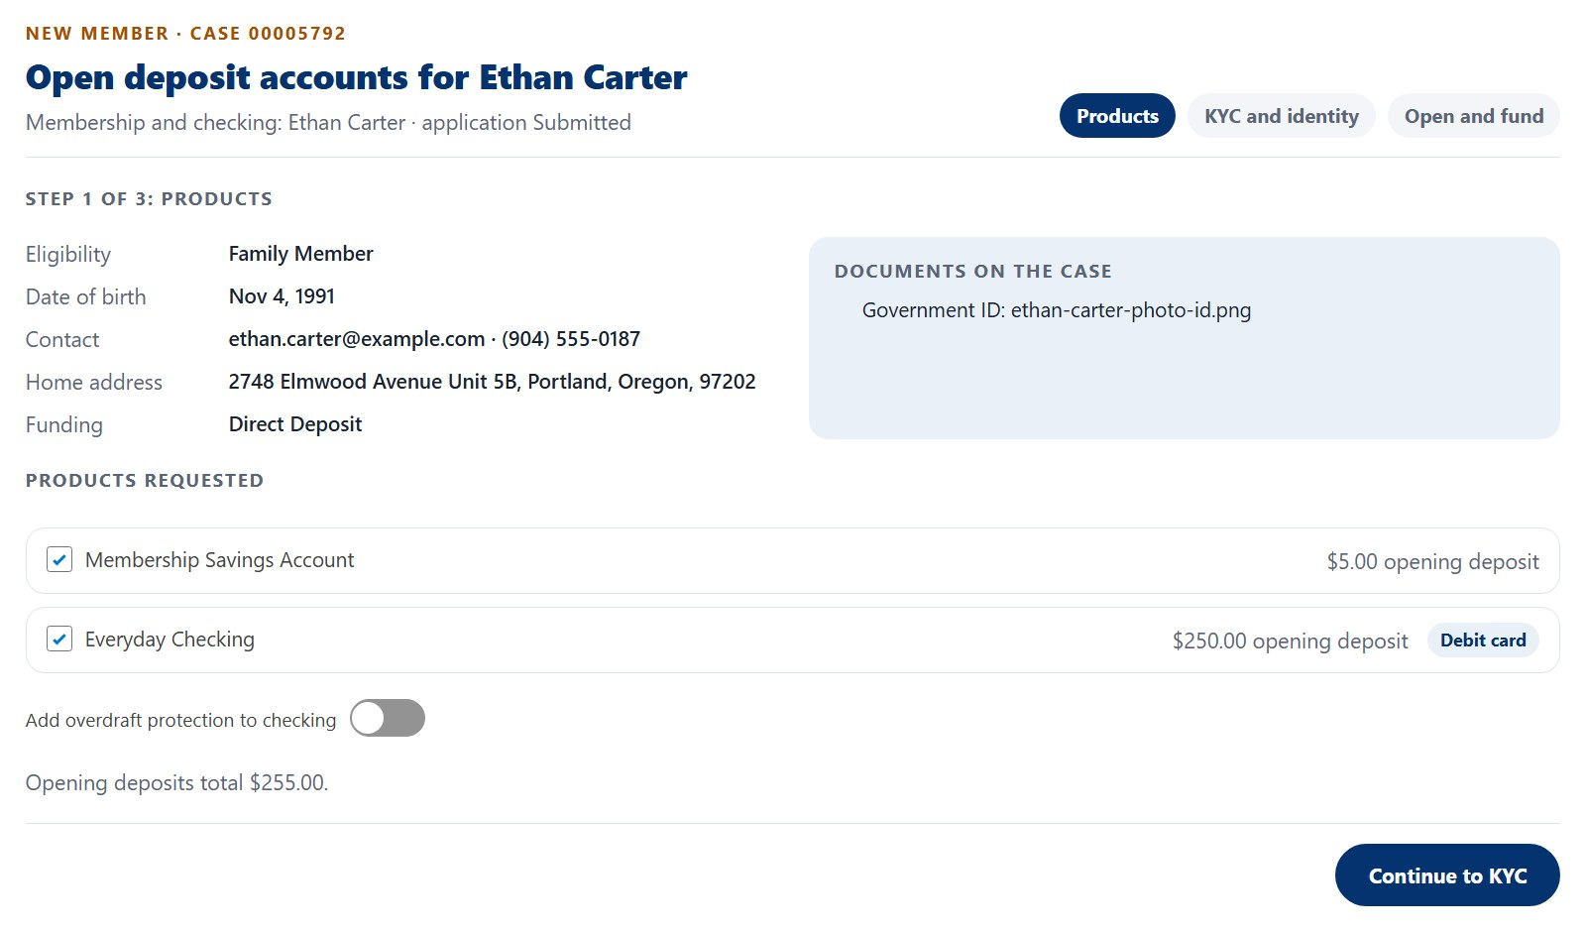 | Over a video appointment, the banker opens the Open Deposit Accounts action. Step one shows what Ethan applied for: the Membership Savings Account and Everyday Checking with a debit card, his eligibility, and the ID he uploaded.  The banker can drop a product or add overdraft protection with Ethan right there.

18. KYC and identity in one step
On screen KYC slide: the questions the banker asks and the five simulated checks
Step two is KYC. The banker asks the customer identification questions: occupation and employer, source of funds, expected deposits and the purpose of the account. The ID details are read from the document Ethan already uploaded.
Then one click runs five checks: identity, document authentication, OFAC sanctions screening, deposit account history and address verification. In the demo these are simulated. In production they'd be the vendors Navy Federal already uses, called through MuleSoft, with results stored on the member's profile.

19. Opened and funded in the same conversation
On screen Open Deposit Accounts · Step 3 of 3: Open and fund
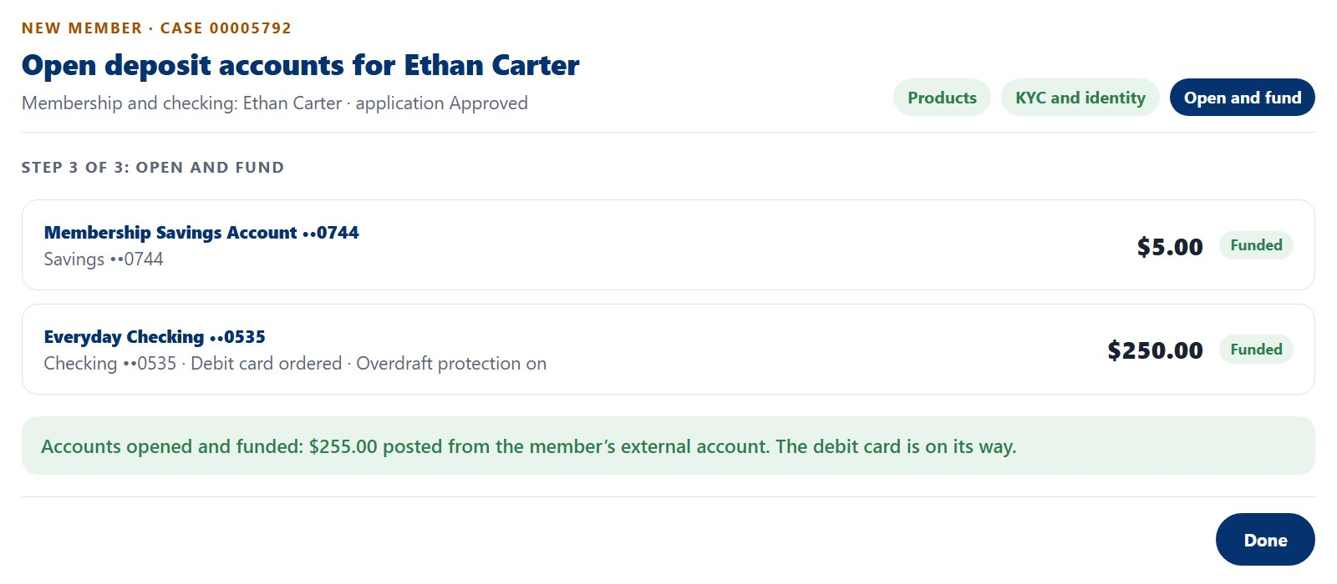 | Step three opens the accounts. Salesforce creates his savings and checking as financial accounts with Ethan as the owner, marks the application approved, and records the KYC result.  Then the opening deposits post: $255 from his external account. The debit card is ordered in the same step. Ethan leaves the call as a funded member.

20. The first 30 days
On screen Act 4 · Experience Cloud
Act four is what happens after the accounts open, the part that turns a new account into a primary relationship.

21. His first 30 days, in one place
On screen Your first 30 days · private link from the welcome email
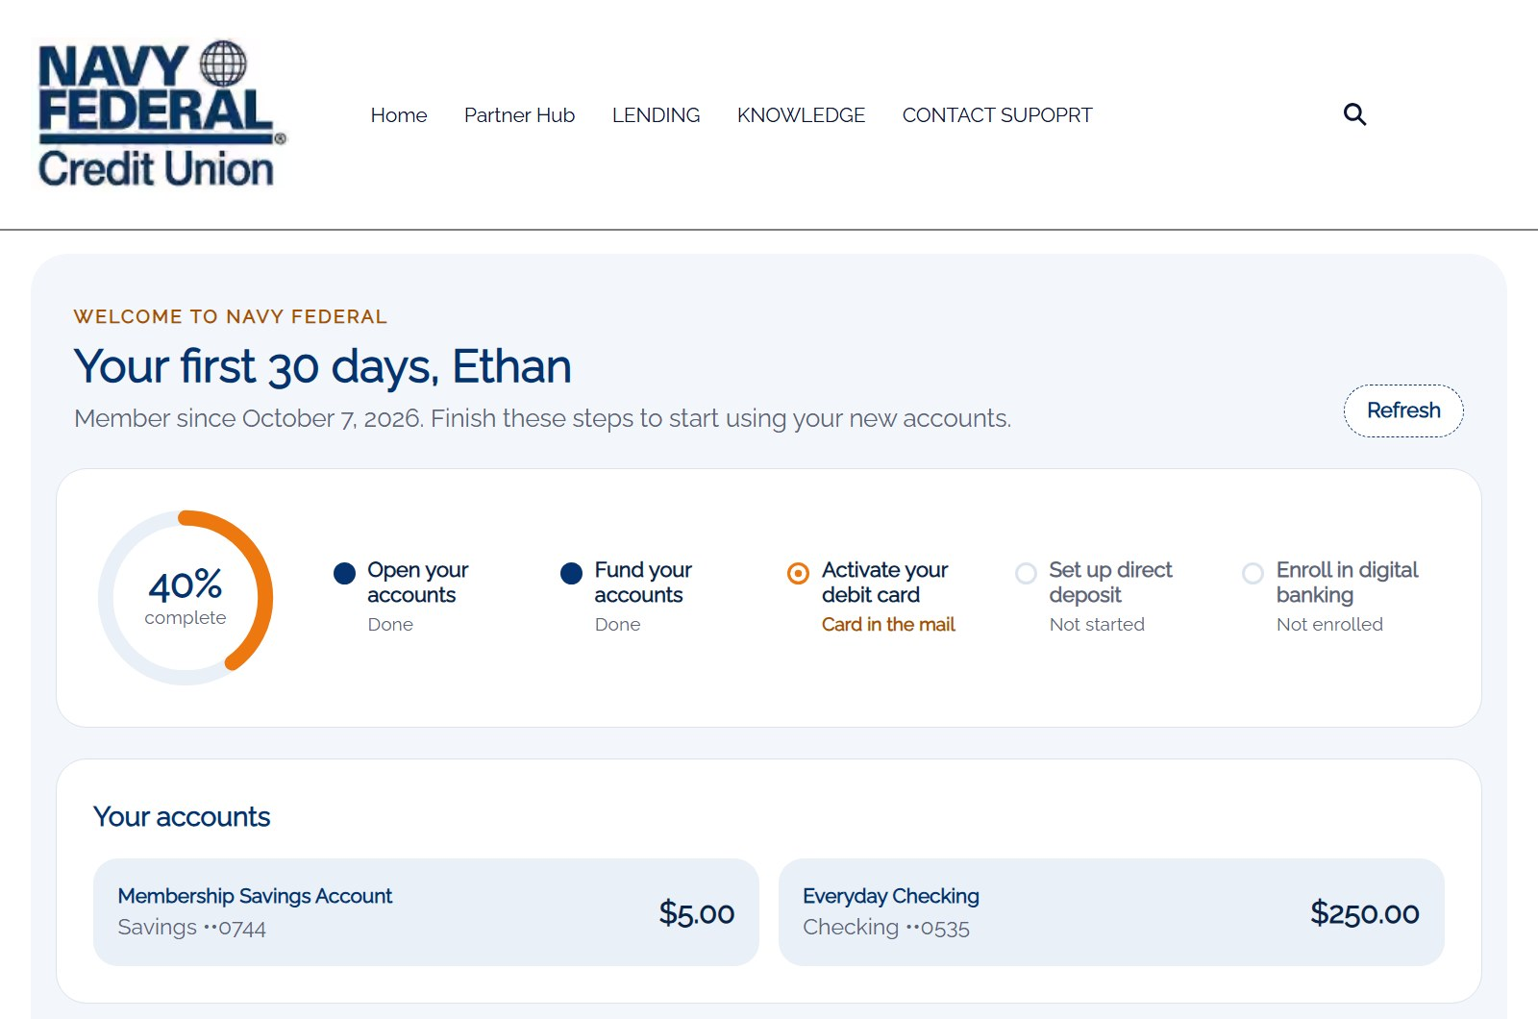 | Now the part most banks leave to a stack of mail: the first 30 days. Ethan opens the private link from his welcome email. No login to set up yet.  He sees his progress, his two accounts and live balances, and the three things left to do: activate his card, move his paycheck, and set up digital banking.

22. Card active, paycheck on its way
On screen Debit card activation and direct deposit
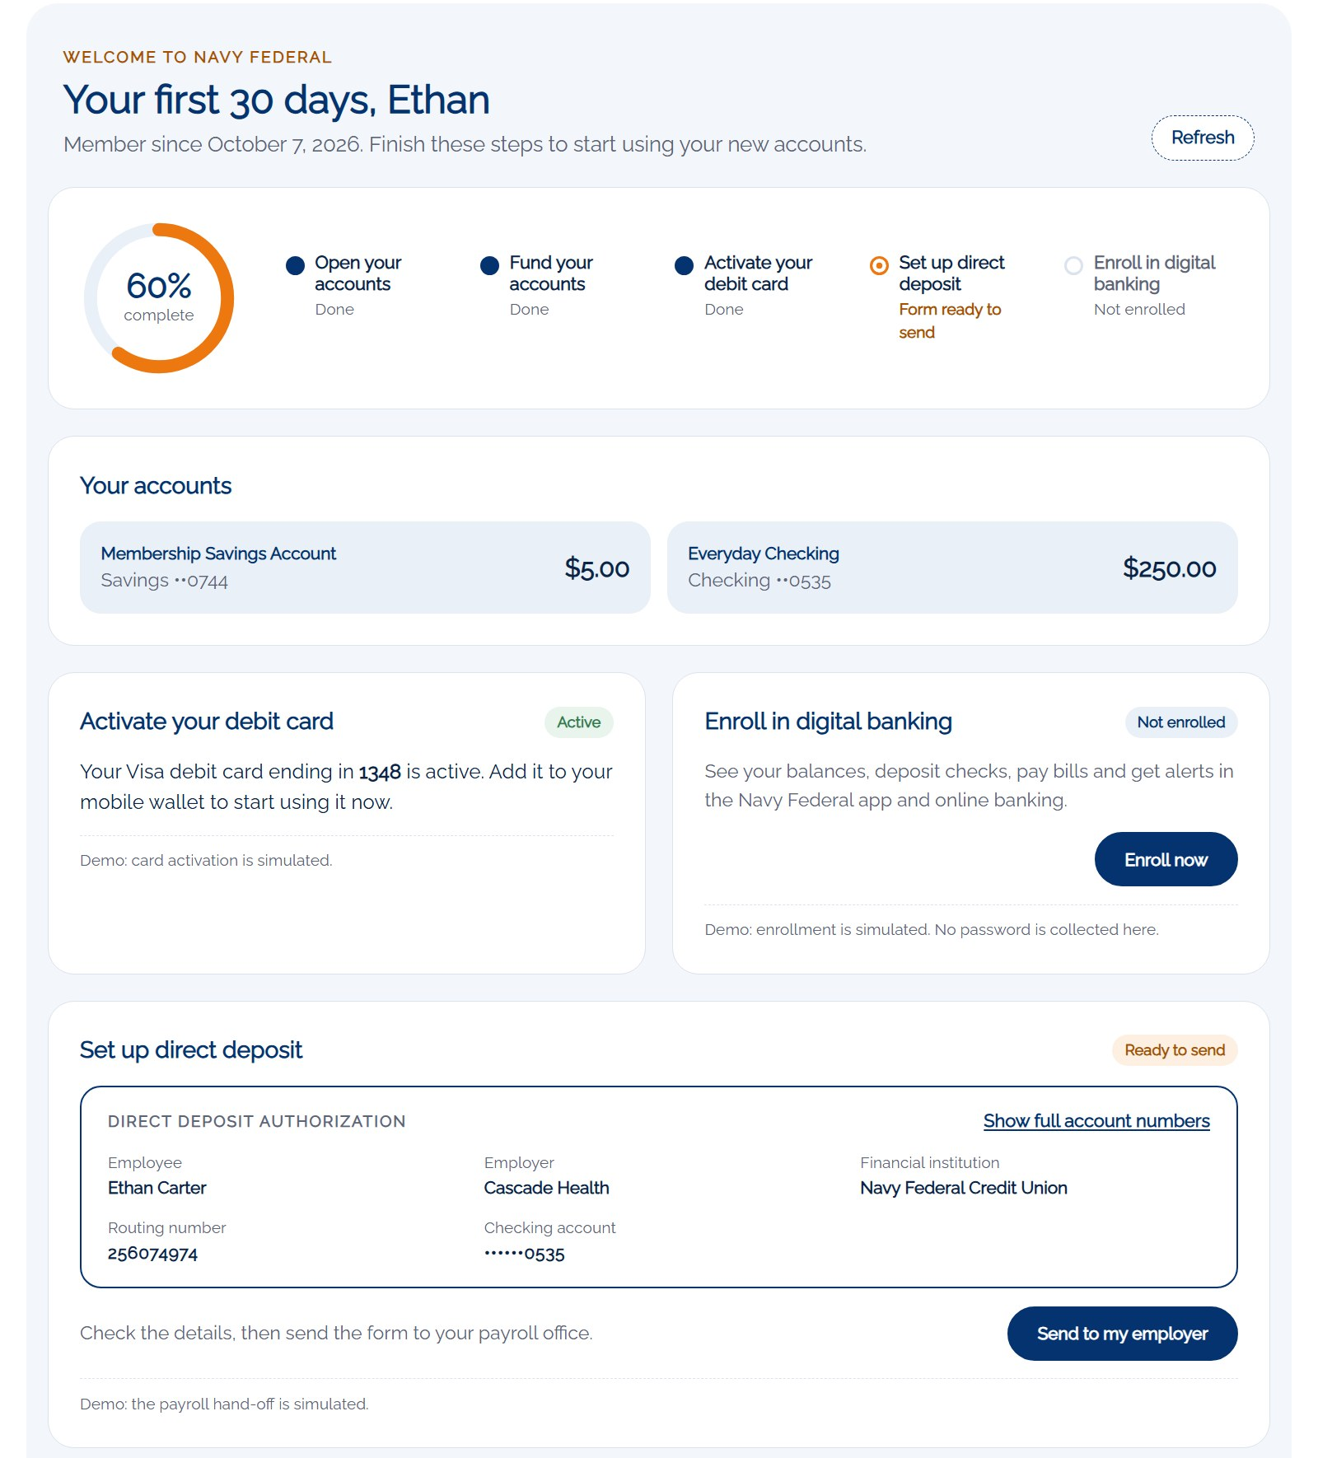 | When the card arrives, he activates it with the last four digits and his date of birth.  Then the step that keeps people at their old bank: switching direct deposit. We fill in the form for him with his employer, Navy Federal's routing number and his checking account, and he sends it to payroll. If he has questions, the Ask Me Anything agent answers from the "How do I switch my direct deposit" knowledge article.  Card activation and the payroll hand-off are simulated in the demo.

23. Fully onboarded
On screen Your first 30 days · 100% complete
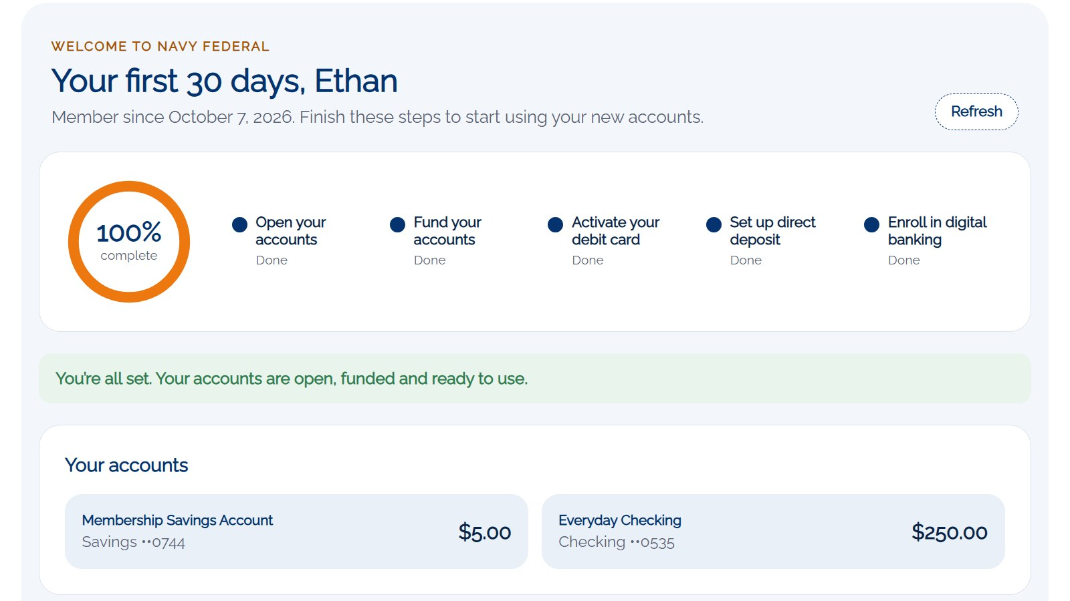 | And he's done. Every step Ethan finished was logged on his case, so the banker and the Service Rep Assistant know exactly where he is without calling him.  This is the moment that matters: Ethan isn't just a new account, his paycheck lands here. That's a primary relationship.

24. One funnel from prospect to primary
On screen Act 5 · Measure and grow
Act five is how Navy Federal measures the whole journey and what it means for the business.

25. One funnel from prospect to primary
On screen Funnel slide: seven stages and the field that measures each
Because everything lives on one platform, Navy Federal can measure the whole journey as one funnel. Every stage you just saw is a field on a record the demo creates: the lead, the conversion, the application, the KYC result, the financial account, the card status and the direct deposit status.
So you can see where new members stall. If people open accounts but never switch their paycheck, you know where to put the next nudge, whether that's an email, a banker call or an agent message.

26. What this means for Navy Federal
On screen Benefits slide
So what does this mean for Navy Federal? You grow through the households you already serve. You replace two applications with one. KYC happens inside the conversation instead of in a back-office queue.
Accounts are funded on day one, and the first 30 days turn a new account into a primary relationship. And because it's one record from prospect to member, you can measure every step.
That's a brand-new relationship, prospect to member to primary, in one integrated flow.

27. Appendix A · Experience Cloud pages and LWCs
On screen SDO - Consumer site · https://storm-6269dbe2d00053.my.site.com/consumer
For the technical team: every Experience Cloud page in the journey with its URL, and every Lightning web component and where it runs.

28. Appendix B · Salesforce objects
On screen Standard: core Salesforce and Financial Services Cloud · Custom: demo-specific
And the data model: standard Financial Services Cloud objects carry the deposit relationship, and two demo objects carry the onboarding record and the product application.

29. Appendix C · Automation, agents and access
On screen Everything else the journey uses
Finally, the Apex, flows, agent topics, knowledge articles and permission sets behind it, plus the demo rule that welcome emails always go to the shared demo inbox.

