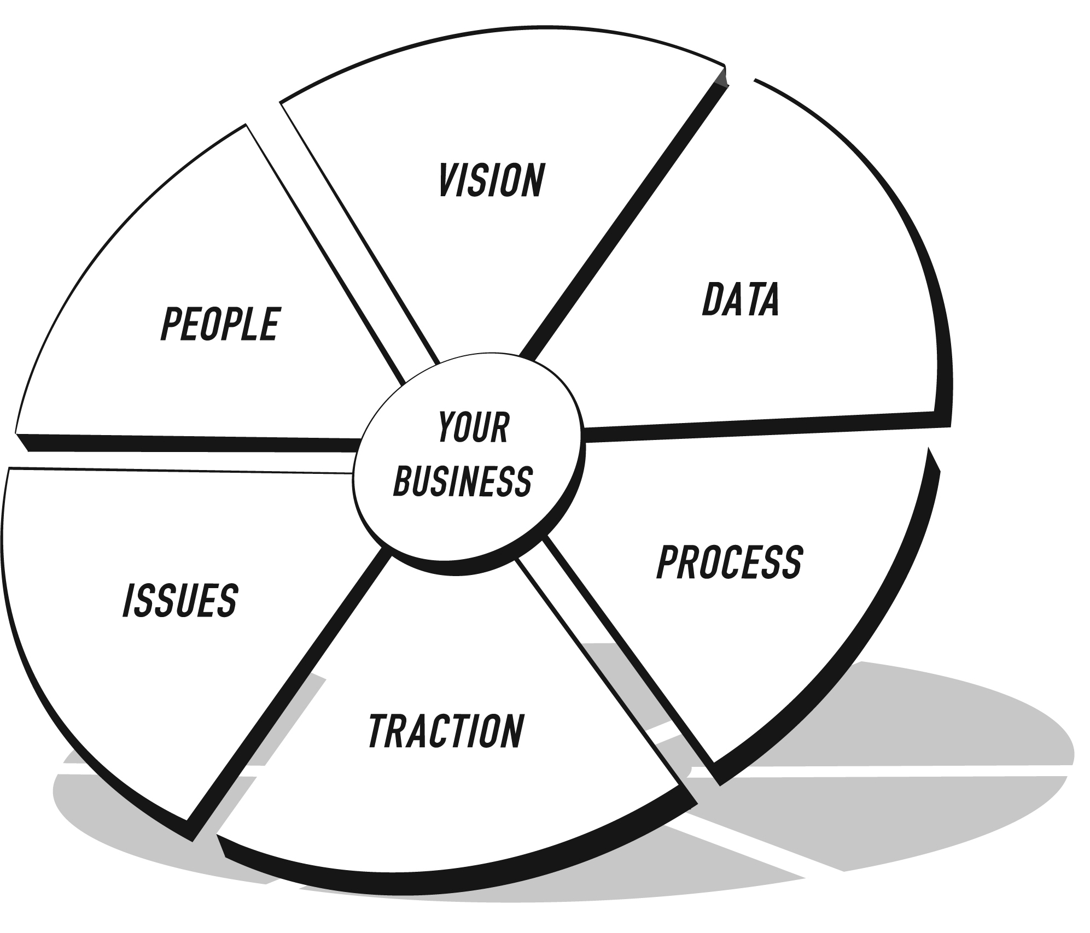

**THE EOS MODEL™**

THE VISION/TRACTION ORGANIZER™

**ORGANIZATION NAME:**

**VISION**

|  |  |  |
| --- | --- | --- |
| **CORE VALUES** |  | **3-YEAR PICTURE™** |
| **Future Date:**  **Revenue:** $  **Profit:** $  **Measurables:**  **What does it look like?** |
| **CORE FOCUS™** | **Purpose/Cause/Passion**:  **Our Niche:** |
| **10-YEAR TARGET™** |  |
| **MARKETING**  **STRATEGY** | **Target Market/“The List”:**  **Three Uniques:**      **Proven Process:**  **Guarantee:** |



**THE EOS MODEL™**

THE VISION/TRACTION ORGANIZER™

**ORGANIZATION NAME:**

**TRACTION**

|  |  |  |
| --- | --- | --- |
| **1-YEAR PLAN** | **ROCKS** | **ISSUES LIST** |
| **Future Date:**  **Revenue:** $  **Profit:** $  **Measurables:**  **Goals for the Year:**   |  |  | | --- | --- | | 1. |  | | 2. |  | | 3. |  | | 4. |  | | 5. |  | | 6. |  | | 7. |  |   With your cursor in the last row, press Tab to add another row. | **Future Date:**  **Revenue:** $  **Profit:** $  **Measurables:**  **Rocks for the Quarter: Who**   |  |  |  | | --- | --- | --- | | 1. |  |  | | 2. |  |  | | 3. |  |  | | 4. |  |  | | 5. |  |  | | 6. |  |  | | 7. |  |  |   With your cursor in the last row, press Tab to add another row. | |  |  | | --- | --- | | 1. |  | | 2. |  | | 3. |  | | 4. |  | | 5. |  | | 6. |  | | 7. |  | | 8. |  | | 9. |  | | 10. |  |   With your cursor in the last row, press Tab to add another row. |