Spec Sheet Buiten verlichting.

**Blynk Auth key:** 1a7a3e1e7e1446c7a8ce647142957ba5

**NTP Time Client Server:** europe.pool.ntp.org

**I2C devices Pinout** **I2C Address**

BH1750 Light sensor. Default = 0x23

16-Channel 12-bit PWM Driver. Default = 0x40

SDA, GPIO4 = D2

SCL, GPIO5 = D1

**Sensors**

**PIR Motion Sensor**

Input GPIO14 = D5

DC5V to 20V

level output: 3.3V high, low 0V

**BH1750F Digital Light Sensor I2C**

SDA, GPIO4 = D2

SCL, GPIO5 = D1

DC3.3V to 5V

16bitADC

**16 Channel PWM Driver I2C**

SDA, GPIO4 = D2

SCL, GPIO5 = D1

DC3.3V to 6V

12-bit

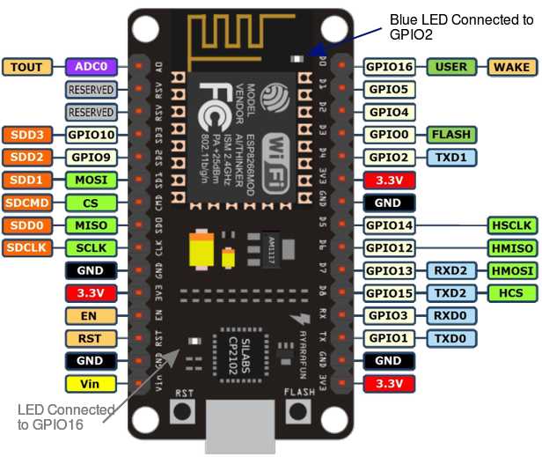

|  |  |  |  |  |
| --- | --- | --- | --- | --- |
| PinOut. | Pin On ESP8266 | Pin In Code | Function | I2C Address |
| Sensors. |  |  |  |  |
| ntpUDP timeClient | Software| europe.pool.ntp.org | Software| europe.pool.ntp.org | Gets real-time Time | Software |
| BH1750 Light sensor | SDA, D1 | SCL, D2 | SDA, GPIO4 | SCL, GPIO5 |  | 0x23 |
| PIR Motion Sensor | D5 | GPIO 14 |  |  |
| PinOut. | **Pin On PWM Driver** | **Pin In Code** | **Function** |  |
| Actuatoren. |  |  |  |  |
| 16-Channel 12-bit PWM Driver | SDA, D1 | SCL, D2 | SDA, GPIO4 | SCL, GPIO5 |  | 0x40 |
| 2 Channel Relay Board |  |  |  |  |