Chris Minheere

[Minheerechris@gmail.com](mailto:Minheerechris@gmail.com)

Tel: 06-46747471

Documentation

Outside Lighting

Documentation outside lighting.

**WIFI**

**SSID:** ******

**WW:** ******

**Blynk Auth key:** ******

**NTP Time Client Server:** europe.pool.ntp.org

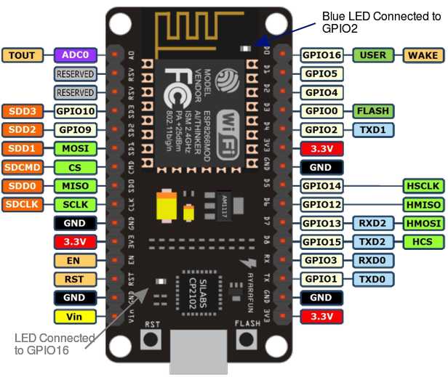

|  |  |  |  |  |
| --- | --- | --- | --- | --- |
| Label | GPIO | Input | Output | Notes |
| D0 | GPIO 16 | no interrupt | No PWM or I2C support | HIGH at boot (used to wake up from deep sleep) |
| D1 | GPIO 5 | OK | OK | SCL (I2C) |
| D2 | GPIO 4 | OK | OK | SDA (I2C) |
| D3 | GPIO 0 | pulled up | OK | connected to FLASH button, boot fails if pulled LOW |
| D4 | GPIO 2 | pulled up | OK | HIGH at boot (connected to on-board LED, boot fails if pulled LOW) |
| D5 | GPIO 14 | OK | OK | SCLK (SPI) |
| D6 | GPIO 12 | OK | OK | MISO (SPI) |
| D7 | GPIO 13 | OK | OK | MOSI (SPI) |
| D8 | GPIO 15 | pulled to GND | OK | CS (SPI) Boot fails if pulled HIGH |
| RX | GPIO 3 | OK | RX Pin | HIGH at boot |
| TX | GPIO 1 | TX Pin | OK | HIGH at boot (debug output at boot, boot fails if pulled LOW) |
| A0 | ADC 0 | Analog Input |  |  |

|  |  |  |  |  |  |  |
| --- | --- | --- | --- | --- | --- | --- |
| PinOut. | Pin On ESP8266 | Pin In Code | Function | I2C Address | RJ45 | Technical specs |
| ntpUDP timeClient |  | Software europe.pool.ntp.org | Gets real-time Time  from the Internet |  |  |  |
|  |  |  |  |  |  |  |
| BH1750 | SDA, D1 | SDA, GPIO4 | measure light | 0x23 | 7 & 8 | In - 3.3V - 5V  level Out - 3.3V - 5V  16bit ADC |
| BH1750 | SCL, D2 | SCL, GPIO5 | measure light | 0x23 | 7 & 8 | In - 3.3V - 5V  level Out - 3.3V - 5V  16bit ADC |
|  |  |  |  |  |  |  |
| PCA9685 | SDA, D1 | SDA, GPIO4 | 16-Channel PWM Driver | 0x40 | 7 & 8 | In & Out 3.3V - 6V  12-bit DAC |
| PCA9685 | SCL, D2 | SCL, GPIO5 | 16-Channel PWM Driver | 0x40 | 7 & 8 | In & Out 3.3V - 6V  12-bit DAC |
|  |  |  |  |  |  |  |
| HD44780 | SDA, D1 | SDA, GPIO4 | LCD Display | 0x27 | 7 & 8 |  |
| HD44780 | SCL, D2 | SCL, GPIO5 | LCD Display | 0x27 | 7 & 8 |  |
|  |  |  |  |  |  |  |
| SDR-05VDC-SL-C |  |  | Relay Board |  |  | In - 3.3V - 5V  Out – 230V 16A |
|  |  |  |  |  |  |  |
| PIR Motion Sensor | D5 | GPIO 14 | measures movement |  | 3 | In 5V - 20V  level out: 3.3V high, low 0V |
|  |  |  |  |  |  |  |
| DHT11 | D4 | GPIO 2 | Digital Temperature and Humidity Sensor |  | 5? | In - 3.3V - 5V  level Out - 3.3V - 5V |
|  |  |  |  |  |  |  |
| RST button | RST |  | resets the esp8266 |  |  | 3.3V |

