Room Pricing Issue

* As seen below, price differential for booking direct vs Tripadvisor = 30% (168 vs 118). This differential is consistent for bookings 3.5+ months away.
* For comparison, on the same dates, Bailey’s Motel’s differential is 12%, white Mantra has less than a 10% differential (152 rooms which is probably why they have a preferential rate).
* Currently we offer a 15% discount if booked direct (contingent on booking being non-refundable). Cancellations are fully refundable 8 days prior to arrival date.

Differential for Baileys Apartments

Differential for Bailey’s Motel

Differential for Mantra

Pricing of carparks

* Currently parking is free for all guests therefore their key card has access to the carpark. Which leads to issues on high volume days when some guests have no car space.

Map of hotels around the area providing free parking ($100+ a night range)

Map of hotels around the area ($100+ a night range)

Hotel prices comparison (booking.com $100+ range)

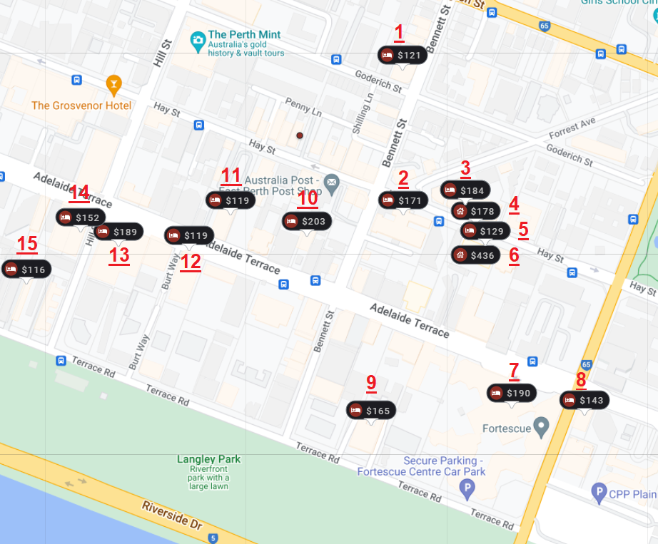

|  |  |  |  |  |  |  |  |  |  |  |  |
| --- | --- | --- | --- | --- | --- | --- | --- | --- | --- | --- | --- |
|  |  | (Using booking.com prices as it is our highest volume) | | | | | |  |  |  |  |
|  | Name | 1 Br Size | 1 Br Price | Pax | 2 Br Size | 2 Br Price | Pax | Parking | Rating | Total rooms | Extra notes |
| 1 | Bailey's Apartments | 57m² | 160 | 3 | 75m2 | 280 | 5 | Free | 8.4 | 25 |  |
| 2 | Mantra on Hay | 55m² | 200/240 | 2/3 | 75m² | 250/290 | 4/5 | 25 | 8.2 | 155 | +40 per night for additional pax |
| 3 | Mont Clare Boutique Apartments | 65m² | 185/210 | 2/3 | 85m² | 220/250 | 4/5 | 10 | 7.1 | 58 | +25 per night for additional pax |
| 4 | - | - | - |  | - | - |  | - | - | - |  |
| 5 | Alderney On Hay | 32m² | 130 | 2 | 65m² | 200 | 5 | Free | 7.7 | 62 | Managed by Starwest Hotel & Apartment |
| 6 | - | - | - | - | - | - | - | - | - | - | holidaylettings listing (airbnb style) |
| 7 | Hyatt Regency Perth | 33m² | 200/250 | 2/3 | - | - | - | No parking | 8.1 | 367 | closest carpark @Fortsecue 15/day 2min walk |
| 8 | ibis Styles East Perth | 16m² | 145 | 2 | - | - | - | No parking | 8.4 | 252 | closest carpark @Fortsecue 15/day 1min walk |
| 9 | Crowne Plaza Perth, an IHG Hotel | 32m² | 170/235 | 2 | 32m² | 300 | 4 | 20 | 7.9 | 96 |  |
| 10 | Quest East Perth | 30m²/45m² | 200/240 | 2 | 70m² | 410 | 4 | 25 | 8.5 | 128 |  |
| 11 | Quality Hotel Ambassador Perth | 24m²/34m² | 120/170 | 2/3 | - | - | - | 12 | 7.7 | 170 | Parking is not assured (not enough spots) |
| 12 | Comfort Inn & Suites Goodearth Perth | 33m² | 120/160 | 2/3 | 63m² | 180/220 | 4/5 | Free | 7.6 | 180 |  |
| 13 | Pan Pacific Perth | 29m² | 190/270 | 2/3 | - | - | - | 16 | 8.4 | 486 | Parking is not assured (not enough spots) |
| 14 | Novotel Perth Langley | 33m² | 175/240 | 2/3 | - | - | - | 25 | 7.8 | 256 |  |
| 15 | City Waters | 35m² | 115/125 | 2/3 | 60m² | 190 | 6 | Free | 6.9 | 63 |  |