# <CM-Capstone-Project: Planit>

A Full-Stack, CRUD application allowing users to Budget & Plan for their next holiday.

Technology:
- React
- Node
- HTML/CSS
- SaSS
- Python
- Axios
- NPM

Please note that this is phase one (Proof of Concept) for a wider project, which will develop in the future.

With this in mind, please excuse incomplete areas of code!

And – keep an eye out for more updates!

## Description

Planning a holiday is now easier than ever. If you live in a major city, you can likely book a getaway with flights and accommodation, leaving the same day, with extreme ease and at increasingly better value. Given that the choice to travel seems to be so easy, a new issue arises – making the most out of the experiences you find. And arriving prepared!

The idea behind Planit is a companion to your city break, or any time away, through educating the user about the destinations they can travel to, to appreciate the culture and experiences which they find when they arrive. And to make sure they have brought the right plugs and currency with them.

Further, staying on budget can make or break the enjoyment of a holiday. Which is why Planit is built upon substantial traveller feedback on how much they spend on their vacations. Helping predict how much a trip can cost can better prepare any traveller to make the most of their journey – and not overrun the budget for their next adventure 😊

This data was built via Python (a tool the author learned –to an extent! -- from scratch just for this project, built upon a backend database.

This project has certainly been a learning code for its author! A culmination of 3months of full-time education, sleepless nights & unhealthy caffeine consumption, this has in fact been a complete joy to work on. I hope this tool can help you out on your next adventure!

## Installation

This project was built on Front-End (react) and backend (Node), for the website & database hosting. In order to run this application, please:
- Open ‘server folder’ within your terminal
- Run the command ‘npm i’
- Run the command ‘npm run dev’
This will set-up the back-end server, for data & hosting
- Open ‘client folder’ within your terminal
- Run the command ‘npm i’
- Run the command ‘npm start’
This should open up Planit within your web browser, at: http://localhost:3000/ (assuming no previous ports are open )

## Usage

Upon arriving at Planit, the passenger can board a plane to one of three wonderful destinations:
- The exotic land of Learn
- The cosmopolitan country of Budget
- The off-the-beaten-trail gem of Plan

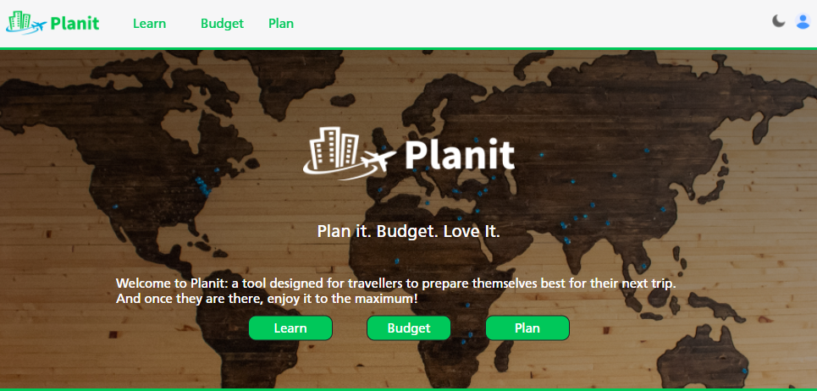

- Learn

Welcome to learn! The land of being informed. Through selecting your next-destination, Planit will guide you with both valuable information regarding your stay: 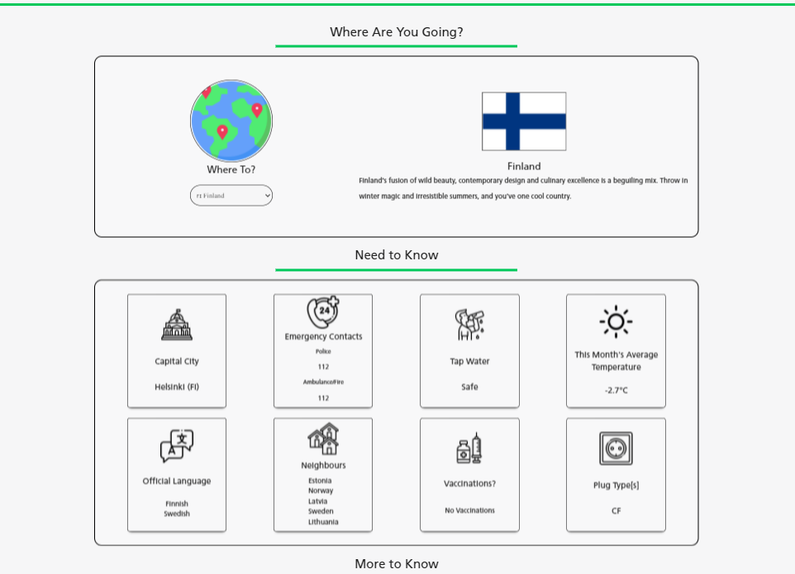

- Budget
Bienbenido a Budget! The culture here is all about finance. As the locals know, the perfect way to be informed about how much a future adventure might cost is by asking the oracle!
Thanks to its hivemind, with the help of the user’s input of their spending style (whether a backpacker or more ‘extravagant’, any Planit visitor should have a great idea of how much money to save up.

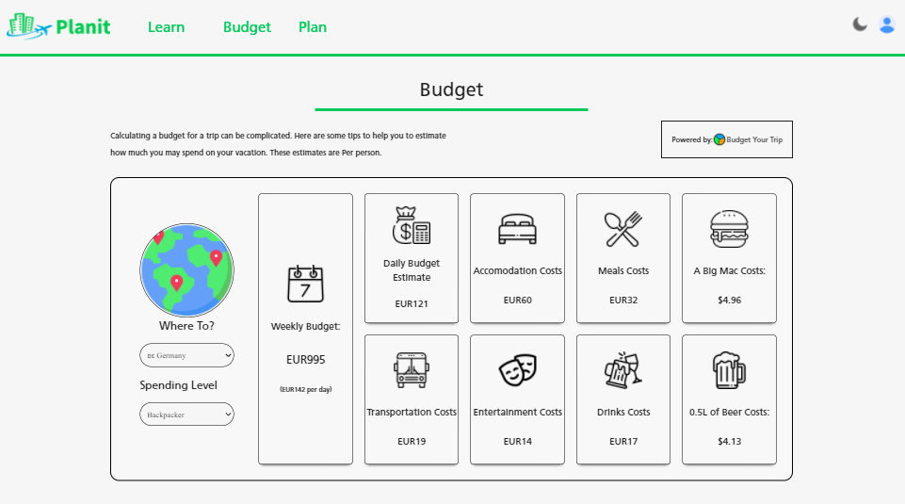
If you have time to spare during your stay, check out the ‘Budget Tips’ section!

- Plan
Warm welcome to the Plan page! Here, the user can track and prepare for their future stays. Think of us as your layover stop before you arrive at your final destination.

The plan page allows the user to:

See a snapshot of a trip they plan on partaking in:
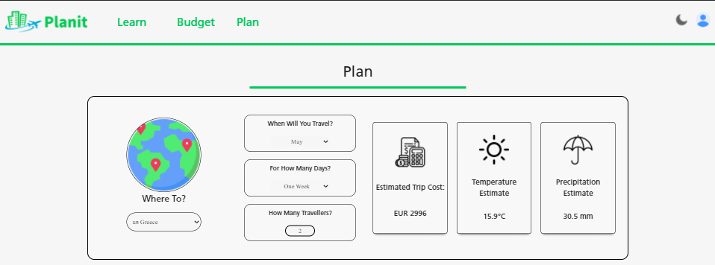
Plan a new trip:
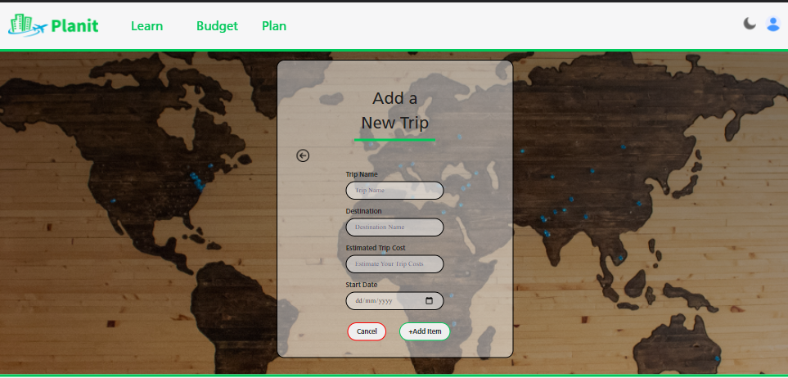

Save & manage an existing planned trip. This includes a delete function for if you have to cancel your plans.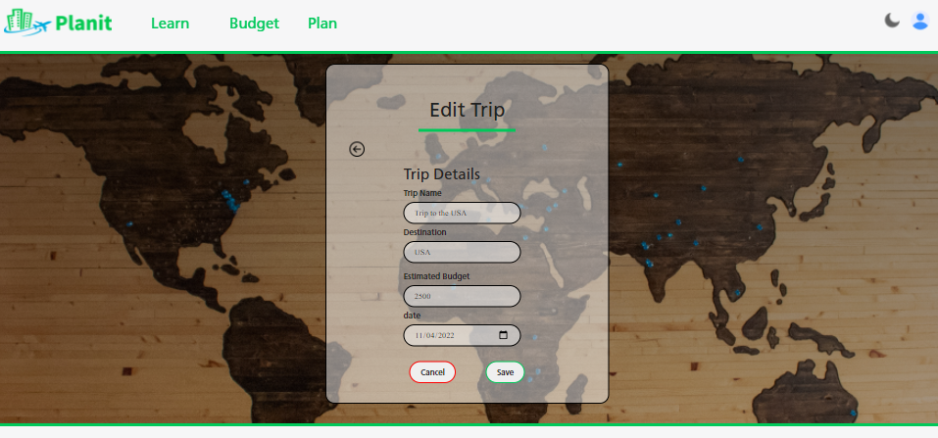

# Credits

BrainStation for providing me with the knowledge to build this application.

My BrainStation peers for supporting me throughout this process.

My coffee machine for putting up with my constant abuse and overworking.

## License
MIT License

Copyright (c) [2022] [Christian Mitchell]

Permission is hereby granted, free of charge, to any person obtaining a copy
of this software and associated documentation files (the "Software"), to deal
in the Software without restriction, including without limitation the rights
to use, copy, modify, merge, publish, distribute, sublicense, and/or sell
copies of the Software, and to permit persons to whom the Software is
furnished to do so, subject to the following conditions:

The above copyright notice and this permission notice shall be included in all
copies or substantial portions of the Software.

THE SOFTWARE IS PROVIDED "AS IS", WITHOUT WARRANTY OF ANY KIND, EXPRESS OR
IMPLIED, INCLUDING BUT NOT LIMITED TO THE WARRANTIES OF MERCHANTABILITY,
FITNESS FOR A PARTICULAR PURPOSE AND NONINFRINGEMENT. IN NO EVENT SHALL THE
AUTHORS OR COPYRIGHT HOLDERS BE LIABLE FOR ANY CLAIM, DAMAGES OR OTHER
LIABILITY, WHETHER IN AN ACTION OF CONTRACT, TORT OR OTHERWISE, ARISING FROM,
OUT OF OR IN CONNECTION WITH THE SOFTWARE OR THE USE OR OTHER DEALINGS IN THE
SOFTWARE.

## How to Contribute

If like an application or package and would like other developers to contribute, please get in touch!

