Type of the Paper: Conference Paper

Instructions for Preparing a Paper for Bicycle and Motorcycle Dynamics 2023

Firstname1 A. Lastname11, Firstname2 B. Lastname22, and Firstname3 C. Lastname32,*

1 Department of Engineering, University of Technology, The Netherlands; email1@uot.nl, ORCID 1111-1111-1111-1111

2 Department of Engineering, University of Technology, Germany; email2@uot.de, ORCID 2222-2222-2222-2222; email3@uot.de, ORCID   
3333-3333-3333-3333

*corresponding author.

Name of Editor: Firstname Lastname

Submitted: dd/mm/yyyy

Accepted: dd/mm/yyyy

Published: dd/mm/yyyy

Citation:

**Abstr**act:

The abstract must fit on this title page and should not include figures, tables, or citations. The abstract has the section heading   
**Abstract:**, bold 11 pt Times New Roman, and the abstract text should be written in Times New Roman, 10 pt. The primary paper contents should start on the second page.

Introduction

Authors are requested to upload a paper of 6 to 12 pages (including references and figures) to the Orvium web site by the stated date in the call for papers.

The paper must be written in English. It must contain the names, affiliations, and e-mail addresses of the authors. Please add this information to the header and footer by replacing the highlighted text with your details and remove the yellow highlighting after replacement. Do not edit any other parts of the headers or footers. The footer on the first and second page both have to be edited individually. The paper size is European A4 (21 x 29.7 cm).The left and right margins are 1.27 cm, the top margin (not including the header) is 2.5 cm, and the bottom margin is 1.9 cm. The title should be in Times New Roman 18 pt, and may extend over more than one line. The author’s name or authors’ names should be in Times New Roman 10 pt and the affiliation should be in 8 pt.

Please upload your finished manuscript as .odt, .docx. or zipped latex project. PDFs will not be accepted.

Equations, Figures and Tables

Equations should be numbered continuously according to the format shown in Equation (1):

| $$e^{iπ}+1=0$$ | (1) |
| --- | --- |

where the unknown symbols are explained after the equation.

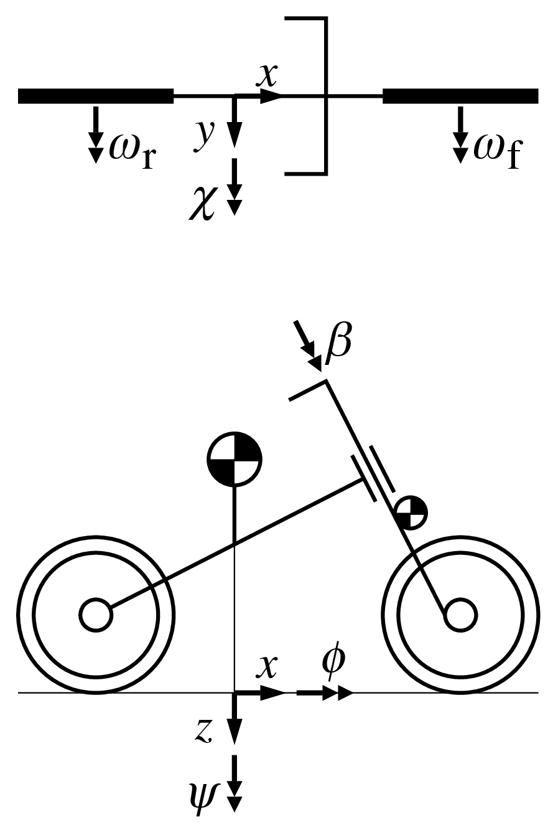Figures, graphs and tables must be included using the same style as in Figure 1 and Table 1. Both figures and tables should be centered on the page. Use of at least 300 dpi resolution for pictures and line art is required, 1 px wide lines in figures should be avoided as they may become invisible in print.

|  |
| --- |
|  |
| **Figure 1.** An example of a figure caption. Use 10 pt Times New Roman. Use the same style for the tables. |

Table 1. Example of a table with a short caption.

|  |  |  |  |
| --- | --- | --- | --- |
|  | *x* | *y* | *z* |
| *x'* | *α1* | *β1* | *γ1* |
| *y'* | *α2* | *β2* | *γ2* |
| *z'* | *α3* | *β3* | *γ3* |

Bibliography

Bibliographical citations should be written in alphabetical order in the **References** section at the end of the document and use the APA citation system and the APA format. See the **References** section below, where (Pacejka, 2002) exemplifies the case of a textbook, (Bertolazzi et al., 2007) is an article in a conference proceedings, and (Sharp, 1971) is an article in a journal.

Conclusion

We very much look forward to welcoming you in Delft! Best wishes and the warmest regards from the Organizing Committee of Bicycle and Motorcycle Dynamics 2023.

References

Bertolazzi, E., Biral, F., Da Lio, M., & Cossalter, V. (2007, June 25–28), The influence of rider’s upper body motions on motorcycle minimum time maneuvering. In C. L. Bottasso, P. Masarati, & L. Trainelli (Eds.), *Proceedings, Multibody Dynamics 2007, ECCOMAS Thematic Conference*, Politecnico di Milano, Milano, Italy, 15.

Pacejka, H. B., (2002). *Tyre and Vehicle Dynamics*. Butterworth and Heinemann, Oxford.

Sharp, R. S. (1971). The stability and control of motorcycles. *Proceedings of the IMechE, Part C, Journal of Mechanical Engineering Science*, 13, 316–329.