Who Scores the Most Points for Your Team?
4/8/2023
STAT 356

We want to know who on your fantasy football team gives you the most points overall and consistently. Fantasy football is arguably one of America’s greatest pastimes for many people; whether gambling or participating just for fun. When real life football players play in their games throughout the NFL season, they accumulate points for your fake, fantasy football team based on their production and statistics in the live game. The objective is to score more points than your opponent every given week in order to eventually win the championship in week 18 of the real-life NFL season. We will attempt to figure out this information by running diagnostics for many regressor variables and see how each contributes to determine how many points a player will score. Feel free to use this information when constructing your own fantasy football team, and good luck!
The data used in this project was manually pulled from pro-football-reference.com, a reference website for everything to do with professional American Football. For this project we grabbed the name, birth state, college, position, team the player played with for a majority of the 2022 season, and various stats from the 2022 season for every Quarterback, Running Back, Wide Receiver, Tight End, and Kicker that played at least 8 games. The numerical stats we grabbed were each of these players’ age at the beginning of the season, games played, passing yards, passing touchdowns, interceptions, rushing yards, rushing touchdowns, receptions, receiving yards, receiving touchdowns, fumbles, two-point conversions, extra points, field goals (0-39 yards), field goals (40-49 yards), field goals (50-59 yards), field goals (60+ yards), and field goals missed. Our project is mainly about fantasy football, which counts a score for these players with a formula, and we will be using the following formula, which is the same as the standard ESPN PPR fantasy football scoring.
Total = Pass_Yards * .04 + Pass_TDs * 4 + Ints * -2 + Rush_Yards * .1 + Rush_TDs * 6 + Receptions + Rec_Yards * .1 + Rec_TDs * 6 + Fumbles * -2 + Two_Pt * 2 + XP + FG_30 * 3 + FG_40 * 4 + FG_50 * 5 + FG_60 * 6 + FG_Miss * -1
We then divided this total by each players’ games played to create a per game score, and along with not including players who played less than 8 games, we also excluded any players with less than 3 points per game as that isn’t very good. We ended up with 307 players included, and considering many sources that rank players for fantasy football release a top 300, this seems to be a good number of players to be looking at. The data is by default sorted by the players’ full names in ascending order.

Our contents procedure shows our 25 different variables and our 307 observations.
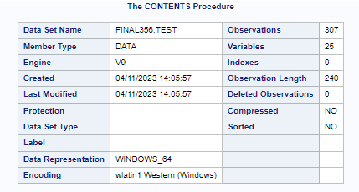
We have two different data sets that we are working with. The bottom data set includes all the statistics with a value of ZERO while the top data set is the same exact data, with ZEROS removed using Excel. We did this in order to use the data set in different ways. Some great players, for example AJ Dillion, did not have a receiving touchdown which is uncharacteristic of him. We want to be able to model our regression equation with these things in mind and in play.
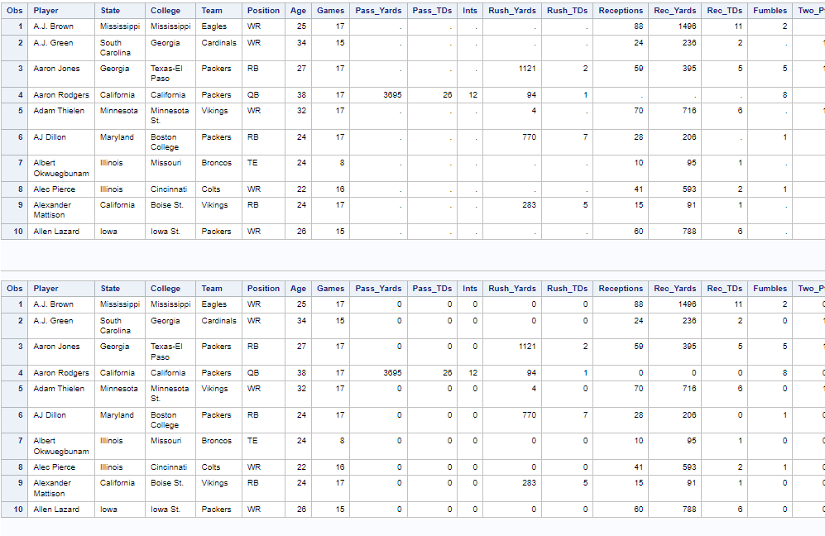
Our ANOVA table and our parameter estimates of the most basic overall model are shown below. These are derived from our data set that includes ZEROS. We can see right off the bat that the biggest help to our total points is brought in by touchdowns, as we could have guessed. Each estimate of our variable is the same as it is in the main equation given in the introduction.
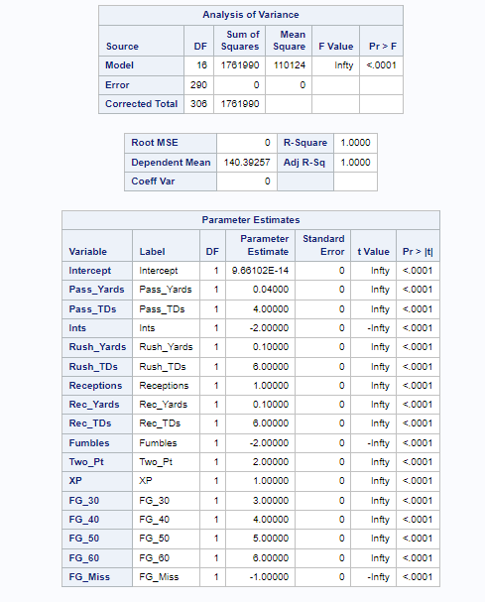
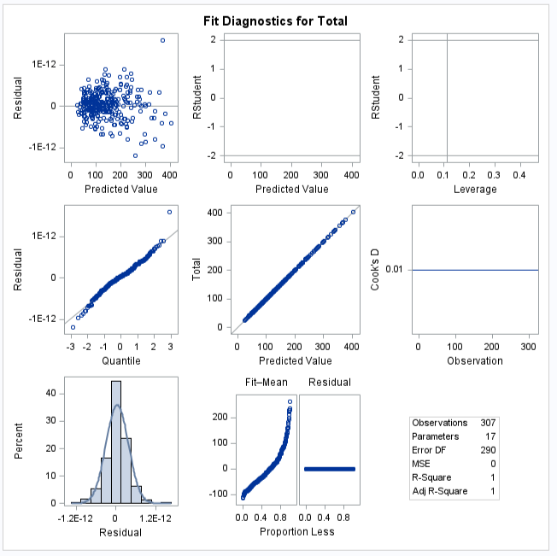
The means procedure produced the tables shown below. We can see that when the zeros are removed the means produced for each variable are obviously found from a smaller sample, but this could be more accurate if we are talking about meaningful statistics by position. When the zeros are included, we see a more dramatic change in variables that only include one position. For example, passing touchdowns are dramatically smaller since nobody other than the quarterback really throws for touchdowns. All of the FG statistics are non-existent in the set with zeros included since only the kicker position did any kicking in 2022.
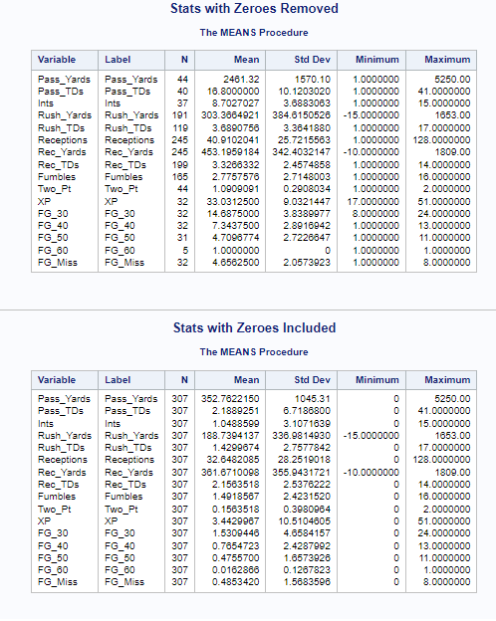
We ran the means procedure again for our 4 other variables. Just some interesting things to see here about NFL players. A mean age of 26/27, and an average games played of 14/15. What is worth noting, is that the Per_Game points by player multiplied by the games played gives us 138 which is very close to the total points during the season.
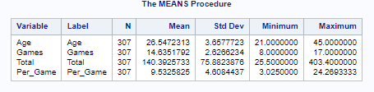
Moving over to our categorical data, the frequency procedure gave us how many players come from each state and college. It also shows us how many players in the data set are from each team and how many players fall into our age categories.
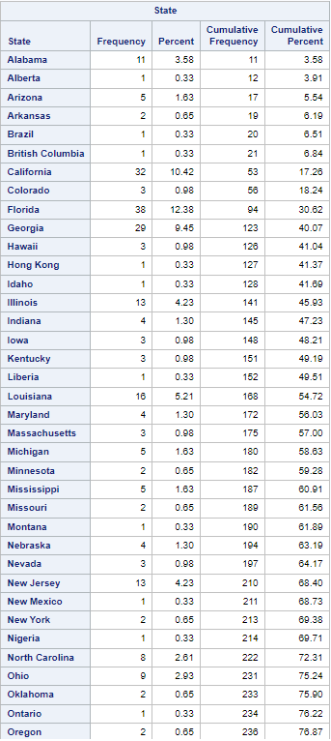
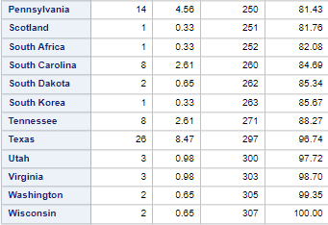
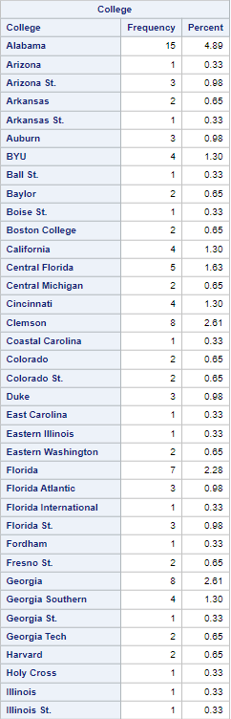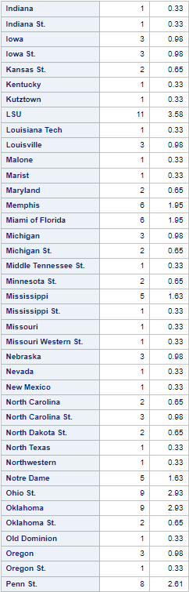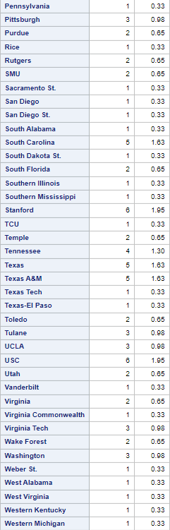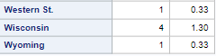
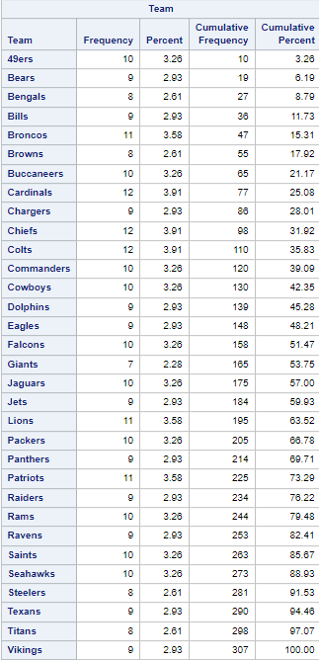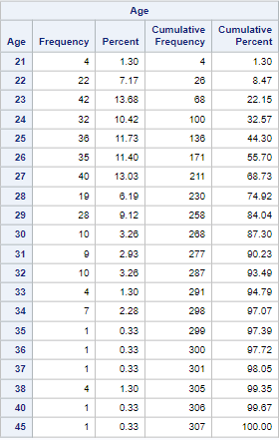
Since we limited the players in the data set to those who have only played 8 games or more, we ran a frequency procedure to see how many players played ‘x’ number of games. We can also see how many players from each position are in the data set as well as the percentage they account for in our statistical procedures.
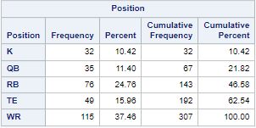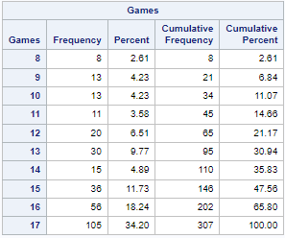
Next, we sorted our dataset by each of the variables we used in the frequency procedure other than Games, and looked at the means procedure by the variable we sorted in that instance to try to get an idea of what attributes make for good players to have in fantasy football.
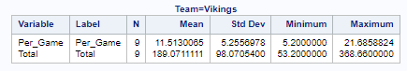
The first was by Team, the teams with the 5 highest mean totals among their players were the Bengals with 197.76, the Vikings, shown above, the Eagles with 179.3, the Bills with 178.58, and the Chargers with 172.81. The teams with the lowest totals were the Panthers with 102.76, the Colts with 105.2, the Broncos with 106.97, the Jets with 110.3, and the Rams with 111.29. The highest scores mean that the players on those teams scored a lot of points, and the lower ones less so, so gravitating towards those teams at the top when picking players may be beneficial towards having a good season.
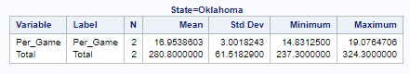
Next was by the State the player was born in, the highest was Oklahoma, shown above. This test is a little harder to gain anything from as players like Josh Jacobs, from Oklahoma, who scored the 10th highest score in fantasy, at 324.3, are going to massively raise the mean of their state when they are one of only two from that state. The highest with a significant amount of samples is both California and Tennessee depending on what you’d consider significant. Tennessee’s mean is slightly higher, but there are 24 more players from California. Not all American Football players are from the States though, some countries and provinces are represented here, the highest being Ontario.
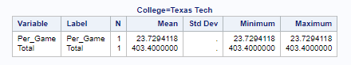
Next is by the College the player last went to, the highest being Texas Tech, shown above. This is similar to State in that it is harder to get anything from, especially since there are way too many Colleges represented by NFL players. Texas Tech is the highest since alum Patrick Mahomes scored the highest total among all players in 2022, and was the only one to make this dataset. Generally players from historically football-strong schools and states, the ones with a long history of good high school and college football are the ones that you want to look for players from, and usually those are the ones in the South. For those wondering, since there are two Minnesota State graduates in the NFL that made this dataset, Adam Thielen and Shane Zylstra, the means for Per Game and Total were 6.87 and 110.5 respectively.
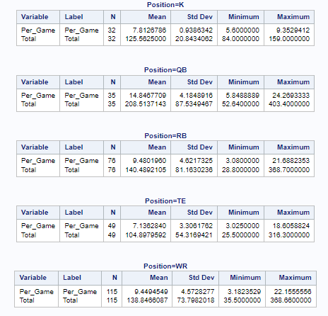
Doing it by Position only tells us what we can learn by observing Football, The QB scores the most, followed by RBs, WRs, Kickers, and TEs because they are more often used for blocking than being part of any form of scoring unless they are used in the passing scheme of a given team.
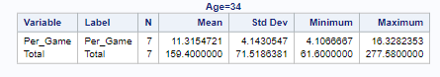
And finally, doing it by Age tells us that it really doesn’t matter what age the players are, they can be good or bad at any age. The highest was 45, but since Tom Brady was the only player remotely near that age, the highest with more than one player is 34, shown above. This shows that there isn’t much of a reason to look at a players exact age unless they are getting into their mid-30s, when players can start to become significantly less good. This result is reflected in all of the regression models we looked at, as Age was never a significant variable. The only other reason to be concerned about a player’s age is if you are in a Dynasty league, where the players you draft are the ones you will use year after year.
Total vs Age and Games
As said above, age does not have much significance on points produced by a player so the point total is not much changed by age as it is the number of games played.
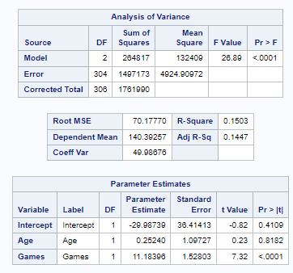
Per_Game vs all stats for all players
Running this test shows us really how many points come from each given variable. It is nice to see that our R-squared value is 0.9734 which means that this model is actually very well suited to predict future values of per-game score. Still, touchdowns are what really boost the points scored by a player; what is interesting to see, is that a rushing touchdown has slightly more pull on the per-game total than receiving. It is also important to note that not all regressors in the model are significant. Such as, FG_60, FG_Miss, Two_Pt, Age, and Ints as a 0.05 significance level.
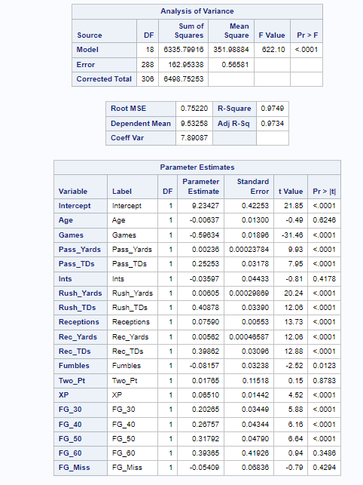
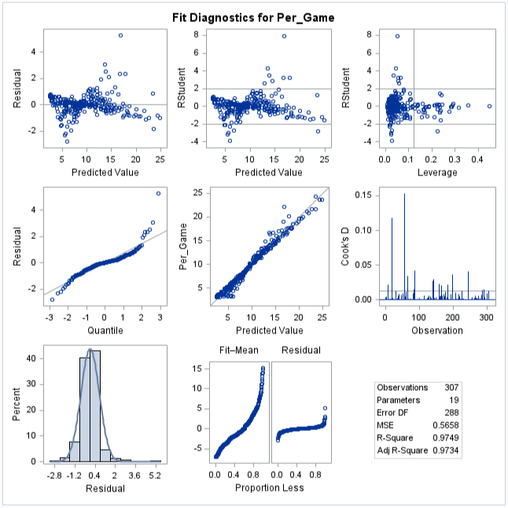
All of the Residual vs Regressor tests, other than for Age, look like a funnel shape, the variance getting smaller as the value gets larger.
Kickers: Per_Game vs stats Kickers are expected to get
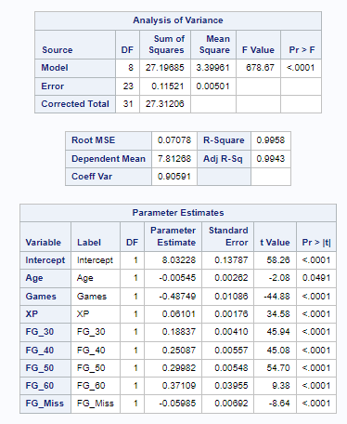
It seems like age might be at least a little important for Kickers, and clearly since more points are given the further the kick is, the longer the kick is the more pull it has on the per_game total.
QBs: Per_Game vs stats QBs are expected to get
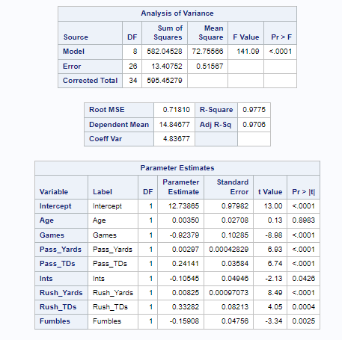
Age and INTS are not significant in this model at a 0.05 significance level, but we can see that the fewer games a QB plays does have an impact on their per_game total. It is also important to say that when a QB rushes for a touchdown it is more impactful than a passing touchdown, even though most QBs just throw for touchdowns.
RBs: Per_Game vs stats RBs are expected to get
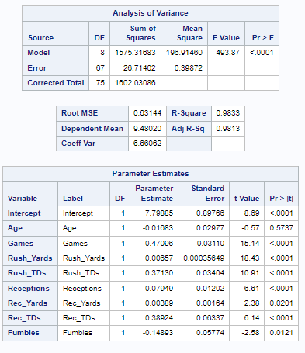
Receivers: Per_Game vs stats WRs and TEs are expected to get (the same ones as RBs)
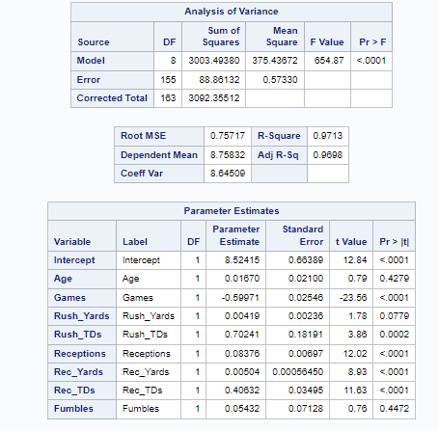
Rushing Yards and Fumbles seem to not be important for Wide Receivers and Tight Ends
These tests seem to give very similar results, for what variables are important, and are also generally really good models, with really high F-values, high R² values, and really low MS_{RES} values.
It seems that for each test we ran for per_game statistics show that each game a player doesn’t play, it has a negative effect on how well they score each game. The FUMBLE variable is not significant in any of these tests, and it seems that age isn’t significant either.
In conclusion of all these tests, the main things to take away are:
- Even though age plays a major role in real life football, it has no significance in the area of points scored in fantasy football.
- Even if a player is naturally a great real life player, if they miss games during the season, it does have an effect on how many points they score in other games. Since the parameter estimate is negative, it actually has a negative effect.
- The most points scored for your fantasy football team is in the following order:
QB > RB > WR > K > TE
- When the sample size is large, it is important to know what team the player is currently on, what state they are from, and what college that player came from. They seem to be good predictors on how many points a player will or won’t score.

Appendix:
libname final356 "M:\My_Private_Files\stat356\final";

proc import datafile="M:\My_Private_Files\stat356\final\test.xlsx"
out=final356.test replace
dbms=xlsx;
run;

proc import datafile="M:\My_Private_Files\stat356\final\2022 Fantasy Points.xlsx"
out=final356.fantasy replace
dbms=xlsx;
run;

proc print data=final356.test (obs=10);
run;

proc print data=final356.fantasy (obs=10);
run;

proc contents data=final356.test;
run;

proc means data=final356.test;
title "Stats with Zeroes Removed";
vars Pass_Yards Pass_TDs Ints Rush_Yards Rush_TDs Receptions Rec_Yards Rec_TDs Fumbles Two_Pt XP FG_30 FG_40 FG_50 FG_60 FG_Miss;
run;

proc means data=final356.fantasy;
title "Stats with Zeroes Included";
vars Pass_Yards Pass_TDs Ints Rush_Yards Rush_TDs Receptions Rec_Yards Rec_TDs Fumbles Two_Pt XP FG_30 FG_40 FG_50 FG_60 FG_Miss;
run;
title;

proc means data=final356.fantasy;
vars Age Games Total Per_Game;
run;

proc freq data=final356.fantasy;
tables State Team Position Age Games;
run;

proc freq data=final356.fantasy;
table College / nocum;
run;

data final356.qbs final356.rbs final356.recs final356.ks;
set final356.fantasy;
if Position = "QB" then output final356.qbs;
if Position = "RB" then output final356.rbs;
if Position in ("WR", "TE") then output final356.recs;
if Position = "K" then output final356.ks;
run;

proc sort data=final356.fantasy out=final356.teamsort;
by Team;
run;

proc means data=final356.teamsort;
by team;
var Per_Game Total;
run;

proc sort data=final356.fantasy out=final356.statesort;
by State;
run;

proc means data=final356.statesort;
by State;
var Per_Game Total;
run;

proc sort data=final356.fantasy out=final356.collegesort;
by College;
run;

proc means data=final356.collegesort;
by College;
var Per_Game Total;
run;

proc sort data=final356.fantasy out=final356.positionsort;
by Position;
run;

proc means data=final356.positionsort;
by Position;
var Per_Game Total;
run;

proc sort data=final356.fantasy out=final356.agesort;
by Age;
run;

proc means data=final356.agesort;
by Age;
var Per_Game Total;
run;

proc reg data=final356.fantasy;
model Total = Pass_Yards Pass_TDs Ints Rush_Yards Rush_TDs Receptions Rec_Yards Rec_TDs Fumbles Two_Pt XP FG_30 FG_40 FG_50 FG_60 FG_Miss;
run;

proc reg data=final356.fantasy;
model Total = Age Games;
run;

proc reg data=final356.fantasy;
model Per_Game = Age Games Pass_Yards Pass_TDs Ints Rush_Yards Rush_TDs Receptions Rec_Yards Rec_TDs Fumbles Two_Pt XP FG_30 FG_40 FG_50 FG_60 FG_Miss;
run;

proc reg data=final356.ks;
model Per_Game = Age Games XP FG_30 FG_40 FG_50 FG_60 FG_Miss;
run;

proc reg data=final356.qbs;
model Per_Game = Age Games Pass_Yards Pass_TDs Ints Rush_Yards Rush_TDs Fumbles;
run;

proc reg data=final356.rbs;
model Per_Game = Age Games Rush_Yards Rush_TDs Receptions Rec_Yards Rec_TDs Fumbles;
run;

proc reg data=final356.recs;
model Per_Game = Age Games Rush_Yards Rush_TDs Receptions Rec_Yards Rec_TDs Fumbles;
run;

References:
Pro Football Stats, history, scores, standings, playoffs, Schedule & Records. Pro. (n.d.). Retrieved April 18, 2023, from https://www.pro-football-reference.com/

