# Binary Search Tree (BST) - Lab 6

## Task Description

This document presents the implementation of a Binary Search Tree (BST) in Java, demonstrating insertion, search, and deletion operations. The BST is visualized using Python. We inserted specific elements into the tree, performed deletions, and analyzed the impact on structure.

## BST Before and After Deletions

### BST Before Deletion

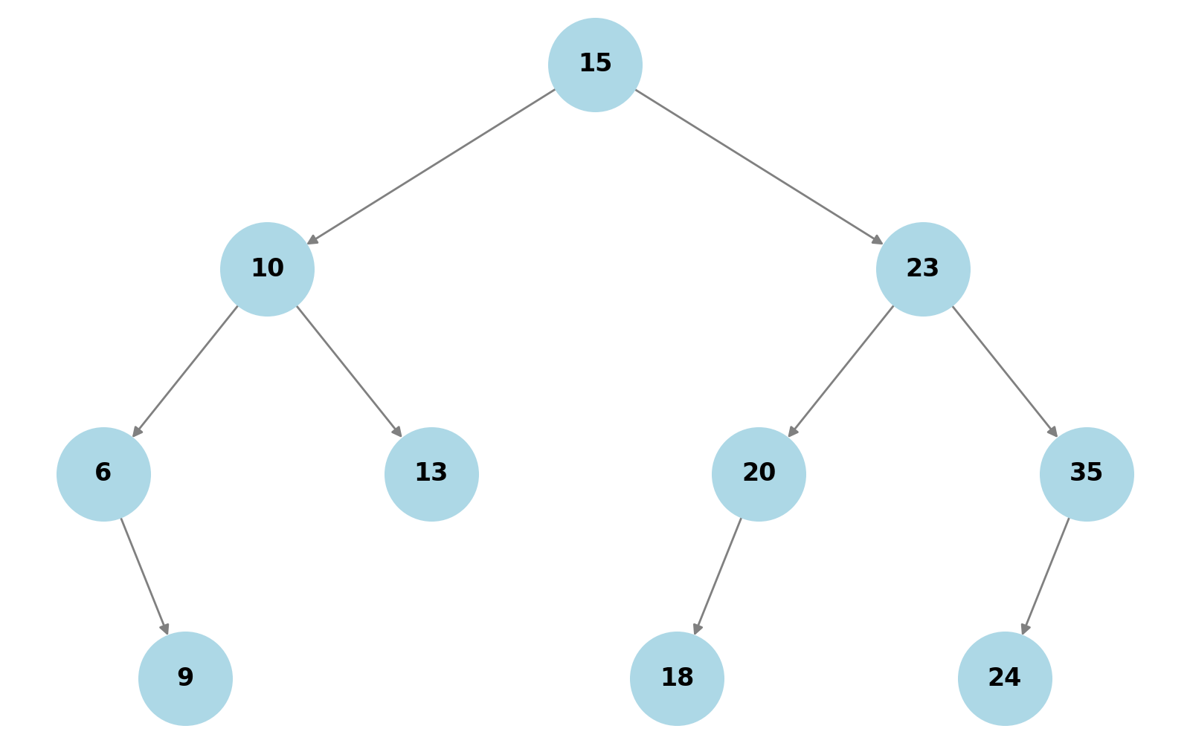

### BST After Deleting 6

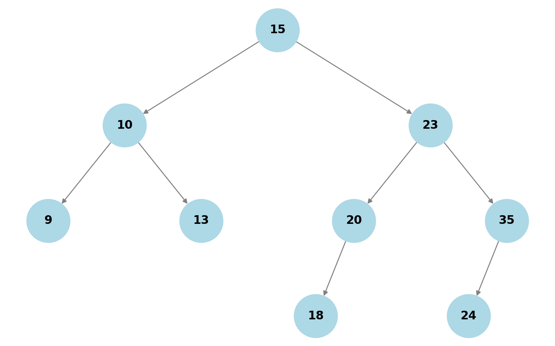

### BST After Deleting 15

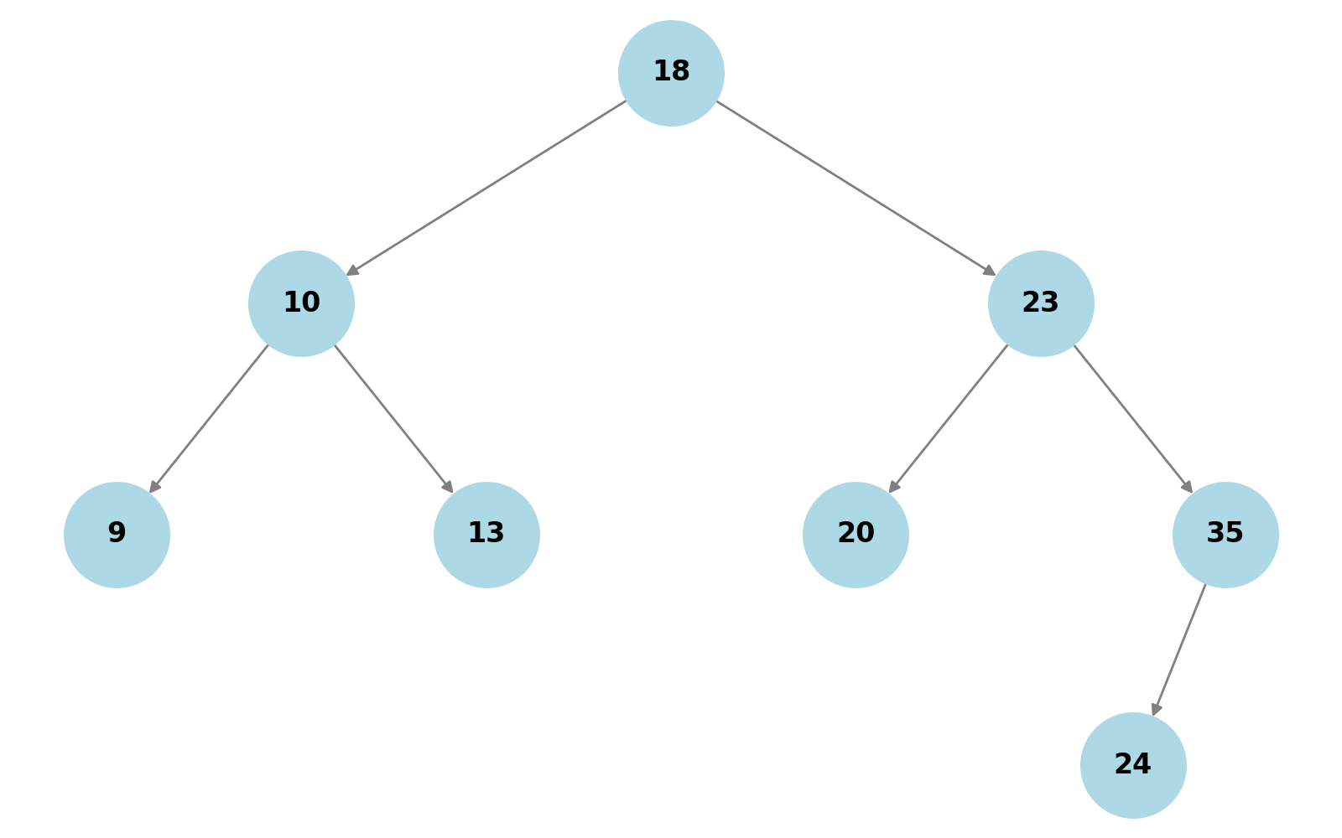

### BST After Deleting 20

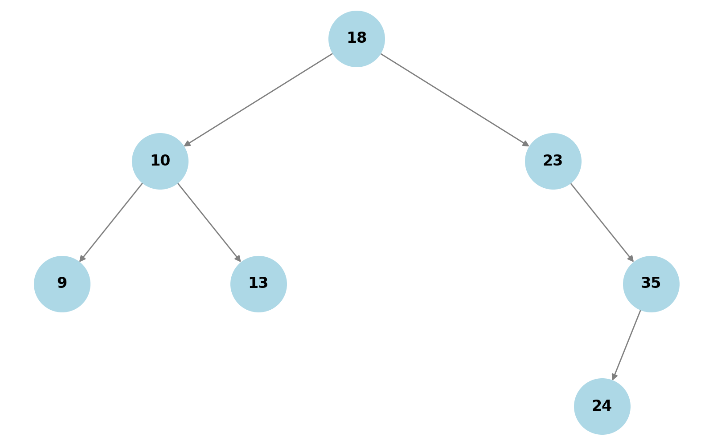

## Justification of BST Changes

1. **Deleting 6**: Since 6 was a leaf node, it was removed directly without affecting the structure.  
2. **Deleting 15**: The node had children (10, 23), so it was replaced by its in-order successor (18).  
3. **Deleting 20**: The node was replaced by its smallest right subtree element (24).  
  
This sequence of operations maintains the BST properties.