KENT SCHOOLS ATHLETICS ASSOCIATION

ESAA RACE WALKS CHAMPIONSHIPS 2019

NOMINATION DETAILS

Exeter
SATURDAY 21st SEPTEMBER 2019

Please complete and return to me asap

Name:…………………………………………………….. Date of birth:…………

Address:…………………………………………………..

……………………………………………. Post Code:…………………….

Tel. No:……………………………………………………

Email:…………………………………………………………………………………...

School Name:…………………………………………………………………………..

School Address:……………………………………………….

……………………………………Post Code:……………………….

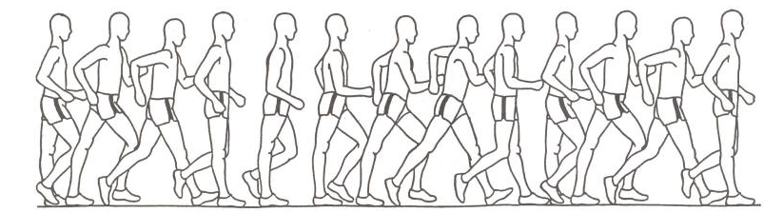

Please return completed form to:
IAIN PRESNELL
23 SWEEPS HILL CLOSE
PEMBURY
KENT. TN2 4LT
ijkl.presnell@btopenworld.com

