**Portfolio Analysis Part II**

*** All tables and graphs generated from yearly return data on four assets (ORCL, BA, GE, and MSFT)

** Return data from 1987 to 2018 found on <http://www.1stock1.com/1stock1_155.htm>

|  |  |  |  |  |
| --- | --- | --- | --- | --- |
| **Yearly Return Data (%)** | | | | |
| **Year** | **BA** | **MSFT** | **GE** | **ORCL** |
| **1987** | -27.63 | 124.87 | 2.62 | 179.52 |
| **1988** | 63.85 | -1.84 | 1.42 | 34.48 |
| **1989** | 46.91 | 63.38 | 44.13 | 139.74 |
| **1990** | 14.63 | 72.99 | -11.05 | -66.31 |
| **1991** | 5.23 | 121.76 | 33.33 | 84.13 |
| **1992** | -15.97 | 15.11 | 11.76 | 95.69 |
| **1993** | 7.79 | -5.56 | 22.66 | 102.64 |
| **1994** | 8.67 | 51.63 | -2.74 | 53.48 |
| **1995** | 66.76 | 43.56 | 41.18 | 44.05 |
| **1996** | 35.89 | 88.32 | 37.33 | 47.79 |
| **1997** | -8.1 | 56.43 | 48.42 | -19.84 |
| **1998** | -33.33 | 114.6 | 39.01 | 93.28 |
| **1999** | 27.01 | 68.36 | 51.72 | 289.78 |
| **2000** | 59.28 | -62.85 | -7.07 | 3.74 |
| **2001** | -41.24 | 52.74 | -16.39 | -52.48 |
| **2002** | -14.93 | -21.96 | -39.25 | -21.8 |
| **2003** | 27.74 | 5.88 | 27.23 | 22.5 |
| **2004** | 22.85 | -2.37 | 17.82 | 3.7 |
| **2005** | 35.68 | -2.13 | -3.97 | -11.01 |
| **2006** | 26.48 | 14.19 | 6.16 | 40.38 |
| **2007** | -1.55 | 19.22 | -0.38 | 31.74 |
| **2008** | -51.21 | -46.17 | -56.3 | -21.48 |
| **2009** | 26.86 | 56.79 | -6.6 | 38.35 |
| **2010** | 20.56 | -8.43 | 20.89 | 26.78 |
| **2011** | 12.4 | -6.99 | -2.08 | -18.05 |
| **2012** | 2.74 | 2.89 | 17.2 | 29.9 |
| **2013** | 81.12 | 40.06 | 33.54 | 14.83 |
| **2014** | -4.77 | 24.16 | -9.85 | 17.54 |
| **2015** | 11.24 | 19.44 | 23.27 | -18.77 |
| **2016** | 7.67 | 12 | 1.44 | 5.26 |
| **2017** | 89.43 | 37.66 | -44.78 | 22.96 |
| **2018** | 9.36 | 18.74 | -56.62 | -4.51 |

<http://www.1stock1.com/1stock1_155.htm>

|  |  |  |  |  |
| --- | --- | --- | --- | --- |
| **Asset Statistics** | | | | |
|
|  | **AvgReturn** | **Var** | **SD** | **Sharpe Ratio** |
| **BA** | 15.98 | 11.18 | 3.34 | 0.48 |
| **MSFT** | 30.20 | 19.99 | 4.47 | 0.67 |
| **GE** | 7.00 | 8.33 | 2.89 | 0.24 |
| **ORCL** | 37.13 | 49.03 | 7.00 | 0.53 |

**\*\* Scatterplots of BA yearly returns against MSFT, GE and ORCL**

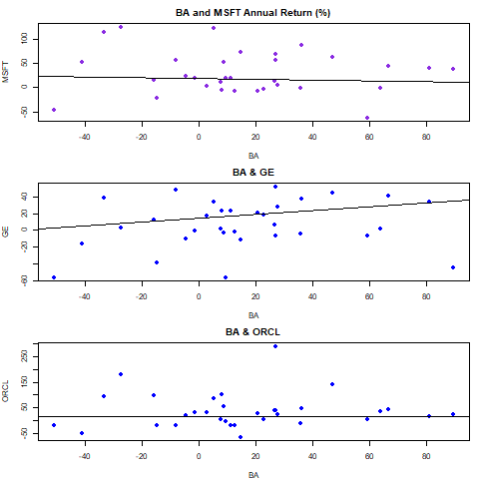

**\*\*\*Covariance between assets**

|  |  |  |  |  |
| --- | --- | --- | --- | --- |
| **Covariance Matrix** | | | | |
|  | **BA** | **MSFT** | **GE** | **ORCL** |
| **BA** | 1.00 | -0.11 | 0.20 | 0.04 |
| **MSFT** | -0.11 | 1.00 | 0.42 | 0.45 |
| **GE** | 0.20 | 0.42 | 1.00 | 0.48 |
| **ORCL** | 0.04 | 0.45 | 0.48 | 1.00 |

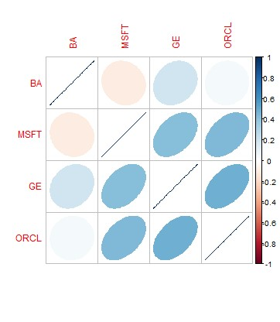

**\*\*\* Analyzing possible portfolio allocations and their associated expected returns**

**\*\* Based on the 32 year sample size, 1000 random normal observations were created to estimate the population parameters**

**\* Portfolio allocations are subject to two constraints- (1) no single asset can make up over 50% of the total portfolio (2) no short sales are allowed**

|  |  |  |  |  |  |  |
| --- | --- | --- | --- | --- | --- | --- |
| **Possible Portfolio Allocations** | | | | | | |
| **Portfolio** | **BA** | **MSFT** | **GE** | **ORCL** | **Return** | **SD** |
| **1** | 0 | 0 | 0.5 | 0.5 | 22.06344 | 4.38505 |
| **2** | 0.025 | 0.025 | 0.475 | 0.475 | 22.11488 | 4.23114 |
| **3** | 0.05 | 0.05 | 0.45 | 0.45 | 22.16631 | 4.08063 |
| **4** | 0.075 | 0.075 | 0.425 | 0.425 | 22.21775 | 3.93391 |
| **5** | 0.1 | 0.1 | 0.4 | 0.4 | 22.26919 | 3.79141 |
| **6** | 0.125 | 0.125 | 0.375 | 0.375 | 22.32063 | 3.65363 |
| **7** | 0.15 | 0.15 | 0.35 | 0.35 | 22.37206 | 3.52113 |
| **8** | 0.175 | 0.175 | 0.325 | 0.325 | 22.4235 | 3.39452 |
| **9** | 0.2 | 0.2 | 0.3 | 0.3 | 22.47494 | 3.27448 |
| **10** | 0.225 | 0.225 | 0.275 | 0.275 | 22.52638 | 3.16177 |
| **11** | 0.25 | 0.25 | 0.25 | 0.25 | 22.57781 | 3.05719 |
| **12** | 0.275 | 0.275 | 0.225 | 0.225 | 22.62925 | 2.96161 |
| **13** | 0.3 | 0.3 | 0.2 | 0.2 | 22.68069 | 2.87592 |
| **14** | 0.325 | 0.325 | 0.175 | 0.175 | 22.73213 | 2.80104 |
| **15** | 0.35 | 0.35 | 0.15 | 0.15 | 22.78356 | 2.73784 |
| **16** | 0.375 | 0.375 | 0.125 | 0.125 | 22.835 | 2.68715 |
| **17** | 0.4 | 0.4 | 0.1 | 0.1 | 22.88644 | 2.6497 |
| **18** | 0.425 | 0.425 | 0.075 | 0.075 | 22.93788 | 2.62604 |
| **19** | 0.45 | 0.45 | 0.05 | 0.05 | 22.98931 | 2.61656 |
| **20** | 0.475 | 0.475 | 0.025 | 0.025 | 23.04075 | 2.6214 |
| **21** | 0.5 | 0.5 | 0 | 0 | 23.09219 | 2.64049 |

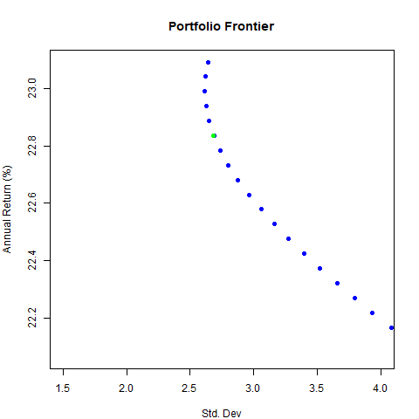

|  |  |  |  |  |
| --- | --- | --- | --- | --- |
| **Global Min Portfolio (no short sales)** | | | | |
| **Expected Return** | 14.957 |  | **Asset** | **Share** |
| **Variance** | 5.137 |  | BA | 0.417 |
| **SD** | 2.2665 |  | MSFT | 0.1815 |
|  |  |  | GE | 0.4015 |
|  |  |  | ORCL | 0 |

**\*\*\* The minimum variance asset allocation hold weighted shares in each asset shown below with the associated expected return, variance and std. deviation**

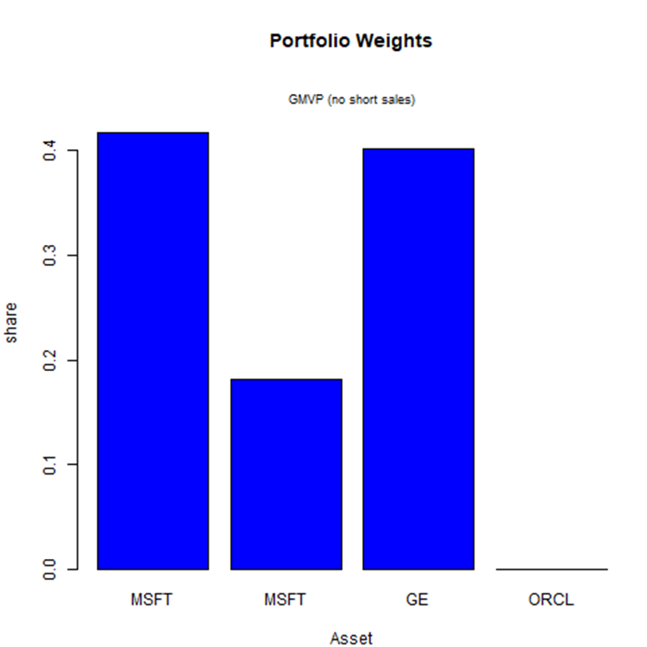

**\*\*\* Based on the 1000 simulated observations the mean, variance, and standard deviation are shown below. The 95% confidence intervals of the estimated parameters are also shown**

|  |  |  |  |  |
| --- | --- | --- | --- | --- |
| **95% Confidence Intervals of Estimated Parameters** | | | | |
|
|  | **Lower Bound** | **Mean** | **UpperBound** | **Std. Error** |
| **BA** | 14.83 | 16.06 | 17.29 | 0.62 |
| **MSFT** | 28.56 | 30.12 | 31.67 | 0.78 |
| **GE** | 5.97 | 6.99 | 8 | 0.51 |
| **ORCL** | 34.54 | 37.08 | 39.63 | 1.27 |
|  |  |  |  |  |
|  | **Lower Bound** | **Variance** | **UpperBound** | **Std. Error** |
| **BA** | 6.07 | 12.14 | 18.21 | 3.04 |
| **MSFT** | 9.64 | 19.27 | 28.91 | 4.82 |
| **GE** | 4.11 | 8.22 | 12.34 | 2.06 |
| **ORCL** | 25.88 | 51.77 | 77.65 | 12.94 |
|  |  |  |  |  |
|  | **Lower Bound** | **SD** | **UpperBound** | **Std. Error** |
| **BA** | 2.61 | 3.48 | 4.36 | 0.44 |
| **MSFT** | 3.29 | 4.39 | 5.49 | 0.55 |
| **GE** | 2.15 | 2.87 | 3.58 | 0.36 |
| **ORCL** | 5.4 | 7.19 | 8.99 | 0.9 |

**\*\* Additional possible Portfolio Allocations are shown below**

