Happynin Games _ game hi-rez artwork and descriptions:

Fowlplay:

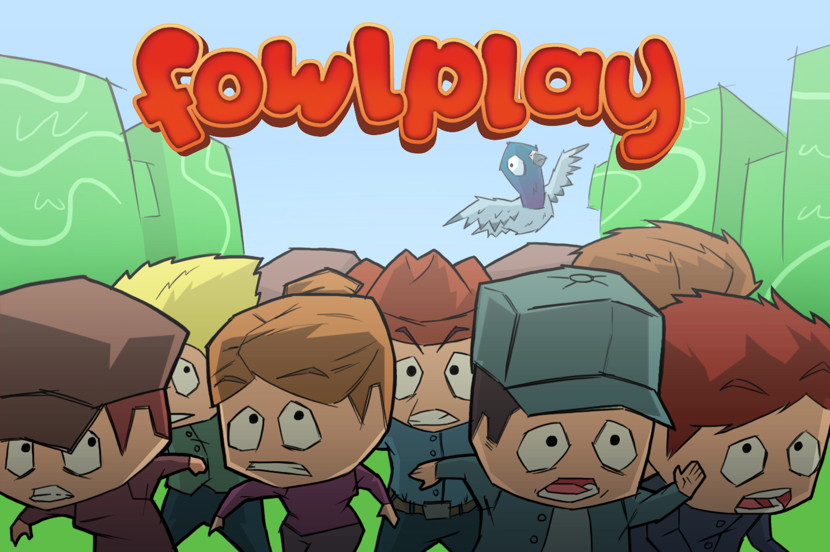

Description
Take to the skies as a pigeon and get ready to poop on the unsuspecting people below. Earn huge points by collecting awesome power-ups and not missing a drop, but watch out for the trees. Featuring beautiful 3D graphics and intuitive controls, it’s time to engage in some fowlplay!

Fruits vs Veggies
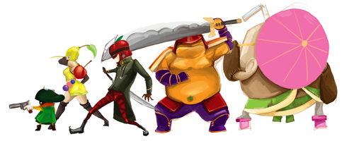

Description:
It’s the ultimate battle for the kitchen- which food group are you? Use the cards to summon fruits or vegetable units, spells, and traps as you battle to infiltrate the enemy’s territory and prevent them from reaching your side. Unlock powerful cards and create a custom deck suited to your individual strategy. It’s a food fight like never before.

Dynotron
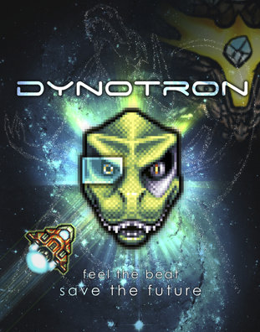

Description:
An evil meteor threatens to destroy Dinotopia and all life, and it’s up to you to save the world! Battle through hordes of enemies to get to the meteor in this unique rhythm based shooter. Fly your ship and shoot your weapons to the beat of the music, and save the future of the Dinotopia.

Thin Ice Rescue

(No artwork available)

Description:
Baby penguins are trapped on thin ice. It’s up to you to rescue all of them, but you’ll have to plan carefully – with each step you take, the ice behind you breaks! Meet a variety of penguins, each with their own unique attributes that add new challenges to the puzzles. Can you get all the baby penguins – and yourself – to safety?

