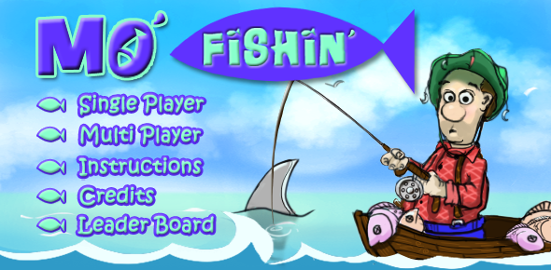
Happynin Games _ game hi-rez artwork and descriptions:

Mo Fishin:

Game Description
Grab a fishing pole and hop in your boat, it's time for Mo Fishin! Catch fish and win tournaments but beware of sharks, barracudas, piranhas and moray eels, they will cut your line and free your fish. Aim the hook by tapping the "reel" button and flick your iPhone for casting. With the right timing and aim you'll be a Master Fisherman in no time! If you want Big Points, go for the gold coins on the bottom of the sea. But don't get too greedy, you might just end up with a tin can or an old boot.

Rotten Eggs:

Game Description:
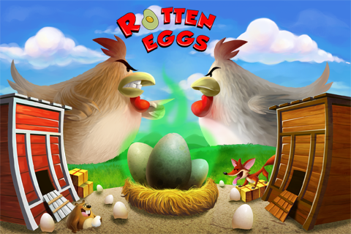
You are the top hen on the farm and are proud of your coop. Defend it and your status against challenging hens by rolling eggs through the farm maze to “splat” the other hens. With enough egg in their faces, they’ll be forced to move onto another farm and you’ll be top hen again. Use designated rotten eggs to really make your point! When rolling your eggs, be careful to avoid the many pitfalls of the farm: A busy gopher who makes holes in your path, hungry egg-eating plants that pop out of the ground to feast and a sneaky fox that roams the farm looking for a meal.

Sumo vs Zombies:

((Illustration to follow))

Game Description:
You are a sumo in a world filled with zombies. Hungry zombies. You have to fight off the hordes to survive. Time is not on your side, but logic is. You have the one thing the zombies don’t have but want: A brain. The longer you survive the more skills you uncover to keep these creatures at bay. How long will you survive?

