# ITDEV-160 Final Project Proposal

Chris Otto

## Function of the Webpage

When initially reading about what the final project all entailed, I knew what I was going to do right away, an online resume. The main function of the site will be to give information about myself. Being that we needed at least three pages outside of the homepage this worked out perfect. I will have a home page that functions as the ‘About’ portion of the resume. The portfolio will be listed as the second page and will list QR codes to applications that I have made. The third page will be the resume portion, displaying my prior work experience and education. Lastly will be the contact page which fill function as the forms portion of the project allowing visitors to send me their information if they want to reach out to me. I will use an external CCS stylesheet and put to use inline styling as well. All scripts will be kept within the HTML files themselves.

## Life after the Project

Being that this kind of development is not only beneficial to the project but also to my career I will be able to use this as template when finishing my whole online resume. Due to time constraints I will not be able to implement my whole portfolio for this site. In fact, the site itself will serve as its own portion of my portfolio due to it being developed by myself, allowing me to show off some of my skills. That being said I will most likely not publish it until more work can be done on it outside of this class to make sure that is to point to where I feel like it represents me. However for this final assignment I will put enough work and effort that it will meet all project requirements.

## Meeting the requirements

Below you will find the different pages of the site drawn out. Below each page you will find a description as to how the will help to meet the overall requirements of the project. But first let me list the requirements:

* HTML
* Form
  + Mailto
  + At least three items including Submit button (Required)
* CSS
  + External
  + Inline
* Picture – one in every page
* Audio/Video – One of either
* Menu Bar
* Javascript/jQuery
  + At least four items including Respond to an event (Required)

### Home Page

The homepage will basically be a landing page and also give the user information about me for the rest of the site. The home page will help to complete the project in that it will contain a video, header image, and menu bar and reference the external CSS.

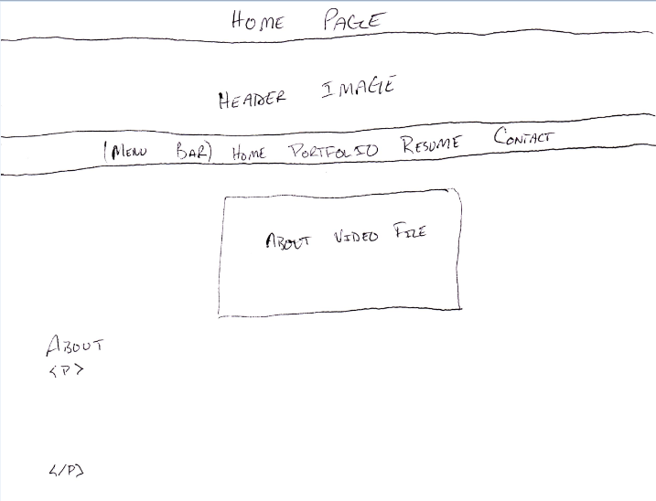

### Portfolio

The portfolio page will contain a descriptive paragraph to display the functionality of it to the user accessing it. The rest of the content will be a table will the name of the android application with a QR code for the user to scan with their android smartphone. Once scanned the application will download to their smartphone and they will be able to use the application. This will help complete the project in that it will contain a header image, QR code image files, a menu bar and reference the external style sheet.

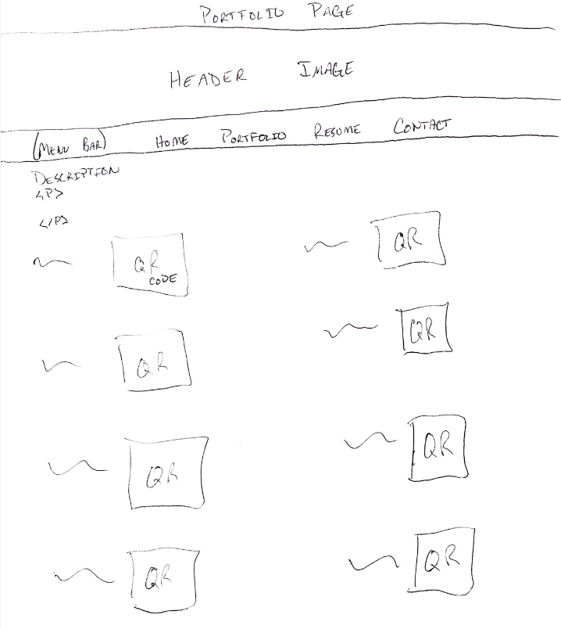

### Resume

The resume portion of the site will list work history, education, technical acumen and an objective of what the purpose of what I would be looking for. This page is where most of the jquery and javascript will be help I want to be able to allow the user to manipulate the site so they see what they are really interested in. On initial load it will display everything, however when element headers are clicked the will slide information away, also on hover the CSS will change. This will complete the following portions of the requirements, header image, menu bar, reference an external stylesheet, inline styles and two to three javascript/jqeury elements.

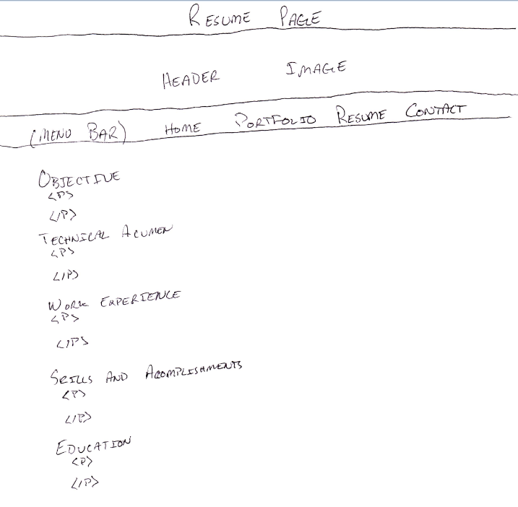

### Contact

The last page for the site will be a call to action, the contact page. Based on everything else listed in the site the user will be able to approach me if they want to! The form will contain a descriptive paragraph, a name text box, email textbox, phone textbox, phone type dropdown, organization textbox, a message textarea and a submit button. This area will complete the following requirements of the project, header image, menu bar, reference an external and inline styles and respond to an event with javascript/jquery (submit button will alert user that email has been sent). After this page all requirements for the project will have been met.

