- Connect the following pins of the debug port to the GPIO port :
  - pin 1 (GND) –> pin 39 (GND)
  - pin 7 (reset) –> pin 35 (GPIO24, BCM19)
  - pin 3 (DC) –> pin 36 (GPIO27, BCM16)
  - pin 4 (DD) –> pin 38 (GPIO28, BCM20)
As with the arduino option above, connecting Target Voltage Sense to a 3.3v source eliminates the need to plug the device into a usb port, so optionally connect the following too:
- pin 2 (Target Voltage Sense) –> pin 1 or pin 17 (3.3v) on Raspi
See above for the dispositions of pins on CC2531, and at https://pinout.xyz/ for pins on Raspberry.
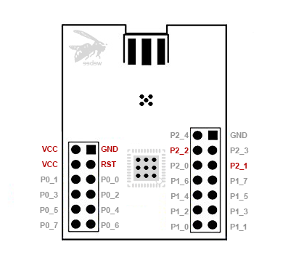

Wiring CC2530 to the Raspberry #
CC C2530 -> Raspberry
VCC -> 3,3V (Pin1)
GND -> GND (Pin6)
P02 -> TXD (Pin8 / BCM 14)
P03 -> RXD (Pin10 / BCM 15)

Rpi → CC2530 + CC2591
Rpi pin | Cc debugger | CC2530 + CC2591 pin
pin 39 (GND) | 1 - GND | pin 1 (GND)
pin 1 or pin 17 (3.3v) on Raspi | 2 - vcc | vcc
pin 36 (GPIO27, BCM16) | 3 – p2.2 | P2.2
pin 38 (GPIO28, BCM20) | 4 – p2.1 | P2.1
pin 35 (GPIO24, BCM19) | 7 – rst | rst
 | 9 - vcc | vcc

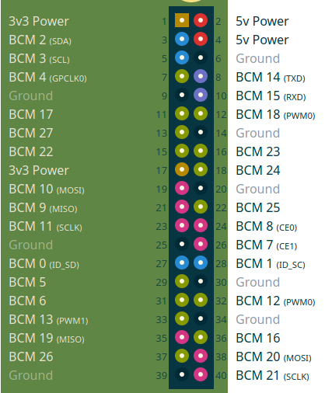

Connect the following pins of the debug port to the GPIO port :
  - pin 1 (GND) –> pin 39 (GND)
  - pin 7 (reset) –> pin 35 (GPIO24, BCM19)
  - pin 3 (DC) –> pin 36 (GPIO27, BCM16)
  - pin 4 (DD) –> pin 38 (GPIO28, BCM20)
As with the arduino option above, connecting Target Voltage Sense to a 3.3v source eliminates the need to plug the device into a usb port, so optionally connect the following too:
- pin 2 (Target Voltage Sense) –> pin 1 or pin 17 (3.3v) on Raspi

op when added

Jul 31 20:32:06 pi3b npm[5237]: zigbee2mqtt:info 2020-07-31 20:32:06: Successfully interviewed '0x00124b001fc64f9f', device has successfully been paired
Jul 31 20:32:06 pi3b npm[5237]: zigbee2mqtt:info 2020-07-31 20:32:06: Device '0x00124b001fc64f9f' is supported, identified as: Custom devices (DiY) [CC2530 router](http://ptvo.info/cc2530-based-zigbee-coordinator-and-router-112/) (CC2530.ROUTER)
Jul 31 20:32:06 pi3b npm[5237]: zigbee2mqtt:info 2020-07-31 20:32:06: MQTT publish: topic 'zigbee2mqtt/bridge/log', payload '{"type":"pairing","message":"interview_successful","meta":{"friendly_name":"0x00124b001fc64f9f","model":"CC2530.ROUTER","vendor":"Custom devices (DiY)","description":"[CC2530 router](http://ptvo.info/cc2530-based-zigbee-coordinator-and-router-112/)","supported":true}}'
Jul 31 20:32:57 pi3b npm[5237]: zigbee2mqtt:info 2020-07-31 20:32:57: MQTT publish: topic 'zigbee2mqtt/THSensor02', payload '{"battery":100,"voltage":3035,"temperature":28.69,"humidity":36.99,"linkquality":139}'
Jul 31 20:32:57 pi3b npm[5237]: zigbee2mqtt:info 2020-07-31 20:32:57: MQTT publish: topic 'zigbee2mqtt/THSensor02', payload '{"battery":100,"voltage":3035,"temperature":28.69,"humidity":55.14,"linkquality":139}'
Jul 31 20:33:05 pi3b npm[5237]: zigbee2mqtt:info 2020-07-31 20:33:05: MQTT publish: topic 'zigbee2mqtt/0x00124b001fc64f9f', payload '{"led":true,"linkquality":139}'

