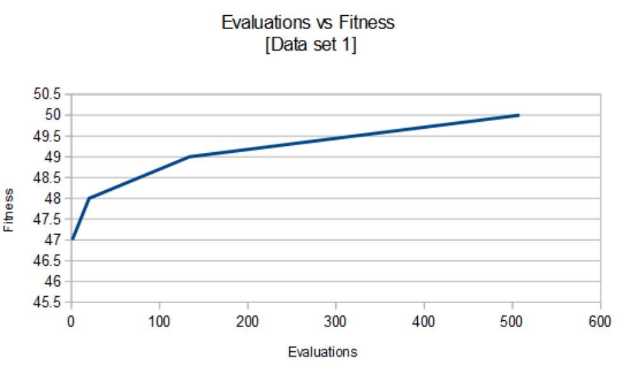
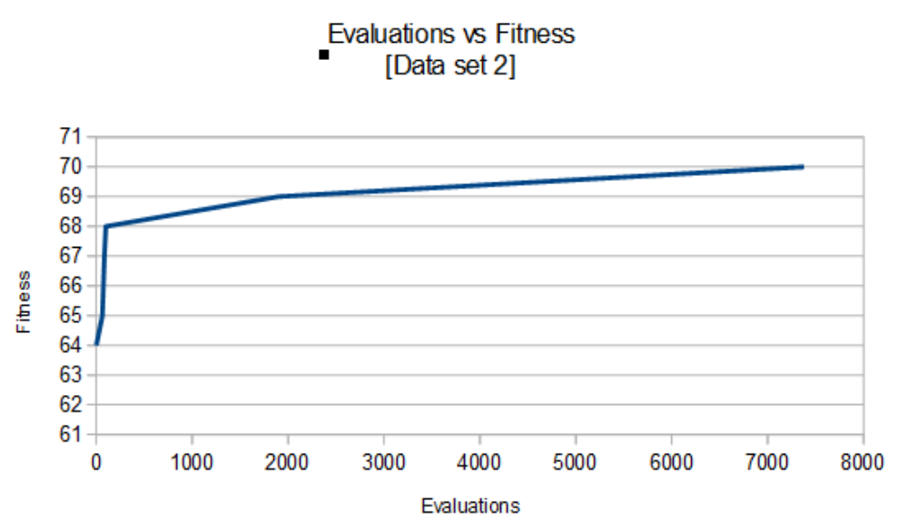
Chris Peabody
cgpzbd@mst.edu
COMP SCI 5401 FS2015 Assignment 1a

