Chris Piech Handout #9
CS 106A January 16, 2017
Section Handout #1—Karel the Robot
Based on a handout by Eric Roberts

This week in section, your first priority is to meet your section leader and discover what sections in CS 106A are all about. Your section leader will therefore spend the first part of this week’s session on introductions and telling you the things you need to know, such as where to get help and how to sign up for interactive grading. After the introductory material, the section will move on to cover some of the important material from class in a setting that is small enough for you to ask questions and thereby find out what you need to know. This week, your goal is to solve a Karel problem that involves stepwise refinement, also known as top-down design.

- United Nations Karel
Three months after the 2010 Pakistan Floods began, considerable damage remained, and many communities were yet to be rebuilt. As part of its plans to help reconstruct infrastructure, the United Nations—that’s right the UN is using Karel—established a new program whose mission is to dispatch house-building robots to repair the damaged area. Your job is to program those robots.

Each robot begins at the west end of a street that might look like this:
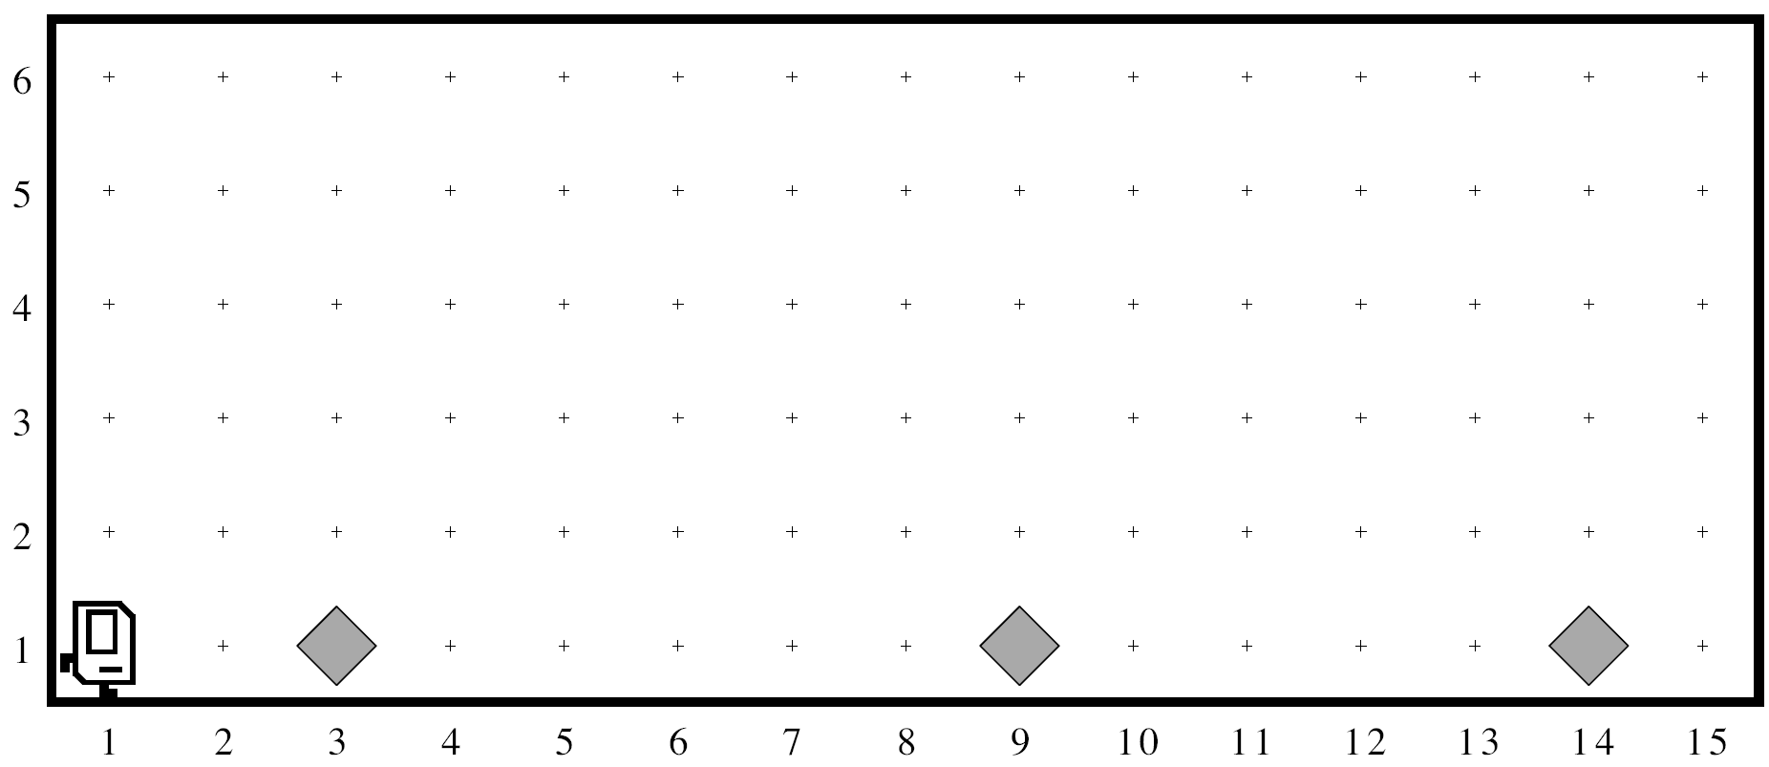
Each beeper in the figure represents a pile of debris. Karel’s job is to walk along the street and build a new house in the place marked by each beeper. Those houses, moreover, need to be raised on stilts to avoid damage from the next flood.

Each house, in fact, should look exactly like this:
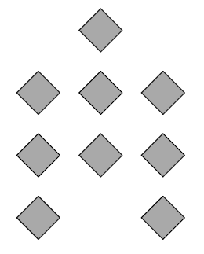
The new house should be centered at the point at which the bit of debris was left, which
means that the first house in the diagram above will be constructed with its left edge
along 2nd Avenue.

At the end of the run, Karel should be at the east end of the street having created a set of
houses that look like this for the initial conditions shown:
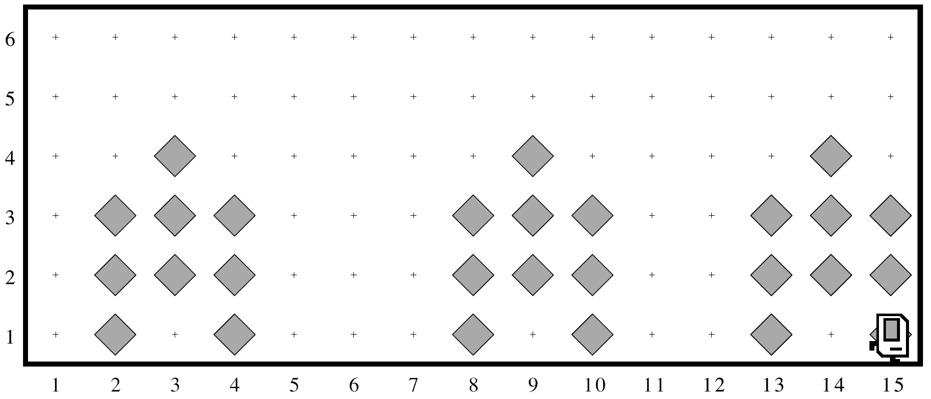

Karel may count on the following facts about the world:

- Karel starts off facing east at the corner of 1st Street and 1st Avenue with an infinite number beepers in its beeper bag.
- The beepers indicating the positions at which houses should be built will be spaced so that there is room to build the houses without overlapping or hitting walls.
- Karel must end up facing east at the southeast corner of the world. Moreover, Karel should not run into a wall if it builds a house that extends into that final corner.

Write a program to implement the United Nations Karel project. Remember that your program should not work only for the example shown in the diagram, but for any world that meets these conditions.

