Chris Piech Handout #8
CS 106A Jan 19, 2018
Assignment #2: Simple Java Programs
Due: 10:30am on Monday, Jan 29th
This assignment should be done individually (not in pairs)

Portions of this handouts by Eric Roberts

Your job in this assignment is to write programs to solve each of these six problems. You should start by downloading the starter project for Assignment #2 from the CS106A assignment page (go to the CS106A web site and click the Assignments link). The starter project will provide java files for you to write your programs in.

- As warmup, write a GraphicsProgram subclass that draws a blue, filled rectangle with width equal to 350 pixels and height equal to 270 in the center of the screen:

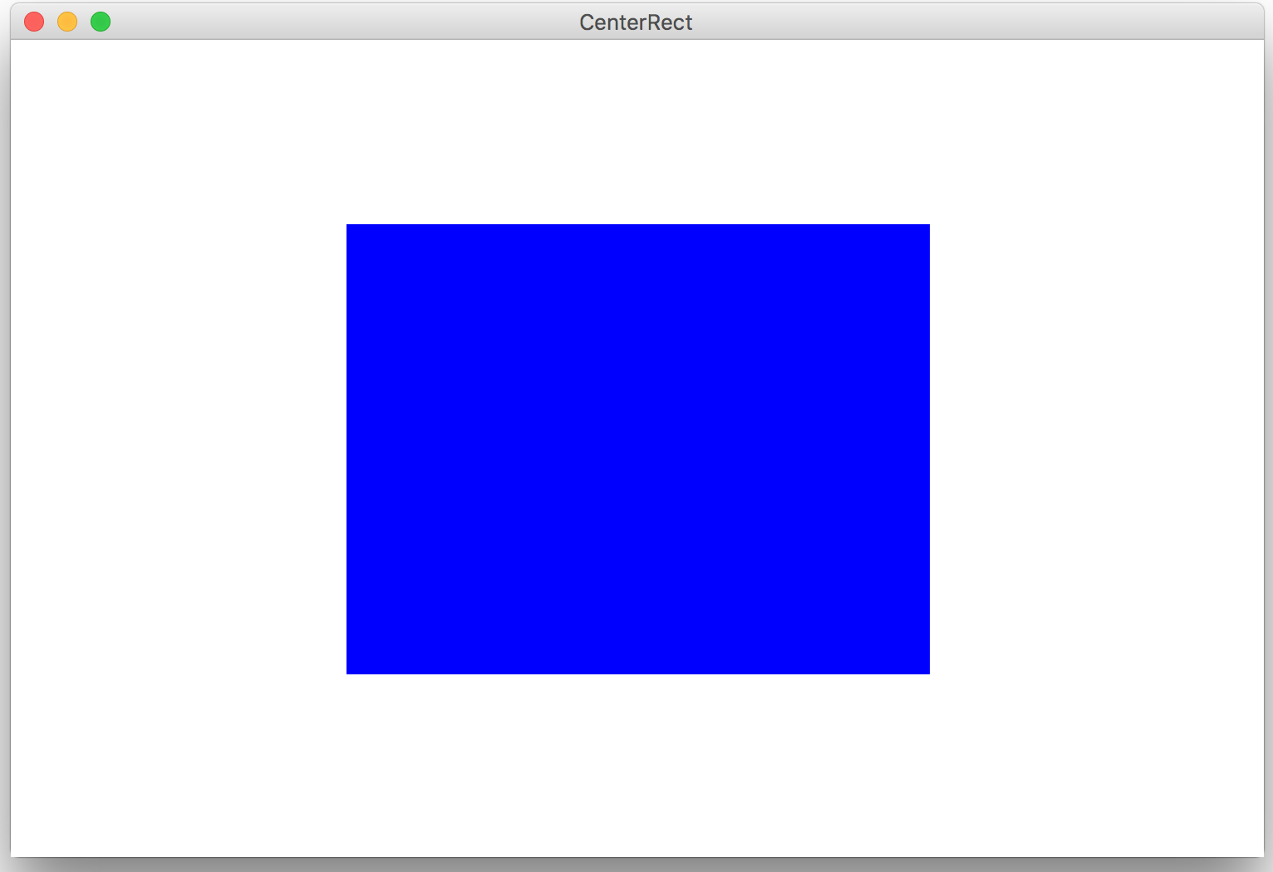

2. As warmup, write a ConsoleProgram subclass that prints out the calls for a spaceship that is about to launch. Write the numbers 10 down to 1 and then write liftoff. You must use a loop:
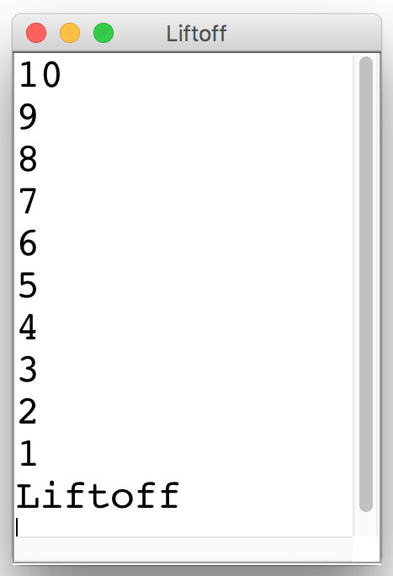
3. Write a GraphicsProgram subclass that draws a pyramid consisting of bricks arranged in horizontal rows, so that the number of bricks in each row decreases by one as you move up the pyramid, as shown in the following sample run:

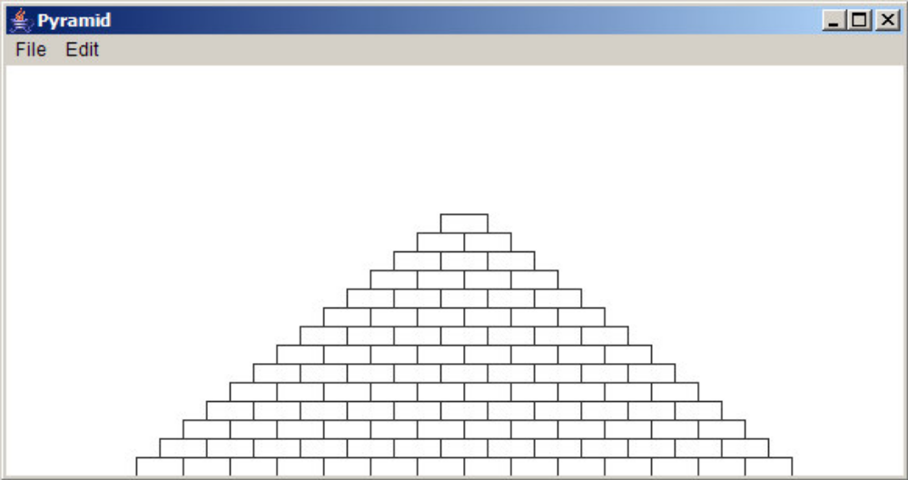

The pyramid should be centered at the bottom of the window and should use constants for the following parameters:

BRICK_WIDTH The width of each brick (30 pixels)
BRICK_HEIGHT The height of each brick (12 pixels)
BRICKS_IN_BASE The number of bricks in the base (14)

The numbers in parentheses show the values for this diagram, but you must be able to change those values in your program.

4. Suppose that you’ve been hired to produce a program that draws an image of an archery target—or, if you prefer commercial applications, a logo for a national department store chain—that looks like this:



This figure is simply three GOval objects, two red and one white, drawn in the correct order. The outer circle should have a radius of one inch (72 pixels), the white circle has a radius of 0.65 inches, and the inner red circle has a radius of 0.3 inches. The figure should be centered in the window of a GraphicsProgram subclass.

5. As an expression of your fondness for CS106A, you should write a GraphicsProgram called CS106ATiles that display four tiles (rectangles), each containing the text “CS106A” in the center of the graphics window, as shown below:

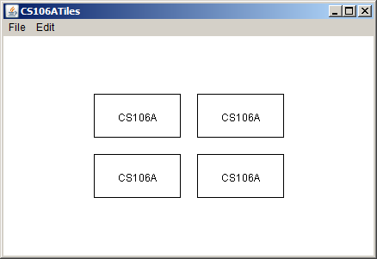

• The width and height of each of the four tiles (rectangles) should be specified as named constants TILE_WIDTH and TILE_HEIGHT, respectively, so that they are easy to change. You should determine reasonable values for these constants to make your picture look similar (but, it need not be exact) to the figure above.
• The text/label “CS106A” should be centered in each of the respective four tiles. You can find the width of a label by calling label.getWidth() and the height it extends above the baseline by calling label.getAscent(). If you want to center a label, you need to shift its origin by half of these distances in each direction.
• The amount of space (in pixels) between each of the four tiles is specified by the constant TILE_SPACE (which is provided in the starter file). This constant should be used both for the horizontal space between tiles and the vertical space between tiles.
• The entire figure (of four tiles) should be centered in the graphics window.

6. In high-school geometry, you learned the Pythagorean theorem for the relationship of the lengths of the three sides of a right triangle:

a2 + b2 = c2

which can alternatively be written as:

c = 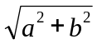

Most of this expression contains simple operators covered in Chapter 3. The one piece that’s missing is taking square roots, which you can do by calling the standard function Math.sqrt. For example, the statement

double y = Math.sqrt(x);

sets y to the square root of x.

Write a ConsoleProgram that accepts values for a and b as doubles (you can assume that a and b will be positive) and then calculates the solution of c as a double. Your program should be able to duplicate the following sample run:

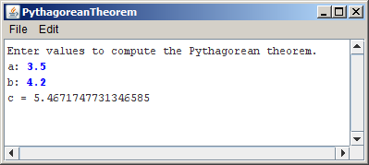

(continued on the next page)

7. Write a ConsoleProgram that reads in a list of integers, one per line, until a sentinel value of 0 (which you should be able to change easily to some other value). When the sentinel is read, your program should display the smallest and largest values in the list, as illustrated in this sample run:

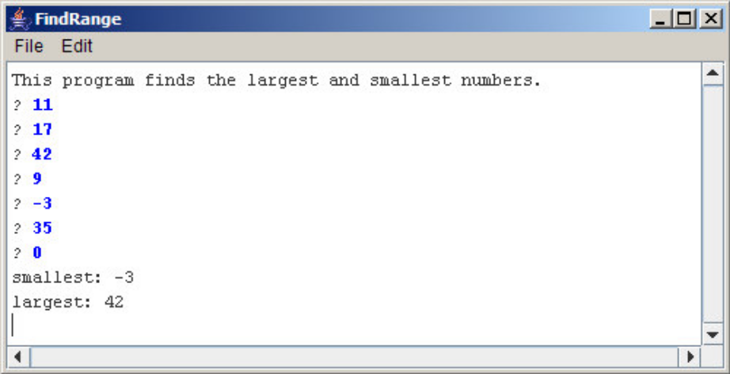

Your program should handle the following special cases:

• If the user enters only one value before the sentinel, the program should report that value as both the largest and smallest.
• If the user enters the sentinel on the very first input line, then no values have been entered, and your program should display a message to that effect.

8. Douglas Hofstadter’s Pulitzer-prize-winning book Gödel, Escher, Bach contains many interesting mathematical puzzles, many of which can be expressed in the form of computer programs. In Chapter XII, Hofstadter mentions a wonderful problem that is well within the scope of the control statements from Chapter 4. The problem can be expressed as follows:

Pick some positive integer and call it n.
If n is even, divide it by two.
If n is odd, multiply it by three and add one.
Continue this process until n is equal to one.

On page 401 of the Vintage edition, Hofstadter illustrates this process with the following example, starting with the number 15:

15 is odd, so I make 3n+1: 46
46 is even, so I take half: 23
23 is odd, so I make 3n+1: 70
70 is even, so I take half: 35
35 is odd, so I make 3n+1: 106
106 is even, so I take half: 53
53 is odd, so I make 3n+1: 160
160 is even, so I take half: 80
80 is even, so I take half: 40
40 is even, so I take half: 20
20 is even, so I take half: 10
10 is even, so I take half: 5
5 is odd, so I make 3n+1: 16
16 is even, so I take half: 8
8 is even, so I take half: 4
4 is even, so I take half: 2
2 is even, so I take half: 1

As you can see from this example, the numbers go up and down, but eventually—at least for all numbers that have ever been tried—comes down to end in 1. In some respects, this process is reminiscent of the formation of hailstones, which get carried upward by the winds over and over again before they finally descend to the ground. Because of this analogy, this sequence of numbers is usually called the Hailstone sequence, although it goes by many other names as well.

Write a ConsoleProgram that reads in a number from the user and then displays the Hailstone sequence for that number, just as in Hofstadter’s book, followed by a line showing the number of steps taken to reach 1. For example, your program should be able to produce a sample run that looks like this:

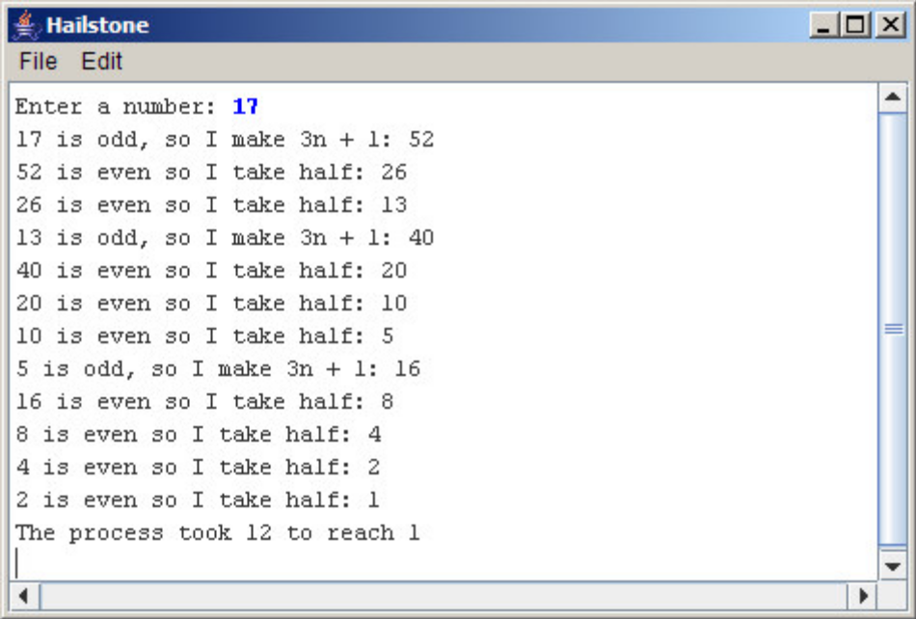

The fascinating thing about this problem is that no one has yet been able to prove that it always stops. The number of steps in the process can certainly get very large. How many steps, for example, does your program take when n is 27?

