Chris Piech Handout #6

CS 106A January 16, 2018

Submitting Work

Based on a handout by Eric Roberts

This handout provides a little more background on submitting work. Remember that all assignments are submitted electronically using Eclipse and Paperless. Eclipse exports your entire assignment as a single zip file, and you must then submit this zip online at paperless.stanford.edu. Whether an assignment is submitted on time is determined by the time we receive your electronic submission, which is timestamped in the submission process. That time is based on the time on the server that receives the assignment, so it pays to submit things with a few minutes to spare, particularly if you discover that your computer’s clock is running slow.

Submitting your assignments electronically

The Stanford version of Eclipse makes submission a relatively painless process. All you need to do is select the **Submit Project** entry under the **Stanford Menu**:

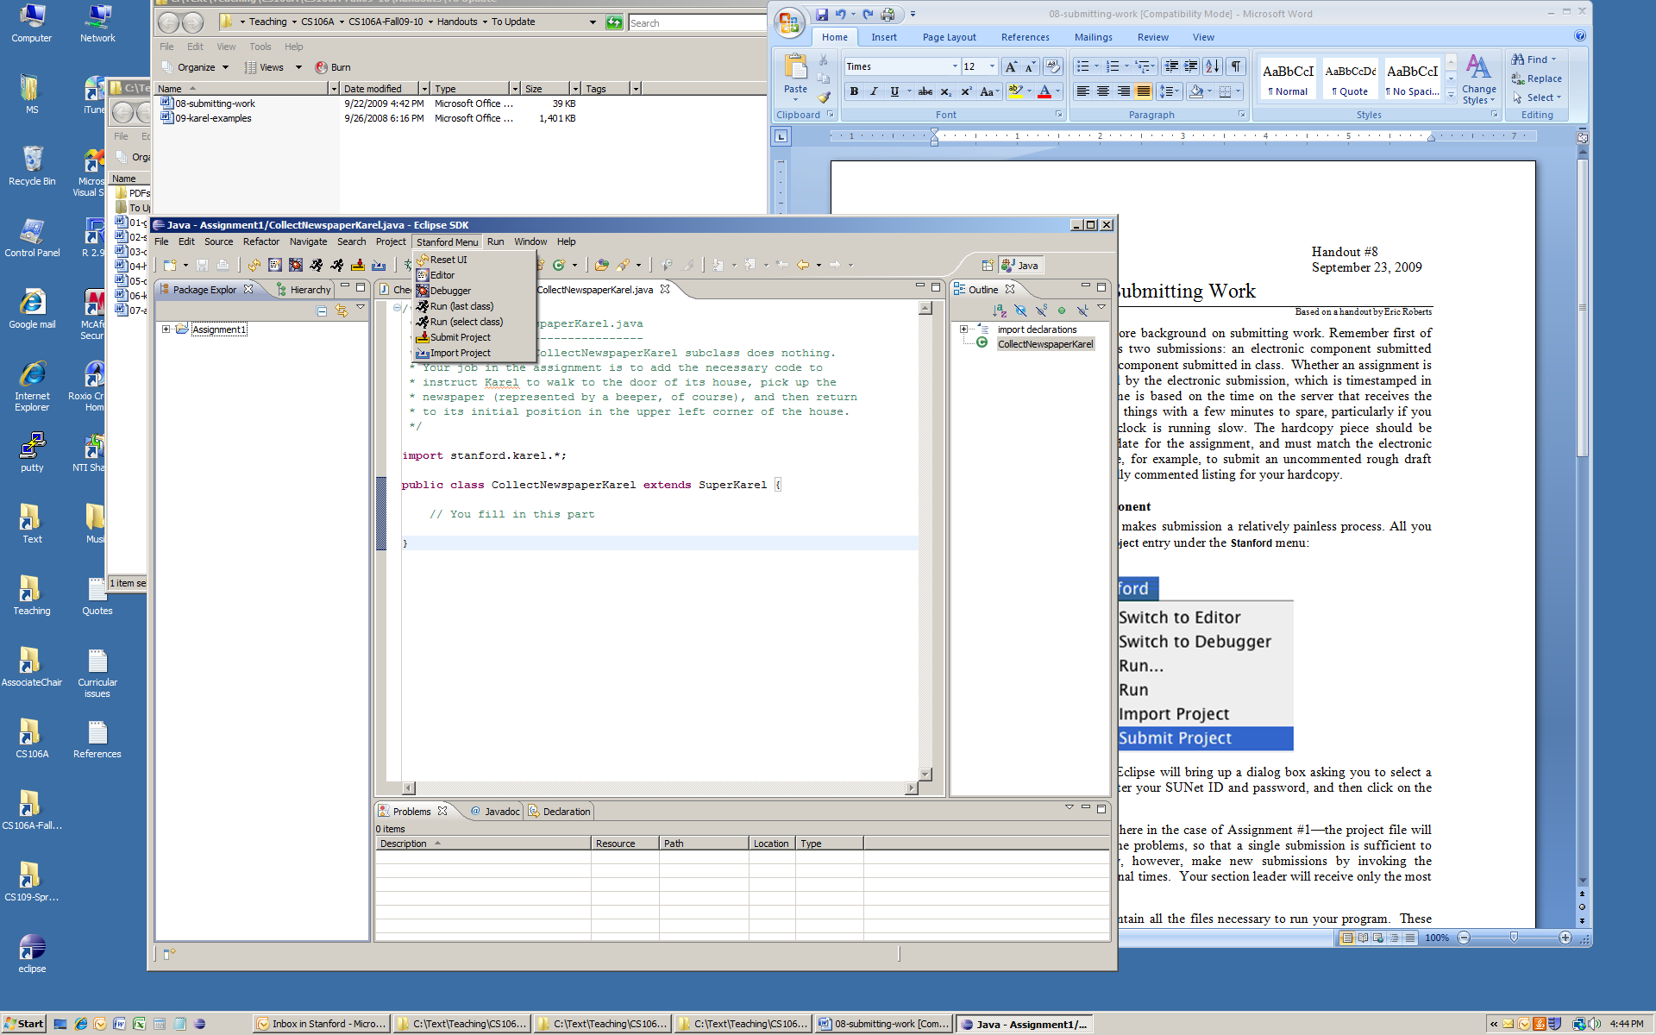

Once you select this option, Eclipse will bring up a dialog box asking you for additional information. Here are the steps you should follow to submit your project:

1. Select the Eclipse project you would like to submit, then click **Ok**.
2. You should then select where you would like to save your zipped assignment. Then click **Save**. This will export your entire Eclipse project, including all code files, and any world, image, or other resource files that it may contain, to a single zip file.
3. Once Eclipse saves the zipped project to your computer, it will tell you to upload this zip to Paperless. Click **ok** to be automatically redirected to Paperless in your web browser.
4. Once on Paperless, click CS106A.
5. Click “Submit Assignment” in the top-right.
6. Select which assignment you would like to submit from the dropdown. Once you do this, an area should appear where you may upload your assignment zip. 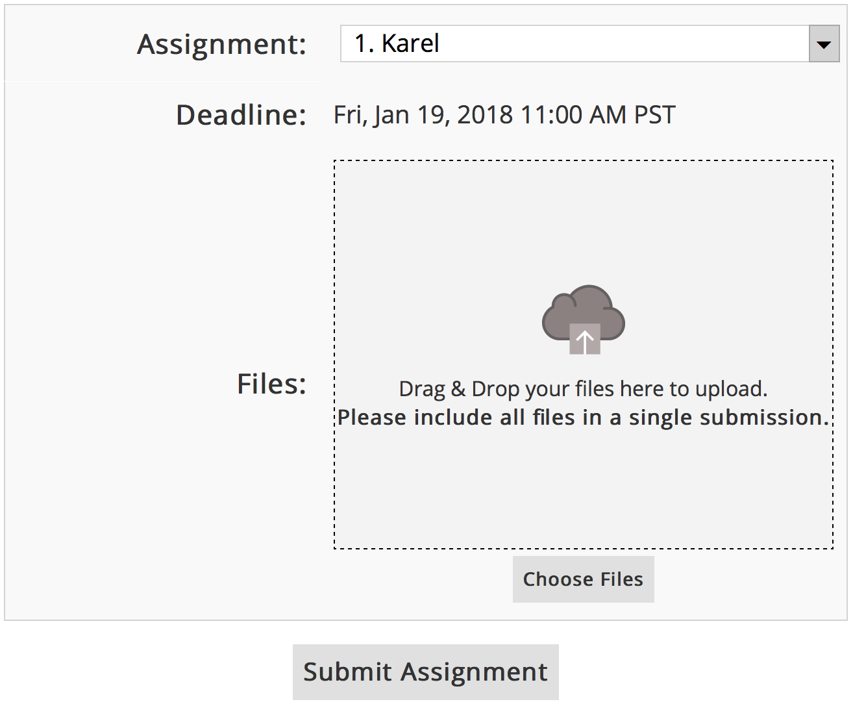
7. Drag and drop your assignment zip into the area marked “Files”. Once you do this, it should be added to the list of files to upload. Then click “Submit Assignment”.
8. Once your project is submitted, you will be taken back to the main Paperless page.
9. Confirm that your files were properly submitted. You can view your submission on the Paperless website, which is what your Section Leader will see when grading your submission, by clicking on the “Assignments” tab at the top. **You are responsible for double-checking Paperless to make sure that your files were submitted properly. Always double-check!**

If you make additional changes to your assignment after submitting, you may make as many new submissions as you would like by repeating the steps above. Your section leader will grade only the most recent submission.

Make a backup copy of your assignment

Although we work hard to keep track of all the assignments that come in, the fact that CS 106A has so many students and such a large staff means that assignments have sometimes not been received as expected. If your assignment goes missing, you will need to resubmit. To make resubmission possible, **you are responsible for keeping a backup copy of your work.**

As a side note, if you have a personal computer, it is always a good idea to have back-ups of the files on your hard drive. For example, you may want to back-up your files on an external hard drive, a zip/thumb drive, or use an on-line storage service such as Dropbox.