Chris Piech Handout #21

CS 106A March 7, 2018

Assignment #7—FacePamphlet

Due: 5PM (not 11AM) on Friday, March 16th

**Note: No late days (free or otherwise) may be used on this assignment**

**This assignment may be done in pairs (which is optional, not required)**

Your Early Assignment Help hours: 7:00pm-8:00pm, Thurs, March 8th in 260-113

Based on an assignment (with the same name) by Mehran Sahami.

S*ocial networking* applications (such as Facebook, LinkedIn, and Snapchat) are used by billions of people. They are immensely popular particularly because of the power of the internet to connect people. In this vein, your job for this assignment is to create an application that keeps track of a simple, internet based, social network: FacePamphlet.

Internet Applications

Internet-connected applications like FacePamphlet are actually two separate programs: the “server” (aka the cloud, aka the backend) and the “client” (aka the frontend). The server stores all of the data for your social network. The client runs on a user’s device. (Fun fact: did you know Facebook’s datacenters and Android phones both run Java?).



The client and the server work as a team to provide a persistent internet experience. They are constantly sending messages back and forth to each other. The client sends requests to the server (such as **setStatus** or **getStatus**) and the server updates its data and returns responses back to the client. All of these communications are sent over the internet.

In this assignment, you are going to write **the server** of the FacePamphlet application, along with a simple **client** program that communicates with your server. You will practice the essential concepts that we have learned in the second half of the course, and in addition learn the crucial elements of creating an internet-based application. The resources we recommend to help with this assignment in particular are lectures on **3/5 and 3/7**, as well as Assignment 7 YEAH hours (listed in the assignment header at the top).

Assignment Overview

This assignment is broken into two parts: the *server* program and the *client* program. The server program keeps tracks of the information about the social network; specifically, all users’ profiles. A profile includes: a name, an optional image for a profile picture, an optional "current status" (a **String** indicating what activity the owner of that profile is currently engaged in), and a list of friend names.

The client program provides a simple interface for users to add, delete, and look up profiles in this social network. It talks to the server in order to display the right information to the user – for instance, when the user wants to pull up a certain user’s profile, the client requests information about that profile (such as its status message, image, etc.) from the server.

As part of the starter files, we include for you demo JAR files with completed versions of both the client and server programs. Note that the client demo contains more features than you are required to implement in this assignment. These demos are helpful both in visualizing how users will interact with your client program (and thus why the server is important), and in testing your programs’ functionality.

A Walkthrough of the Client Demo Program

(Note: this is *not* a description of the client program you are required to implement in this assignment. The client program you must implement can be found in part 2).

After starting the demo server program (which starts out with a new empty social network), when the demo client application starts, it shows a blank screen with a few interactors. To create a new profile, the user would enter a name in a **Name** text field and click the **Add** button. For example, say we entered **Mehran Sahami** in the text field and clicked **Add**. Assuming there is not already a profile with the name "Mehran Sahami" in the social network, we would create a new profile for Mehran which is then displayed on the client. Importantly, the FacePamphlet data lives on the server – so at this point the client will be communicating to your server program that a new user should be created. The client will then ask the server about the user’s status and friends. Based on the server’s response, the client displays the profile:

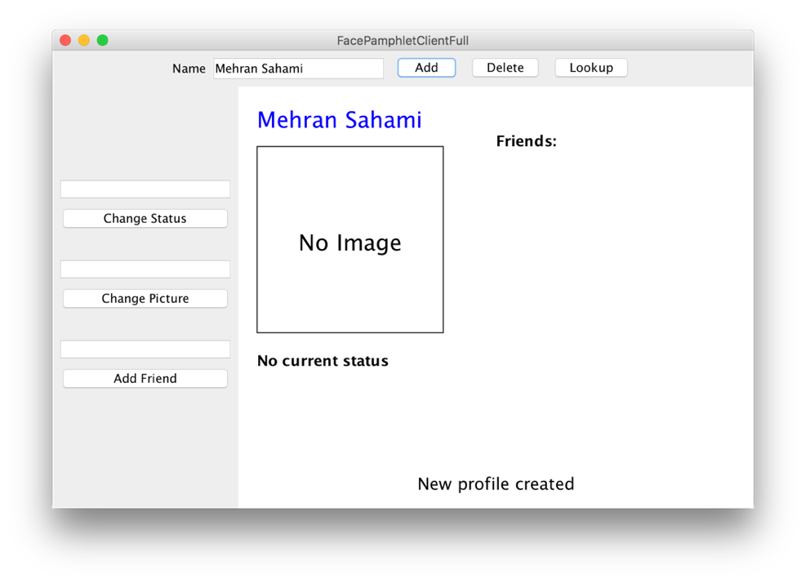

In this profile displayed above, we note five display elements of interest:

* **Name**: The name associated with the profile ("Mehran Sahami") is displayed prominently in the top left corner of the display canvas.
* **Image**: Although there is currently no image associated with this profile, there is space available to display a picture immediately under the name of the profile.
* **Status**: Under the area for the image, the *current status* of the person with this profile is displayed. Since a newly created profile does not have a status yet set, the display simply shows the text "No current status".
* **Friends**: To the right of the profile's name, there is the header text "Friends:", and space available under this text to list the friends of this profile. Again, since we have just created a new profile, there are no friends yet associated with it, so there are no entries listed under the "Friends:" header.
* **Application Message**: Centered near the bottom of the display canvas is a message from the application ("New profile created") letting us know that a new profile was just created (which is the profile currently being displayed).

The user can use the visible interactors to then edit information about the current profile. Here is a version of Chris’s profile after (1) setting his picture to “images/ChrisP.jpg” (2) setting his status to “teaching at Stanford” and (3) having him become friends with Mehran Sahami (another CS106A instructor in the CS department in our social network):

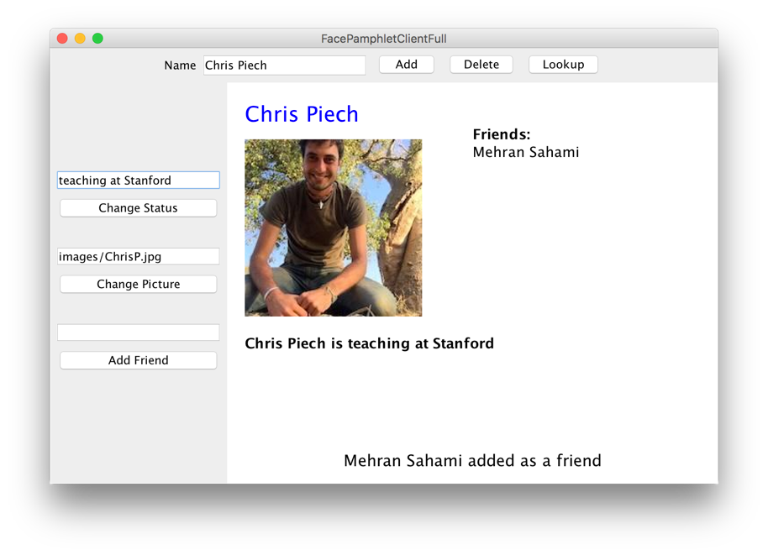

In this way, you can use the client to continue building your social network. You can add more users, look up a user (and go to their profile) and edit their status, pictures, or add friends. Each of these steps relies on communication with your server.

**NOTE:** because images are being sent over the network, it may take a few seconds for profile pictures to be sent/received, both in the client and server programs. This is expected behavior.

Part 1: Server

The heart and soul of this application is a program called a “server”. In theory you could execute the server on a computer very far away, though while testing you will be running it on your own computer (your computer can treat two programs as though they are communicating over the internet, even though they are actually on the same computer).

To explain why we need a server, first think: how would you feel if you went to facebook.com and created a profile, but then nobody in the world could see it, and the next time you opened up the website your profile was gone? In order for data to be visible across the internet, and to persist across client sessions (e.g. your phone and your computer), it is stored and managed by a separate program: the server.

The server stores all of the data and contains the logic for keeping track of profiles and getting and setting profile properties. It doesn’t display the data to a user. That is the job of a client. When the server receives a request (usually from a client), it updates its internal data and sends back a string response. Here is an example of a server that has received many requests (e.g. the **addProfile** command) and its corresponding responses:

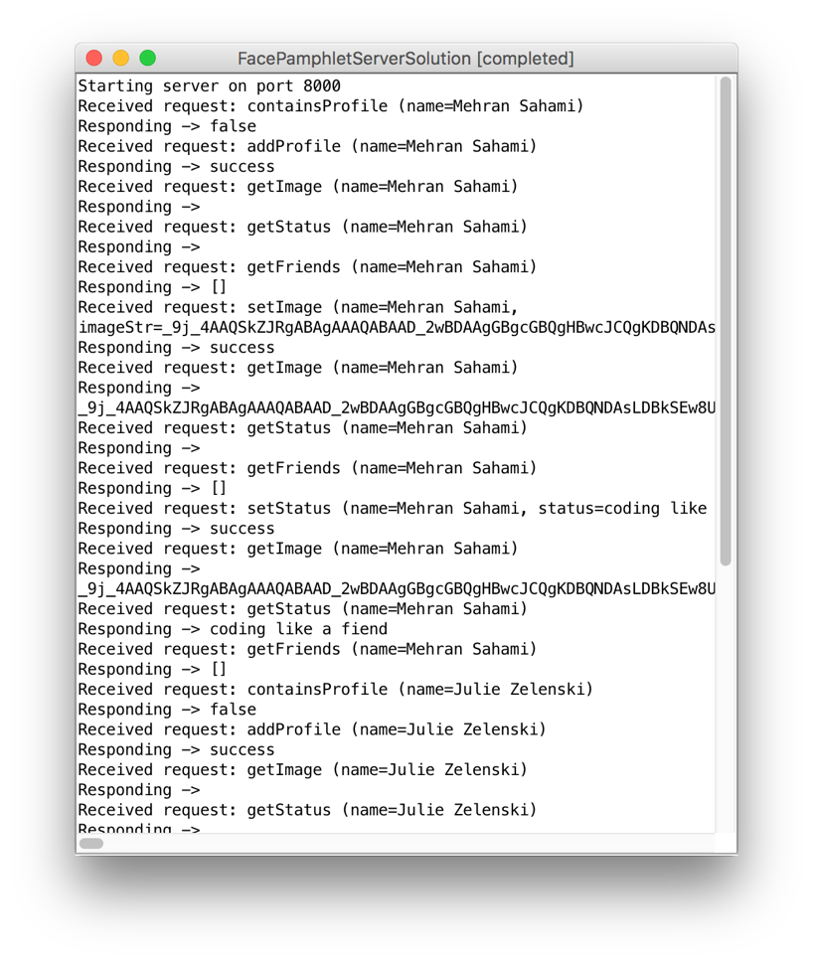

Don’t be fooled by its textual display. This server is much more than just a **ConsoleProgram**. It is the backend of this internet application.



Here’s a way of thinking of a server: A server is a bit like a database (e.g. NameSurferDataBase), and a client is like a canvas (e.g. NameSurferGraph).

The functionality of a server is handled almost entirely by a single method:

**String requestMade(Request request)**

This method receives a request that has a command, and optionally some parameters. The server processes the request, updates its database and returns a response as a **String**. We’ll talk about what a **Request** is in the following section.

In order to support a FacePamphlet client,your server is going to need to handle nine different types of request commands:

|  |  |  |
| --- | --- | --- |
| Command | Parameters | Response |
| addProfile | name | Creates a profile with the given name. Returns “success” or, if the profile already exists, returns an error message. |
| containsProfile | name | Returns “true” if a profile with the given name exists, and “false” otherwise. |
| deleteProfile | name | Removes a profile from the database. Returns “success” or, if the profile doesn’t exist, returns an error message. |
| setStatus | name, status | Sets the status of the user with the given name. Returns “success” or, if the profile doesn’t exist, returns an error message. |
| getStatus | name | Returns the status of the user with the given name, or the empty string if the user exists but does not have a status. Returns an error message if the profile doesn’t exist. |
| setImage | name, imageString | Sets the image for the user with the given name. Return “success” or, if the profile doesn’t exist, returns an error message. |
| getImage | name | Returns the profile image of the user with the given name, or the empty string if the user exists but does not have an image. Returns an error message if the profile doesn’t exist. |
| addFriend | name1, name2 | Makes the user with name name1 friends with user with name name2, and vice versa. Returns “success”, or an error message if either a) either user does not exist, b) if they are already friends, or c) if they are the same person. |
| getFriends | name | Returns the list of friends, as a string, for the user with the given name. Returns an error message if the profile doesn’t exist. |

The FacePamphlet server program consists of several separate class files, as follows:

• **FacePamphletServer**—This is the main program class that runs the server. It is a **ConsoleProgram** (though this is just for viewing what the server is doing – the user does not interact with it) and it is responsible for responding to requests from the client.

• **FacePamphletProfile**—This class should encapsulate all the information for a single profile in the social network. Given a **FacePamphletProfile** object, you can find out that profile's name, associated image (or lack thereof), associated status (or lack thereof), and the list of names of friends for that profile.

• **ServerTester** —This program is already written for you. It will send test requests to your server to help you test your server’s functionality.

To help you develop your program in stages, we have outlined some development milestones below.

Milestone 1: Ping

Let’s start out with a simple task: write code to have your server respond to the “ping” command. If your server receives a request with the command “ping”, you should simply return the string “Hello, internet”. Open **FacePamphletServer** to get started.

The starter code is already set up with a **SimpleServer** instance variable. In the **run** method when we call **start()** on the server variable, this signifies your program saying it is ready to receive incoming requests. Every time a request is sent to your program, the method **requestMade** will be called with the details of the request. As we talked about in class there are two methods that you can call on the request that you are passed in: **getCommand()**, which returns the request’s command, and **getParam(*key*)** which returns the value associated with a request parameter. Your task for this milestone is to update the **requestMade** method to check if a given request has the command **“ping”**, and if so return **“Hello, internet”.**

For now, we can test out our ping response by making a request to your server from a web browser (e.g. Chrome or Firefox). Run your server program and navigate to <http://localhost:8000/ping> to send a request to the server with the command “ping”. Your browser will display the string that your server sends back (note: this is how real web servers work; except for webpages, you would send back a string containing *HTML* that the browser would display as a webpage).

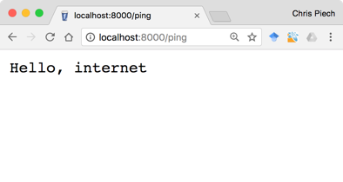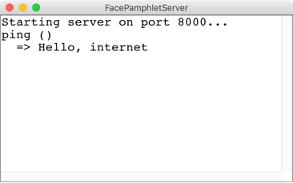

The browser sends a request to the server with the command “ping”

The server responds with the string “Hello, internet” which the browser displays

Browser

Server

The server in the picture above **printlns** the received request and the response returned. You do not have to imitate this functionality—what matters is that your server **returns** the appropriate string. Having said that, console output is useful for debugging.

You now have a program that is receiving (and responding to) an internet request! Next up, let’s figure out how to store the data for FacePamphlet, and then we can make our server process commands relevant to the FacePamphlet client.

Milestone 2: Implement the FacePamphletProfile class

The server is responsible for storing all of FacePamphlet’s data so that it can respond to requests from the client. We are not going to explicitly tell you how to structure your data. Instead, on a high level, it is useful to think of the server as keeping track of many profiles, each of which the server can look up based on the user’s name:

|  |  |  |
| --- | --- | --- |
| “Chris Piech” | 🡪 | name = “Chris Piech”  status = “teaching”  friends = [“Mehran Sahami”, “Julie Zelenski”]  image = |
| “Mehran Sahami” | 🡪 | name = “Mehran Sahami”  status = “teaching”  friends = [“Chris Piech”, “Julie Zelenski”]  image = |
| “Julie Zelenski” | 🡪 | name = “Julie Zelenski”  status = “”  friends = [“Mehran Sahami”, “Chris Piech”]  image = |

We have provided the shell of a class **FacePamphletProfile.** This class defines a new variable type which represents one user’s profile. The starter file for the **FacePamphletProfile** class includes definitions for all of the public methods we expect you to define. The method definitions in the starter files, however, do nothing useful (they are just ***stubs***), although they occasionally include a **return** statement that gives back a default value of the required type. For example, the **getName** method always returns the empty string ("") to satisfy the requirement that the method returns an **String** as defined in its definition.

The **FacePamphletProfile** class encapsulates the information pertaining to one profile in the social network. That information consists of four parts:

1. The name of the person with this profile, such as **"Chris Piech"**
2. The status associated with this profile. This is just a **String** indicating what the person associated with the profile is currently doing. It should initially be the empty string.
3. The image associated with that profile. This is a **GImage.** It should initially be **null**.
4. The list of friends of this profile. The list of friends is simply a list of the *names* (**String**s) that are friends with this profile. This list starts empty. The data structure you use to for this is left up to you.

Fill in the **FacePamphletProfile** class such that it is a fully functional variable type. Note that you may add extra **private** methods if you would like, but you may not add any **public** methods other than the ones specified below:

public **FacePamphletProfile**(String name)

In this constructor, you should initialize the state of a new profile with the given name.

public String **getName**()

In this method, you should return the name associated with this profile.

public GImage **getImage**()

In this method, you should return this profile’s image, or null if this profile has no image.

public void **setImage**(GImage image)

In this method, you should set the image associated with this profile to be the provided image.

public String **getStatus**()

In this method, you should return the status associated with the profile, or the empty string if this profile has no status.

public void **setStatus**(String status)

In this method, you should set the status associated with the profile to be the provided status.

public boolean **addFriend**(String friend)

In this method, you should add the given friend name to this profile’s list of friends if they are not already friends. If the name is not already in this profile’s friends list, it adds it and returns **true**. If the name is already in this profile’s friends list, it does not modify the friends list, and returns **false**.

public boolean **removeFriend**(String friend)

In this method, you should remove the given friend name from this profile’s list of friends, if they are friends. If the name is in this profile’s friends list, it removes it and returns **true**. If the name is not in this profile’s friends list, it does not modify the friends list, and returns **false**.

public ArrayList<String> **getFriends**()

In this method, you should return a list of this profile’s friend names.

Now that you have a new variable type (FacePamphletProfile), think about what data structure you might use to store them.

Milestone 3: Handle requests to addProfile, containsProfile and deleteProfile

You must now implement the server functionality to handle requests related to managing profiles. These may be sent from the client if, for instance, the user hits the “Add” button to add a new profile (which would send an addProfile request). The relevant commands, which are listed earlier in the handout, are repeated here for convenience:

|  |  |  |
| --- | --- | --- |
| Command | Parameters | Response |
| addProfile | name | Creates a profile with the given name. Returns “success” or, if the profile already exists, returns an error message. |
| containsProfile | name | Returns “true” if a profile with the given name exists, and “false” otherwise. |
| deleteProfile | name | Removes a profile from the database. Returns “success” or, if the profile doesn’t exist, returns an error message. |

A request is a lot like the client program trying to execute a method on your server. The command is akin to the method name, and just like a method call, requests can contain parameters.

Start by modifying the **requestMade** method so that it can handle requests with the command **addProfile**. When your server receives such a request, the server should prepare to generate a new profile for a new user. Every request with command **addProfile** will include a parameter with key **“name”**. You can get the value of this parameter by calling:

**request.getParam(“name”); // the name associated with this request.**

If your FacePamphlet server does not already have a profile with the given name, create a new profile, store it, and return the string **“success”.**

If your FacePamphlet server already has a profile with the given name, you should return an error message. An error message is any string which starts with “Error:”. The remainder of the string describes what went wrong. For example:

**“Error: Database already contains a profile with name Trogdor”**

For this assignment, we don’t mind what description you send, as long as the string you return is an error message starting with “Error:”.

For **addProfile**, you do not need to do any further error handling. For instance, you do not need to worry about correctly responding to a command that does not have a **“name”** parameter.

Next, you should expand your **requestMade** method to respond to the commands **containsProfile** and **deleteProfile**. Your implementation should match the specifications in the table above.

Testing the Server

Servers need to be tested thoroughly. In your project we provide a program called **ServerTester**. This program will send test requests to your server and let you know if the responses were the ones we expected. Note that this tester is *not exhaustive* and may not alert you to all errors. We highly recommend doing additional testing as you implement different commands. First, launch your **FacePamphletServer** program, then launch the included **FacePamphletServerTests**. You should pass all of the tests with the commands you just implemented.

At this point, if you start your server and then execute the provided demo client by double-clicking on it, you will get a client that can add, delete and lookup a profile, but since the client can’t get the status, image or friends from the server, it can’t display a profile:

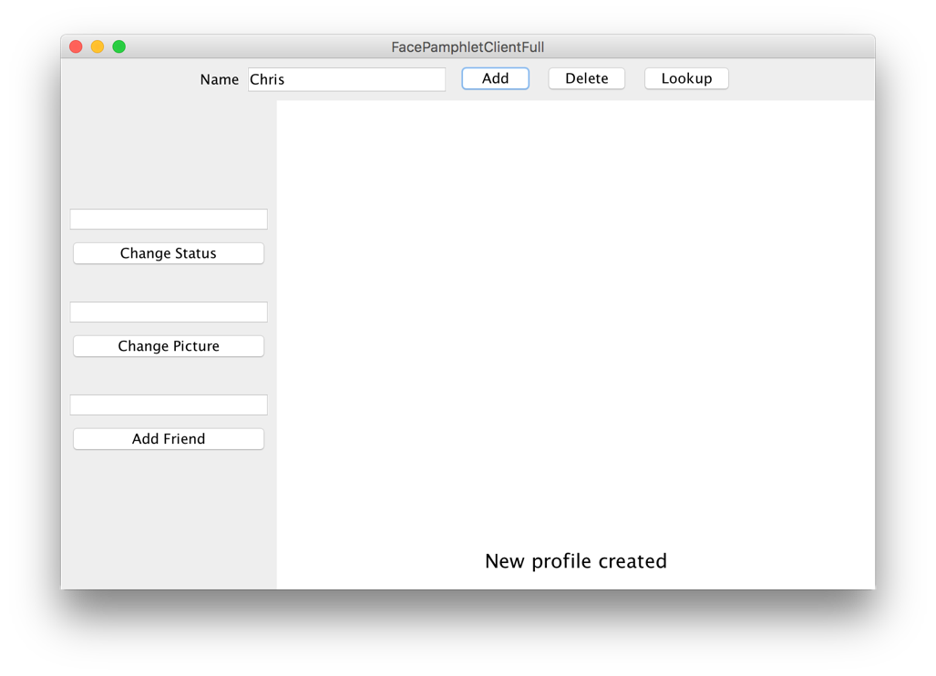

**Milestone 4: Handle requests to get and set the status and profile image**

Want that client program to be able to do more? You need a server that can handle more requests! Now that the server can store users, the next step is to expand the **requestMade** method so that it can handle requests to get and set a user’s status, and to get and set a user’s image. The relevant commands, which are listed earlier in the handout, are repeated here for convenience:

|  |  |  |
| --- | --- | --- |
| Command | Parameters | Response |
| setStatus | name, status | Sets the status of the user with the given name. Returns “success” or, if the profile doesn’t exist, returns an error message. |
| getStatus | name | Returns the status of the user with the given name, or the empty string if the user exists but does not have a status. Returns an error message if the profile doesn’t exist. |
| setImage | name, imageString | Sets the image for the user with the given name. Return “success” or, if the profile doesn’t exist, returns an error message. |
| getImage | name | Returns the profile image of the user with the given name, or the empty string if the user exists but does not have an image. Returns an error message if the profile doesn’t exist. |

For all four requests, the parameter “name” tells you which user’s data should be modified. If name refers to a user who does not exist, your server should return an error message. Again, it does not matter what description you provide in your error message, as long as the string starts with “Error:”. You do not need to do any further error checks.

Two commands in this milestone have to do with getting and setting images. When sending information over the internet, *everything* has to be text; even images. For this reason, when handling images in your server, you will need to convert between **GImage** and **String**. We have provided two methods to help you do this:

**/* Converts a GImage to its string representation**

**String SimpleServer.imageToString(GImage image)**

**/* Converts a string representation of an image to a GImage**

**GImage SimpleServer.stringToImage(String str)**

For instance, when you receive a request with command **setImage**, the parameter **imageString** is a string, not a **GImage**. To convert it to a **GImage**, you could write:

**String imageString = request.getParam(“imageString”);**

**GImage image = SimpleServer.stringToImage(imageString);**

Similarly, when you receive a request with command **getImage**, to convert a **GImage** on the server to a **String** to send it as a response, you could say:

**GImage image = ...**

**String imageString = SimpleServer.imageToString(image);**

Note: a null image converts to the empty string, and vice versa.

**Milestone 5: Handle requests to addFriend and getFriends**

Everything is better with friends. Your final task is to expand your **requestMade** method to also handle requests to **addFriend** or **getFriends**. The relevant commands, which are listed earlier in the handout, are repeated here for convenience:

|  |  |  |
| --- | --- | --- |
| Command | Parameters | Response |
| addFriend | name1, name2 | Makes the user with name name1 friends with user with name name2, and vice versa. Returns “success”, or an error message if either a) either user does not exist, b) if they are already friends, or c) if they are the same person. |
| getFriends | name | Returns the list of friends, as a string, for the user with the given name. Returns an error message if the profile doesn’t exist. |

When adding a friend, the request will contain two parameters: **name1** and **name2**. If the two parameters are names of two different users in the database who were not previously friends you should update your database so that the users are now friends. Friendship in FacePamphlet is reciprocal, so if Chris becomes friends with Nick, then Nick becomes friends with Chris. Once the users are made to be friends, the server responds with the string “success.”

When the server receives a request with the command **getFriends**, return the user’s list of friends as a string. For example, if Chris is friends with Nick and Laura, then when the server receives a **getFriends** request with the parameter **name** = Chris, return:

**“[Nick, Laura]”**

which is a string representation of the friend list. If a user has no friends, simply return the string:

**“[]”**

**Hint**: **ArrayLists** have a method **toString** which returns exactly this string representation.

The following cases should lead you to return an error message:

* Either **name1** or **name2** are users who are not in the database.
* The two users are already friends.
* Both **name1** and **name2** are the same. Eg **name1** = Chris and **name2** = Chris. Sorry Chris, you can’t be your own friend ☺.

In all cases where you should return an error, make no changes to the database. Again, it does not matter what description you provide in your error message, as long as the string starts with “Error:”. You do not need to do any further error checks.

**Finishing Up The Server**

At this point, when you launch the **FacePamphletServerTests** you should pass (almost) all of the tests. One request command that you may have to revisit is the **deleteProfile** command. When you delete a profile, because friendships are reciprical, you should remove that person’s name *from all their friends’ friend lists* as well. For example, if Chris and Mehran are friends and then later Mehran’s profile is deleted, Mehran should no longer be listed in Chris’ friends. Sad. That’s life in the city.

One other point is that, if you receive a request with an *unknown* command, you should simply respond with an error message.

At this point, you have implemented all required server functionality! If you run your server and then run the provided demo client, the client and your server should start to communicate and the result should be a fully functional internet application:

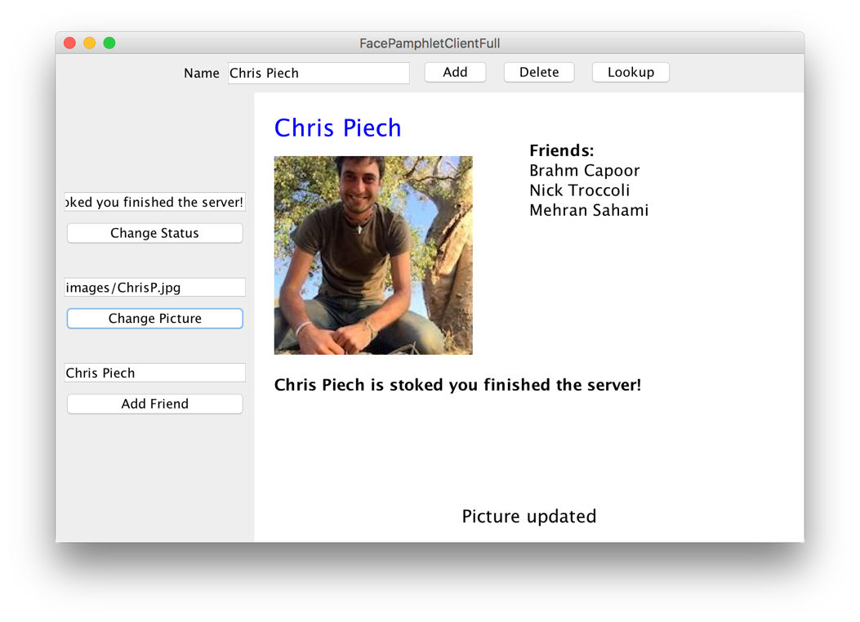

How can other computers access my server?

Right now your server is running on <http://localhost:8000> which is a special address that means “my computer port 8000”. For a client running on another computer to access it you first need to get a public web-address for your computer. You can use a service like [ngrok](https://ngrok.com/) to give you a temporary address that will map to your computer (in a way that is respectful of Stanford’s firewalls).

**Part 2: Client**

Now that you have implemented the server part of FacePamphlet, your next task is to implement a basic client that can interact with your server, much like the client demo we provided with the starter code. Note that you do not have to implement all the functionality present in our client program; we specify below what functionality you should include.

At its core, the client program is a program with interactors and a canvas, much like the ones you have seen before. The main new concept is how to generate a request and send it to your server. As an example, in the starter code for **FacePamphletClient.java**, which is the file where you should implement the client program, we create a ping request and turn the response into a **GLabel** that we display in the center of the canvas. The method you use to do this is

**String SimpleClient.makeRequest(String host, Request request)**

For instance, in your client program you could use it as follows:

**Request myRequest = ... // make a new Request and add any params**

**String response = SimpleClient.makeRequest(HOST, myRequest);**

If an error occurs while sending the request or receiving the response, an *IOException* will be thrown. **This includes when the server sends back a response that begins with the text “Error:”** (as you did when implementing your server). To access the error message, you can say:

**try {**

**Request myRequest = ...**

**String response = SimpleClient.makeRequest(HOST, myRequest);**

**// if we get here, the request was successful – continue on...**

**} catch (IOException e) {**

**// if we get here, there was an error**

**String errorMessage = e.getMessage();**

**// Do something with errorMessage**

**}**

On launch, the client application you are required to implement should look like this:

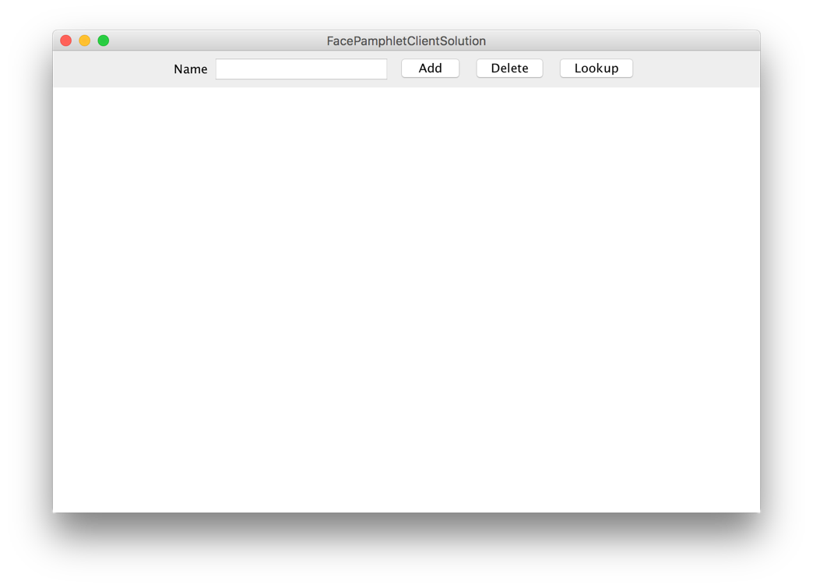

Along the **NORTH** border of the application, is a “Name” label, a text field, and three buttons: **Add**, **Delete**, and **Lookup**. The text field should be **TEXT_FIELD_SIZE** characters wide, and should *not* respond to the ENTER key. The functionality of each button is described below.

**Add**

When the user types something into the text field and clicks “Add”, your client program should attempt to add a new profile to the FacePamphlet social network; you will need to communicate with the FacePamphlet server to do this. If the profile is successfully added, you should display the new profile name on the canvas, as well as a message indicating that the profile was successfully created:

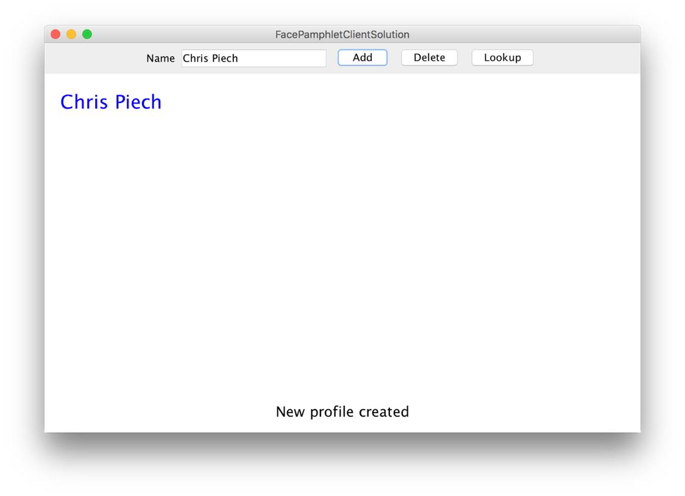

The name label should be colored blue, with font **PROFILE_NAME_FONT**, be positioned **LEFT_MARGIN** from the left side of the screen, and the *top* of the label should be **TOP_MARGIN** from the top of the screen. You should also add a success message saying “New profile created” at the bottom of the screen. This label should be colored black, with the font **MESSAGE_FONT**, centered horizontally on the screen, and the vertical *baseline* of the label should be **BOTTOM_MESSAGE_MARGIN** from the bottom of the screen.

In the event that an error occurs, you should simply display the error message received at the bottom of the screen. You should also remove any profile information that was currently displayed.

**Delete**

When the user types something into the text field and clicks “Delete”, your client program should attempt to delete the profile for the entered name from the FacePamphlet social network; you will need to communicate with the FacePamphlet server to do this. Note that it does not matter what profile (if any) is currently displayed on the screen – deleting a profile involves only the text in the text field. If the profile is successfully deleted, you should remove any profile information that was currently displayed on the canvas, and display a message indicating that the profile was successfully deleted:

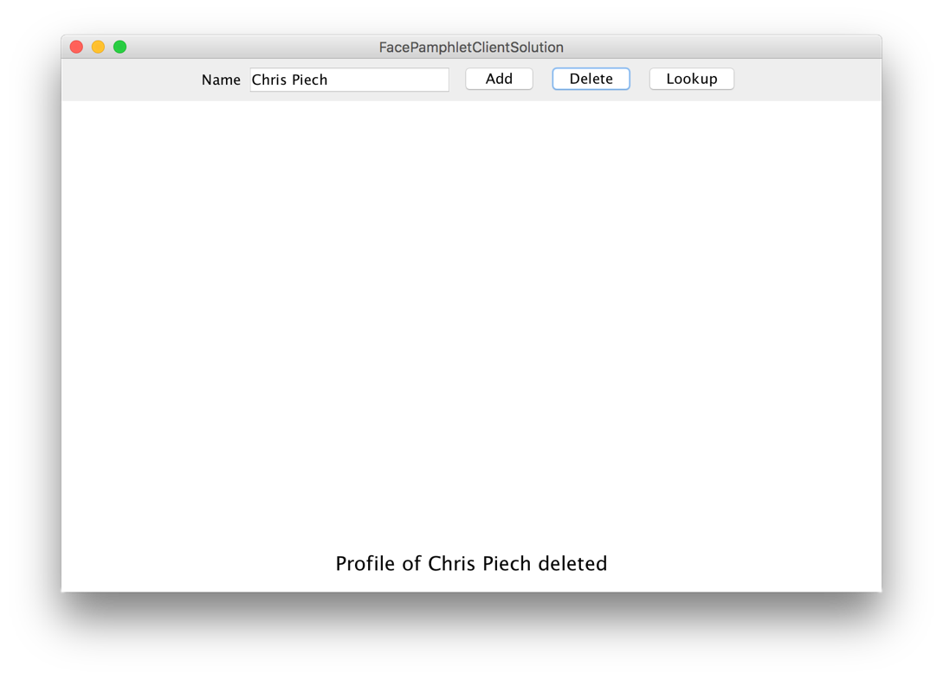

In the event that an error occurs, you should simply display the error message received at the bottom of the screen. You should also remove any profile information that was currently displayed.

**Lookup**

When the user types something into the text field and clicks “Lookup”, your client program should attempt to display the profile corresponding to that name, if any, in the FacePamphlet social network; you will need to communicate with the FacePamphlet server to do this. If a profile exists for the given name, you should display the profile name on the canvas, as well as a message that says “Displaying [NAME]” (replacing [NAME] with the entered name:

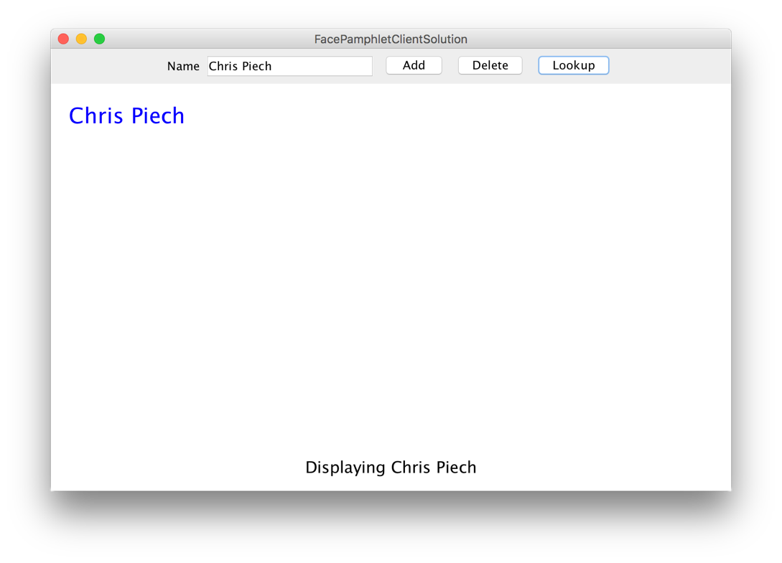

The labels should be positioned the same as in the “Add” case.

If no profile exists for the entered name, you should clear the canvas of any existing profile information and display a message “A profile with the name [NAME] does not exist” (replacing [NAME] with the entered name).

In the event that an error occurs, you should simply display the error message received at the bottom of the screen. You should also remove any profile information that was currently displayed.

**Other Notes:**

* You are not required to implement any additional client functionality beyond what is specified above, though you are welcome to do so as an extension.
* None of the interactors above should respond if the text field contains no text (i.e. if the text field’s text is the empty string).
* Now that you have implemented the server, as the client think about what types of requests you will need to send to get the information you need.
* Feel free to test your client using the provided server demo
* The cool thing about implementing the client and server is that, even if you close the client program, as long as the server is still running the social network data will still be there. In other words, you can quit your client, restart it, and view a profile you created earlier. Pretty neat!

**Extensions**

As mentioned earlier, you may add additional features, either that are included in our demo, or that you invent on your own. Here are some additional ideas for ways to extend your FacePamphlet program (some of which may require modifications in both the client and server). **Important:** please implement extensions in separate file(s). To create a new class in your Eclipse project, right-click on “default package” and select New -> Class. Enter the name you’d like, confirm, and it will be added to your project.

• *Implementing support for images*. You can add support in your client program for images, such as profile images (like in our client demo) or other image features. In your client, you have access to the same **String**/**GImage** conversion methods, but these methods are on the **SimpleClient** instead of the **SimpleServer**. In other words, the provided methods are

**/* Converts a GImage to its string representation**

**String SimpleClient.imageToString(GImage image)**

**/* Converts a string representation of an image to a GImage**

**GImage SimpleClient.stringToImage(String str)**

• *Keep track of additional information for each profile.* The current profile only keeps track of a name, image, status and a list of friends. In real social networks, there is much more information about users that is kept track of in profiles (e.g., age, gender, where they may have gone to school, etc.) Use your imagination. The more challenging issue will be how you appropriately display this additional information graphically in the client.

• *Click on friends to see their profile.* First of all, in your friends list you could keep a picture of each friend beside the name of the friend. Then, you could implement mouse listeners so that if the user clicks on one of the friend’s photos (or name) you go straight to that friend’s profile.

• *Support for* *groups.* Many social networking applications allow for keeping track of "groups" (or "communities") that profiles can belong to. In many ways, being a member of a group is similar to having that group as a "friend"—a "group" has a list of members (similar to a list of friends for a profile) and each profile can be a member of many groups (much in the same way that a profile can have many friends). Adding support for groups would help make your social network more realistic and may not actually require too much work if you can leverage some of the conceptual similarities with respect to "groups" being like "friends".

• *Finding friends of friends.* Another interesting aspect of social networks is not only keeping track of how many people you have as friends, but also how quickly that number grows as you consider all the friends of your friends, and their friends, and so on. Displaying these sorts of properties of the social network is a neat feature that shows just how few degrees of separation there are between people. Along these same lines, it would be interesting to find and display "friendship chains" that show the shortest sequence of friendship relations that create a chain from one profile to another. For example, if X is a friend of Y, and Y is a friend of Z, then a friendship chain exist that goes: X → Y → Z. Finding longer chains can be a fun and challenging problem.

• *Adjust the profile display as the application window is resized.* You got some practice with this already with the NameSurfer application and it would be an interesting extension to apply some of those same ideas here. The more challenging issue is how you would decide to change font sizes and the size of the image as the display size grew or shrank.

• *Go nuts!* There's really no shortage of ways that you could extend your FacePamphlet application. In fact, whole companies have been started based on creating a social network application with some cool new features. And if you do end up starting the next multi-billion dollar company based on social networking, just remember where it all started... CS106A!