Chest X-ray Disease Diagnosis

Lin Shao, Tong Wu, Yahui Ke, Yinuo Liu

Abstract

We develop a web application that can diagnose diseases based on Chest X-ray. Users can upload Chest X-ray images, and our backend algorithms provide the most possible diseases with probabilities. The backend model is a deep convolutional neural network trained based on ChestX-ray14 data set. The web application will use Django web framework which hosts in AWS.

Introduction

Chest X-rays is the most popular method to diagnose related diseases, and early correct diagnosis and treatment is critical to save patients’ lives and improve health care system efficiency. However, accurate detections highly depend on the radiologist’s expertise, which requires long time training and practicing. With the advancements in deep learning over the past decade, we can train computers to detect various objects or classify different groups with high accuracy. In this project, we implement two CNN architectures - CheXNet [Rajpurkar] and VGG-16 to detect 14 diseases from the ChestX-ray14 dataset. We build a web application which apples the best model and hyper parameters at backend and provides potential user a user-friendly tool.

Literature Review

Recently, multiple deep neural networks [1-5] have been proposed to detect pathologic patterns from chest x-rays since a large-scale data set [1] from National Institutes of Health Clinical Center became available. Wang et al. [1] applied a unified Deep Convolutional Neural Network (DCNN) based on four pre-trained models, AlexNet, GoogleNet, VGGNet-16 and ResNet-50. This work is a performance benchmark and triggered several other groups to study the application of CNNS in disease detection. Yao et al. [2] utilized a combination of CNNs and Long Short-Term Memory Networks (LSTM) to predict the 14 thoracic diseases and explore the interdependencies among them. Rajpurkar et al. [3] presented a modified Densely Connected Convolutional Networks (DenseNet) to classify the 14 diseases, raising the Area Under Curve (AUC) scores after fine-tuning. Li et al. [4] used a pre-trained residual neural network (ResNet) to extract features and deployed a CNN to produce a disease probability map. Guendel et al. [5] proposed a location aware Dense Networks (DNetLoc), which achieved better AUC scores on multilabel classification and pathology location.

**Dataset**

In this study, we use ChestX-ray dataset, which was extracted from the clinical PACS database at National Institutes of Health Clinical Center by Wang and et al [1]. It includes 112,120 frontal-view X-ray images of 30,805 patients with 14 disease image labels. The resolution is 1024 $×$ 1024 for all images. This dataset is already split into training/validation and testing. We further split the training/validation by 95%/5%. For typical CNN classification, image augmentation is necessary to cover the variations in actual prediction. However, Chest X-ray images are quite similar, we do not expect to see different rotation, lighting condition, or noises. Therefore, we only do horizontal flip for training. The input for our model is RGB images, and outputs are 14 class with probabilities.

**CNN Training**

We use Keras with TensorFlow as backend for our CNN model training. We plan to use our own PC with GPU for training for now. Depends on the training speed and costs, we may migrate to AWS.

For each model architecture, we need select the optimal hyper parameters, including loss function, batch size and learning rate. We will select with the following.

1. Loss function: because this is a 14 classes classification problem, we choose ‘categorical_corssentropy’ as loss function.
2. Batch size: batch size means the number of images used in one forward/backward pass. Since the training dataset is huge for memory, we choose mini-batch gradient for the training. We will test batch size ranging from 32 to 256 (or other ranges) to select the best.
3. Learning rate: learning rate means how quickly the weights change. Big learning rate may not converge, while small learning rate can be slow. We will test various learning rates with Adam optimizer.

In addition, we will reduce learning rate and apply early stop during the training. For example, we reduce learning rate by a factor of 0.1 if no validation loss improvement for 3 epochs and stop training if no improvement for 10 epochs. The model with smallest validation loss will be selected as the best. The details will be addressed in our following work. We will use validation loss to select the best model and hyper parameters. We will also provide training graphs generated by Tensorboard.

Software Design

The final software product will include a web application, an Android app (optional) which allows the user to upload an image of X-ray and then the classification/detection result will be presented to the user. The overview of the system is shown in Figure 1 below.

We will have a Django web application which has the web frontend and also some REST API to accept input images and send back model prediction result. In the web backend side, the latest Tensflow.js library will be used to make the prediction based on our pre-trained model.

Conclusion

In this project, we will build a Chest X-ray disease diagnosis web application based on ChestX-ray14 dataset. This application utilizes deep learning to give health care system users an easy to use tool in disease detection.

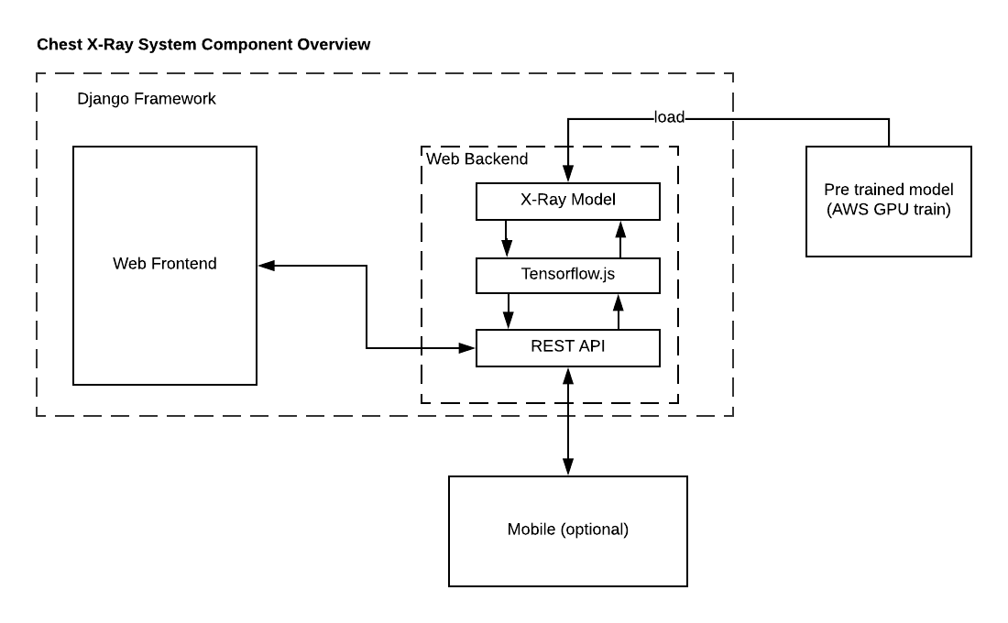

Figure 1. System Component Overview

References

1. Wang, Xiaosong, Yifan Peng, Le Lu, Zhiyong Lu, Mohammadhadi Bagheri, and Ronald M. Summers. "Chestx-ray8: Hospital-scale chest x-ray database and benchmarks on weakly-supervised classification and localization of common thorax diseases." In *Computer Vision and Pattern Recognition (CVPR), 2017 IEEE Conference on*, pp. 3462-3471. IEEE, 2017.
2. Yao, Li, Eric Poblenz, Dmitry Dagunts, Ben Covington, Devon Bernard, and Kevin Lyman. "Learning to diagnose from scratch by exploiting dependencies among labels." *arXiv preprint arXiv:1710.10501* (2017).
3. Rajpurkar, Pranav, Jeremy Irvin, Kaylie Zhu, Brandon Yang, Hershel Mehta, Tony Duan, Daisy Ding et al. "Chexnet: Radiologist-level pneumonia detection on chest x-rays with deep learning." *arXiv preprint arXiv:1711.05225* (2017).
4. Li, Zhe, Chong Wang, Mei Han, Yuan Xue, Wei Wei, Li-Jia Li, and F. Li. "Thoracic disease identification and localization with limited supervision." *arXiv preprint arXiv:1711.06373* (2017).
5. Guendel, Sebastian, Sasa Grbic, Bogdan Georgescu, Kevin Zhou, Ludwig Ritschl, Andreas Meier, and Dorin Comaniciu. "Learning to recognize abnormalities in chest x-rays with location-aware dense networks." *arXiv preprint arXiv:1803.04565* (2018).