1.1.1

﻿

{ (Pointing, 2),

(Rests, 2),

(Driving, 1),

(Relaxed, 1),

(Tense, 1),

(Seat,1),

(Gun, 1),

(Vincent, 0),

(Marvin, 0),

(Jules, 0) }.

1.1.3

D = {d1,d2,d3,d4,d5}

F(VINCENT) = d1

F(MARVIN) = d2

F(JULES) = d3

F(RELAXED) = {d1}

F(GUN) = {d4}

F(SEAT) = {d5}

F(RESTS) = {(d4, d5)}

F(POINTING) = {(d4, d2)}

F(DRIVING) = {d3}

F(TENSE) = {d2}

1.1.4

{(block,1),

(cubical, 1),

(pyramid,1),

(red,1),

(green,1),

(large,1),

(small,1),

(yellow,1),

(table, 1)

(on, 2)}.

F(BLOCK) = {d1,d2,d3,d4, d5}

F(CUBICAL) = {d1, d2}

F(PYRAMID) = {d3, d4}

F(RED) = {d1, d2}

F(GREEN) = {d3}

F(LARGE) = {d3}

F(SMALL) = {d1, d2, d4}

F(YELLOW) = {d4}

F(TABLE) = {d5}

F(ON) = {(d1, d5), (d2, d5), (d3, d5), (d4, d1)}

1.1 & 1.2 from the notes

D={d1,d2,d3, d4, d5, d6, d7,d8, d9, d10, d11, d12,d13,d14,d15}

F(CHAIR)={d1}

F(DOG)={d2}

F(FLOWER)={d4}

F(HOUSE)={d3}

F(TREE) = {d5, d6}

F(GARDEN) = {d7}

F(BOY) = {d8}

F(WOMAN)= {d9}

F(FENCE) = {d10}

F(NEAR)={(d1,d2), (d3,d4)}

F(PANTS) = {d11, d12}

F(SHIRT) = {d13, d14}

F(CAP) = {d15}

F(IS-WEARING) = {(d8, d11), (d8, d13), (d8, d15), (d9, d12), (d9, d14)}

WordRobe

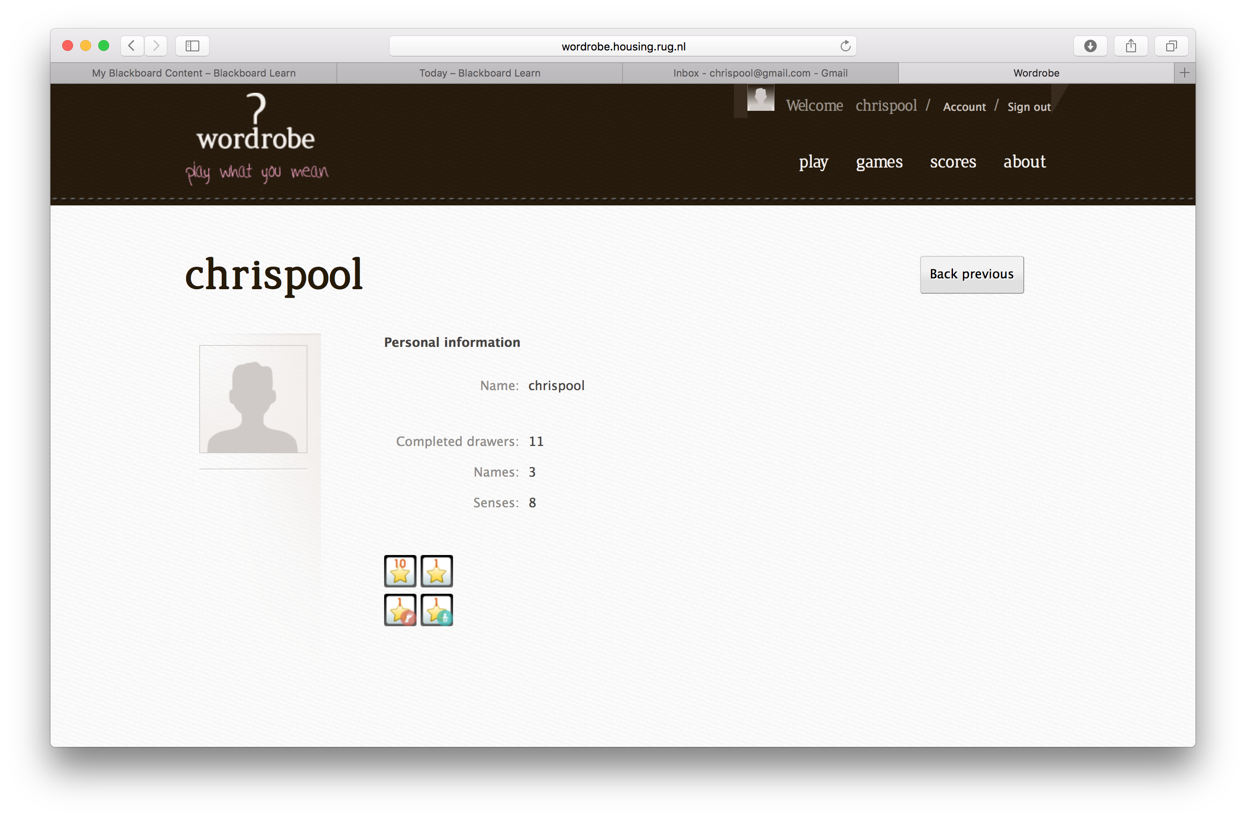

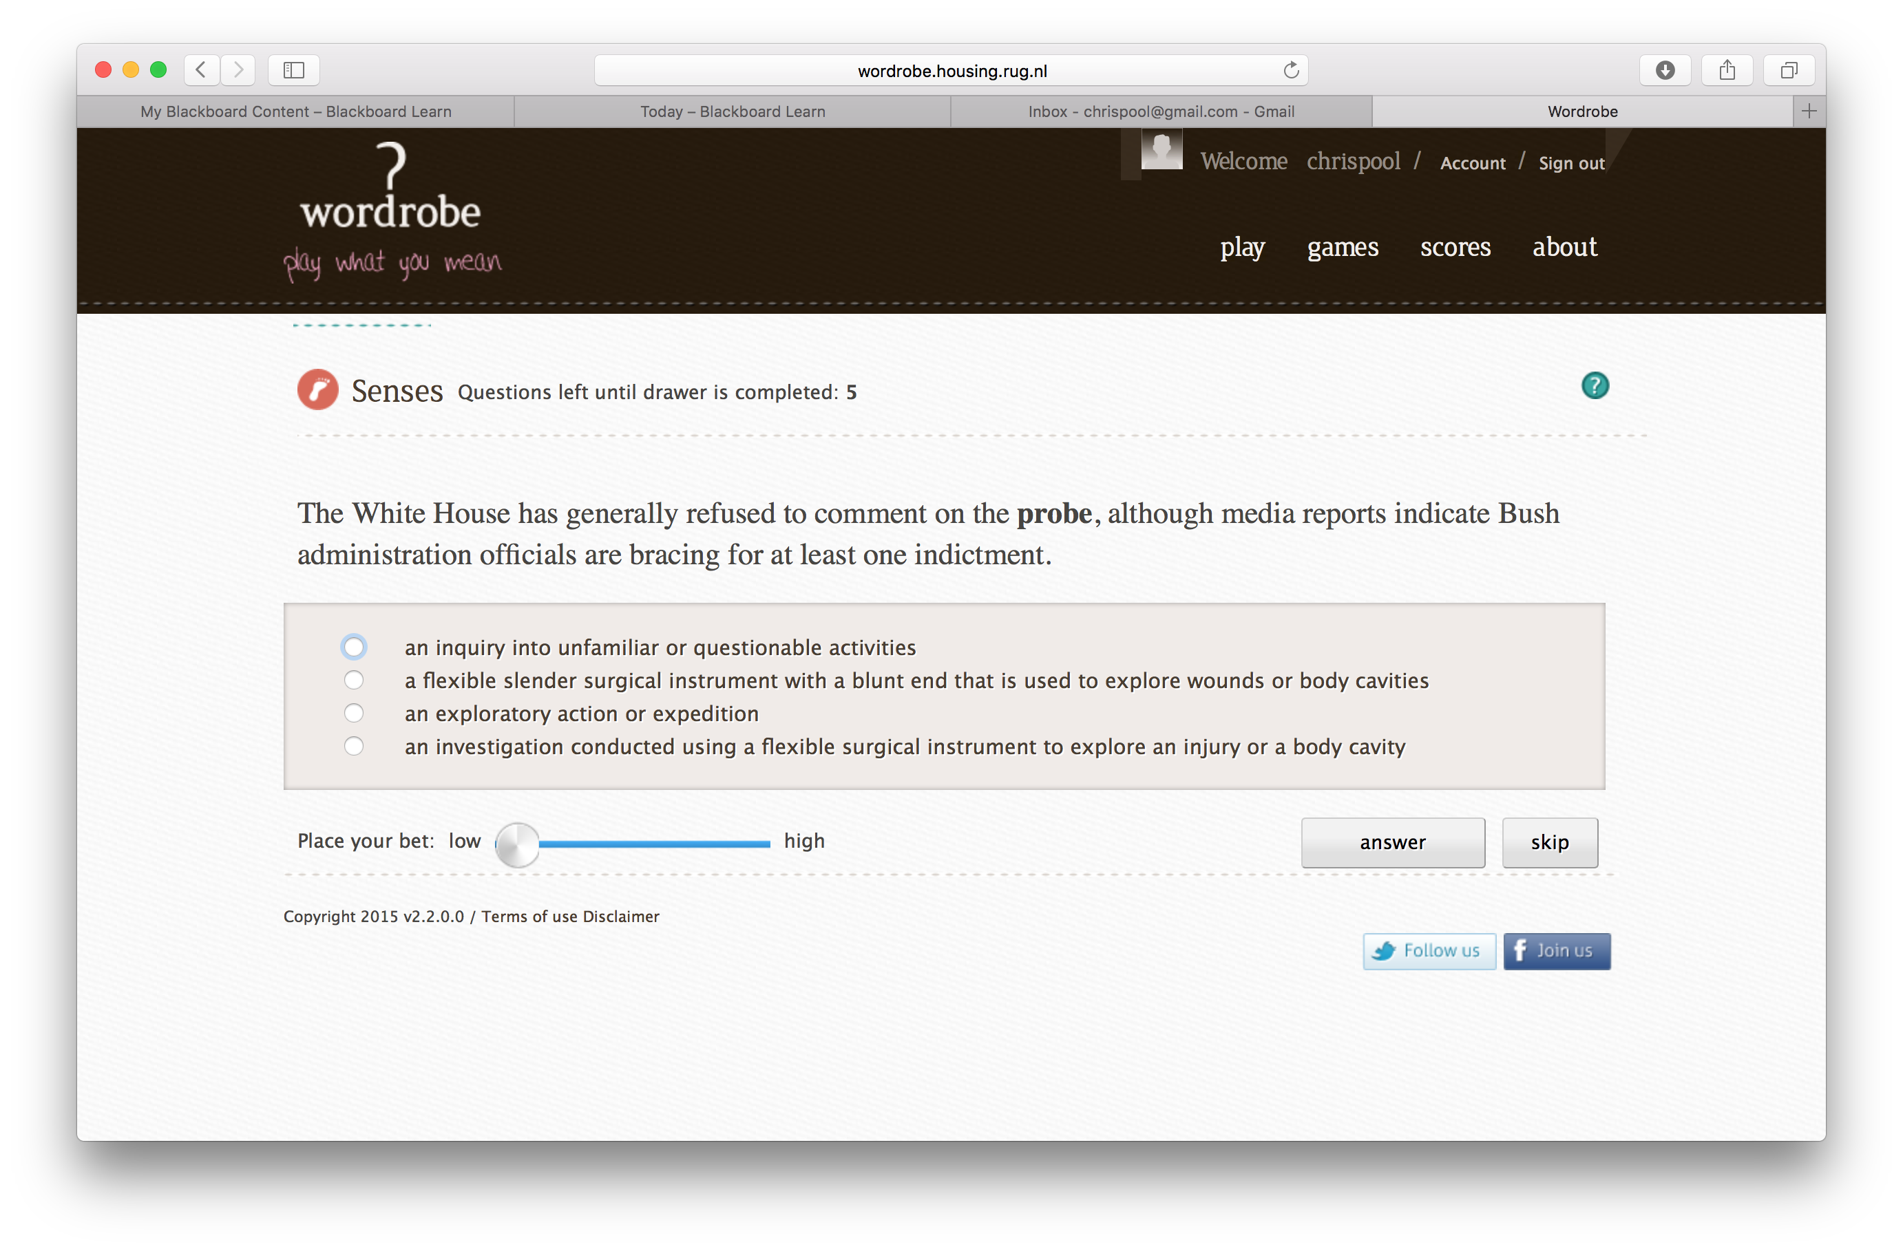

Afbeelding 1Deze vraag was lastig omdat je niet de context weet, probe kan antwoord 1 en 3 zijn

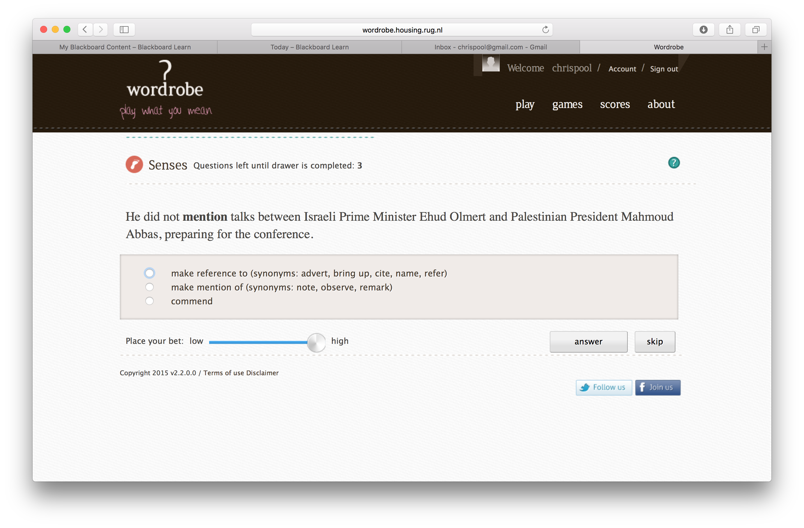

Afbeelding 2 Sense 1 en 2 lijken erg op elkaar en het duurde even voordat ik het doorhad welke het had moeten zijn