Text 1 – Nicaragua

Open Calais
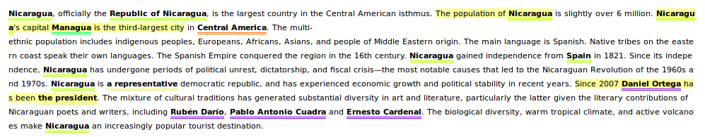

All above annotations are correct except for one, the representative is seen as position which is false in this case. The “central American isthmus” should be annotated as a region. Europeans, Africans, Asians and people of Middle Eastern Origin should also been annotated.

DBpedia
﻿Nicaragua, officially the Republic of Nicaragua, is the largest country in the Central American isthmusisthmusisthmus. The population of Nicaragua is slightly over 6 million. Nicaragua's capital Managua is the third-largest city in Central America. The multi-ethnic population includes indigenous peoples, Europeans, Africans, Asians, and people of Middle Eastern origin. The main language is Spanish. Native tribes on the eastern coast speak their own languages. The Spanish Empire conquered the region in the 16th century. Nicaragua gained independence from Spain in 1821. Since its independence, Nicaragua has undergone periods of political unrest, dictatorship, and fiscal crisis—the most notable causes that led to the Nicaraguan Revolution of the 1960s and 1970s. Nicaragua is a representative democratic republic, and has experienced economic growth and political stability in recent years. Since 2007 Daniel Ortega has been the president. The mixture of cultural traditions has generated substantial diversity in art and literature, particularly the latter given the literary contributions of Nicaraguan poets and writers, including Rubén Darío, Pablo Antonio Cuadra and Ernesto Cardenal. The biological diversity, warm tropical climate, and active volcanoes make Nicaragua an increasingly popular tourist destination.

Here all annotations are correct. Also “respresentative democratic” is annotated correctly (and links to Representative_democracy). I expected that “Europeans, Africans, Asians and people of the middle eastern origin where also annotated.
Text 2 – West Bromwich Albion Football club
Open Calais
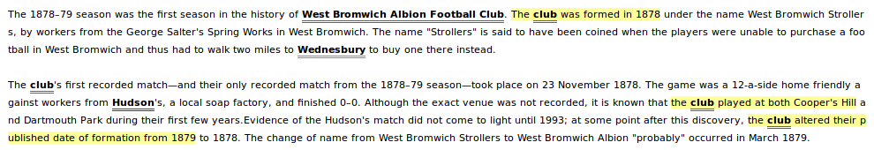

There are a lot of entities not annotated correctly. In the second sentence the name of the club, a company name and a name of a city are not annotated.

DBpedia
﻿ The 1878–79 season was the first season in the history of West Bromwich Albion Football Club. The club was formed in 1878 under the name West Bromwich Strollers, by workers from the George Salter's Spring Works in West Bromwich. The name "Strollers" is said to have been coined when the players were unable to purchase a football in West Bromwich and thus had to walk two miles to Wednesbury to buy one there instead.

The club's first recorded match—and their only recorded match from the 1878–79 season—took place on 23 November 1878. The game was a 12-a-side home friendly against workers from Hudson's, a local soap factory, and finished 0–0. Although the exact venue was not recorded, it is known that the club played at both Cooper's Hill and Dartmouth Park during their first few years.Evidence of the Hudson's match did not come to light until 1993; at some point after this discovery, the club altered their published date of formation from 1879 to 1878. The change of name from West Bromwich Strollers to West Bromwich Albion "probably" occurred in March 1879.

Also using DBpedia a lot of entities are missed or linked to the wrong page. Strange is that entities like Hudson’s are missed.

Results

 | Open Calais | DBpedia | Open Calais | DBpedia
Entities correct | 14 | 22 | 5 | 5
Entities incorrect | 1 | 0 | 2 | 7
Entities not annotated | 6 | 4 | 11 | 5

﻿
It is difficult to compare the two systems because they do not try to annotate the same entities. I found it strange that the second text was annotated poorly because the entities are mostly place names and other still existing entities.

