I3335 Project
Academic Year 2025-2026
Report

Team Composition

Project Title: Pathfinding Visualizer
Student Full Name: Christian Rahhal
Student ID: 61172
Student Full Name: Lea El Khoury
Student ID: 61029

Problem Description

The problem addressed in this project is the determination and visualization of optimal paths between two points in a discrete environment. Specifically, the goal is to find a path from a starting node to a target node within a two-dimensional grid while avoiding obstacles and, in some cases, minimizing traversal cost. This problem is fundamental in computer science and arises in various real-world applications such as network routing, robotics navigation, and game development. The motivation behind this project is to better understand and compare different pathfinding algorithms, including Breadth-First Search (BFS), Depth-First Search (DFS), Dijkstra’s algorithm, and A*, by visualizing how each algorithm explores the search space and constructs a solution. Through this approach, the project highlights the differences in efficiency, optimality, and behavior of these algorithms, providing both a theoretical and practical perspective on graph traversal and shortest path problems.

Methodology

The problem is modeled as a graph using a two-dimensional grid, where each cell represents a node. Each node stores its position, a state, a weight, and a list of neighboring nodes, and is connected to its adjacent cells (up, down, left, and right), forming a structured graph. During execution, nodes transition between different states such as empty(white), wall(black), start(green), end(red-orange), visited(blue), frontier(yellow), and path(purple), which reflects the progression of the algorithms. The project implements several pathfinding algorithms, including Breadth-First Search (BFS), Depth-First Search (DFS), Dijkstra’s algorithm, and A*. BFS guarantees the shortest path in unweighted graphs, while DFS explores deeply without ensuring optimality. Dijkstra’s algorithm computes the shortest path based on node weights, whereas A* improves efficiency by using a heuristic function, specifically the Manhattan distance, to guide the search toward the goal. The cost of a path is calculated either as the number of steps or as the sum of node weights, depending on the algorithm used. Once the goal is reached, the final path is reconstructed by following parent references from the end node back to the start node. The system also includes a visualization mechanism that allows step-by-step execution of the algorithms while displaying metrics such as the number of visited nodes, path length, total cost, and execution time

Experimentations and Results

To evaluate the behavior of the implemented algorithms, several experiments were conducted using different grid configurations, including varying obstacle placements and node weights. Each algorithm: Breadth-First Search (BFS), Depth-First Search (DFS), Dijkstra’s algorithm, and A*, was executed under the same conditions to ensure a fair comparison. The performance was measured using metrics such as the number of visited nodes, path length, and total path cost. The results show that BFS consistently finds the shortest path in unweighted scenarios but may explore a large number of nodes. DFS, while faster in some cases, does not guarantee an optimal solution and often produces longer paths. Dijkstra’s algorithm successfully computes the minimum-cost path in weighted grids but is generally slower due to its exhaustive exploration. A* demonstrates the best overall performance by reducing the number of visited nodes and execution time while still producing optimal paths, thanks to its heuristic guidance. These observations confirm the theoretical expectations and highlight the trade-offs between exploration completeness, optimality, and efficiency among the different algorithms.

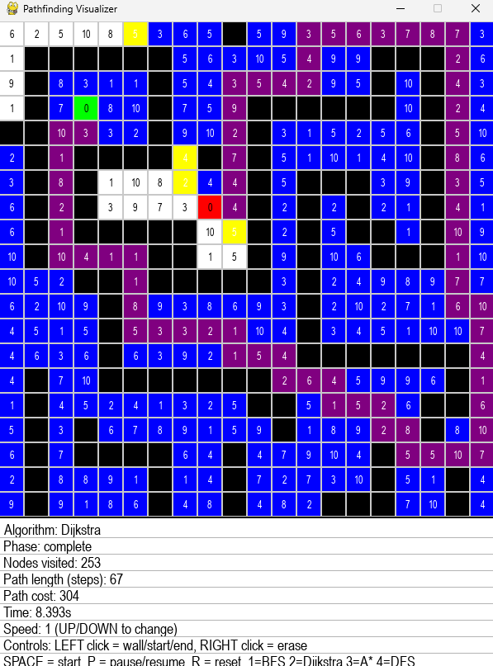

Used AI tools: The implementation of this project was supported using free AI-assisted development tools, including the free version of ChatGPT and GitHub Copilot. These tools were primarily used for code suggestions, debugging assistance, and improving development efficiency.

