OPERATOR GUIDE
DX Pilot for JTDX
Installation, safe setup, hunting modes and Band Analysis
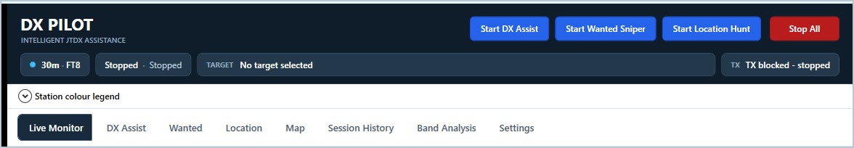
Figure 1. The persistent status header and workspace navigation.
For DX Pilot v4.1 | Windows 10 and Windows 11
Software by G1CEC | Manual prepared August 2026

How to use this manual
This guide is written for operators rather than developers. Start with installation and the Setup Wizard, then read the section for the hunting mode you intend to use. Screenshots contain live example data; callsigns, scores, counts and colours will change as JTDX decodes arrive.
SAFETY FIRST
DX Pilot can issue UDP Reply commands and calibrated mouse clicks to JTDX. Keep JTDX at the size and position used during calibration, confirm that the header shows the correct band/mode and TX state, and use Stop All immediately if anything looks wrong.

Contents
Section | Use it when you want to...
1-2 Install and set up | Connect JTDX, logs and optional companion programs safely.
3-4 Main window and Live Monitor | Understand the header, observe decodes and verify connection health.
5 DX Assist | Work the best DX opportunity on the current band.
6 Wanted Sniper | Work only DXCC, grids or USA states still needed by the selected callsign profile.
7 Location Hunt | Restrict normal hunting to chosen world regions.
8-9 Map and Session History | Explore where stations are and review everything heard during the run.
10-11 Band Analysis | Compare enabled bands using received activity and outward PSK reports.
12-14 Settings, workflow and help | Maintain confirmation rules, operate routinely and solve common problems.

What Stop All means
Stop All switches off DX Assist, Wanted Sniper and Location Hunt. DX Pilot can continue to receive and display UDP information, but the v4 monitor-only protection prevents it from clicking JTDX while stopped. JTDX should then behave normally under manual control.

1. Install DX Pilot
- Open https://github.com/chrisraynerd/DxPilot/releases and choose the latest stable release.
- Expand Assets and download the Windows win-x64 ZIP file.
- Extract the entire ZIP into a normal folder. Do not run the executable from inside the ZIP.
- Open JTDX, then run DXPilot-for-JTDX-G1CEC.exe.
- If Windows SmartScreen appears, review the publisher information and use More info > Run anyway only when the file came from the official release page.
PORTABLE APPLICATION
The self-contained release does not normally require a separate .NET Desktop Runtime. Keep all extracted files together. Your personal settings and history are stored separately under %APPDATA%\JtdxAutoResume.V3.

Before the Setup Wizard
- Have your station callsign and home Maidenhead locator ready.
- Open JTDX and arrange it at the size and position you normally use.
- Know which programs receive JTDX UDP messages (for example GridTracker or Log4OM).
- Locate your main ADIF export, JTDX wsjtx_log.adi and the current JTDX YYYYMM_ALL.TXT file.

2. Run the Setup Wizard
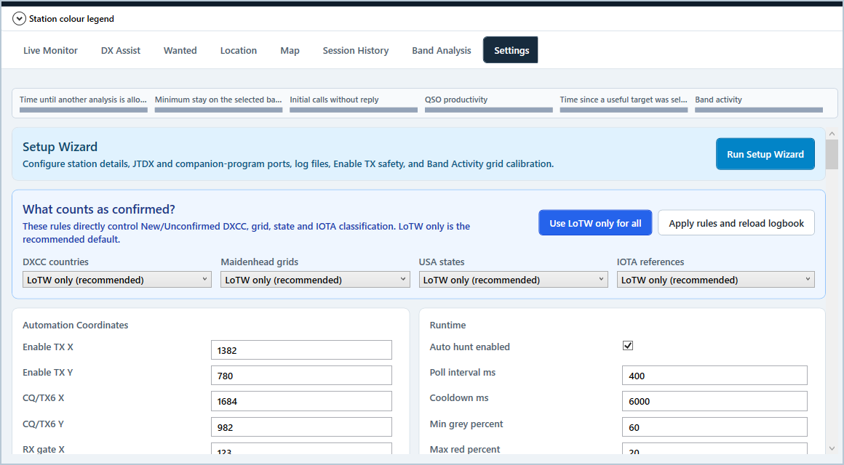
Figure 2. Settings begins with the Setup Wizard and the recommended LoTW confirmation controls.
- Open Settings and choose Run Setup Wizard.
- Enter your callsign and home grid. The grid is used for distance, direction and new-grid scoring.
- Choose the JTDX-only, GridTracker, logger or combined connection layout that matches your station.
- Copy the displayed ports into JTDX File > Settings > Reporting. Use 127.0.0.1 and tick Accept UDP requests.
- Choose your main ADIF, JTDX live ADIF and JTDX monthly ALL.TXT files. The main log should include LoTW confirmation fields.
- With Enable TX definitely OFF and grey, capture a clear grey area inside the button. Do not sample its text, border or edge.
- Align the blue Band Activity overlay so its green lines pass through the centres of every complete visible row, then finish the wizard.
CALIBRATION RULE
Re-run the Enable TX and Band Activity calibration after moving or resizing JTDX, changing Windows display scaling, changing the number of visible rows, or transferring DX Pilot to another PC.

Confirm the connection
- The top-left radio pill should show the same band and mode as JTDX.
- Live Monitor should report increasing UDP packet and decode counts.
- The Live decode feed should populate after a complete FT8/FT4 cycle.
- The TX pill must describe the JTDX state; if it is unknown, do not start assistance.

3. Read the main window
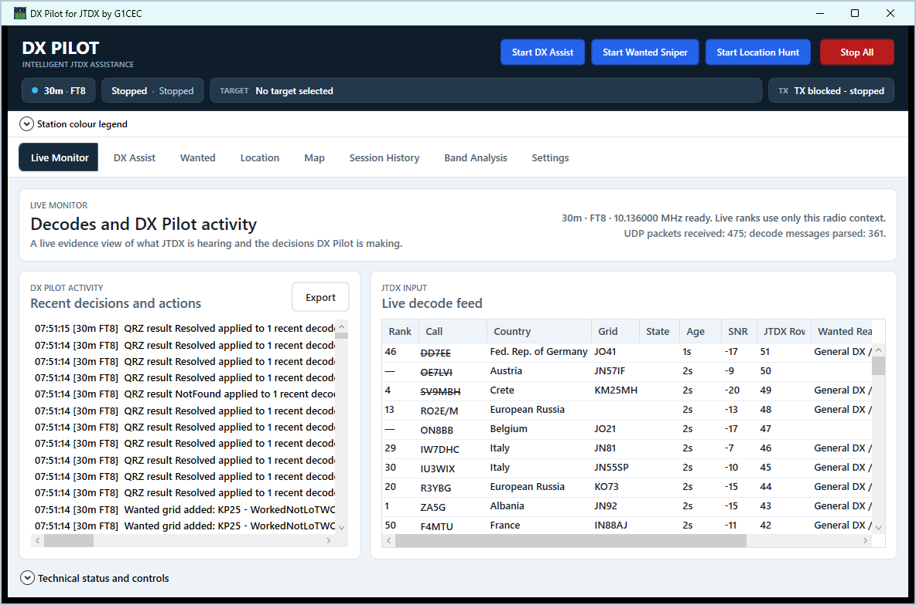
Figure 3. The application-wide header remains visible on every workspace.
Header area | Meaning
Band and mode | The live JTDX radio context used for all ranking and selection.
Operating state | Stopped, DX Assist, Wanted Sniper, Location Hunt or Band Analysis.
Target | The station DX Pilot intends to call or has locked for an active QSO.
TX | Whether transmitting is permitted, blocked or being verified against JTDX.
Blue Start buttons | Start one hunting purpose. Starting one mode pauses the others.
Stop All | Return DX Pilot to monitoring-only operation immediately.

Station colour legend
Expand Station colour legend below the header whenever a row or marker colour is unclear. New DXCC has absolute priority. Calling/selected, in-QSO/worked and failed/mismatch states use strong borders so they remain visible even when the row has another achievement colour.
WORKED CALLSIGNS
A struck-through callsign has been worked before. Hover it for QSO history. A grey struck-through call with the return marker was worked only under another station callsign; it may still be new to the achievement profile currently selected on Wanted.

4. Live Monitor
Live Monitor is the evidence view: it shows what JTDX is hearing and what DX Pilot is deciding. It is useful for confirming that data is flowing before any hunting mode is started.
- Live decode feed shows recent ranked stations, grid, state, age, SNR, JTDX row and wanted reason.
- Recent decisions and actions records selections, lookups, recoveries, band changes and safety decisions.
- Technical status and controls contains UDP and lower-level diagnostics; leave it collapsed during normal operation.
- Export saves the Recent Actions text when detailed troubleshooting is needed.
GOOD FIRST CHECK
Before enabling any assistance, watch the packet count and decode table for one or two cycles. Confirm the reported band/mode and ensure no old target remains in the header.

5. DX Assist
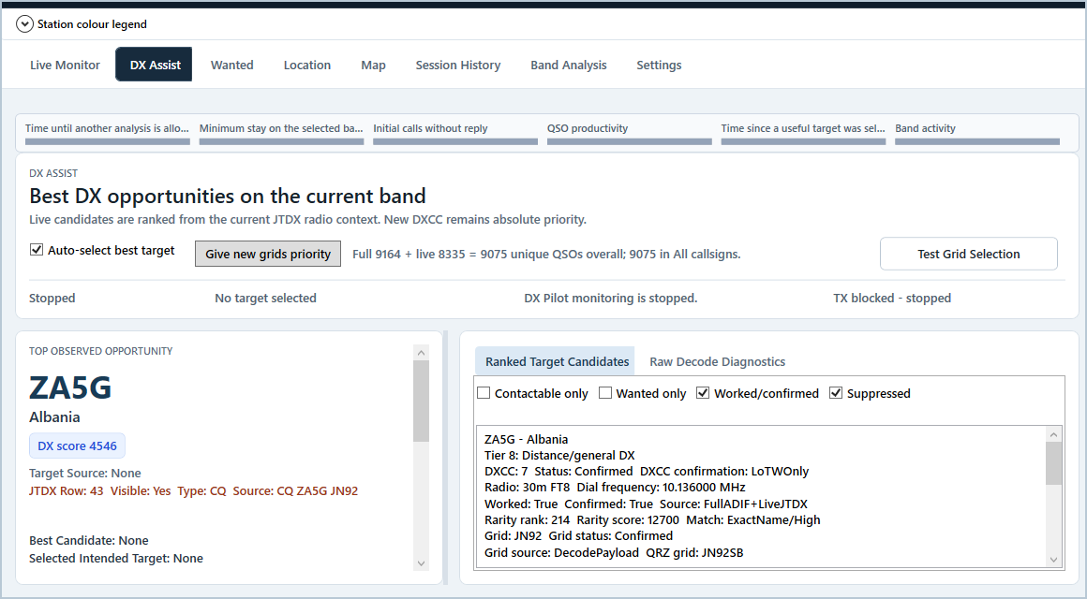
Figure 4. DX Assist ranks contactable opportunities heard on the current band.
Use DX Assist when you want the strongest overall DX opportunity on the band rather than only strict logbook needs. New DXCC remains absolute priority. Other stations are ranked using distance, rarity, grids and live contactability.

Start and supervise DX Assist
- Open DX Assist and confirm Auto-select best target is ticked if you want automatic selection.
- Choose Give new grids priority only when globally new grids should outrank ordinary distance/general DX. DX Assist falls back to normal DX ranking when none are present.
- Select Start DX Assist in the top header.
- Watch Top observed opportunity, the locked target and the header TX state. The ranked table continues to update while the active QSO remains protected.
- Use Stop All to end automatic operation.

Candidate controls
- Contactable only hides stations with no safe live JTDX selection source.
- Wanted only narrows the visible diagnostics; it does not turn DX Assist into Wanted Sniper.
- Worked/confirmed and Suppressed are display filters for investigation.
- Test Grid Selection verifies the calibrated JTDX row model without beginning general hunting.

6. Wanted Sniper
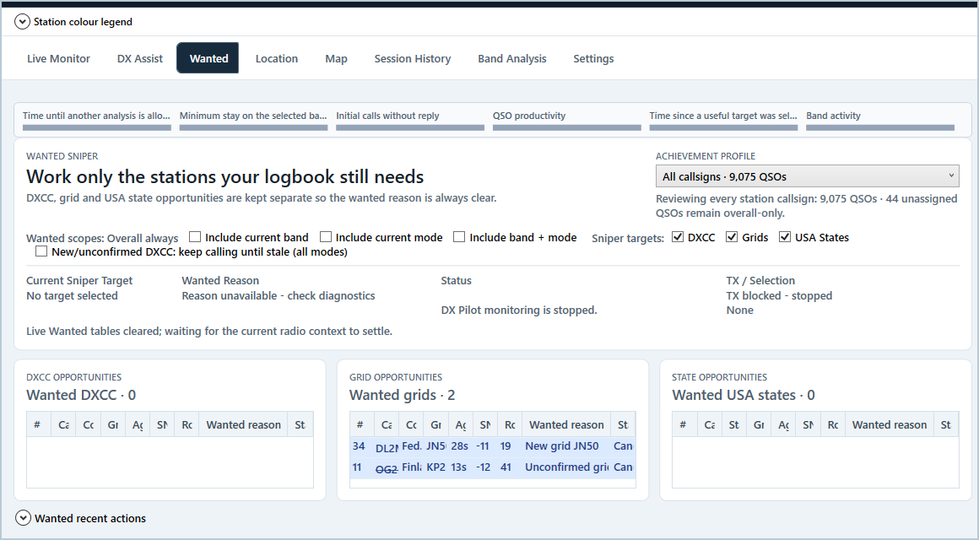
Figure 5. Wanted keeps DXCC, grid and USA state opportunities separate.
Use Wanted Sniper when the logbook need is the purpose. The three tables explain whether a station is wanted for DXCC, Maidenhead grid or USA state, and the Sniper targets checkboxes determine which categories may be selected automatically.

Choose the achievement profile
The Achievement profile selector is built automatically from STATION_CALLSIGN values in the imported ADIF. All callsigns combines every identity; choosing one callsign asks what is new or unconfirmed specifically for that identity. Change the profile only while assistance and Band Analysis are stopped. During an active operation, the chosen profile remains visible beside a PROFILE LOCKED badge so it is always clear which logbook identity is controlling Wanted decisions.

Choose scope and targets
Control | Effect
Overall always | The normal all-time achievement view and the safest general default.
Include current band | Adds band-specific needs to the candidate set.
Include current mode | Adds mode-specific needs.
Include band + mode | Adds the narrowest band-and-mode needs.
DXCC / Grids / USA States | Determines which wanted category Wanted Sniper may call.
Keep calling until stale | Allows new or unconfirmed DXCC to remain selected beyond the usual short retry sequence.

- Select the desired achievement profile.
- Choose scope and target categories.
- Confirm the three opportunity panels agree with your expectations.
- Select Start Wanted Sniper.
- Watch Current Sniper Target, Wanted Reason, attempt count and TX/Selection state.
WORKED IS NOT CONFIRMED
With the recommended LoTW-only rules, a grid or DXCC can be worked but still unconfirmed. Such a station may remain wanted for confirmation. The callsign strike-through records contact history; the wanted reason records whether the achievement is satisfied under the selected confirmation rule.

7. Location Hunt
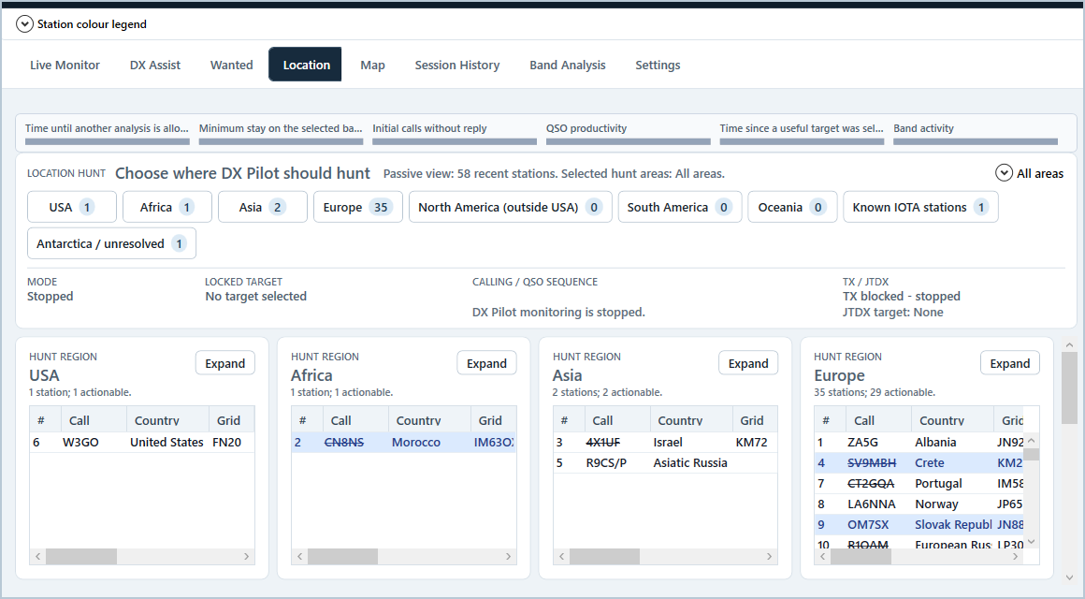
Figure 6. Location Hunt gives a four-panel overview with counts and expandable regions.
Use Location Hunt when geography is the objective. Selected regions are combined into one ranked candidate list; a contactable New DXCC anywhere still has absolute priority.
- Open Choose regions and tick the areas DX Pilot may hunt, or use All areas/None.
- Use the overview buttons to see the number of recent candidates in each region and jump to its panel.
- Review the status strip for mode, locked target, call sequence and actual JTDX target.
- Choose Expand on a busy region to give it a larger station list; choose Collapse to return to the overview.
- Select Start Location Hunt in the top header.
The panels include USA, Africa, Asia, Europe, North America outside the USA, South America, Oceania, known IOTA stations and Antarctica/unresolved. Empty regions remain visible so an opening is obvious as soon as stations arrive.

8. Live Map and CALL NOW
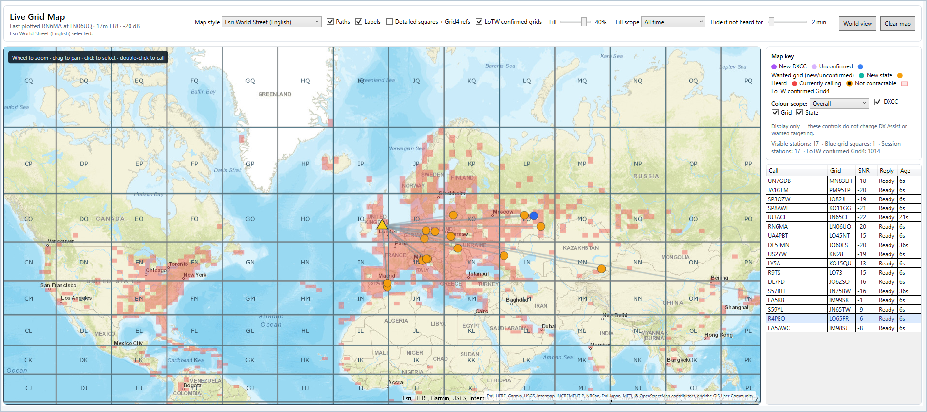
Figure 7. The map combines live stations, paths, Maidenhead overlays and LoTW-confirmed Grid4 shading.

Explore the map
- Use the mouse wheel to zoom and drag to pan. World view restores the broad view.
- Map style chooses the cached OpenStreetMap or Esri background.
- Paths connects your home locator to heard stations; Labels and detailed squares control map detail.
- LoTW confirmed grids overlays the confirmation wash. Fill and Fill scope control its strength and whether it reflects all time, the current band or current mode.
- The station list at right shows live contactability and age. A red marker follows the active locked target.

Call a station manually
- Click a marker or station row to inspect it.
- Confirm that Reply says Ready and the decode is still fresh.
- Double-click the marker/row, or use CALL NOW from the station context menu where available.
- If assistance was stopped, DX Pilot runs a one-station session and returns to stopped. If a hunting mode was active, that mode resumes after the manual station finishes.
UNABLE TO CONTACT
DX Pilot will reject CALL NOW when the station is stale or no longer has a safe selectable JTDX row/UDP Reply source. Wait for a fresh decode rather than forcing transmission.

9. Session History
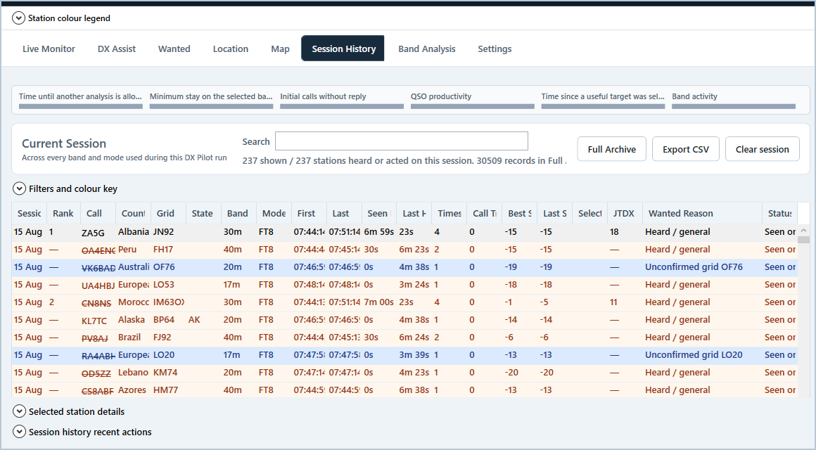
Figure 8. Current Session retains stations heard across band and mode changes.
Session History is the record of the entire DX Pilot run. Unlike the live band tables, it is not cleared when JTDX changes band. Each station can retain first/last time, number of decodes, call tries, SNR, selection method, wanted reason and outcome.
- Search filters the visible station list.
- Filters and colour key controls wanted categories and outcomes without deleting records.
- Selected station details expands the full evidence for the highlighted row.
- Full Archive searches the permanent locally stored archive, including earlier runs.
- Export CSV creates a portable table for analysis or support.
- Clear session removes only the current-run view; use it deliberately.
LOCAL STORAGE
The permanent archive contains far more detail than an ADIF log, including repeated decodes and decision evidence, so it can become substantially larger. It is stored locally under %APPDATA%\JtdxAutoResume.V3.

10. Manual Band Analysis
Band Analysis compares enabled bands using both sides of propagation: stations and wanted targets received by JTDX, plus reports of your two controlled CQ probes received through PSK Reporter.
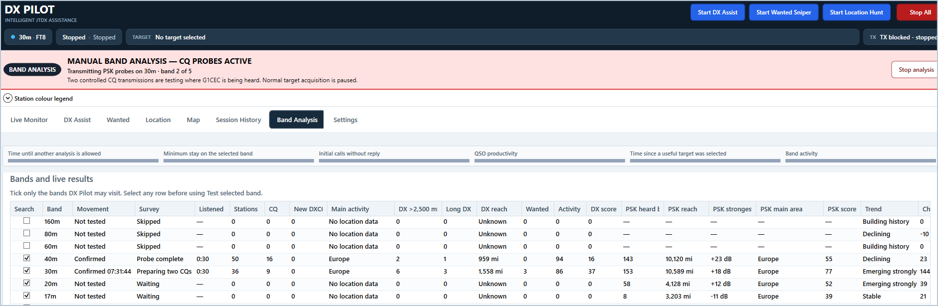
Figure 9. A prominent banner warns when a manual analysis is listening or transmitting CQ probes.
MANUAL MEANS IMMEDIATE
Start Band Analysis is a manual command. It does not wait for automatic cooldown, inactivity or trigger bars. If a hunting mode is active, DX Pilot safely pauses it, finishes any current transmission, runs the analysis and then resumes the same mode on the selected band.

Required calibration
- The complete 12-button JTDX band strip must be mapped.
- The JTDX Tx 15/45 or Tx 00/30 timing selector must be mapped.
- The JTDX Tx1 button must be mapped so normal target acquisition can be restored after CQ probing.
- Fresh JTDX UDP status and internet access to PSK Reporter are required for the full test.
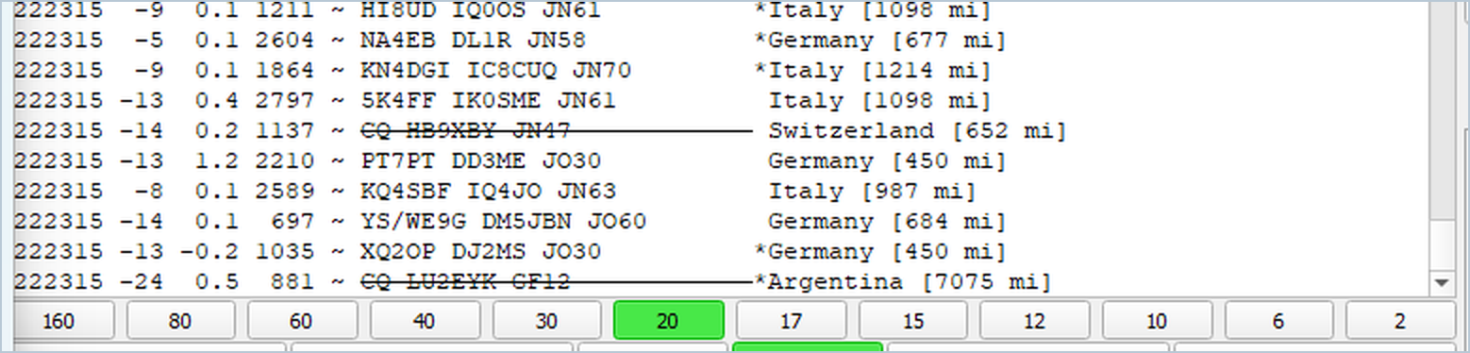
Figure 10. Map the complete band-button strip from 160m through 2m; DX Pilot calculates each button centre.

Run a survey
- Open Band Analysis setup and tick only the bands DX Pilot may visit.
- Choose one to five minutes per band. Every band receives a complete passive sample followed by exactly two verified 15-second CQs; longer durations add listening time, not more CQs.
- Use Test selected band to verify each mapped button before transmitting a multi-band survey.
- Select Start Band Analysis and accept the transmission warning.
- Watch the application-wide banner and Bands and live results table. Current-run values begin empty and appear as each band completes.
- When the survey finishes, review the selected band, PSK map and conditions history. If assistance was active, it resumes on the final confirmed band.

Understand Band Analysis results
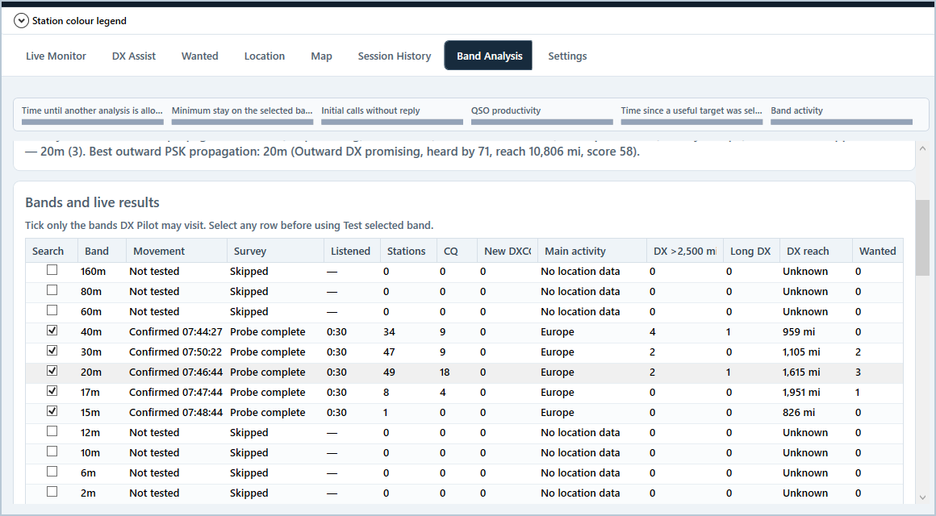
Figure 11. The live table separates received opportunity quality from outward PSK propagation.
Column/group | Interpretation
Stations / CQ | Unique stations and CQ callers received during the fair sample.
New DXCC / Wanted | Immediate logbook opportunities. New DXCC overrides numerical scoring.
Main activity | Where most located received stations were heard.
DX >2,500 mi / Long DX / reach | Distance evidence; a quiet band with genuine DX can beat a crowded regional band.
Activity / DX score | Separate measures of volume and useful DX reach.
PSK heard by / reach / strongest | Unique receiving stations, farthest report and best SNR from your probes.
PSK main area / score | Primary outward region and a transparent 0-100 outward-propagation score.
Trend / Choice | Recent direction and final combined comparison. Trend is only a modest tie-breaker.

Conditions history graph
The graph shows the latest 14 completed analyses for enabled bands. Hollow points are provisional during the current run; a larger outlined point marks the selected destination. The 0-100 graph score is a visual summary only and does not replace the established New DXCC priority or final selection logic. The X-axis labels actual analysis times, and hovering a dot shows its full local date/time and supporting details.

PSK map retention
A successful locator-bearing PSK map is saved and restored at startup so useful propagation evidence remains visible between surveys. Starting a new analysis clears the current live table; it does not erase saved history. Once the new survey has usable reports, the latest map replaces the retained view.

11. Automatic Conditions Search
Automatic Conditions Search decides when the current band deserves reassessment. It is separate from the manual Start Band Analysis button: automatic analysis observes the configured thresholds, while manual analysis starts on request.
Trigger bar | What empties it
Time until another analysis is allowed | Cooldown since the last completed analysis.
Minimum stay on selected band | Residence time given to the last chosen band.
Initial calls without reply | Early transmissions made without a reply or QSO progress.
QSO productivity | Time and calling effort since a completed QSO appeared in JTDX's ADIF. Partial replies do not reset it.
Time since a useful target | Time since the active mode accepted a selectable useful target.
Band activity | Persistent silence or low unique-station activity in the rolling window.

Bars empty toward their thresholds. Reaching zero makes that condition ready, but cooldown, minimum stay, a protected QSO and other safety gates can still defer automatic analysis. A banner explains any pending or active event.

Configure automatic analysis
- Enable Automatically analyse enabled bands when current conditions deteriorate.
- Grant Allow automatic analysis to transmit two CQ propagation probes only if unattended CQ probing is acceptable at your station.
- If automatic PSK probes are disabled or unavailable, the optional one-minute receive-only fallback can make a quick comparison.
- Move automatically to the best band permits the final confirmed movement. A meaningful-improvement margin avoids marginal changes; the current band may remain selected when it is still genuinely best.
- Survey after startup and scheduled UTC checks are optional sources of automatic analysis.
NEW DXCC PRIORITY
If a contactable New DXCC appears during monitoring or analysis, DX Pilot abandons the survey path and hands the station to the normal absolute-priority calling sequence.

12. Settings and logbook rules

Confirmation rules
Settings begins with four confirmation selectors for DXCC countries, Maidenhead grids, USA states and IOTA references. LoTW only is the recommended default and is used when Use LoTW only for all is chosen. Apply rules and reload logbook after changing them.
- Worked means at least one matching QSO exists.
- Confirmed means the QSO satisfies the selected rule, normally LoTW-only.
- Unconfirmed means worked but not yet satisfied under that rule.
- Changing confirmation rules can alter colours, wanted tables and rankings immediately after the log reload.

Multiple station callsigns
DX Pilot reads the operator identity recorded in each ADIF QSO. Use the Wanted page Achievement profile to review All callsigns or a specific previous/current callsign. A country worked only under another identity can therefore appear as New to the selected callsign while still displaying its earlier QSO history on hover.

Other important settings
- Station identity and home grid.
- Full and live ADIF paths, ALL.TXT monitoring and startup loading.
- UDP listen, reply-fallback and forwarding destinations.
- QRZ lookup credentials and cache behaviour.
- Retry limits, stale time, attempt counters and safety timing.
- JTDX Band Activity row count and calibrated coordinates.
- Settings export/import; protected QRZ passwords are excluded from portable exports.
DO NOT COPY CALIBRATION BLINDLY
A settings export can move preferences to another PC, but screen coordinates and JTDX row geometry must be recalibrated on that computer. Pixel appearance, DPI, theme and window size differ between systems.

13. Recommended daily workflow
- Open JTDX and place it at the calibrated size and position.
- Open DX Pilot and use Stop All while the connection settles.
- Confirm band, mode, packet count, fresh decodes and the TX gate in Live Monitor.
- Choose the purpose: DX Assist for best DX, Wanted Sniper for strict needs, or Location Hunt for chosen regions.
- Review that mode's filters and achievement profile before pressing its Start button.
- Supervise the target, call attempts and actual JTDX target during the first few contacts.
- Run a manual Band Analysis when you want an immediate multi-band comparison; otherwise allow Conditions Search to wait for its configured triggers.
- Use Stop All before changing calibration, importing settings, changing the achievement profile or taking manual control of JTDX.

A sensible first test on a new PC
- Keep the transmitter connected to a dummy load or use a no-RF test arrangement where appropriate.
- Confirm UDP state changes when Enable TX is manually toggled in JTDX.
- Use Test Grid Selection on a harmless visible row and verify the expected DX Call appears.
- Test each enabled band movement individually before starting Band Analysis.
- Start with one assistance mode and watch several complete FT8 cycles before leaving it unattended.

14. Troubleshooting
Symptom | Checks
No UDP or no decodes | JTDX Reporting: 127.0.0.1, matching port, Accept UDP requests enabled; no second program competing for the same port.
Wrong band/mode in header | Wait for a fresh JTDX Status packet; stop assistance and restart UDP/JTDX if the context does not settle.
Target visible but not selected | Check contactability, age, JTDX row count, grid alignment and window size; use Test Grid Selection.
DX Pilot turns TX the wrong way | Press Stop All. Verify fresh UDP TX state, then recapture the OFF/grey centre of Enable TX on that PC.
Band movement fails | Keep JTDX restored; remap the complete strip, select the intended band and test it; verify UDP confirms the resulting band.
PSK survey stops | Check timing-button and Tx1 mapping, internet access, callsign/home grid and whether JTDX confirms both CQ transmissions and receive-only cleanup.
Wanted result looks wrong | Check main/live ADIF paths, selected callsign profile, LoTW confirmation rules and Apply rules and reload logbook.
Map is blank | Check internet access and map style, allow cached tiles time to load, then change map style or return to World view.
Application feels slow | Collapse diagnostic sections, avoid keeping enormous archive detail expanded and export Recent Actions before restarting for investigation.

When reporting a problem
- State the exact time, band, mode and intended target.
- Include what JTDX displayed in DX Call and its outgoing message area.
- Export Recent Actions and, when relevant, the Band Analysis CSV log.
- Attach a screenshot showing the persistent header, target and TX state.
- Do not share QRZ passwords, protected settings values or private log files publicly.

15. Quick glossary
Term | Meaning in DX Pilot
Contactable | A current decode with a safe UDP Reply or calibrated visible-row selection source.
Locked target | The station protected while DX Pilot is calling or completing a QSO.
New DXCC | No matching worked entity in the selected achievement profile; absolute priority.
Unconfirmed DXCC/grid | Worked, but not confirmed under the selected rule, normally LoTW-only.
Wanted | A DXCC, grid or state need allowed by Wanted scope and target controls.
General DX | A useful distance/rarity opportunity even when no strict wanted item applies.
PSK heard by | Unique PSK Reporter receivers that matched one of the two verified survey CQs.
Conditions score | Band comparison value combining received evidence, modest PSK contribution and trend; not a prediction.
CALL NOW | A guarded one-station override from a live contactable row or map marker.
Monitor-only | Stop All state: observation continues, but DX Pilot does not click JTDX.

FINAL OPERATING PRINCIPLE
DX Pilot is designed to make a reasoned choice and then verify JTDX's state. Treat the persistent header and JTDX itself as the final evidence. If they disagree, use Stop All and investigate before transmitting again.

