Christopher Reyes
Professor Yanilda Peralta
CIS 345
13 May 2026

Xv6 Lottery Scheduler
Introduction:
This project modifies the xv6 operating system to implement a Lottery Scheduler. Each process is assigned a few tickets, and the scheduler randomly selects a winning ticket to decide which process runs. Processes with more tickets have a higher probability of being scheduled. The project also tracks how many times each process is selected by the scheduler.
The following xv6 files were modified:
- kernel/proc.h
- kernel/proc.c
- kernel/sysproc.c
- kernel/syscall.h
- kernel/syscall.c
- user/user.h
- user/usys.pl
- Makefile

I also added a new user file which is lotterytest.c
Explanation on code and changes made:
The xv6 operating system was modified to implement a Lottery Scheduler using a ticket-based CPU scheduling system. New variables called tickets and ticks were added to the proc structure in proc.h to store the number of lottery tickets assigned to each process and the number of times the process was scheduled. The scheduler in proc.c was changed to calculate the total number of tickets for all runnable processes, randomly select a winning ticket, and run the process that owned the winning ticket. Each time a process was selected, its tick counter was incremented to track CPU usage. Two new system calls, settickets() and getpinfo(), were implemented in sysproc.c to allow processes to set their ticket counts and retrieve scheduling statistics. Additional changes were made to syscall.h, syscall.c, user.h, and usys.pl so the new system calls could be recognized and used in user programs. A user program called lotterytest.c processes with ticket ratios of 30, 20, and 10 and measure how often each process ran. The final results showed that processes with more tickets received more CPU ticks, demonstrating that the Lottery Scheduler worked correctly.
Testing and Result:
Three processes were tested with ticket ratios of 30, 20, and 10. The process with 30 tickets received the highest number of scheduler ticks, while the process with 10 tickets received the fewest ticks. This demonstrates that the lottery scheduler distributes CPU time proportionally based on ticket count.
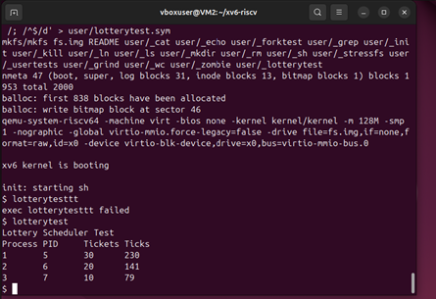
Graph Explanation:
The graph shows the distribution of scheduler ticks over time. Processes with higher ticket counts accumulated CPU time faster than processes with fewer tickets. This confirms that the lottery scheduling implementation works correctly.
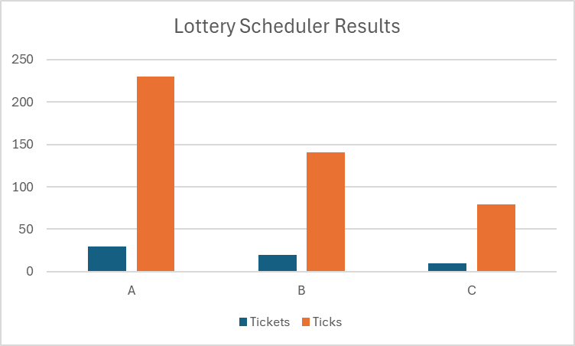
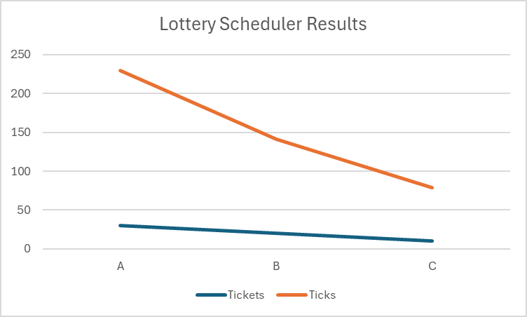

Conclusion:
This project successfully implemented a Lottery Scheduler in xv6. The scheduler used ticket-based random selection to determine which process would run. Testing showed that processes with more tickets received more CPU time. The graph and scheduler statistics confirmed that the implementation behaved as expected.

Screenshots:
