Class Diagram & Description of Classes MW Team 4

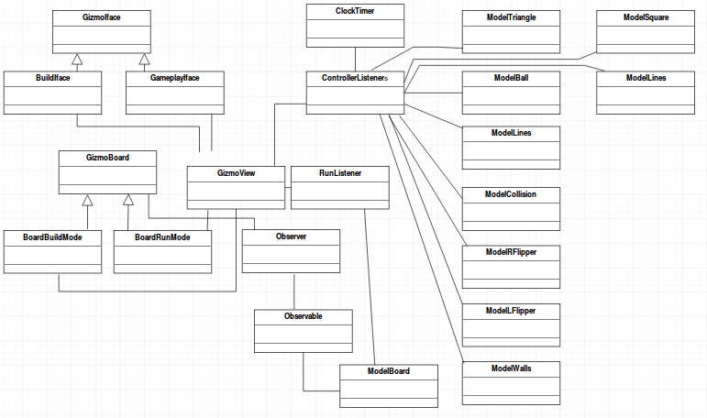
Class Diagram:

Description of Classes: <<to be added>>

