# HumanizeJS

Created by Chris Rink.

An example can be run from the examples/test.html

## Deployment.

1. Add humanizeJS.jar as a library in your project.
2. Copy ‘Resources\humanize’ folder to your application’s ‘\Resources’ folder.

## Customization/Repackaging.

1. New functions can be added to the’ src\humanize\content\humanize\humanize.js’
2. Create/Copy function declaration from ‘src\humanize\config\humanize’ folder. New function declarations shouldn’t include content for humanize or moment.js
3. Package by using 7zip to package the humanize and META-INF folders in the ‘\src’ location.

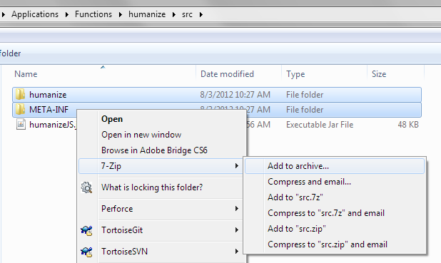

1. Rename archive to use jar extension.