# Casual Theme

Created by Chris Rink.

## Deployment.

1. Add thm.WhiteTheme.jar as a library in your project.
2. Go to Master page and choose White Theme

## Customization/Repackaging.

1. The main theme file is ‘src\white-theme.scss’ This file only includes css classes that will override the base theme. You can add your own css classes without the need to import anything else.
2. You can leverage the ‘base theme reference’ to add mixins for overriding widget styles.
   1. Be sure to import variables or mixins from the base theme if you plan to leverage values.
   2. When importing from the base theme you will need to add ‘xcp/default/’ to the paths used in the reference files.
   3. When importing from the extJS theme you will need to add ‘ext4/default/’ to the paths used in the reference files.
3. If you want to use an image, you will need to put it in the Resource folder for your applications. Images can then be referenced by using the relative path ‘Artifacts/Resources/<name of file>’
4. Compass mixins can be leveraged by using import @import 'compass'; For a list of compass functions visit <http://compass-style.org/reference/compass/>
5. SCSS syntax can be found at <http://sass-lang.com/docs.html>
6. Rename theme by editing the ‘src/META-INF/MANIFEST.mf’ file. Ensure all properties are set. Here is an example.

Manifest-Version: 1.0

Theme-Name: Casual and Property Insurance Theme

Created-By: Chris Rink

Theme-Sass-File: casual.scss

Bundle-Name: CasualPropertyTheme

Bundle-SymbolicName: CasualPropertyTheme

Bundle-Version: 1.0

NAMESPACE: casual

1. Package by using 7zip to package the casual.scss and META-INF folders in the ‘\src’ location. 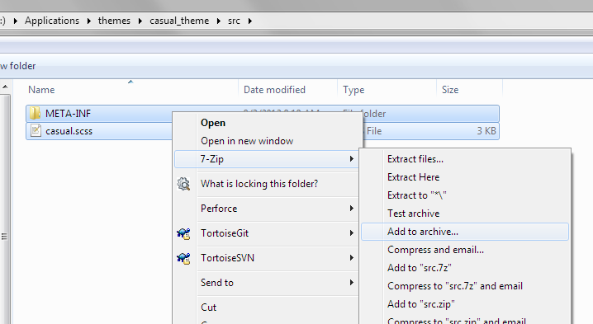
2. Rename archive to use jar extension.

## Updating an imported theme

The library file is stored under the application directory in the lib folder.

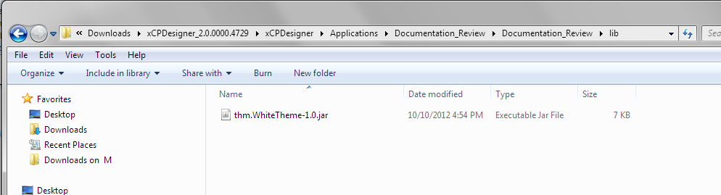

You can either replace the jar or you can use 7zip to open archive and edit any of the source files

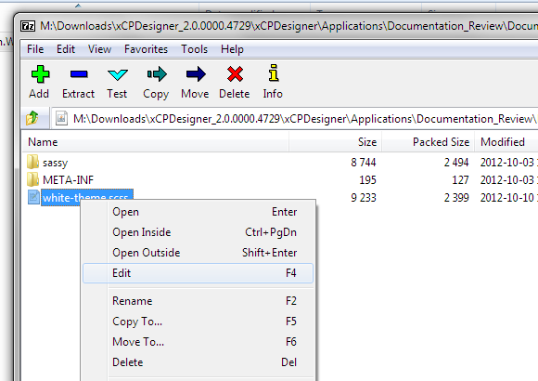

After you update the jar, refresh the theme in your Master page.