Multi-ancestry leukemia GWAS pipeline
Workflow: what happens to the data, module by module
Every box is a Nextflow subworkflow or process and every arrow is a file handed from one module to the next. The same steps exist as SLURM array scripts under slurm/, which call the same bin/ scripts (section 6). Ancestry strata are EUR, AAC, LAT1 and LAT2, with EAS and SAS analysed separately when they reach 30 samples and pooled into OTHER otherwise.

1. End-to-end overview

Part A: genotypes to summary statistics
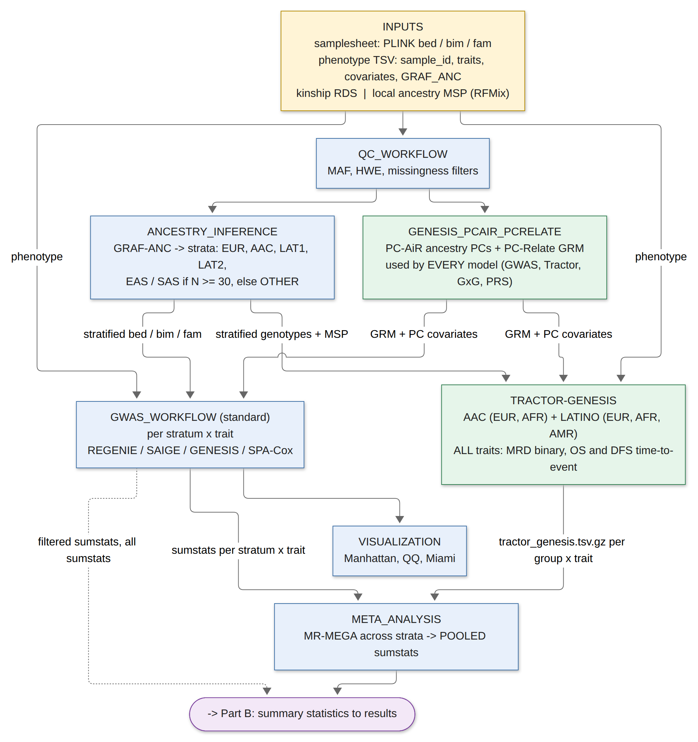
Every trait goes through Tractor-GENESIS (green) as well as the standard per-stratum GWAS, so MRD, DFS and OS are comparable.

Part B: summary statistics to results
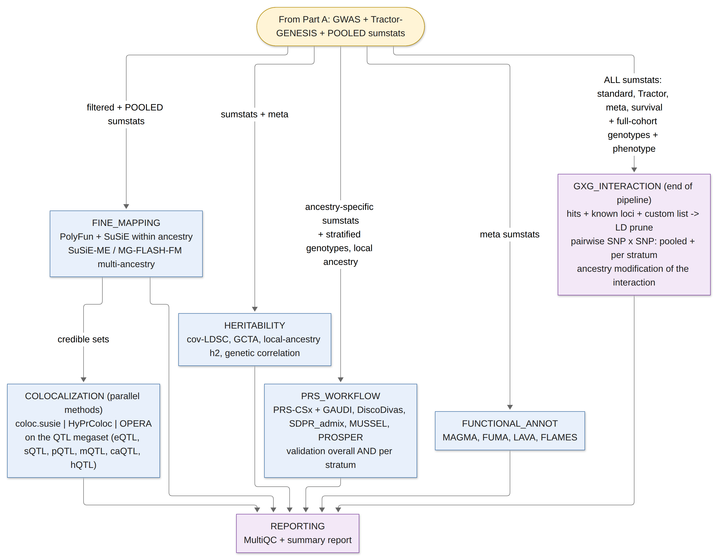
GxG interaction testing is the last analysis step and reads all summary statistics produced upstream.

2. Module inputs and outputs
Module | Reads | Writes | Feeds
INPUT_CHECK | samplesheet CSV | validated genotype channel | QC
QC_WORKFLOW | bed / bim / fam | QC'd bed / bim / fam, QC report | ANCESTRY, PC-AiR, GxG (full cohort)
GENESIS_PCAIR_PCRELATE (bin/genesis_pcair_pcrelate.R) | QC'd full cohort, phenotype | PC-AiR PCs (.pcair.pcs.tsv); PC-Relate GRM (.pcrelate.grm.rds); kinship; unrelated set; phenotype with PC1..PCn replaced by PC-AiR PCs | GWAS null models, Tractor-GENESIS, GxG, PRS validation: every model uses the same GRM and PCs
ANCESTRY_INFERENCE | QC'd genotypes, GRAF reference, MSP | ancestry_calls.tsv; stratified bed/bim/fam per group; local ancestry channel | GWAS, Tractor, PRS
GWAS_WORKFLOW (standard) | stratified genotypes x trait, phenotype, covariates, kinship | <id>.<ancestry>.<trait>.sumstats.gz; filtered sumstats; significant variants | META, FM, H2, VIS, GxG
PLINK_TO_VCF -> TRACTOR_EXTRACT_TRACTS | AAC and merged LATINO genotypes + MSP; meta.tractor_pops | <id>.ancdose.<k>.tsv.gz and <id>.hapcount.<k>.tsv.gz per ancestry k | TRACTOR_GENESIS
TRACTOR_GENESIS (bin/tractor_genesis_adapter.R) | dosages + hapcounts, phenotype, kinship, covariates; meta.model | <prefix>.tractor_genesis.tsv.gz (sorted by P_JOINT), .genomic_order.tsv.gz, .top_hits.tsv, .significant.tsv, .heterogeneous.tsv, .<anc>_specific.tsv, .null_model.rds | META, GxG
META_ANALYSIS | sumstats grouped by trait across strata | MR-MEGA results, heterogeneity table. SLURM path: bin/meta_analyze_strata.R -> POOLED.sumstats.gz | FM, H2, PRS, FUNC, GxG
FINE_MAPPING | filtered sumstats, LD reference or cohort LD | credible sets, PIPs | COLOC
COLOCALIZATION (COLOC_RUN = bin/run_colocalization.R) | every ancestry-stratified GWAS (standard + Tractor-GENESIS) and the meta / POOLED GWAS; QTL megaset pooled by type (curated_qtl_sources.yml via download_qtl_datasets.R, harmonize_qtl.R); optional cohort LD | per GWAS: .coloc_susie.tsv, .hyprcoloc.tsv, .opera.tsv; per trait: coloc_combined.tsv, coloc_consensus.tsv, shared / divergent / meta-only tables, PP4 heatmap | REPORTING
HERITABILITY | sumstats, meta results, LD reference | h2 per stratum, local-ancestry h2, genetic correlations | REPORTING
PRS_WORKFLOW (PRS_METHOD = bin/calculate_prs_admixed.R) | ancestry-specific sumstats per trait, LD reference, full-cohort genotypes, local ancestry, phenotype with PC-AiR PCs; Tractor dosages + Tractor-GENESIS betas for the partial scores | per method: weights and .sscore; <trait>.la_partial.scores.tsv (the part of each score carried on EUR / AFR / AMR haplotypes); <trait>.validation.tsv (OVERALL + one row per stratum, AUC / R2 / C-index); prs_comparison.tsv and best_prs.tsv (best overall and per stratum, disparity flags) | REPORTING
FUNCTIONAL_ANNOT | meta or filtered sumstats | MAGMA / FUMA / LAVA / FLAMES outputs | REPORTING
GXG_INTERACTION (bin/run_gxg_interaction.R) | all sumstats for the trait, known loci, custom list, full-cohort genotypes, phenotype, optional Tractor dosages | gxg.<stratum>.tsv, gxg.all.tsv, gxg.significant.tsv, gxg.hits_pruned.tsv, gxg.ancestry_heterogeneity.tsv, gxg.local_ancestry.tsv, gxg_summary.tsv, gxg_top_interactions.tsv | REPORTING
REPORTING | everything above | HTML report | user

3. Tractor-GENESIS: one engine for every trait
Every trait goes through the same conditional score test. The trait's model, set in main.nf from binary_traits and survival_traits, only changes where the projection comes from: the GENESIS mixed-model null for binary and quantitative traits, or a Cox null with a kinship frailty and martingale residuals for OS and DFS. DFS (relapse or death) and OS are single-event outcomes, so no competing-risk model is needed.
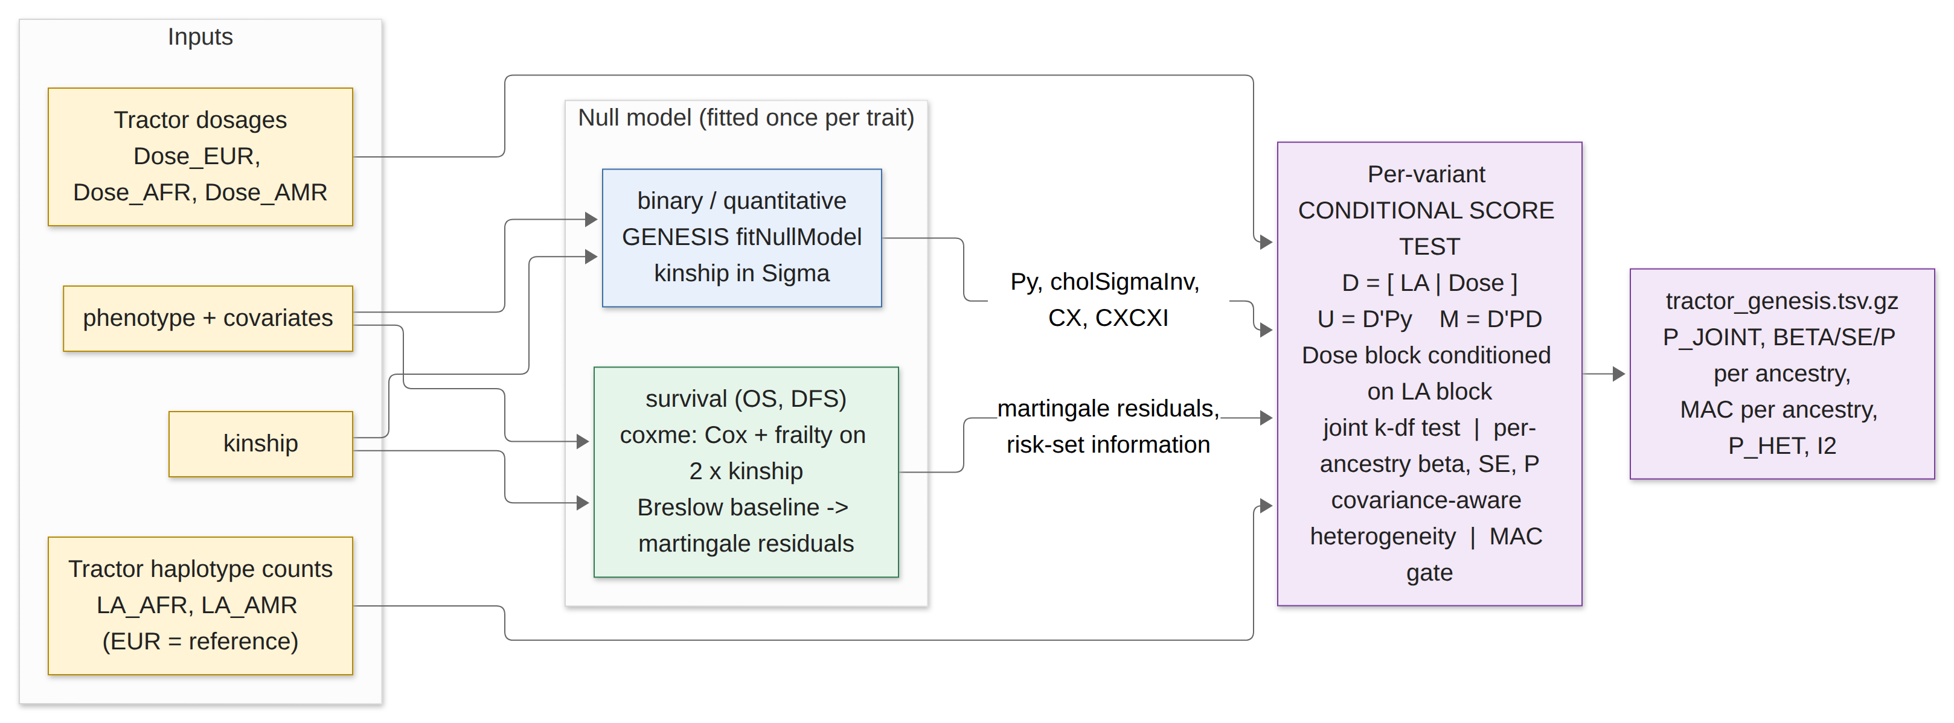
D = [LA terms | Dose terms]. The dose block is conditioned on the local-ancestry block, giving the joint k-df test, per-ancestry effects and a covariance-aware heterogeneity test.

4. GxG interaction (end of pipeline)
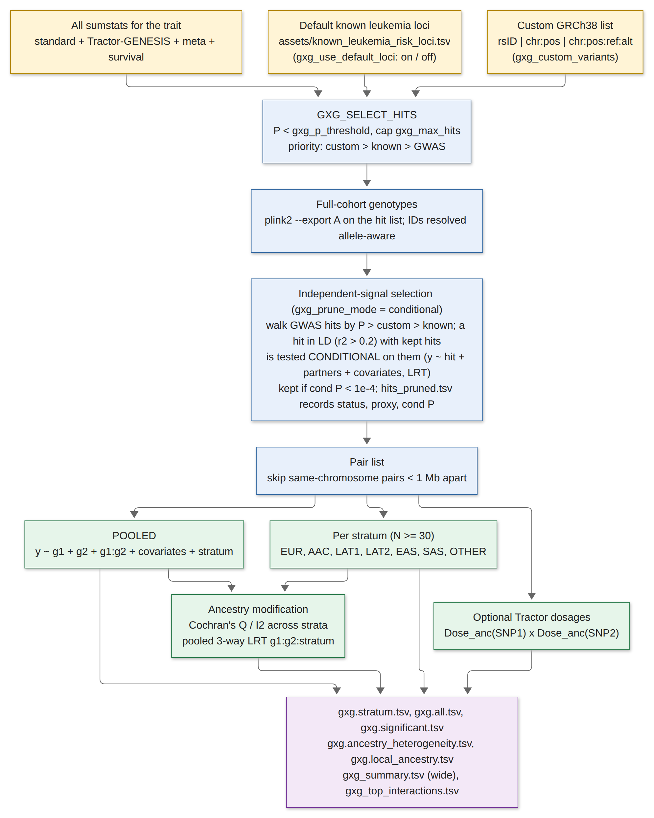
Models: logistic for binary traits, linear for quantitative, Cox for survival. Each pair reports Wald and LRT p-values with Bonferroni over pairs and BH FDR.

How hits in LD are resolved: conditional testing
- Hits are ordered GWAS hits by p-value first, then the custom list, then the default known loci.
- Walking down that order, a hit whose r2 with an already-kept hit on the same chromosome exceeds gxg_max_pair_r2 (0.2) is not dropped. It is tested conditional on all its kept LD partners in the pooled cohort (y ~ hit + partners + covariates + stratum, likelihood-ratio test).
- If its conditional p-value is below gxg_cond_p_threshold (1e-4) it is kept as an independent signal; otherwise it is recorded as explained by its proxy. hits_pruned.tsv lists status, proxy, r2 and conditional p for every hit.
- This is an individual-level stepwise conditional and joint analysis, the analysis GCTA-COJO approximates from summary statistics and reference LD. It runs on the hit list, not genome-wide.
- Proximity alone never drops a variant: nearby independent signals both stay, they are just not paired with each other. gxg_prune_mode = variant keeps only the strongest per cluster; pair keeps everything and skips LD pairs.

5. Traits, covariates, strata: what is customisable
Setting | Nextflow | SLURM | Notes
Traits | phenotype_cols | TRAITS_LIST | any phenotype columns
Binary traits | binary_traits | everything not in SURVIVAL_TRAITS | 0 / 1
Time-to-event traits | survival_traits (+ survival_time_cols, survival_event_cols) | SURVIVAL_TRAITS | default columns <trait>_time, <trait>_status
Covariates | covariate_cols, gxg_covariates | COVARIATES | any phenotype columns
Ancestry column | gxg_ancestry_col | ANCESTRY_COL | GRAF-ANC codes or labels
Strata rules | min_stratum_n, bin/ancestry_config.R | STRATA_LIST, bin/ancestry_config.R | N < 30 pools to OTHER
Known loci | gxg_known_loci, gxg_use_default_loci | KNOWN_LOCI, GXG_USE_DEFAULT_LOCI | default table is a starting point; verify positions
Custom variants | gxg_custom_variants | GXG_CUSTOM_VARIANTS | GRCh38, one per line
LD-correlated hits | gxg_prune_mode, gxg_cond_p_threshold, gxg_max_pair_r2, gxg_min_distance_kb | GXG_PRUNE_MODE, GXG_COND_P | conditional (default): tested conditional on kept hits, kept if cond P < 1e-4; GWAS > custom > known
Tractor | tractor_aac_pops, tractor_lat_pops, tractor_ref_ancestry, tractor_mac_min | ANCESTRIES case in submit_gwas_array.sh

6. SLURM orchestration (slurm/submit_full_pipeline.sh)
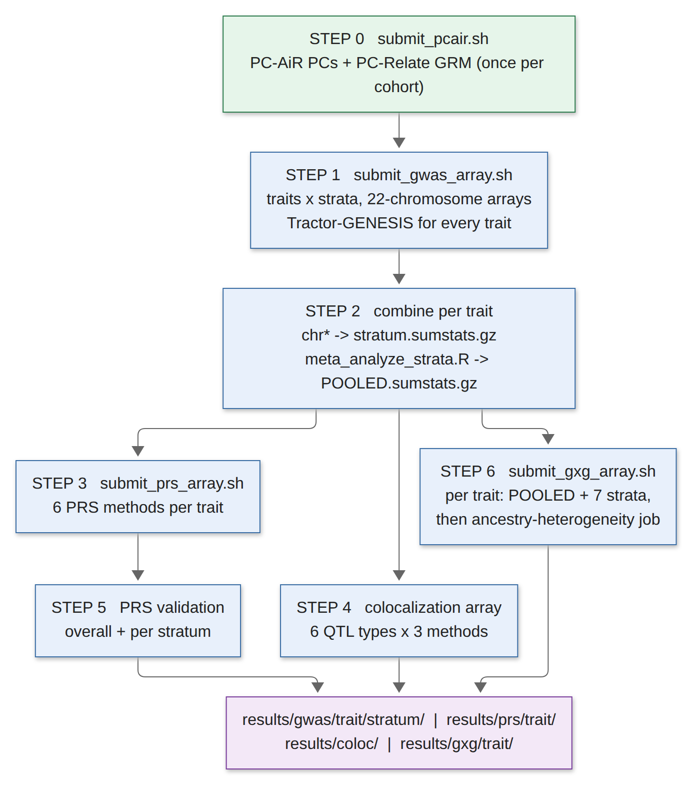
Step 6 needs only the combined summary statistics, so it runs in parallel with PRS and colocalization.

7. Dual structure: both paths call the same scripts
Every analysis step has one implementation in bin/ that both the Nextflow modules and the SLURM scripts call, so the two paths cannot drift apart.
Step | Script | Nextflow process | SLURM
PC-AiR + PC-Relate | genesis_pcair_pcrelate.R | GENESIS_PCAIR_PCRELATE | submit_pcair.sh (step 0)
Tractor-GENESIS GWAS | tractor_genesis_adapter.R | TRACTOR_GENESIS | submit_gwas_array.sh
Strata meta-analysis | meta_analyze_strata.R | MR-MEGA in Nextflow | step 2
PRS: 6 methods, LA partial, stratified validation | calculate_prs_admixed.R | PRS_METHOD, PRS_LA_PARTIAL, PRS_VALIDATE_STRATIFIED | submit_prs_array.sh
Colocalization: coloc.susie, HyPrColoc, OPERA | run_colocalization.R | COLOC_RUN, COLOC_COMBINE | step 4
GxG interaction | run_gxg_interaction.R | GXG_SELECT_HITS, GXG_TEST, GXG_ANCESTRY_HETEROGENEITY, GXG_COMBINE | submit_gxg_array.sh

8. What comes out per ancestry
Tractor-GENESIS reports, for every variant and trait: P_JOINT (any effect) and, for each ancestral background, BETA, SE, Z, P and MAC, plus P_HET and I2 for whether the effects differ across backgrounds. The per-stratum SLURM runs add stratum-level results (EUR, AAC, LAT1, LAT2, and so on) on top, and meta_analyze_strata.R pools each background across strata. PRS adds the local-ancestry partial scores. GxG reports every interaction pooled, per stratum, and for ancestry modification.

